# A Guild to Building a Lego Trailer

## Introduction

Under construction…

## Req­uired Materials

Special pieces:

|  |  |
| --- | --- |
| Piece Name | Count |
| Wheels | 1x |
| Trailer Hitch | 1x |
| Seat | 1x |
| Gray Flat 2x2 | 1x |
| Gray Flat 2x4 | 1x |
| Blue 4x12 (Base) | 1x |
| Blue Flat 6x8 | 2x |

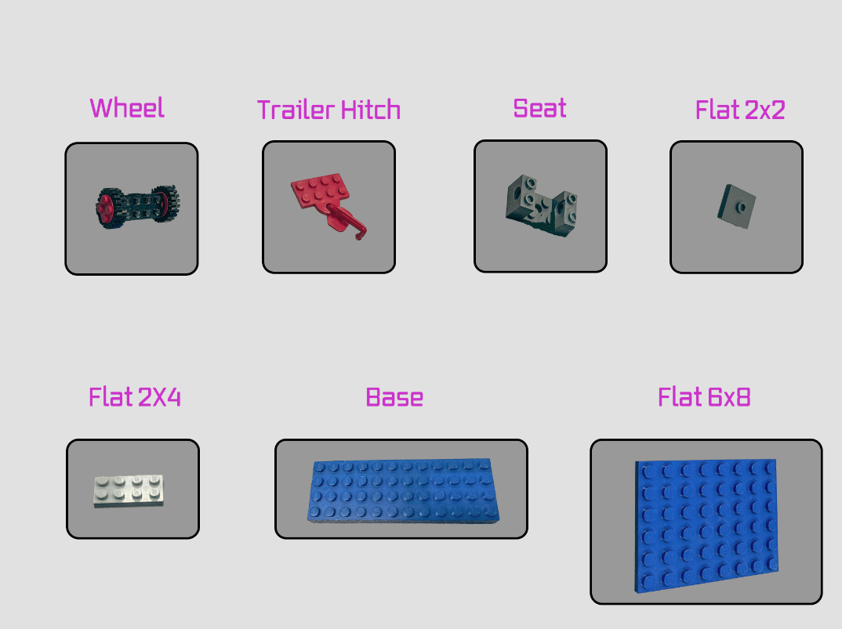

Figure : Special Pieces

Normal pieces:

|  |  |
| --- | --- |
| Piece Name | Count |
| Any Color 2x4 | 15x |
| Any Color 2x6 | 2x |

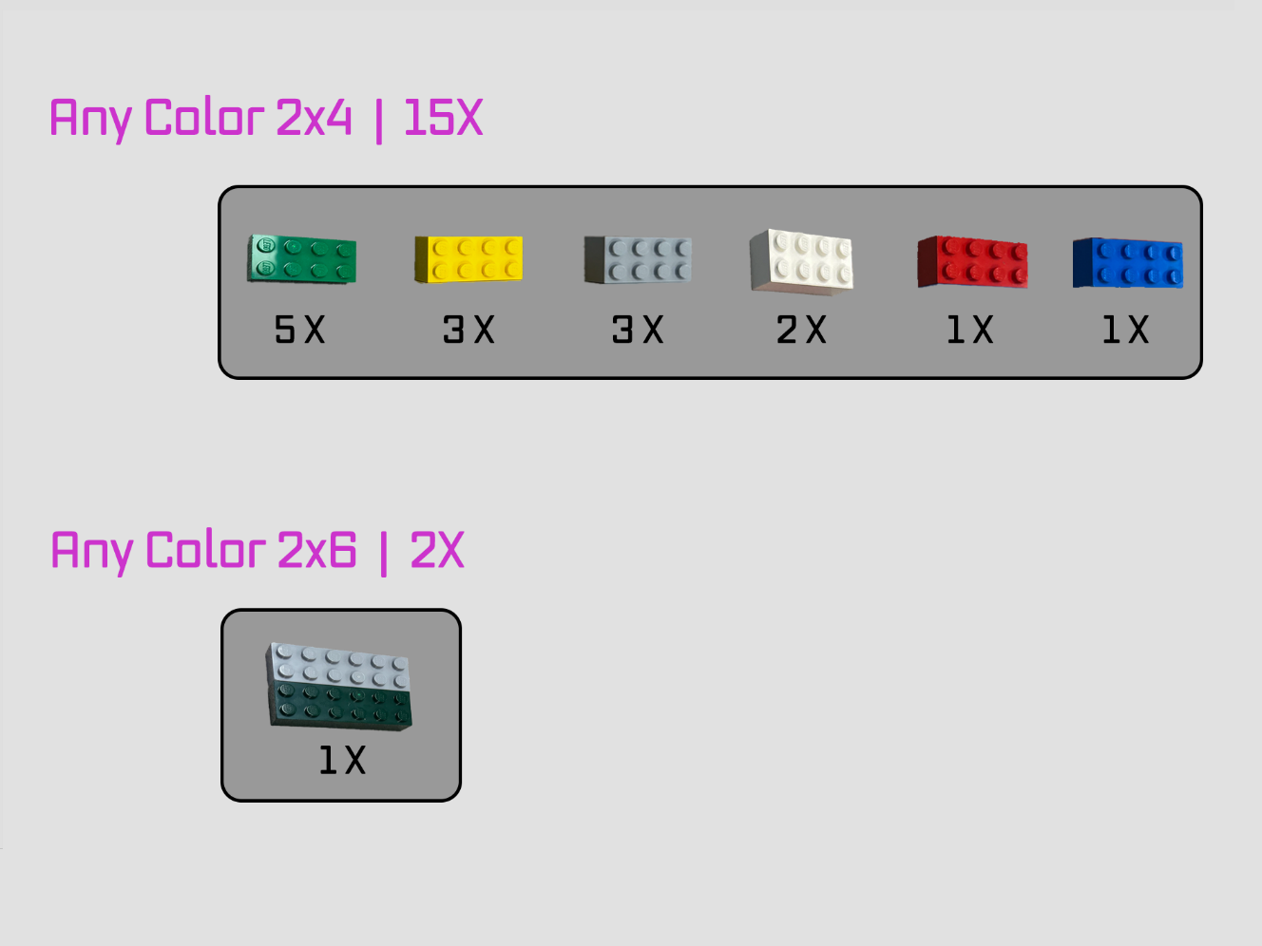

Figure : Normal Pieces

## Procedure

## Conclusion