# A Guild to Building a Lego Trailer

## Introduction

Lego is one of the most popular construction toys in the world. Infinite amount of structure can be build using lego. Below are the instructions for making a trailer using lego building blocks for fun or nostalgia. It will take upto 5-7 minutes to build this trailer. Without any special skill required. Anyone who can read and understand instructions can build it with ease. The pieces are small and can be lost easily so put them with care.

## Req­uired Materials

Special pieces:

|  |  |
| --- | --- |
| Piece Name | Count |
| Wheels | 1x |
| Trailer Hitch | 1x |
| Seat | 1x |
| Gray Flat 2x2 | 1x |
| Gray Flat 2x4 | 1x |
| Blue 4x12 (Base) | 1x |
| Blue Flat 6x8 | 2x |

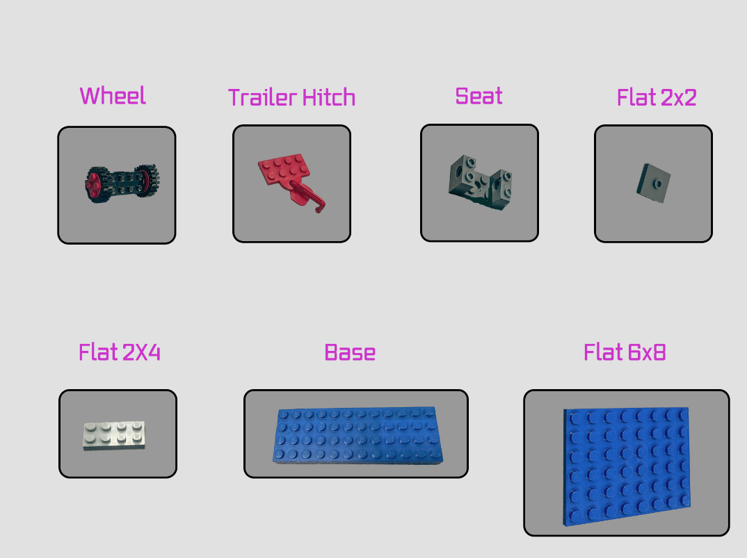

Figure 1: Special Pieces

Normal pieces:

|  |  |
| --- | --- |
| Piece Name | Count |
| Any Color 2x4 | 15x |
| Any Color 2x6 | 2x |

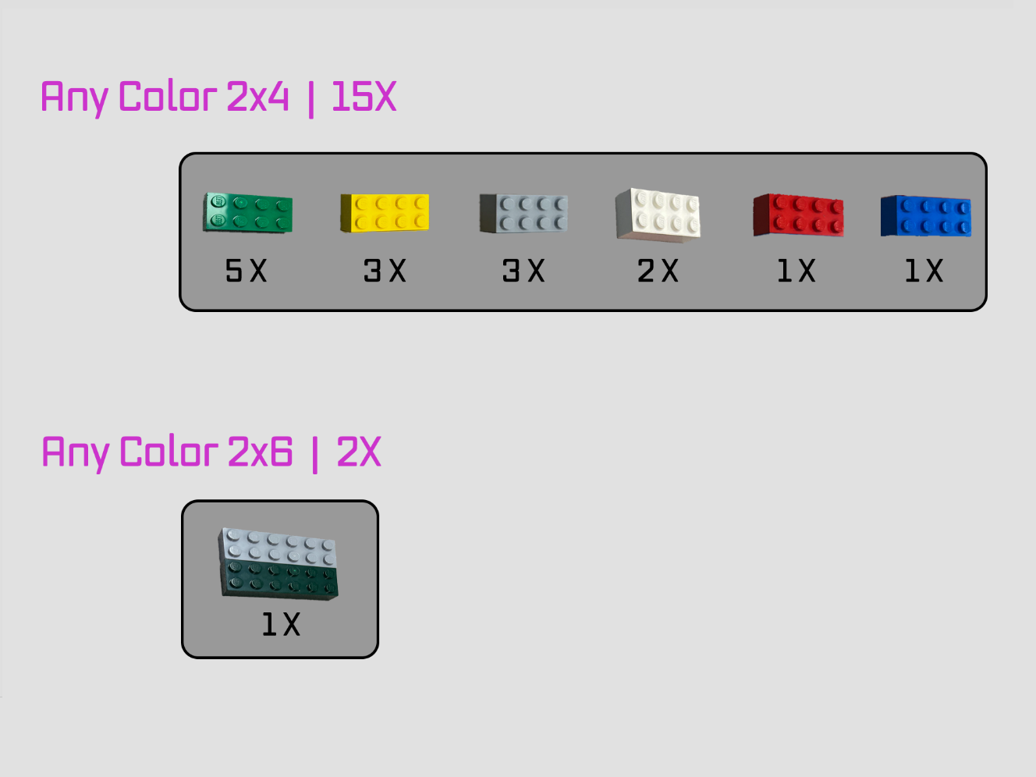

Figure 2: Normal Pieces

## Procedure

## Conclusion