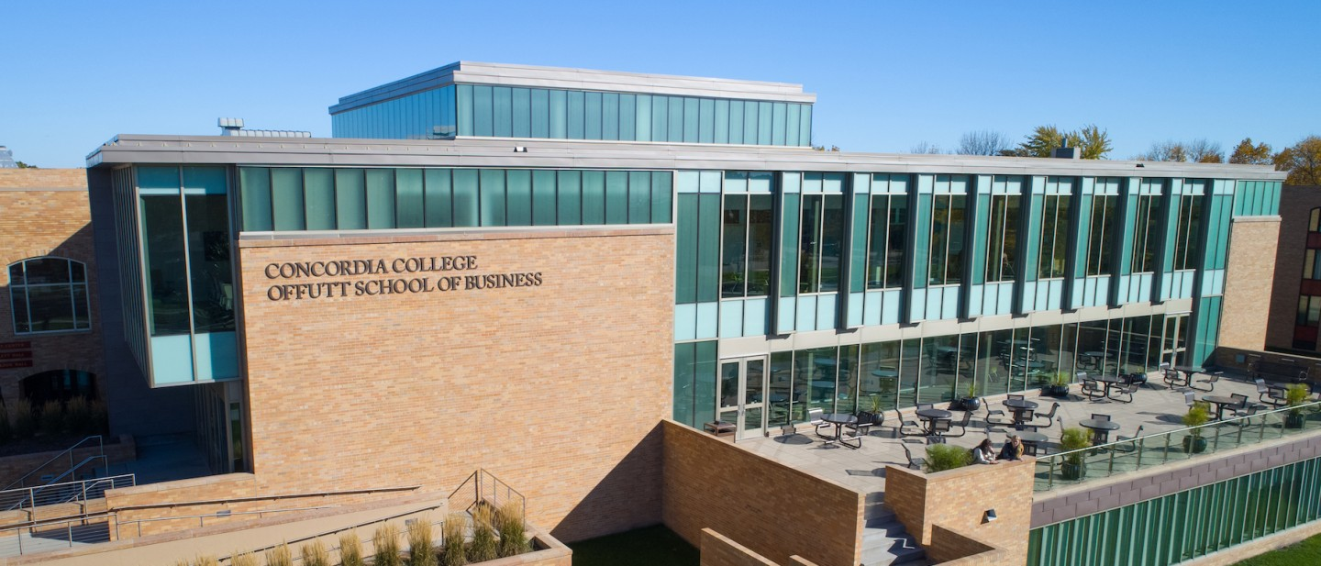

PROJECT NAME – EDIT THIS

**CSC 225- Fundamental Structures**

Course Name

**ENOPAM**

**Team Name**

**Team Member 1: Amira  
Team Member 2: Oriana   
Team Member 3: Elias**

**Team Members**

Briefly describe the project in big-picture terms; like an elevator pitch. What will it do? Who is it for? Why does it matter? How will you solve the problem?

The Online Shopping tool is designed to make shopping experience fast and easy. It will include different components such as the administration permissions, security, delivery service, return process. Customers will have a varity of products to choose from and add to either their wish list or cart, then they will be able to go through the security where they insert their Credit/Debit card information. If they wish to return the product they will go through a similar process and they will be able to get a refund. The sellers will have the ability to have admin access, they will be able to restoke products and put a sale on least selling products.

**Synopsis**

Describe the purpose of the project. What is the problem being solved? Why is the project important? Who might benefit from the project? The purpose of this project to make online shopping convenient for both the business owners and customer, our project aims to design and develop a website system that is fast and high security.

**Purpose**

Executive Summary

# Background

;

State the problem again and provide more details about it, such as historical context, relevance, importance to your group, importance to a target audience, etc.

The historical context for this project is shopping websites in general, many shopping websites can be hard to navigate through. For our project we want to make it really simple and fast for both the sellers and customers. This project is important to our group because, this project is challenging and will help us gain some coding experience. This project will help us see how programming can be applied to the real world.

**Problem**

# Project Plan

List each milestone and briefly describe what you intend to deliver and/or present; what work will you perform for each milestone?

Milestone 1: We worked on the group contract. We made sure to make a schedule for this project.

Milestone 2: We worked on coming up with project idea and talked about what we wanted to do. Each member did their role.

**Milestone Summary**

Provide detailed milestone information, including milestone roles and who worked on what tasks.

Milestone 1: We worked on the group contract. We made sure to make a schedule for this project.

Roles:

Elias – Team leader

Amira – Technical support

Oriana – Technical support

Milestone 2: We brainstormed/ researched project ideas.

Roles:

Amira– Team leader

Elias– Technical support

Oriana – Technical support

**Milestone 1 Details**

# Project Resources

|  |  |  |
| --- | --- | --- |
| Date | Name/URL | Note |
| 2/2/21 | https://www.kaashivinfotech.com/mini-projects/ | This is where we got our project inspiration from. |