React-Native Day3
- Make stack/bottom Navigation to handle navigation
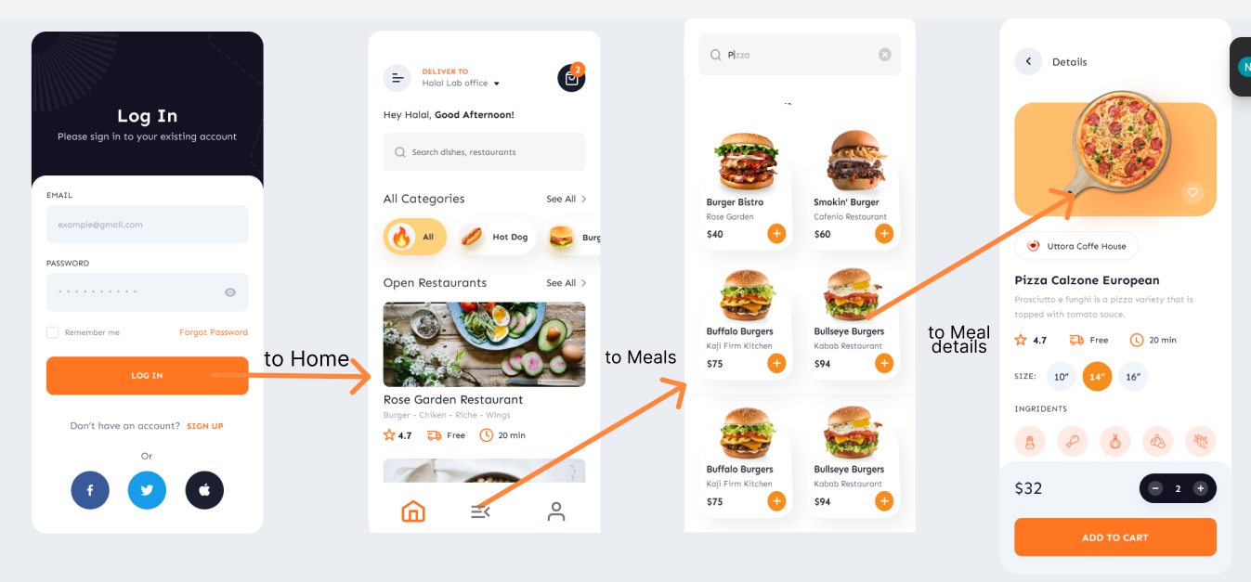

- When click on a meal card display its details by sending meal object as props
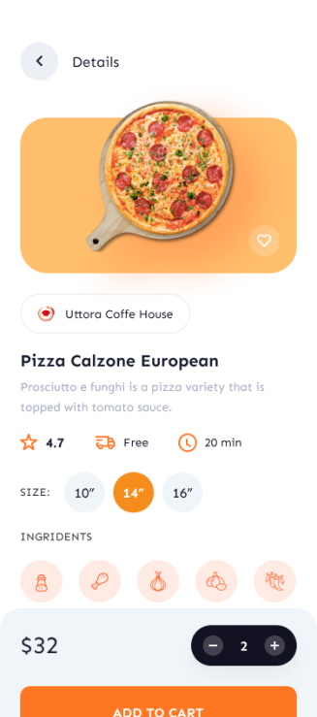

Bonus:
start your app to those 3 screens and finally navigate to the home
