 <Project Logo>

Herfa

Prepared by:

Mohamed Ahmed Attia

Tarek Hassan

Hager Abdo

Amira Abdelhalim

Track: Open Source Application Development

Supervised By:

Eng. Noha Salah

Intake 40

17th of June 2020

1. Introduction 1

1.1 Background(Problem)

1.2 Purpose

1.3 Previous work done(Competitors Analysis)……………………………………………………………...

1.4 Customers' Analysis…………………………………………………………………………………………..

1.5 Scope

1.6 Stakeholders/Beneficiaries………………………………………………………………………………….

1.7 Business Model………………………………………………………………………………………………...

2. Requirements 6

*2.1 User/Functional Requirements*

2.1.1<List of Functional Requirements or Features>

2.2 Use Cases

2.2.1 Actors

2.2.2 List of Use Cases

*2.2.3 Use Case Diagrams…………………………………………………………………………………………………….*

2.3 Classes

2.3.1 <List of Classes >

2.4 Non-Functional Requirements

2.4.1 Performance Requirements(Availability, Security……etc.)

3. Objectives/List of Services(measurable) 10

4. Design Overview 12

4.1 System Architecture

4.2 Data Design(Entity RelationShip Diagram)

5. Implementation 15

*5.1 Tools & Technologies*

*5.2 Hardware Requirements………………………………………………………………………………………………….*

*5.3 Steps of Installation.......................................................................................................................................*

6. User/Customer Testing 18

*6.1 Users/Customers Feedback……………………………………………………………………………………………*

*6.2 Improvements done................................................................................................................*

7. Recommendations(Future Work) 21

8. User Guide(See Attachment) 22

*8.1 Quick Start Guide*

*8.2 Main Scenarios………………………………………………………………………………………………………………*

*8.3 Troubleshooting............................................................................................................................................…*

**1. Introduction**

“It is fairy dust and wanderlust that guide our hands to create what our hearts desire.”  
― **Gayle Wray**

let’s modify this quote a little bit and say “to create, do and learn what our hearts desire”. This is the core idea behind Herfa website. It is the right place if you want to learn any type of handcrafts, know places to buy the needed materials for whatever crafting you intend to do.

1.1 Background

The idea behind Herfa was originated when one of the team member faced the problem of looking for a place where she wanted to learn carpentering, but she did not find a place, after a while she knew that there are a lot of places that can teach you lots of crafting.

Many of the students of faculty of Fine Arts look for places where they can buy certain products for their projects and work. It takes a lot of time looking for the proper place.

Many other people learn or already creating things or wanting to give courses but the do not know if what they are doing or looking for shall be received by the intended ones.

1.2 Purpose

Herfa’s purpose is to make life easier for its users. If user is investor then he/she would be so sure that his/her products, courses or events will reach the interested buyer. So that the investor and buyer are fully connected.

As for normal user he/she will be able to spot his/her need immediately according to his/her subscriptions or by performing a simple search.

1.3 Competitors Analysis

A search was conducted about how to reach a place where you can learn a handcraft profession, what was found are Facebook groups, where people ask how to do something or where to buy something ex “Craftsmen [الحرفيـون الهـواة](https://www.facebook.com/Craftsmen.eg/)” group on Facebook.

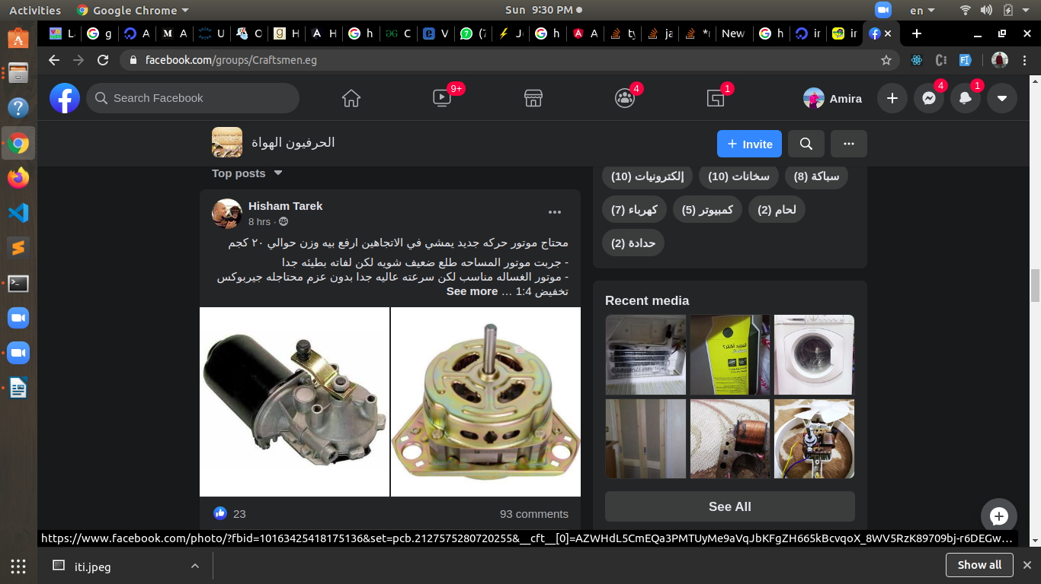

(Fig.1.3.1 Asking where to buy motor)

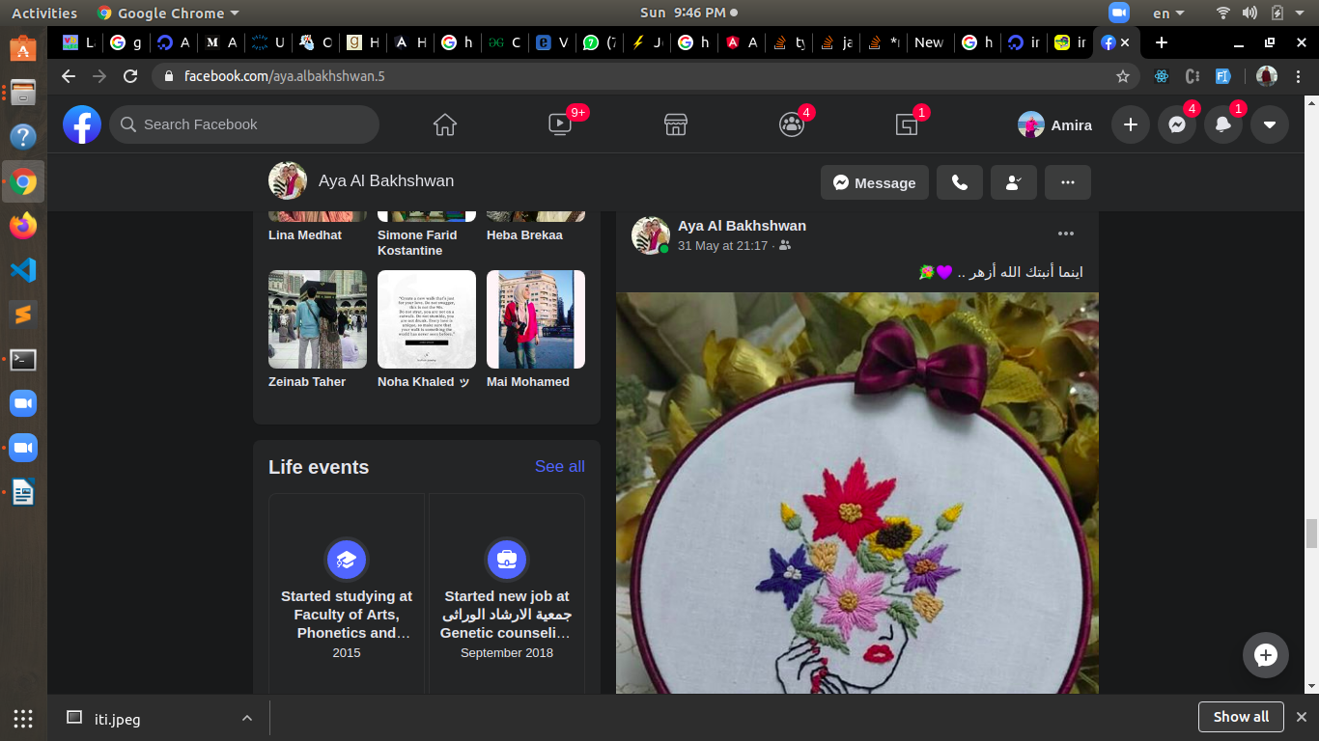 Also lots of crafts makers advertise their work on Facebook pages, groups or their own account.

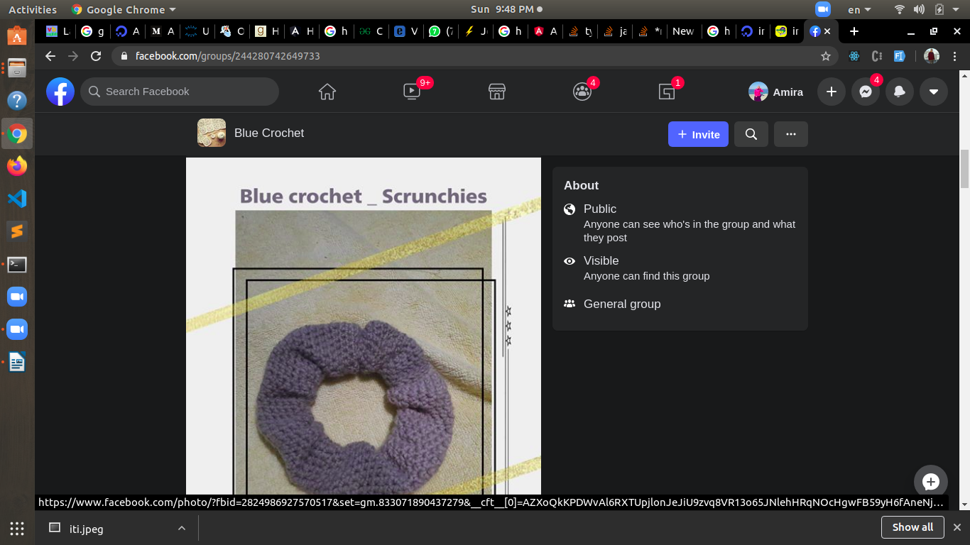

(Fig.1.3.2 Displaying products in facebook groups and pages)

Some websites like SkillShare, it is a website where user enroll can follow a certain skill like sewing, jewelry design ...etc and it displays lots of online courses and after compilation students make a project to make sure the now have the skill.

(<https://www.skillshare.com/browse/crafts>)

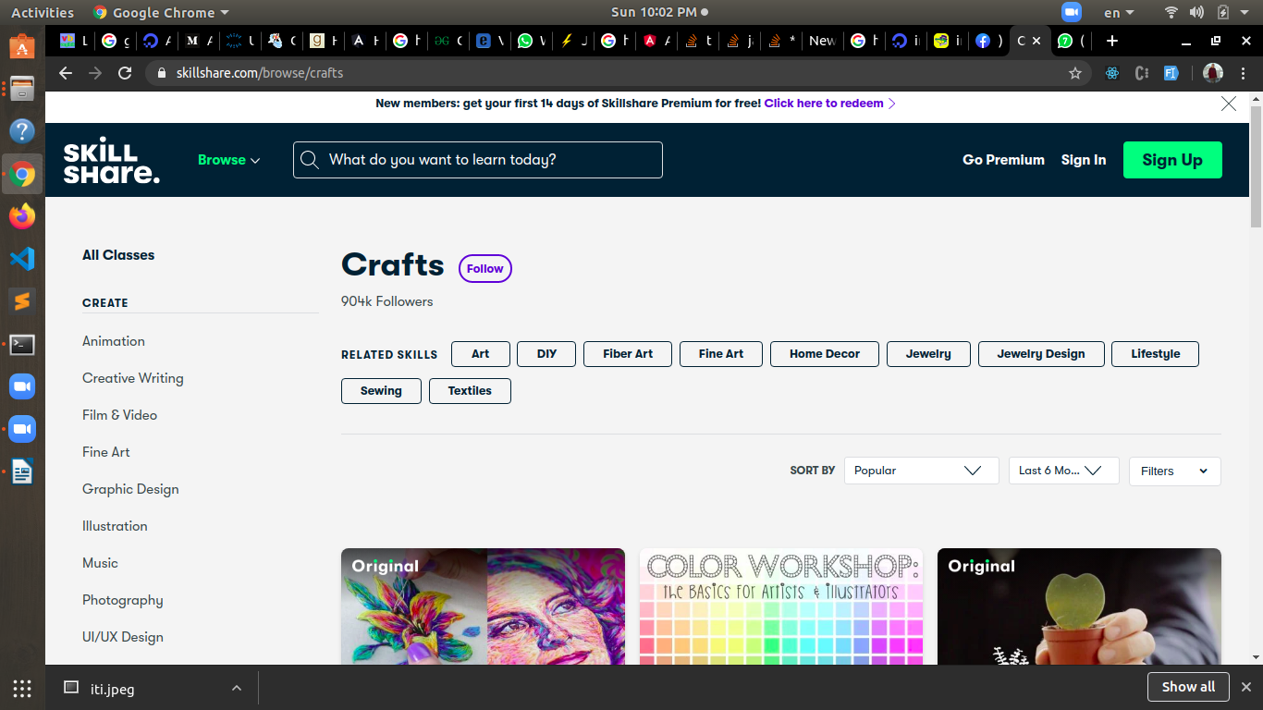

(Fig.1.3.3 Display the crafts page from SkillShare website)

Creativelive website also interested in crafts by giving them courses about lots of crafts.

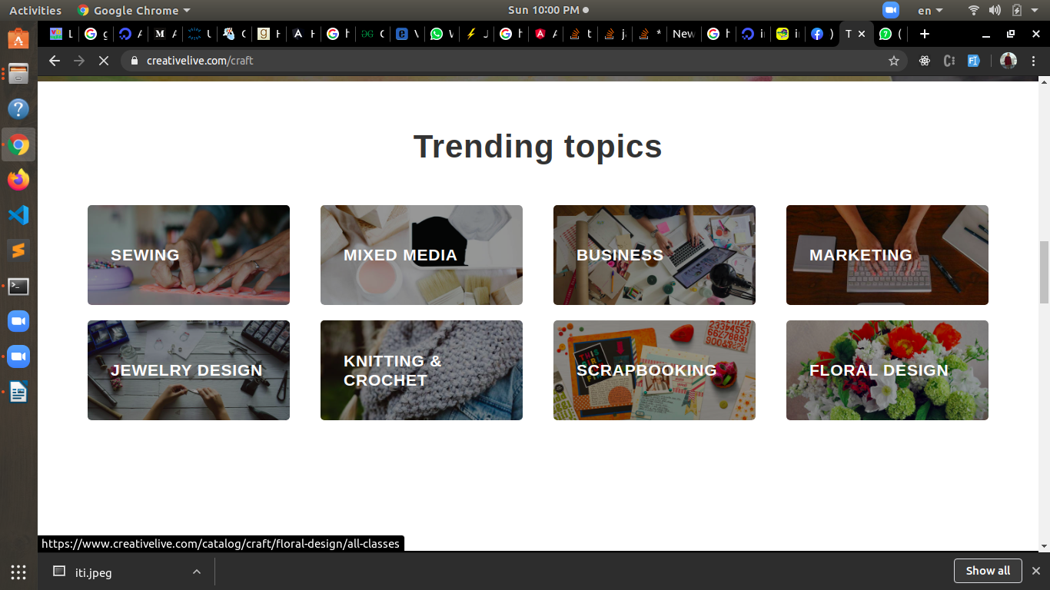(<https://www.creativelive.com/craft>)

(Fig.1.3.4 Displayin the trending courses from Creativelive website)

And other websites like Ebey where you can buy products.

(<https://www.ebay.com/>)

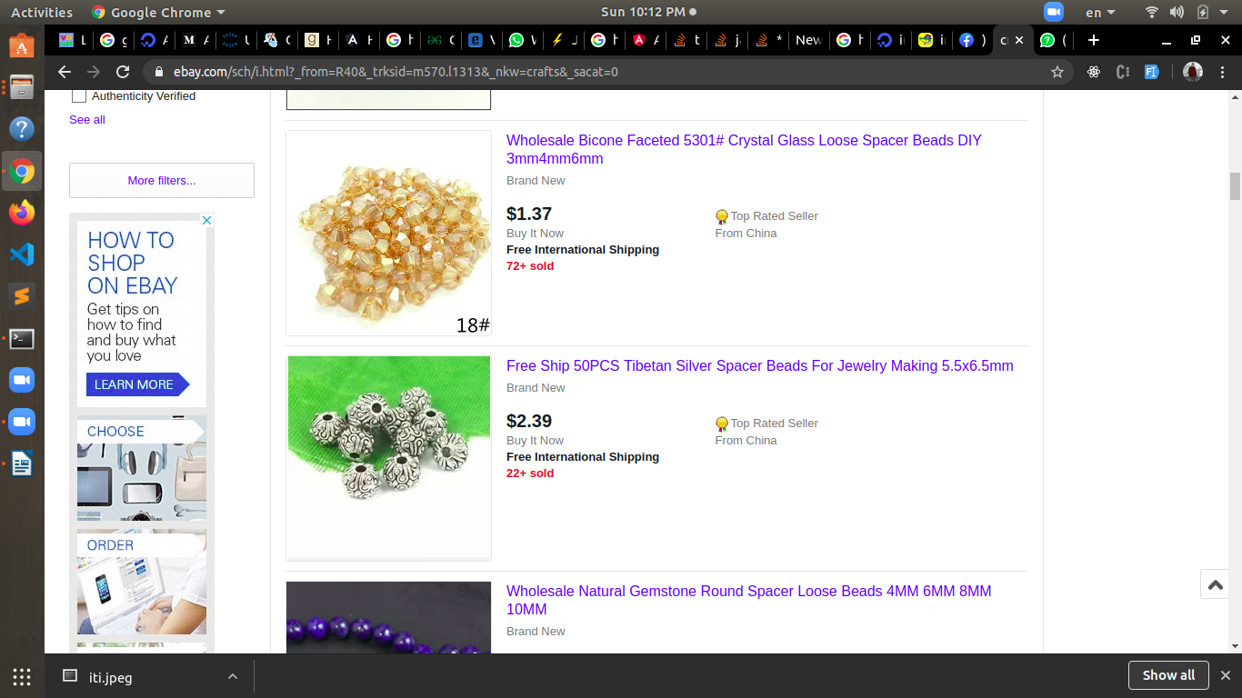

(Fig1.3.5 Displaying products from Ebey website)

What makes Herfa different that the user can perform many tasks from one place.

1.4 Customer’s Analysis

A survey has been done where people were asked about what’s their opinion about the website, will they use such a website, what are the things they need and look for.

Some people had interacted with the idea and encourage the topic they even left ways of communication. The survey was conducted in two languages Arabic and English, the reason was to seek many opinions from different people with different culture.

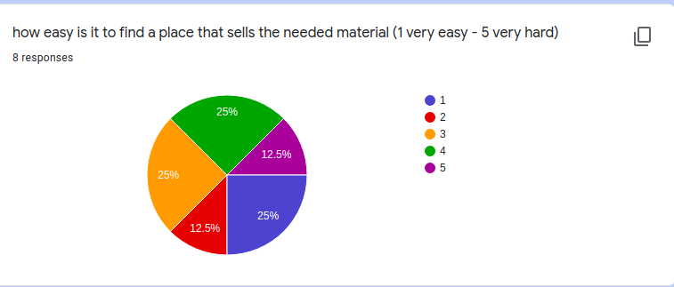

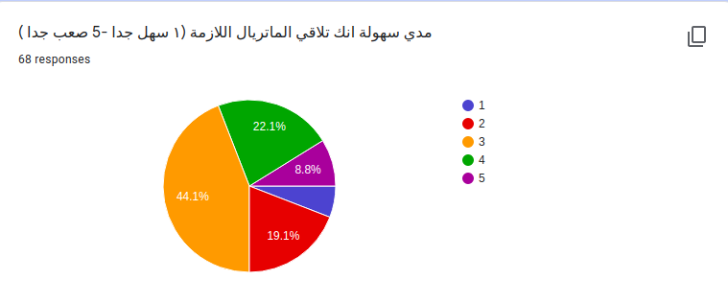(Fig.1.4.1 percentage of easiness of finding materials)

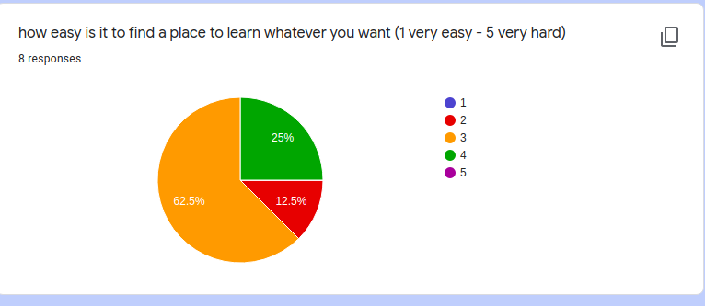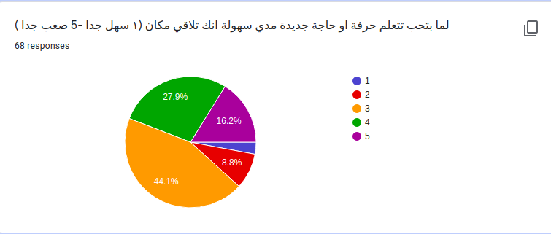(Fig.1.4.2 percentage of easiness of finding places to learn)

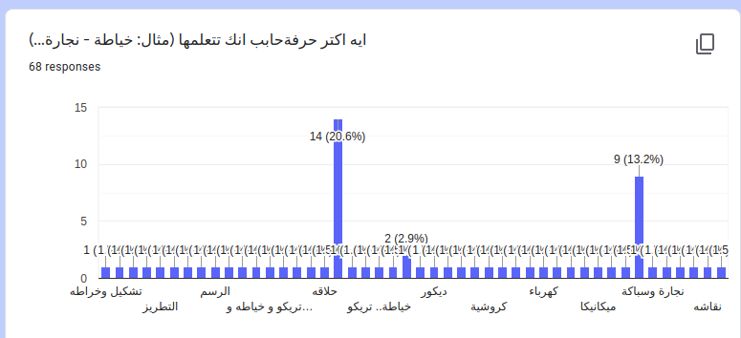

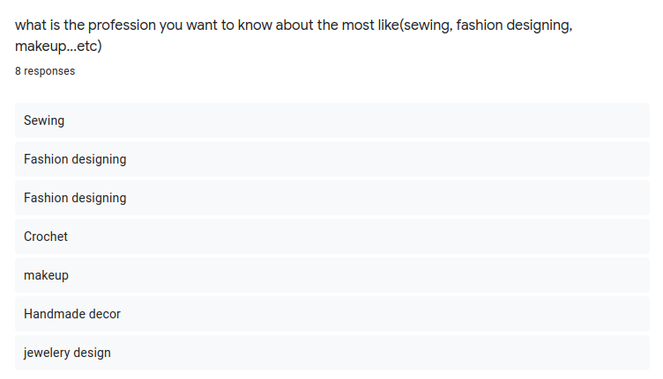

(Fig.1.4.3 The most wanted handcrafts)

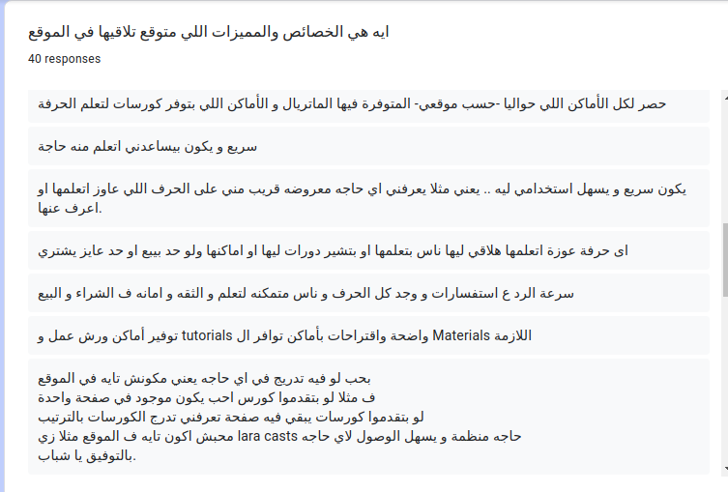(Fig.1.4.4 Sample of what people want or expect from the website)