ANOVA family

Amira Ibrahim

October 10, 2019

# Attach Data

library(readr)   
HW8 <- read_csv("D:/Biostatistics/Lecture/Module 2/HW8.csv")

## Parsed with column specification:  
## cols(  
## Treatment = col_character(),  
## `vitamin B` = col_character(),  
## Age = col_double(),  
## FBS = col_double(),  
## HbA1c = col_double()  
## )

attach(HW8)  
View(HW8)

## Check normality :

library(moments)   
skewness(FBS)

## [1] 0.3448501

#accepted range from -1 to +1  
kurtosis(FBS)

## [1] 2.833659

#accepted range from -2 to +2 may to +3  
boxplot(FBS ~ Treatment , xlab = "Treatment" , ylab = "FBS" , main = "Effect of Drug on FBS")

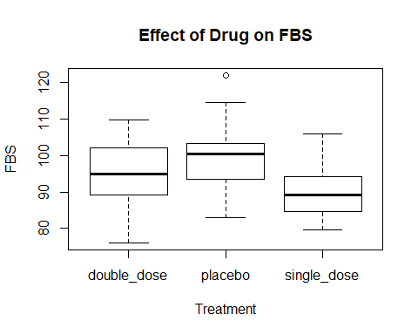

#visually , the data is normally distributed  
shapiro.test(FBS)

##   
## Shapiro-Wilk normality test  
##   
## data: FBS  
## W = 0.98356, p-value = 0.2549

#P-value > 0.05 , So data in normally distributed

# More than 2 levels in variable >> So use ANOVA family

# 1st case : phase III trial to assess the efficacy of single & double dosing of an oral hypoglycemic

# primary endpoint :acheving normal FBS

# H0 :

mu FBS(single dose) = mu FBS(double dose) = mu FBS(placebo)

ANOVA1 <- (aov(formula = FBS ~ Treatment , data = HW8))   
summary(ANOVA1)

## Df Sum Sq Mean Sq F value Pr(>F)   
## Treatment 2 1556 777.8 12.06 2.12e-05 ***  
## Residuals 96 6191 64.5   
## ---  
## Signif. codes: 0 '***' 0.001 '**' 0.01 '*' 0.05 '.' 0.1 ' ' 1

#p-value (F distribution) < 0.05 , reject H0  
#there is significant difference >> The Drug has an effect on FBS

I need to Know which type of treatment is significant :

TukeyHSD(ANOVA1)

## Tukey multiple comparisons of means  
## 95% family-wise confidence level  
##   
## Fit: aov(formula = FBS ~ Treatment, data = HW8)  
##   
## $Treatment  
## diff lwr upr p adj  
## placebo-double_dose 4.968588 0.2621729 9.67500286 0.0360170  
## single_dose-double_dose -4.740552 -9.4469665 -0.03413654 0.0479501  
## single_dose-placebo -9.709139 -14.4155544 -5.00272442 0.0000110

plot(TukeyHSD(ANOVA1))

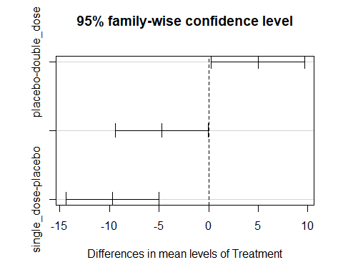 the best significant diffrence is between single dose & placebo

# 2nd case : phase III factorial trial to assess the efficacy of single & double dosing of an oral hypoglycemic with or without vitamen B

# primary endpoint :acheving normal FBS

ANOVA2 <- aov(formula = FBS ~ Treatment + `vitamin B` , data = HW8)   
summary(ANOVA2)

## Df Sum Sq Mean Sq F value Pr(>F)   
## Treatment 2 1556 777.8 11.989 2.28e-05 ***  
## `vitamin B` 1 27 27.4 0.423 0.517   
## Residuals 95 6164 64.9   
## ---  
## Signif. codes: 0 '***' 0.001 '**' 0.01 '*' 0.05 '.' 0.1 ' ' 1

#there is significant diff by treatment on FBS   
#Vit.B not has any effect ( no significant diff)

# if Age is a prospected covariate in 1st case :

ANCOVA1 <- aov(FBS ~ Treatment + Age , data = HW8)   
summary(ANCOVA1)

## Df Sum Sq Mean Sq F value Pr(>F)   
## Treatment 2 1556 777.8 11.971 2.31e-05 ***  
## Age 1 18 17.9 0.276 0.601   
## Residuals 95 6173 65.0   
## ---  
## Signif. codes: 0 '***' 0.001 '**' 0.01 '*' 0.05 '.' 0.1 ' ' 1

#there is significant diff by treatment on FBS   
#Age not has any effect ( no significant diff)

# if Age is a prospected covariate in 2nd case :

ANCOVA2 <- aov(FBS ~ Treatment + `vitamin B` + Age , data = HW8)   
summary(ANCOVA2)

## Df Sum Sq Mean Sq F value Pr(>F)   
## Treatment 2 1556 777.8 11.908 2.46e-05 ***  
## `vitamin B` 1 27 27.4 0.420 0.519   
## Age 1 23 23.4 0.359 0.551   
## Residuals 94 6140 65.3   
## ---  
## Signif. codes: 0 '***' 0.001 '**' 0.01 '*' 0.05 '.' 0.1 ' ' 1

#there is significant diff by treatment on FBS   
#Age, vit.B not have any effect ( no significant diff)

# 3rd case : phase III trial to assess the efficacy of single & double dosing of an oral hypoglycemic

# (one way MANOVA)

# primary endpoint : acheving normal FBS & HbA1c

MANOVA1 <- manova(cbind(FBS,HbA1c)~Treatment , data = HW8)  
summary(MANOVA1)

## Df Pillai approx F num Df den Df Pr(>F)   
## Treatment 2 0.23185 6.294 4 192 8.847e-05 ***  
## Residuals 96   
## ---  
## Signif. codes: 0 '***' 0.001 '**' 0.01 '*' 0.05 '.' 0.1 ' ' 1

## there is significant diff , but I want to know the effect of treatment on each variable :  
summary.aov(MANOVA1)

## Response FBS :  
## Df Sum Sq Mean Sq F value Pr(>F)   
## Treatment 2 1555.7 777.85 12.062 2.123e-05 ***  
## Residuals 96 6191.0 64.49   
## ---  
## Signif. codes: 0 '***' 0.001 '**' 0.01 '*' 0.05 '.' 0.1 ' ' 1  
##   
## Response HbA1c :  
## Df Sum Sq Mean Sq F value Pr(>F)  
## Treatment 2 0.01540 0.0076980 1.7034 0.1875  
## Residuals 96 0.43384 0.0045191

# there is significant diff (treatment , FBS), Drug has an effect on FBS   
# But Drug Not affect HbA1C

# 4th case : phase III factorial trial to assess the efficacy of single & double dosing of an oral hypoglycemic with or without vitamin B :

# (two way MANOVA)

# primary endpoint : acheving normal FBS & HbA1c

MANOVA2 <- manova(cbind(FBS,HbA1c)~Treatment + `vitamin B` , data = HW8)  
summary(MANOVA2)

## Df Pillai approx F num Df den Df Pr(>F)   
## Treatment 2 0.232494 6.2481 4 190 9.598e-05 ***  
## `vitamin B` 1 0.004432 0.2092 2 94 0.8116   
## Residuals 95   
## ---  
## Signif. codes: 0 '***' 0.001 '**' 0.01 '*' 0.05 '.' 0.1 ' ' 1

## to know the effect separately:  
summary.aov(MANOVA2)

## Response FBS :  
## Df Sum Sq Mean Sq F value Pr(>F)   
## Treatment 2 1555.7 777.85 11.9891 2.276e-05 ***  
## `vitamin B` 1 27.4 27.42 0.4226 0.5172   
## Residuals 95 6163.6 64.88   
## ---  
## Signif. codes: 0 '***' 0.001 '**' 0.01 '*' 0.05 '.' 0.1 ' ' 1  
##   
## Response HbA1c :  
## Df Sum Sq Mean Sq F value Pr(>F)  
## Treatment 2 0.01540 0.0076980 1.6857 0.1908  
## `vitamin B` 1 0.00002 0.0000177 0.0039 0.9505  
## Residuals 95 0.43382 0.0045665

#Treatment has an effect on FBS only   
#Vit B not has any effect on FBS or HbA1c

# if Age is a prospected covariate in 3rd case :

MANCOVA1 <- manova(cbind(FBS,HbA1c)~Treatment + Age , data = HW8)  
summary(MANCOVA1)

## Df Pillai approx F num Df den Df Pr(>F)   
## Treatment 2 0.231904 6.2301 4 190 9.884e-05 ***  
## Age 1 0.027461 1.3271 2 94 0.2702   
## Residuals 95   
## ---  
## Signif. codes: 0 '***' 0.001 '**' 0.01 '*' 0.05 '.' 0.1 ' ' 1

## to know the effect separately:  
summary.aov(MANCOVA1)

## Response FBS :  
## Df Sum Sq Mean Sq F value Pr(>F)   
## Treatment 2 1555.7 777.85 11.9706 2.31e-05 ***  
## Age 1 17.9 17.91 0.2756 0.6008   
## Residuals 95 6173.1 64.98   
## ---  
## Signif. codes: 0 '***' 0.001 '**' 0.01 '*' 0.05 '.' 0.1 ' ' 1  
##   
## Response HbA1c :  
## Df Sum Sq Mean Sq F value Pr(>F)  
## Treatment 2 0.01540 0.0076980 1.7300 0.1828  
## Age 1 0.01113 0.0111255 2.5004 0.1171  
## Residuals 95 0.42271 0.0044496

#Treatment has an effect on FBS only   
#Age not has any effect on FBS or HbA1c

# if Age is a prospected covariate in 4th case :

MANCOVA2 <- manova(cbind(FBS,HbA1c)~Treatment + `vitamin B`+Age , data = HW8)  
summary(MANCOVA2)

## Df Pillai approx F num Df den Df Pr(>F)   
## Treatment 2 0.232522 6.1831 4 188 0.0001074 ***  
## `vitamin B` 1 0.004452 0.2079 2 93 0.8126463   
## Age 1 0.028738 1.3759 2 93 0.2577146   
## Residuals 94   
## ---  
## Signif. codes: 0 '***' 0.001 '**' 0.01 '*' 0.05 '.' 0.1 ' ' 1

## to know the effect separately:  
summary.aov(MANCOVA2)

## Response FBS :  
## Df Sum Sq Mean Sq F value Pr(>F)   
## Treatment 2 1555.7 777.85 11.9082 2.457e-05 ***  
## `vitamin B` 1 27.4 27.42 0.4198 0.5186   
## Age 1 23.4 23.44 0.3588 0.5506   
## Residuals 94 6140.1 65.32   
## ---  
## Signif. codes: 0 '***' 0.001 '**' 0.01 '*' 0.05 '.' 0.1 ' ' 1  
##   
## Response HbA1c :  
## Df Sum Sq Mean Sq F value Pr(>F)  
## Treatment 2 0.01540 0.0076980 1.7129 0.1859  
## `vitamin B` 1 0.00002 0.0000177 0.0039 0.9501  
## Age 1 0.01136 0.0113633 2.5284 0.1152  
## Residuals 94 0.42246 0.0044942

#Treatment has an effect on FBS only   
#Both Vit.B & Age not have any effect on FBS or HbA1c