  - Report

FreedomFlyer Sales Assistant
  - CAP 931 Technical Report
Amira Lions
October 17, 2026
I built a Python and Streamlit prototype that retrieves account evidence, chains two model requests, and prepares a sourced sales brief. The workflow runs locally and exports a one-page PDF. Generated claims still require factual review; the reviewed submission candidate was edited after generation.

Contents
Overview — purpose, architecture, and model choice
Steps — setup, validation, web evidence, document upload, and PDF export
Conclusion — experiment results, challenges, and lessons
Appendix — deployment plan, evidence locations, and approximate time
Repository: https://github.com/AmiraLions/CAP_931_Amira_Lions
This report follows the supplied Per Scholas KB template headings. Screenshots document successive development milestones, so earlier screens differ from the finished interface. The README contains detailed setup instructions and limitations.

Overview

Purpose and sales scenario
The assistant helps a sales representative prepare for a conversation with Sunshine State RVs in Gainesville, Florida. Nick Schmidt is identified on the dealership staff page as General Manager/Owner. His title is verified; specific purchasing authority and interest in electric vehicles require discovery.
FreedomFlyer is a fictional electric luxury Class B motorhome concept. Electric propulsion, a long-wheelbase Chevrolet BrightDrop conversion, roof solar, and three solar-covered awnings are proposed design targets. Engineering feasibility, range, battery integration, pricing, and availability are unvalidated. “Advantures” is intentional brand wording.

Application design
The form collects product name, prospect URL, product category, competitor URLs, value proposition, and target contact. Required text and basic HTTP/HTTPS format checks run before retrieval. Category remains an editable input; automatic category inference is not implemented.
requests and BeautifulSoup download supplied pages and extract text. Successful pages receive source IDs. GPT first extracts research findings, then writes a brief from those findings and references. These are two sequential prompt roles, not independently acting autonomous agents. Streamlit keeps results in session state and provides previews and downloads.
An optional PDF/TXT upload supplies labeled, unverified product context after inclusion is selected. Local code checks word count and citation structure. ReportLab formats the PDF, and pypdf checks that it has exactly one page. Neither formatting nor mechanical checks establish factual correctness.

Model choice and tradeoffs
I selected GPT-4.1 mini as a starting point for instruction following, response speed, and low text-processing cost. The connection test returned model gpt-4.1-mini-2025-04-14 and used 18 tokens. I did not measure latency systematically or benchmark another model. Factual errors in later drafts prevent a claim of reliable accuracy.
A separate paid generation button makes the two API requests explicit. Saved snapshots and local PDF preparation let me inspect and export existing results without another paid request. Usage is recorded for comparison; token counts are not billing statements.

Scope boundaries
Research is limited to supplied readable text. Public filings or strategy documents are used only if supplied and accessible; no comprehensive filing search is implemented. Prompts distinguish evidence, hypotheses, and gaps, but their boundaries are not a guarantee against off-task output or prompt injection.

Steps

1 Set up a reproducible project
I initialized a packaged application with uv, used src/cap_931_amira_lions for code, pinned Python 3.14.7, and retained uv.lock. Git records implementation checkpoints. Local credentials stay in .env, excluded from Git; the named local API-key backup is also ignored.
To reproduce, clone the repository, run uv sync --locked, configure a local OPENAI_API_KEY, and start the app with uv run python -m streamlit run src/cap_931_amira_lions/app.py --server.address 127.0.0.1. The README explains each setup step. Windows blocked the separate Streamlit executable, so the Python module launch was used successfully without changing security settings.

2 Build and review editable inputs
I first tested a greeting app, then replaced it with the sales form. I changed a field in the browser, reviewed its submitted value, and restored the original. This confirmed that user inputs flow into the application.
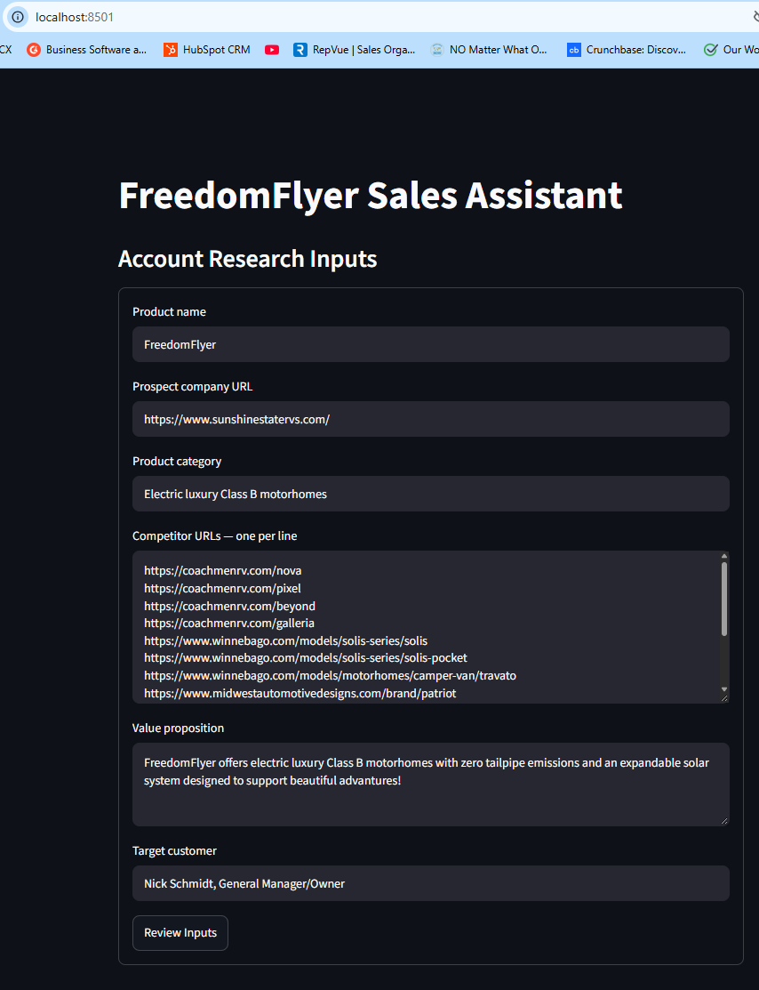
Figure 1. Six editable fields populated with the fictional product and prospect scenario.

Steps continued

3 Reject missing and malformed inputs
I removed the product name and submitted the form. The required-field message appeared. I restored it, entered hello as the prospect URL, and submitted again. The URL error appeared. These checks screen basic format; they do not establish that a website exists or is safe to request.
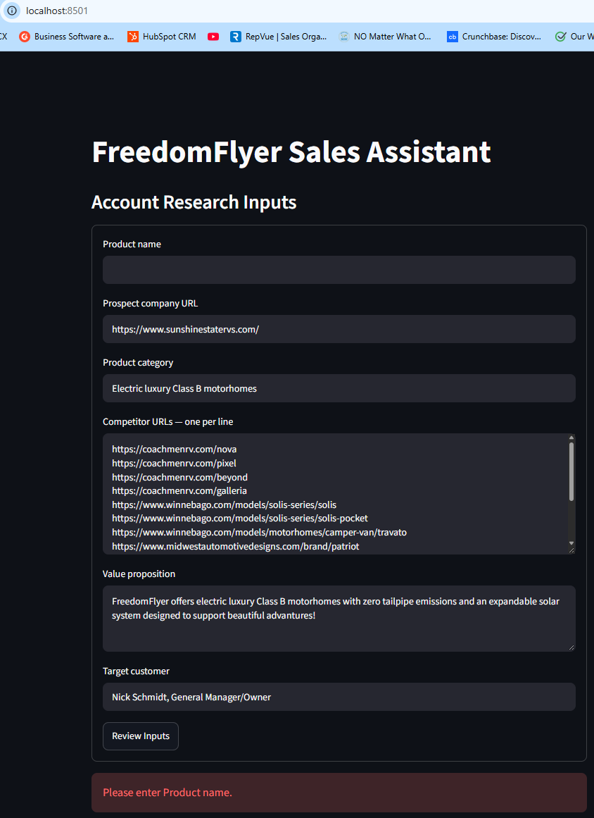  Figure 2. Blank product name produces a required-field error. | 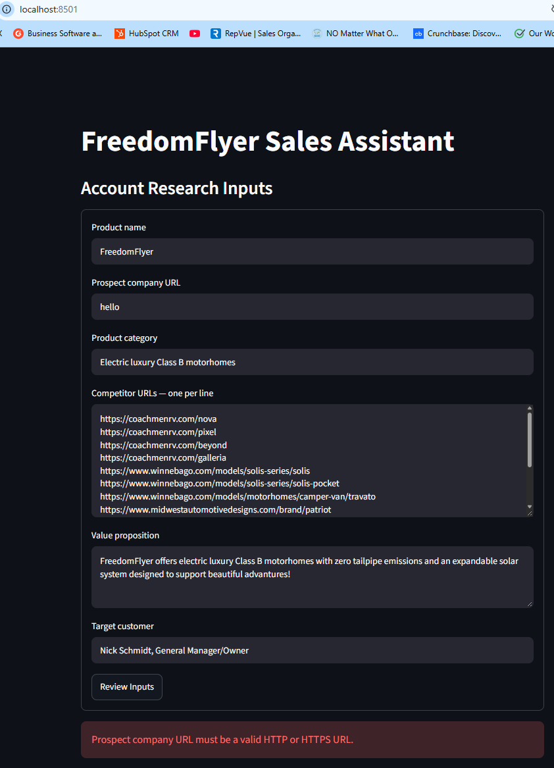  Figure 3. A prospect URL without HTTP/HTTPS produces a format error.
Observed results: both tests passed. Validated input review was withheld while errors were present.

Steps continued

4 Identify an invalid competitor and restore valid inputs
I added hello as competitor entry 14. The application identified that entry in its error message. I removed the invalid entry and restored the original values; the success message and submitted-input review then appeared.
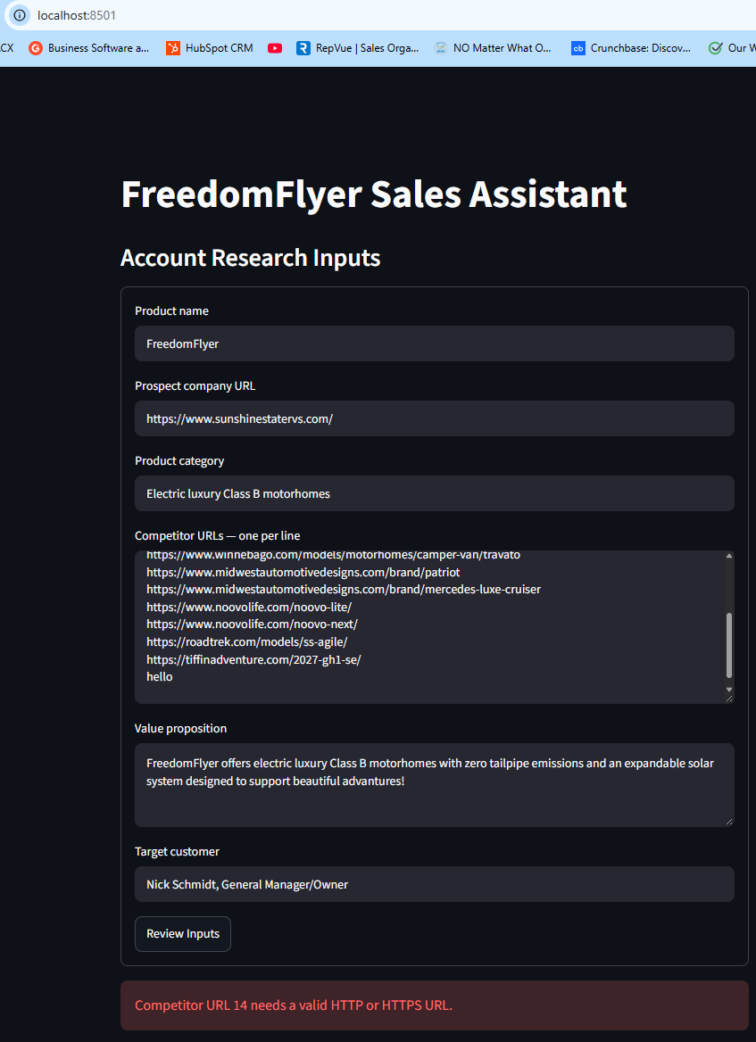  Figure 4. Entry-specific feedback identifies competitor URL 14. | 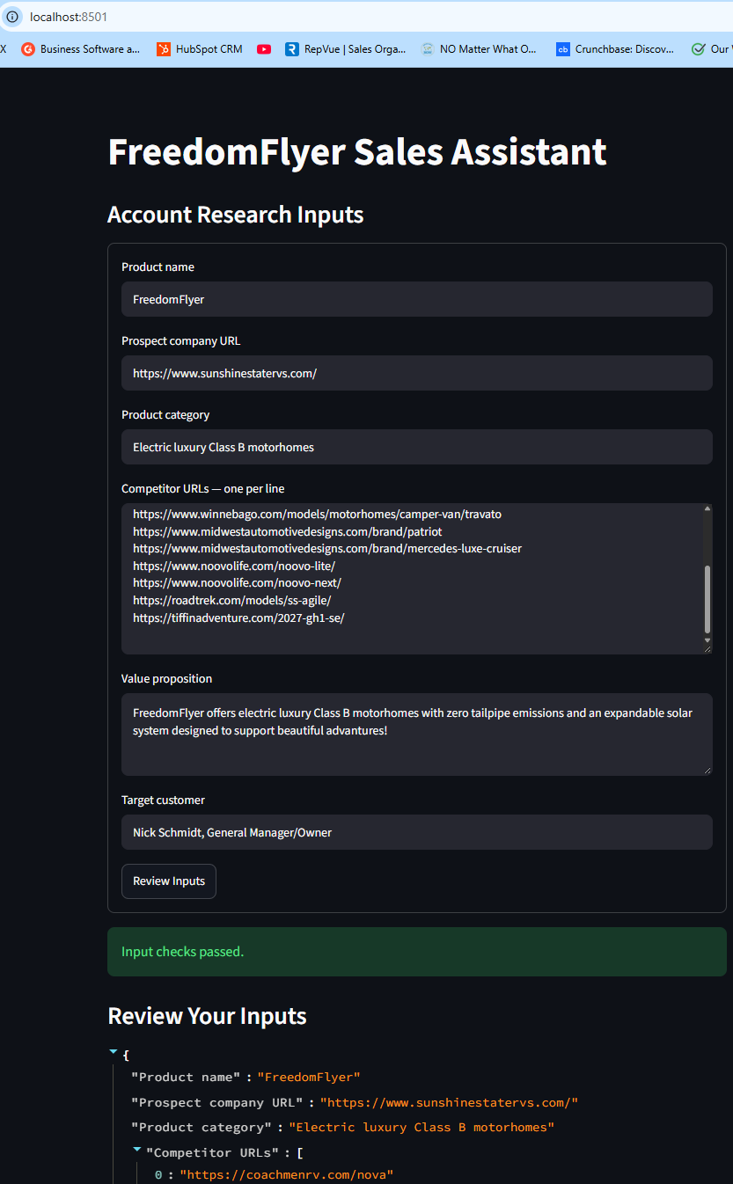  Figure 5. Restored inputs pass validation and appear in the review.
Observed results: both tests passed. Each competitor line is cleaned and checked separately. URL format validation is distinct from later download and content-quality checks.

Steps continued

5 Inspect web evidence and optional product text
I retrieved the staff page and inspected the extracted text. A name comparison initially failed because the page contained extra spaces and line breaks. Normalizing whitespace for the comparison confirmed Nick Schmidt and General Manager/Owner; the preview retained original formatting.
I tested a text-based product PDF and valid TXT. The PDF preview contained 870 characters. Empty files, unsupported DOCX, and a damaged PDF returned helpful messages. The upload is preview-only until inclusion is selected. Removing the file and resubmitting cleared its saved text.
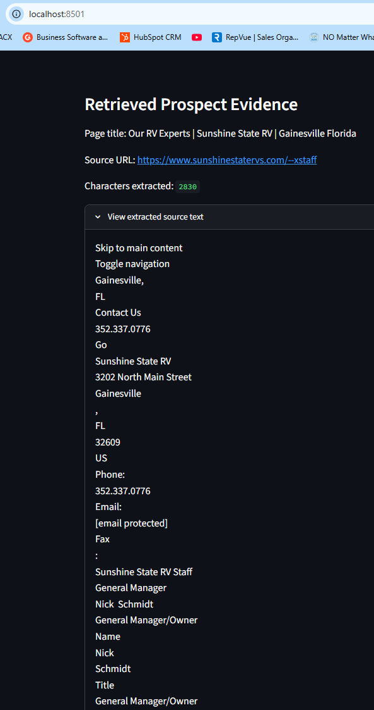  Figure 6. Staff-page evidence includes the contact name and title. | 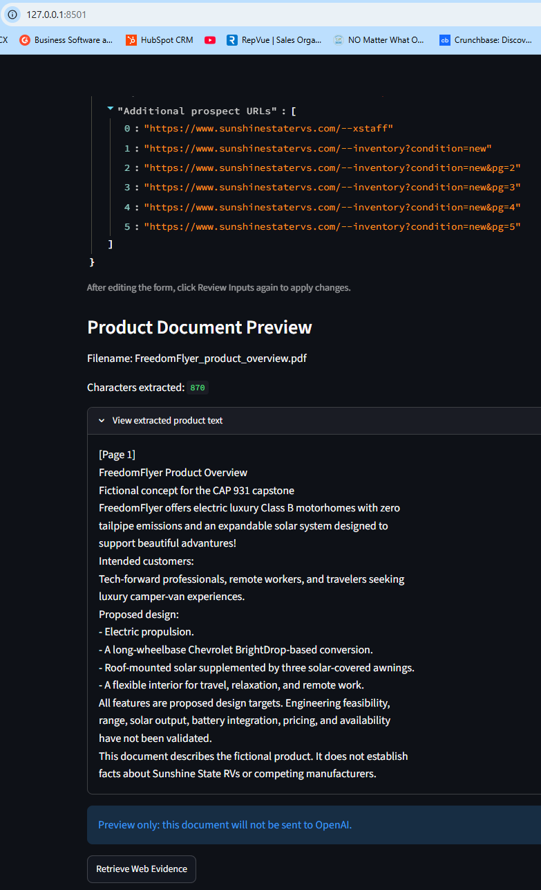  Figure 7. Product extraction is visible with preview-only sharing status.
The later checked inclusion state was tested separately and recorded in Experiment 4. Limits: 5 MB per file, 30 PDF pages, and 20,000 retained text characters. No OCR is implemented.

Steps continued

6 Generate a draft and export a reviewed brief
I retrieved all five new-inventory pages and supplied manufacturer pages. The final recorded generation used 13 of 20 sources with readable text. One technically successful Travato response contained an error message; the page-quality check excluded it. The model then completed both chained requests.
I preserved the generated Markdown and JSON snapshots, inspected warnings, and reviewed claims against saved evidence. The separately reviewed brief was edited after generation. A saved experiment can also be loaded locally without calling GPT.
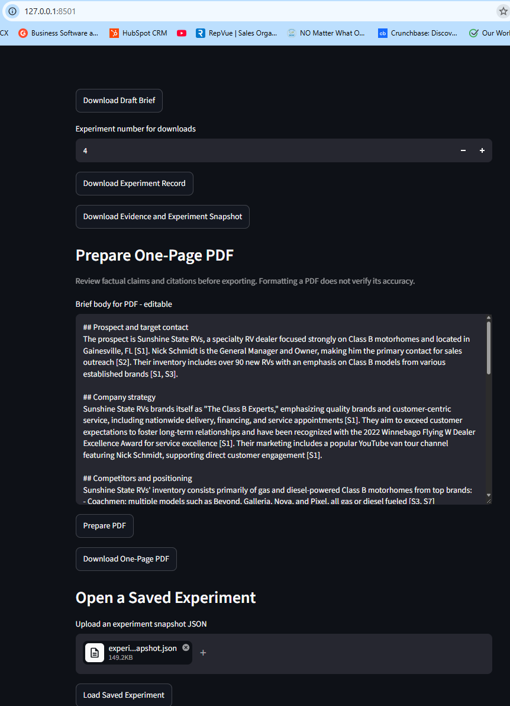
Figure 8. PDF preparation and saved-experiment loading controls. This screenshot demonstrates the export workflow using Experiment 4, not factual approval of that draft.
I checked the downloaded PDF: one page, no clipped text. The reviewed candidate is reports/FreedomFlyer_reviewed_sales_brief.pdf; experiment_04_pdf_export_test.pdf is an unapproved export test.

Conclusion

Experiments and observed limitations
Four developmental runs tested changes in prompts, evidence coverage, and document context. These were not controlled model comparisons because several inputs and implementation details changed between runs. Original outputs are retained.
Run | Readable sources | Input / output tokens | Observed outcome
1 | 9 / 15 | 9,604 / 1,910 | Missing dealer evidence led to unsupported brand-relationship conclusions.
2 | 14 / 20 | 35,248 / 2,387 | Five inventory pages improved coverage; overstatement and scope errors remained.
3 | 14 / 20 | 35,238 / 2,148 | 462 body words; grouped citations and factual issues required review.
4 | 13 / 20 | 36,857 / 2,203 | Upload context included; error-only page excluded; 476 words and recurring errors remained.
Token counts combine both requests. The target body length is 350–450 words. Experiments 3 and 4 exceeded it. Checks also flagged grouped citations; these warnings are advisory and do not block all exports.

Challenges and solutions
Missing inventory evidence was initially treated as proof of absence. I added five inventory URLs, inspected entries labeled NEW, and revised evidence instructions. Models still made absolute claims about electrification and generalized availability. I narrowed those statements during human review rather than treating stronger prompts as proof of correctness.
Grouped citation markers lost source references in an early parser. The revised parser extracted S1, S2, S3, S5, and S6 from [S1-S3] [S5,S6]. Unknown IDs do not receive invented URLs. An error-page heuristic now rejects the observed Travato error text, but cannot identify every unusable response.
Incomplete file transfers and a filename ending in (1).py caused syntax/import failures. I restored complete files, corrected names, and checked imports. Git line-ending warnings on PDFs were addressed by marking PDF/PNG files as binary.

What I learned
I learned to separate Python code from terminal commands, trace module failures, preserve reproducible dependencies, and test the interface before adding API work. Retrieval success, citations, and a clean PDF do not establish claim accuracy. The prototype completes the workflow, but external sales use requires factual review.
I used AI assistance for explanations, commented code examples, troubleshooting, review, and documentation. I ran local commands, tested screens, inspected outputs, and managed Git checkpoints. I remain responsible for understanding and explaining my implementation.

Appendix

Proposed deployment plan
This is a plan for future production use. The prototype has not been deployed as a production service, and the controls below are not implemented.

Hosting and secrets
Package the app in a supported container, validate the pinned Python and locked dependencies on the host, and separate development, staging, and production configuration. Require HTTPS and authenticated access. Store API credentials in a host secret manager. Keep secrets and unnecessary document text out of logs.

Retrieval and document safety
Restrict outbound requests and redirects to approved public destinations; reject private, loopback, link-local, and infrastructure metadata addresses. Apply request/response limits and timeouts. Isolate document parsing with resource limits and appropriate scanning. Define upload consent, retention, deletion, and access rules. Current basic URL and file checks do not provide these protections.

Scale and spending
Use a bounded queue with worker limits, cancellation, per-user quotas, and freshness-aware caching. Respect website access policies. Add bounded retries for suitable transient failures and account for duplicate-request costs. Monitor token usage, latency, failures, and provider budgets; verify which provider controls enforce limits versus only send alerts.

Quality and maintenance
Keep fixed evidence snapshots and refresh test cases for changing websites. Add automated smoke, regression, attribution, and adversarial tests in CI. Compare prompt/model changes in staging, preserve versions, and retain rollback options. Require human approval before a brief is used externally. Test factual support beyond citation syntax.

Optional extensions
A future scheduler could compare approved sources with stored timestamps or content hashes and send deduplicated keyword alerts to opted-in recipients. No scheduler or email alert service exists. Product-deck/vision analysis and presentation generation are also future extensions requiring separate testing and source preservation.

Testing scope
The screenshots and manual outcomes document local behavior. Additional AI-assisted checks used saved evidence and simulated API/UI behavior. They were not live production, security, or accuracy certification tests. No measured factual accuracy score or model-to-model benchmark is claimed.

Appendix continued

Approximate time management
I reconstructed these figures from conversation timestamps and recollection. Known breaks and longer unconfirmed gaps were excluded where identifiable. Session windows may include short pauses and are not verified active coding hours.
Task or date | Approximate time | Work represented
Product and account planning | 3 hours | Learner estimate for defining the fictional product, prospect, contact, and competitors.
October 11 | 30 minutes | Partial validation and documentation window.
October 12 | 7 hours | GitHub, API setup, retrieval, testing, screenshots, chaining, and early experiments.
October 14 | 1 hour 40 minutes | Preserving experiments, revising modules, repairing transfers, and import checks.
October 16 | 2 hours 25 minutes | Evidence review, citation/page checks, uploads, Experiment 4, and PDF development.
Partial planning/session-window subtotal: approximately 14 hours 35 minutes. This combines an estimate with reconstructed windows. October 7, October 9, additional October 11 work, and October 17 are not separately totaled. Planning may include earlier dates and must not be counted twice. All reconstructed times are Pacific.
October 17 documentation work is ongoing. The errand ending at approximately 4:32 p.m. is excluded. A new one-hour sprint began at approximately 4:45 p.m.; elapsed active time should be recorded when it ends. The complete project total remains uncertain.

Files for the reviewer
README.md supplies full setup and reproduction instructions. Source modules live in src/cap_931_amira_lions. Its experiments folder contains original drafts, snapshots, and freedomflyer_reviewed_brief.md with revision notes. Its screenshots folder contains Figures 1–8. reports contains the reviewed PDF and the separate Experiment 4 export test.
Key modules: app.py for interface/state; web_research.py for retrieval; document_reader.py for uploads; prompts.py for instructions; llm_client.py for chaining, checks, and snapshots; report_generator.py for PDF layout. API and PDF test scripts are in the project root.

Evidence and access
Dealer sources: https://www.sunshinestatervs.com/ and https://www.sunshinestatervs.com/--xstaff, plus five new-inventory pages. Exact manufacturer URLs, retrieval text, and model usage are retained in the experiment snapshots. The reviewed sales brief includes its own source links. Saved evidence is historical; inventory has not been freshly verified for this report.

