IC-PRO-S: Operator-Aware Proximal Reconstruction for Robust Cross-Instrument Computational Spectroscopy

Amira Samy Talaat
Computers and Systems Department, Electronics Research Institute, Cairo 12622, Egypt
amtalat@yahoo.com ORCID: 0000-0002-9413-3079

Abstract
Reconstructive spectrometers infer high-dimensional spectra from compact detector measurements through calibrated forward operators, making reconstruction tightly coupled to instrument response. We present IC-PRO-S, a compact deterministic operator-aware inverse that uses the current calibrated sensing matrix directly at inference. The method combines a Tikhonov physics anchor, response-conditioned residual refinement, and one exact quadratic proximal displacement to restore measurement consistency, with adaptive under-relaxation before nonnegativity projection. A simulation-calibrated nearest-manifold guard selectively routes measurements outside the supported operator family. Across five independent training seeds, IC-PRO-S improves Relative-L2 error over Tikhonov by 28.17% on held-out Test data and 23.91% on OOD data. In a frozen seven-method cross-instrument benchmark, it achieves the lowest mean error for interpolation (0.3505) and severe structural shift (0.3856), while remaining competitive under detector-count extrapolation without target retraining. The same reconstruction principle transfers zero-shot to unseen wavelength grids and, after response-only adaptation, to an independent measured responsivity operator, outperforming the evaluated ReSpecNN, PnP, NNLS-TV, and Tikhonov comparators under the controlled protocol. Public real-device evaluation and five-seed calibration-perturbation experiments further show that soft proximal reconciliation remains advantageous through moderate calibration mismatch. These results show that calibrated response can serve as a practical interface between changing spectrometer hardware and a shared learned inverse.

Keywords: reconstructive spectroscopy; computational spectroscopy; optical spectroscopy; inverse problems; operator-aware reconstruction; proximal data consistency; cross-instrument transfer; response conditioning; calibration robustness; selective deployment.

1. Introduction
Miniaturized and computational spectrometers replace part of the conventional dispersive optical train with a calibrated encoding device and numerical inverse reconstruction [1–9]. The instrument therefore cannot be separated from its reconstruction: a detector response vector y is meaningful through the calibrated forward operator A that maps an unknown spectrum to the measured channels. This coupling enables compact optical hardware, but it also creates a strongly ill-conditioned or underdetermined inverse problem, particularly when the number of detector channels M is much smaller than the spectral dimension N. Classical regularization provides explicit measurement consistency and stability, whereas learned spectral priors can represent structure that is difficult to encode with a fixed penalty [10–23].
For practical deployment across instruments, the central physics problem is not only reconstruction accuracy on one calibrated device but whether the inverse remains useful when the calibrated operator itself changes. Variations in responsivity, detector count, calibration, or wavelength discretization alter the forward physics seen by the decoder. A device-specific learned inverse can therefore require retraining or redesign even when the underlying spectral structure is unchanged. This motivates an operator-aware reconstruction in which the current calibration is an explicit input to inference, allowing shared learned spectral structure to be reconciled with the measurement physics of each instrument. A complementary deployment layer should also identify measurements that lie outside the support represented by the simulated operator family. Recent Sim2Real, physics-aware and physics-embedded, hybrid physics-neural, sensor-adaptive diffusion, robustness, and model-guided unfolding studies provide important foundations for this direction [10–16,33].
Here we introduce IC-PRO-S as a physics-reconciled family-level inverse for cross-instrument computational spectroscopy. The method couples (i) a shared response-conditioned spectral proposal with (ii) one exact quadratic data-consistency displacement computed from the current calibrated operator and (iii) a learned under-relaxation that controls how strongly the analytic physics correction is applied. This produces a compact deterministic reconstruction path that directly incorporates the active instrument response. We evaluate the same reconstruction principle under held-out operators, detector-count extrapolation, structurally distinct response families, unseen wavelength grids, measured responsivity, and calibration perturbations, and couple it to a simulation-calibrated selective-deployment guard. The resulting evaluation tests reconstruction accuracy, measurement consistency, and transfer as the calibrated spectrometer changes.

1.1 Contributions
- Operator-aware family inverse: one shared reconstruction model explicitly consumes the current calibrated operator and is evaluated across held-out response matrices, detector counts, response structures, and wavelength-grid sizes, making instrument calibration an explicit interface between hardware and inference.
- Single-step physics reconciliation: an exact quadratic proximal displacement is computed from the active forward operator and softly under-relaxed by a learned reliability coefficient; matched ablation improves Test Relative-L2 and lowers the forward residual by 11.00%.
- Cross-instrument portability without target retraining: the same learned weights are evaluated across detector-count extrapolation, structurally distinct operators, and unseen wavelength grids; in the frozen seven-method benchmark, IC-PRO-S achieves the lowest mean Relative-L2 error for interpolation (0.3505) and severe structural shift (0.3856) while remaining competitive under detector-count extrapolation.
- Support-aware deployment: a nearest-manifold support score calibrated entirely from simulation provides a selective routing path when a measurement lies outside the learned operator-family support.
- Controlled comparison across reconstruction paradigms: Tikhonov, NNLS-TV, per-device and shared ReSpecNN, a physics-anchor CNN, validation-tuned PnP, PiGDM controlled diffusion, and an MGDUN-inspired six-stage unfolding adaptation are evaluated under matched protocols.
- Measured-operator and real-device evidence: on the public Sim2Real benchmark, the response-only path improves mean full-shape Relative-L2 from 0.8592 for Tikhonov to 0.7370 across 15 paired real measurements, with improvement on 80% of pairs; in the independent measured-responsivity benchmark, IC-PRO-S is the lowest-error evaluated method at both M=32 and M=101 under noiseless and noisy conditions, while experimental target spectra remain evaluation-only.
- Calibration operating range: fixed-relaxation nonexpansiveness and perturbation bounds are paired with a five-seed calibration-mismatch experiment; at ε=0.05, learned and fixed-soft proximal reconciliation reach pooled Relative-L2 0.4092 and 0.4070, remaining lower than proposal-only (0.4234) and Tikhonov (0.4913) at the same perturbation level.
- Reproducibility: deterministic splits and seeds, five archived V7 checkpoints, full CUDA freezes for the seven-method cross-instrument benchmark, measured-operator transfer benchmark, and calibration-robustness study, exact frozen cross-instrument benchmark tensors, checksums, and executable provenance support independent audit and future reproduction.

2. Related Work and Positioning
Computational spectrometry spans disordered photonics, speckle, diffractive optics, filter arrays, compressive sensing, electrically tunable junctions, and integrated photonics [1–9,30–32,34]. Recent reconstruction work increasingly combines learned priors with explicit forward models. Sim2Real uses device-informed simulation for real-device transfer [10]. PhyspeNet and physics-embedded speckle reconstruction connect physical models and neural inference [11,12]. Shen et al. combine a regularized Tikhonov estimate with neural fusion [13]. In pseudoinverse-guided diffusion inference [14] the calibrated responsivity is used in PiGDM. Yang et al. develop model-guided deep unfolding for broadband reconstructive spectrometers [33]. In general, adaptive reconstruction networks illustrate the benefits of training on families of forward operators in inverse problems [35] and selective prediction and OOD methods offer proven tools for support-aware deployment [24–29].
IC-PRO-S treats the calibrated operator as an active part of a compact one-pass inverse: a shared response-conditioned proposal is followed by one exact soft proximal reconciliation and a simulation-calibrated support guard. This design targets cross-instrument reconstruction under changing measurement physics while retaining a single shared learned inverse. Table 1 positions this reconstruction principle relative to representative reconstructive-spectroscopy approaches and summarizes the operator, wavelength-grid, measured-response, real-device, and calibration-transfer evaluations used in this study.
Table 1 Positioning of IC-PRO-S relative to representative reconstructive-spectroscopy approaches
Prior work | Already covers | How IC-PRO-S extends the direction
Sim2Real [10] | Device-informed simulation; real-device transfer | Shared response-conditioned family model with structural operator extrapolation and simulation-calibrated selective deployment
Physics-aware/embedded [11,12] | Physics-aware learned reconstruction | Extends physics-aware learning to shared family inference across variable M/N and structural response shifts
Hybrid physics-neural [13] | Regularized Tikhonov + neural fusion | Adds operator-family conditioning and exact under-relaxed quadratic reconciliation
PiGDM [14] | Sensor-adaptive diffusion + pseudoinverse guidance | Compact deterministic one-pass family inverse with a single analytic correction and selective routing
Fisher / robustness bounds [15,16] | Information/robustness analysis | Translates operator statistics into reconstruction features and tests calibration robustness empirically
PnP / inverse-learning [17–23] | Consistency coupling and learned iterative solvers | Combines single-pass learned reconstruction with matched data-consistency ablation and family-portability tests
MGDUN [33] | Six-stage unfolding for reconstructive spectrometers | Uses one shared family model across zero-shot operator variation and wavelength-grid changes
p-graded-n device [34] | Measured voltage-dependent responsivity and experimental spectra | Measured-responsivity transfer with response-only adaptation and experimental target evaluation

2.1 Distinctive methodological positioning
These modern methods incorporate physical knowledge through complementary strategies: regularized anchors with learned refinement [13], sensor-adaptive diffusion with calibrated responsivity [14], model-guided unfolding [33], and adaptive reconstruction networks for variable inverse operators [35]. IC-PRO-S uses a compact spectrometer-level design in which the shared inverse is directly conditioned on the current calibrated response, while one exact under-relaxed quadratic correction enforces measurement consistency without multi-stage unfolding or iterative diffusion. The evaluation spans detector count, operator structure, wavelength grid, measured responsivity, and calibration mismatch, providing a common test of the same reconstruction principle across multiple forms of changing measurement physics.

3. Problem Formulation
Let x ∈ ℝⁿ₊ be the unknown nonnegative spectrum, y ∈ ℝᵐ the detector vector, and A ∈ ℝᵐˣⁿ the calibrated response matrix. The forward model is y = Ax + ε, A has size M×N, x ≥ 0, M ≪ N. We want to find a reconstruction map x̂ = Fθ(A,y) that explicitly depends on the current calibrated operator and keeps one set of learned weights fixed when A, detector count M, response structure or wavelength discretization N is changed. The design incorporates learned spectral structure, an analytic measurement-consistency step, and a simulation-calibrated support score for deployment.

4. IC-PRO-S Method

4.1 Physics anchor
x₀ = Aᵀ (A Aᵀ + λI)⁻¹ y, λ = 10⁻³.
The Tikhonov anchor is computed using an M×M solve, which is computationally inexpensive in the target regime M << N, and couples each reconstruction with the current instrument response prior to learning.

4.2 Response-conditioned spectral proposal
The learned residual receives four one-dimensional channels: the Tikhonov anchor x₀; a deterministically normalized backprojection Aᵀy; a centered local gradient of x₀; and a standardized response-energy/observability profile derived from the current operator and noise scale. The preprocessing applied to these response-derived channels is fixed by the training configuration and does not use Test or OOD statistics; the exact implementation-level scaling constants are frozen with the code/reproducibility archive. A width-64 stem is followed by seven residual blocks with dilation pattern 1-2-4-8-4-2-1 and a zero-initialized 1×1 output head. A tanh-bounded residual with learned global amplitude forms the proposal z = x₀ + Δθ. The observability channel supplies compact operator information that improves the response-conditioned reconstruction, as quantified by the matched ablation in Table 5 and Fig. 5.
L = RelL2(x̂,x) + 0.015·SAM(x̂,x) + 0.001·mean(Δθ²).

4.3 Exact quadratic proximal physics reconciliation
For g(x)=½||Ax−y||₂² and step γ>0, the exact proximal point at z is obtained from the first-order condition (I+γAᵀA)x = z+γAᵀy. Using the push-through identity gives
P(A,y; z) = z + Aᵀ(AAᵀ + γ⁻¹I)⁻¹(y − Az).
Let c denote the proximal displacement and let η∈(0,1) be predicted from compact operator statistics and the normalized measurement residual. The final update is
c = Aᵀ(A Aᵀ + ρI)⁻¹(y−Az), x̂ = [z + η(A,y,z)c]₊.
The coefficient η softly under-relaxes the exact data-fidelity correction, enabling a graded physics update. Here, the ridge parameter in the correction equals the reciprocal of the proximal step, γ⁻¹; in the deployed implementation it is set to max(σ²,10⁻⁶), where σ denotes the assumed noise standard deviation. Matched three-seed retraining shows that the proximal correction reduces Test Relative-L2 by 2.92% and lowers the forward residual by 11.00%.

4.4 Stability and calibration-aware relaxation
For fixed A and y, define P(A,y;z) as the exact quadratic proximal map and, for a constant relaxation η∈[0,1], define Tη(z)=Π₊[(1−η)z+ηP(A,y;z)]. Because P is firmly nonexpansive, the convex combination (1−η)I+ηP is nonexpansive, and composition with the nonnegative orthant projection Π₊ remains nonexpansive. This fixed-relaxation result provides a clear analytical basis for the soft physics-reconciliation step.
For the fixed-relaxation map, H(A)=I+γAᵀA satisfies ‖H(A)⁻¹‖₂≤1. A measurement perturbation δy therefore obeys ‖P(A,y+δy;z)−P(A,y;z)‖₂≤γ‖A‖₂‖δy‖₂, and a constant η scales the corresponding correction envelope. For B=A+E, an operator perturbation satisfies ‖P(B,y;z)−P(A,y;z)‖₂≤γ‖E‖₂[(‖A‖₂+‖B‖₂)‖P(A,y;z)‖₂+‖y‖₂].
The deployed relaxation η(A,y,z) is learned from the current state, so the calibration-robustness study complements the fixed-relaxation analysis with direct five-seed calibration-perturbation evidence. This pairing of analysis and experiment quantifies how the soft correction behaves as the calibrated operator moves away from its nominal value.

4.5 Compact deployment path
Post-hoc architecture diagnostics support a streamlined deployment path built directly from the active response-conditioned residual and proximal components. On the archived representative seed-7 checkpoint, the streamlined and exact evaluation paths agree to within 1.54×10⁻⁴ on Test and 7.7×10⁻⁵ on OOD. The resulting deployed path contains 291,499 active parameters.

4.6 Simulation-calibrated selective deployment
A 12,000-sample nominal simulated measurement manifold is constructed from the calibrated response matrix. For a query measurement y, the nearest-manifold support score is the minimum Euclidean distance between its deterministically preprocessed measurement representation and the corresponding representations in this nominal simulation bank. A separate 600-sample device-augmented simulated validation set fixes the threshold at the 99th percentile before Test/OOD evaluation. In-support measurements follow IC-PRO-S, while measurements beyond the calibrated support threshold are routed to NNLS-TV. No Test or OOD labels are used for threshold calibration. The complete reconstruction and routing workflow is summarized in Fig. 1.

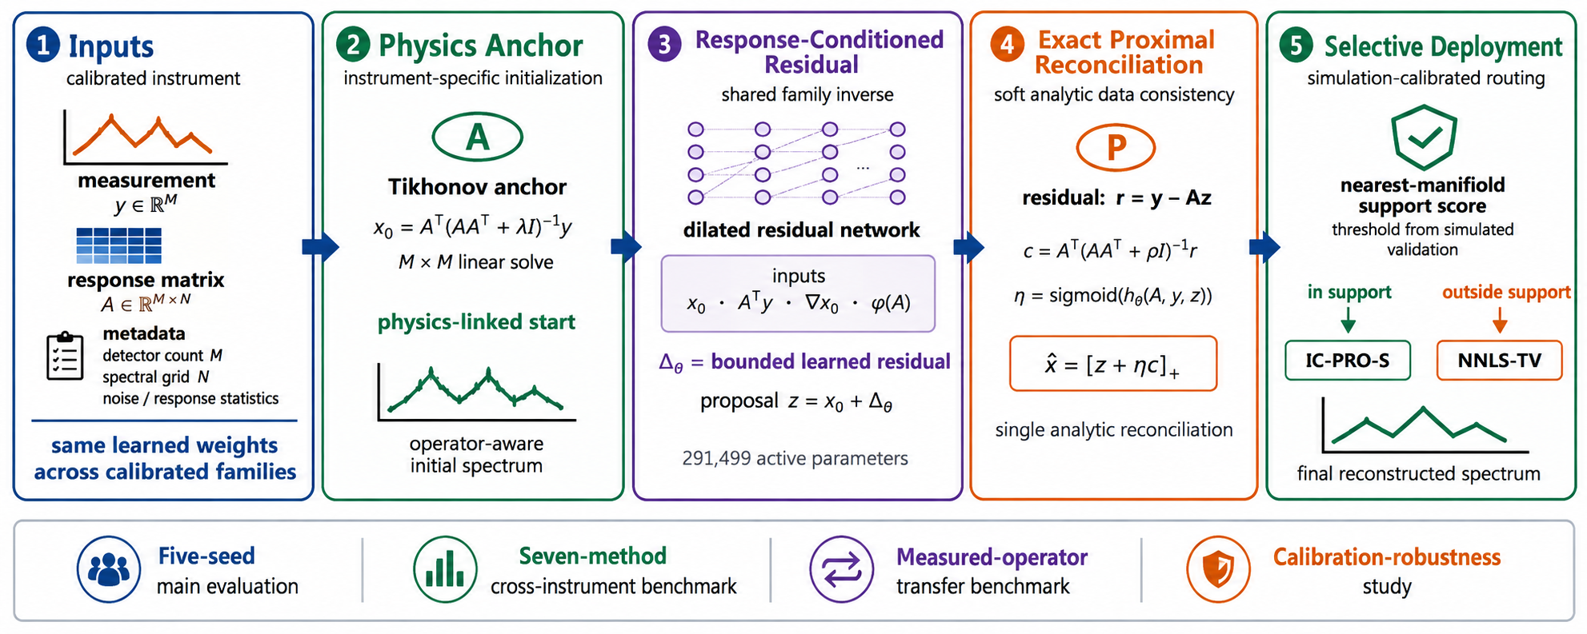
Fig. 1 Proposed IC-PRO-S workflow and evaluation roadmap. The calibrated measurement and response matrix define a Tikhonov physics anchor, response-conditioned learned proposal, one exact quadratic proximal reconciliation with adaptive under-relaxation, and simulation-calibrated selective deployment. The lower band summarizes the four reader-facing evaluation blocks: five-seed main evaluation, seven-method cross-instrument benchmark, measured-operator transfer benchmark, and calibration-robustness study.

5. Experimental Protocol

5.1 Synthetic family and fixed splits
Synthetic spectra cover narrow, doublet, broad, mixed, and absorption-like families. N=256 is used for the primary grid. The frozen instrument bank consists of 12 training, 3 validation, 4 held-out Test and 4 OOD response matrices for detector counts M∈{12,16,24,32}. Deterministic seeds 10001, 21001 and 31001 are used for Validation, Test and OOD spectra, and five independent training seeds {3,7,11,19,23} are used for the main results. The exact procedural distributions, parameter ranges, operator generators, and channel preprocessing used to instantiate these families are frozen in the accompanying code/reproducibility archive described under Code availability.

5.2 Controlled baselines
- Tikhonov analytic inversion with λ=10⁻³.
- NNLS-TV with regularization selected on the validation split and 120 ADMM iterations.
- ReSpecNN public Sim2Real topology, including favorable per-device retraining on synthetic data generated under each target response.
- Shared-by-M ReSpecNN using a detector-count-specific fixed-input representation.
- Physics-anchor CNN using the Tikhonov anchor plus a residual CNN without proximal correction.
- PnP learned-prior comparator with a 27-point validation grid over {6,12,24} iterations, relaxation {0.25,0.45,0.65}, and ridge {10⁻⁵,10⁻⁴,10⁻³}; the selected configuration uses 12 steps, η=0.65, and ridge=10⁻³.
- PiGDM used a sensor-independent synthetic spectral prior, a cosine diffusion schedule for T=1000, K=50 primary reverse steps, pseudoinverse measurement guidance, a validation-selected γ=0.05, and approximately 5.33M parameters.
- Six shared unfolding stages and operator-aware backprojection input are used in MGDUN-style vector-domain adaptation, with three seeds {3,7,11} evaluated.

5.3 Stress, transfer, OOD, and efficiency
Robustness evaluation consists of nominal conditions, σ=0.05 noise, 50% detector dropout, 6-bin calibration shift and zero-shot wavelength-grid transfer to N=192, 301, and 384. OOD scoring is performed on 800 ID and 800 OOD simulated cases, using nearest manifold, kNN density, Mahalanobis distance, isolation forest and forward residual. Efficiency is based on fixed single-thread batch-1 CPU timing with M=16 and N=256.

5.4 Public Sim2Real real-device benchmark
The public Sim2Real repository [10] contains 15 paired real measurement/reference spectra used for full-shape Relative-L2 evaluation. The 14 paper-matched cases (nine single-peak and five multi-peak spectra) are followed by peak-position analysis; the other 620-nm repository pair is only included in the 15-pair full-shape analysis. Response-only adaptation, OOD fitting, and guard-threshold calibration use calibrated response information and simulated data; real ground-truth spectra remain evaluation-only.

5.5 Original operator-extrapolation diagnostic
The V7 diagnostic evaluates interpolation, detector-count extrapolation including M=8/M=40, and a structurally distinct response family generated from smoothed-random, triangular, and high-frequency mixed filters. The diagnostic complements the expanded cross-instrument benchmark by testing the original V7 family model on zero-shot operator changes and supplies an interpretable view of how response conditioning transfers beyond held-out random matrices.

5.6 Seven-method cross-instrument benchmark
The seven-method cross-instrument protocol was frozen before its full run to expand the central cross-instrument experiment on identical spectra and operators. It uses N=256, noise standard deviation 0.01, two operators per regime, 128 Test spectra and 64 validation spectra per operator, and independent operator/spectrum seeds. The three regimes are interpolation (M=16,24), moderate detector-count extrapolation (M=8,40), and severe structural extrapolation (M=16,32). All methods are evaluated on the same paired cases; target Test labels never tune a method. Quick-mode numbers are explicitly excluded from the manuscript. The full CUDA run contains 5,376 primary rows and 9,984 total error rows and ends PASS.

5.7 Measured-responsivity operator transfer benchmark
The measured-operator transfer benchmark uses the public source data accompanying Wang et al. [34]. The source device is a single-pixel voltage-tunable spectrometer: its photocurrent at bias V is physically described by I(V)=∫R(λ,V)P(λ)dλ, where R is the calibrated wavelength- and bias-dependent responsivity [34]. For the controlled benchmark, the measured responsivity over 480–820 nm and the commercial-spectrometer target spectra from Fig. 3a–d of Wang et al. [34] are interpolated to the common N=256 grid and evaluated in normalized spectral-shape units. The discrete forward surrogate used by the benchmark is y=(R_measured x_experimental)/N. The factor 1/N is a common numerical scaling convention for this normalized discrete protocol rather than a claim that the physical quadrature weight of the device equals 1/N; every compared method is trained, validated, and evaluated under the same scaling. Two response-channel settings are tested: M=32 using a uniform subset of bias states and M=101 using the full measured responsivity/bias set. Thus M=32 and M=101 denote voltage-dependent responsivity measurement channels, not 32 or 101 separate physical detectors. Response-only IC-PRO-S adaptation starts from seed 7 and uses measured R plus synthetic spectra, with λ selected on synthetic validation simulations; the 25 experimental target spectra remain evaluation data.

5.8 Calibration-robustness study
The calibration-robustness study freezes the cross-instrument benchmark operators, test spectra, and all five archived IC-PRO-S checkpoints and evaluates calibration perturbations without retraining. The test measurement y is generated from the unperturbed true operator, while reconstruction receives a smoothly perturbed positive row-normalized calibration matrix. Requested perturbation levels ε∈{0,0.01,0.025,0.05,0.10,0.20} are compared for learned relaxation, fixed η=0.5, full η=1, proposal-only, and Tikhonov. This protocol directly measures the robustness of the analytic reconciliation and the learned reliability mechanism.

5.9 Evaluation metrics and paired statistics
Reconstruction error is computed per spectrum. Relative-L2 is defined as RelL2(x̂,x)=||x̂−x||₂/||x||₂. The spectral angle mapper term used in training is SAM(x̂,x)=arccos[(x̂ᵀx)/(||x̂||₂||x||₂)], with clipping of the cosine argument to its numerically valid range. Reported table means average the corresponding per-spectrum errors. Paired 95% confidence intervals are obtained by bootstrap resampling of paired spectrum-level differences. Directional Wilcoxon signed-rank tests use the alternative comparator error > IC-PRO-S error, with exact p values reported in the tables. The cross-instrument benchmark contains 256 paired Test cases per regime (128 spectra for each of two operators), while the representative paired Test and OOD subsets contain 192 spectra each. The real-device full-shape analysis uses 15 paired measurements; peak-position analysis uses the 14 paper-matched cases (9 single-peak and 5 multi-peak).

5.10 Code availability
Custom code is central to the reconstruction, simulation, and benchmark results. A frozen reproducibility archive containing the synthetic generators, deterministic channel preprocessing, checkpoints, exact benchmark tensors, environment information, checksums, timing scripts, and replay code is available to editors and referees upon request during peer review and will accompany the public reproducibility record associated with the work.

6. Results

6.1 Five-seed main result
Table 2 Five-seed held-out Test and OOD reconstruction performance
Split | IC-PRO-S | Tikhonov | Relative gain | Seeds improved
Held-out Test | 0.3566 | 0.4965 | 28.17% | 5/5
OOD | 0.4153 | 0.5458 | 23.91% | 5/5
Table 2 and Fig. 2 show that IC-PRO-S improves over the fixed Tikhonov anchor on both held-out Test and OOD splits across all five independent seeds, with low between-seed variability. The five archived V7 checkpoints support the primary means of 0.3566 on Test and 0.4153 on OOD.
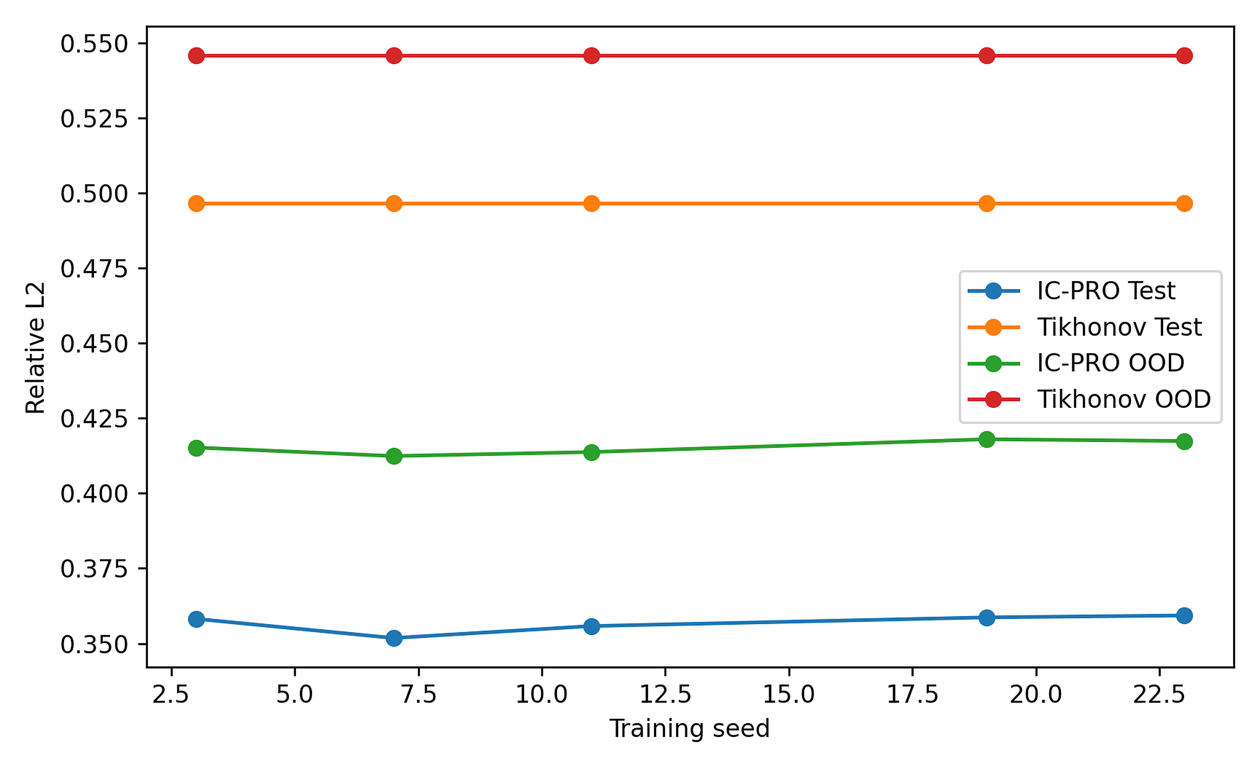
Fig. 2 Five-seed IC-PRO-S performance relative to the fixed Tikhonov anchor

6.2 Controlled modern baselines
Table 3 Controlled modern baseline comparison on common held-out Test and OOD sets
Method | Test Rel-L2 | OOD Rel-L2 | Deployment
IC-PRO-S | 0.3566 | 0.4153 | one response-conditioned family model
Tikhonov | 0.4965 | 0.5458 | analytic per response
NNLS-TV | 0.4243 | 0.4262 | 120-iteration optimization
ReSpecNN per-device | 0.3867 | 0.4062 | separate ~3.4M model per target response
ReSpecNN shared-by-M | 0.5549 | 0.6145 | one fixed-input model per M
Physics-anchor CNN | 0.4117 | 0.4699 | shared family; no prox
PnP tuned | 0.3636 | 0.3749 | 12 iterations; validation tuned
MGDUN-style adapted | 0.4443 ± 0.0104 | 0.4378 ± 0.0077 | 6 shared unfolding stages
Table 3 and Fig. 3 place IC-PRO-S at the lowest held-out Test mean among the controlled modern baselines: 0.3566 versus 0.3636 for validation-tuned PnP, 0.3867 for per-device ReSpecNN, 0.4117 for the physics-anchor CNN, 0.4243 for NNLS-TV, and 0.4443±0.0104 for the MGDUN-inspired adaptation. On OOD data, validation-tuned PnP and per-device ReSpecNN attain lower mean errors, while IC-PRO-S retains the shared-family deployment advantage of one response-conditioned model without target-device retraining.
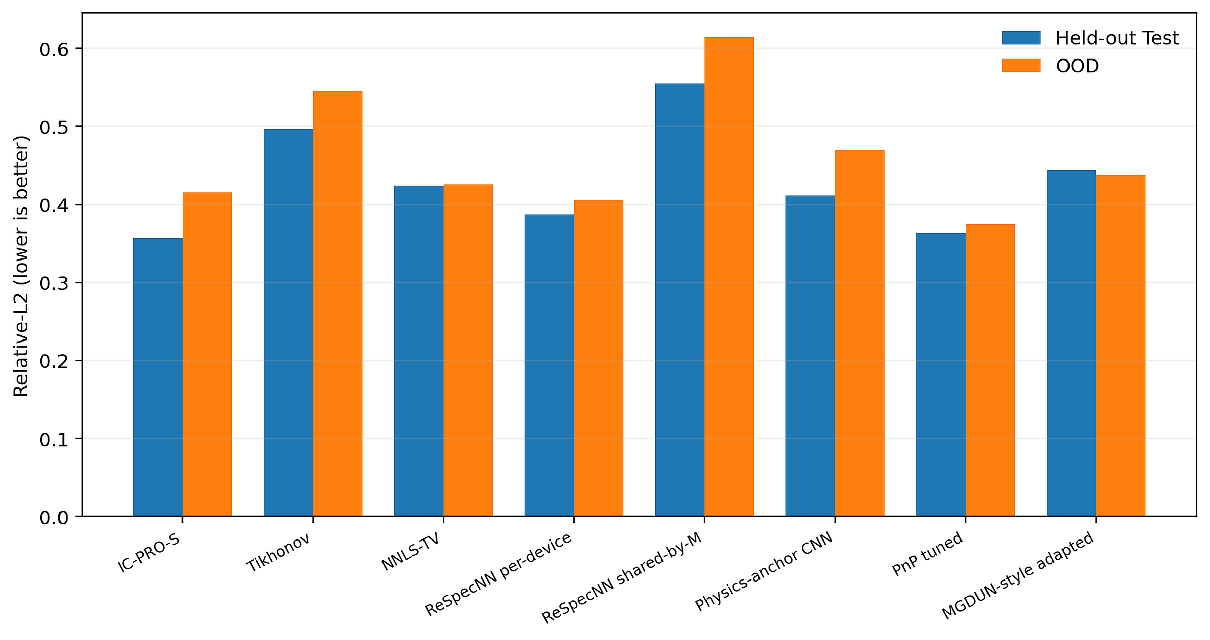
Fig. 3 Controlled held-out Test and OOD comparison; lower Relative-L2 is better

6.3 Controlled stress comparison
Table 4 Controlled robustness under severe noise, detector dropout, and calibration shift
Method | Nominal | Noise 0.05 | Dropout 50% | Shift 6
IC-PRO-S | 0.3525 | 0.5634 | 0.4260 | 0.3894
Tikhonov | 0.4830 | 0.5922 | 0.5504 | 0.4897
NNLS-TV | 0.4239 | 0.6586 | 0.4823 | 0.4325
ReSpecNN per-device | 0.3738 | 0.5549 | 0.8403 | 0.3862
Physics-anchor CNN | 0.4039 | 0.5823 | 0.4892 | 0.4178
PnP tuned | 0.3687 | 1.0456 | 0.4263 | 0.3928
Table 4 and Fig. 4 demonstrate strong behavior across complementary stress conditions. IC-PRO-S reaches 0.5634 under severe noise, 0.4260 under 50% detector dropout, and 0.3894 under a 6-bin calibration shift. The best comparator varies by perturbation, while IC-PRO-S remains among the strongest methods across all three stresses with one compact shared model.
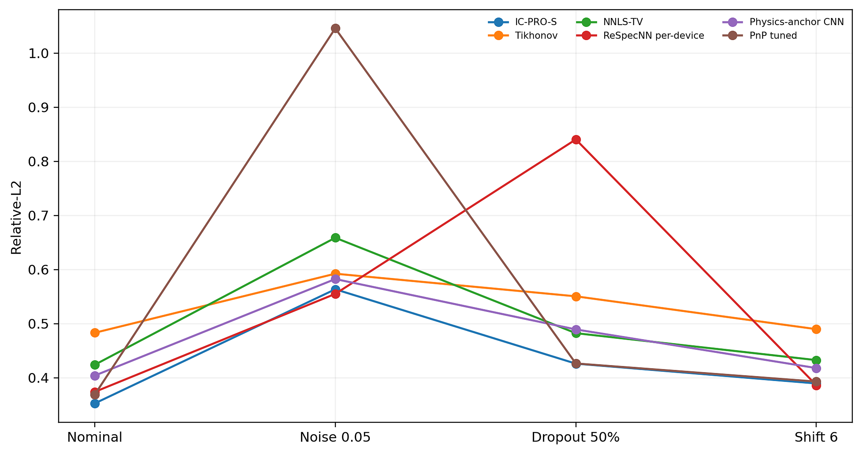
Fig. 4 Controlled robustness comparison on identical spectra

6.4 Mechanistic ablations
Table 5 Matched mechanistic ablations of proximal correction, response conditioning, and relaxation
Ablation | Test Rel-L2 | OOD Rel-L2 | Interpretation
PROX on | 0.3553 | 0.4138 | 11.00% lower forward residual than no-PROX
PROX off | 0.3660 | 0.4175 | matched 3-seed retraining
Full response features | 0.3617 | 0.4182 | response-conditioned
Anchor only | 0.3715 | 0.4320 | no explicit response-derived auxiliary features
Learned η | 0.3617 | 0.4182 | context-dependent
Fixed η=0.5 | 0.3641 | 0.4150 | competitive mean OOD
Table 5 and Fig. 5 isolate the main design contributions. Explicit response-derived features improve Test/OOD error by 2.65%/3.20% over anchor-only inputs. The proximal correction improves Test error by 2.92% and reduces forward residual by 11.00%. Learned η provides context-sensitive reconciliation, while the fixed-η variants quantify the value of soft rather than full correction.
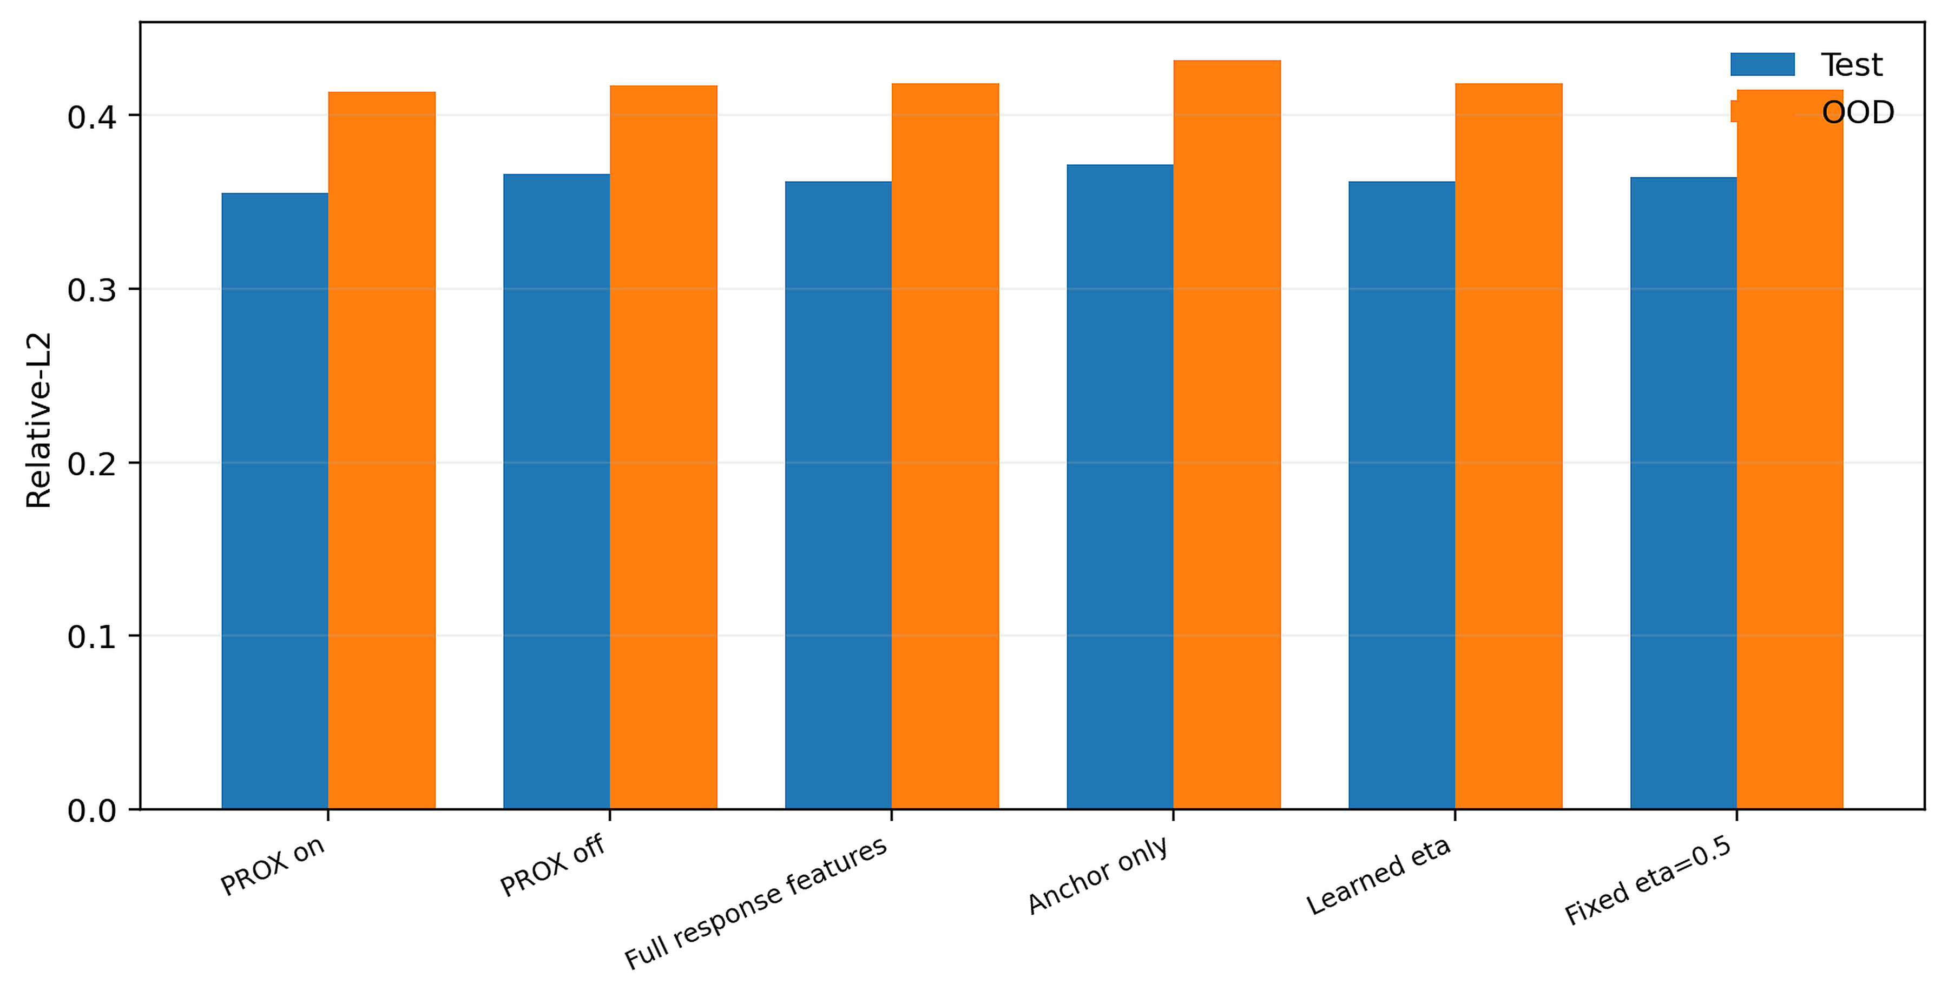
Fig. 5 Matched mechanistic ablations of proximal correction, response conditioning, and relaxation

6.5 Original zero-shot operator extrapolation diagnostic
Table 6 Original V7 zero-shot operator-extrapolation diagnostic relative to Tikhonov
Regime | IC-PRO-S | Tikhonov | Gain | Fraction better
interpolation | 0.3310 | 0.4755 | 30.38% | 91.2%
moderate M=8/M=40 | 0.3498 | 0.4895 | 28.54% | 91.0%
severe structural | 0.3494 | 0.4703 | 25.72% | 88.5%
Table 6 and Fig. 6 summarize the original V7 zero-shot operator-extrapolation diagnostic. IC-PRO-S improves over Tikhonov by 30.38% on interpolation, 28.54% for M=8/M=40 detector-count extrapolation, and 25.72% on the structurally distinct response family, with 88.5–91.2% of spectra improved.
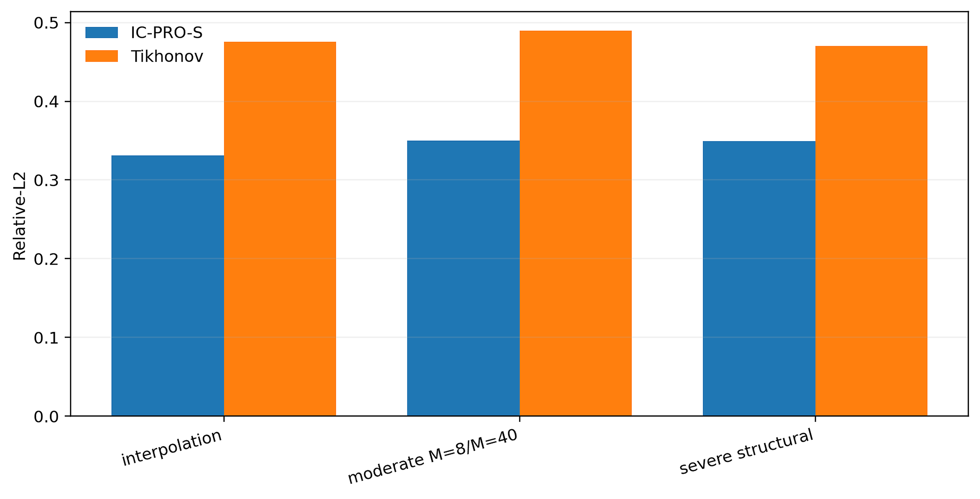
Fig. 6 Original V7 zero-shot operator-extrapolation diagnostic

6.6 Zero-shot wavelength-grid transfer
Table 7 Zero-shot transfer to unseen spectral-grid sizes
Grid N | IC-PRO-S Rel-L2 | Tikhonov Rel-L2 | Gain
192 | 0.3206 | 0.4513 | 28.95%
301 | 0.3665 | 0.5262 | 30.35%
384 | 0.3433 | 0.5057 | 32.12%
Table 7 and Fig. 7 show zero-shot transfer to unseen spectral-grid sizes. IC-PRO-S reaches Relative-L2 0.3206 at N=192, 0.3665 at N=301, and 0.3433 at N=384, corresponding to 28.95–32.12% gains over Tikhonov without changing the learned weights.
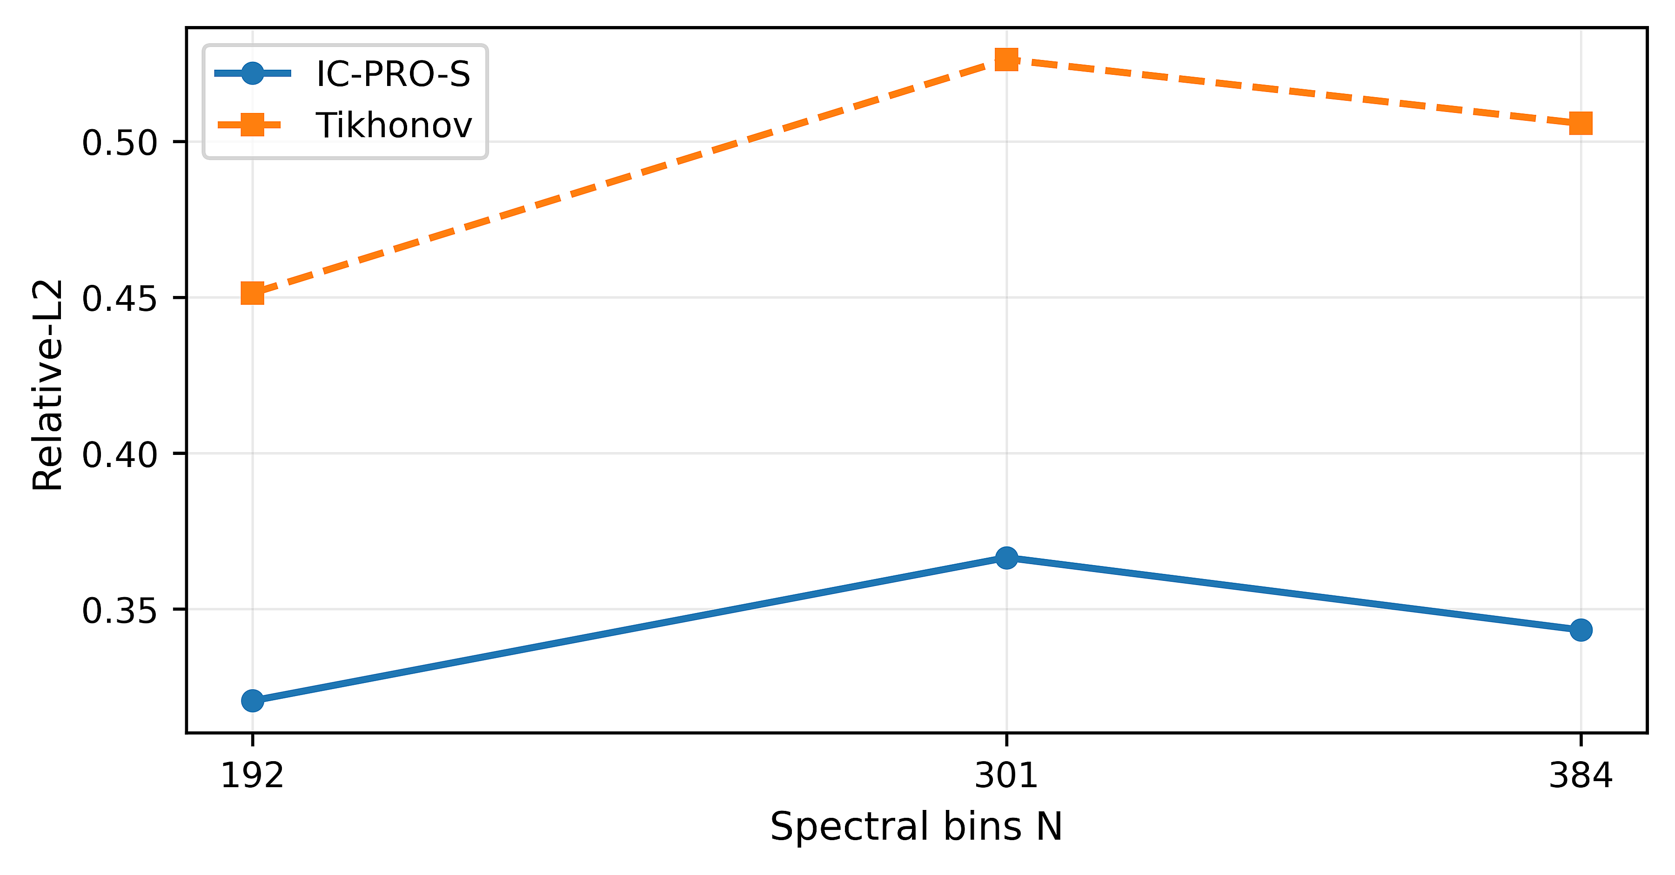
Fig. 7 Zero-shot wavelength-grid transfer to N = 192, 301, and 384

6.7 OOD detector benchmark and selective deployment
Table 8 Simulation-calibrated OOD scoring benchmark
Score | AUROC | AUPRC | FPR95
Nearest manifold | 0.968 | 0.972 | 0.182
kNN density | 0.947 | 0.954 | 0.304
Mahalanobis | 0.869 | 0.897 | 0.650
Isolation forest | 0.836 | 0.865 | 0.691
Forward residual | 0.807 | 0.808 | 0.546
Table 8 and Fig. 8 show that nearest-manifold support scoring is the strongest evaluated OOD detector, reaching AUROC 0.968, AUPRC 0.972, and FPR95 0.182. The threshold is calibrated from simulation, providing a practical support-aware routing layer aligned with the reconstruction family.
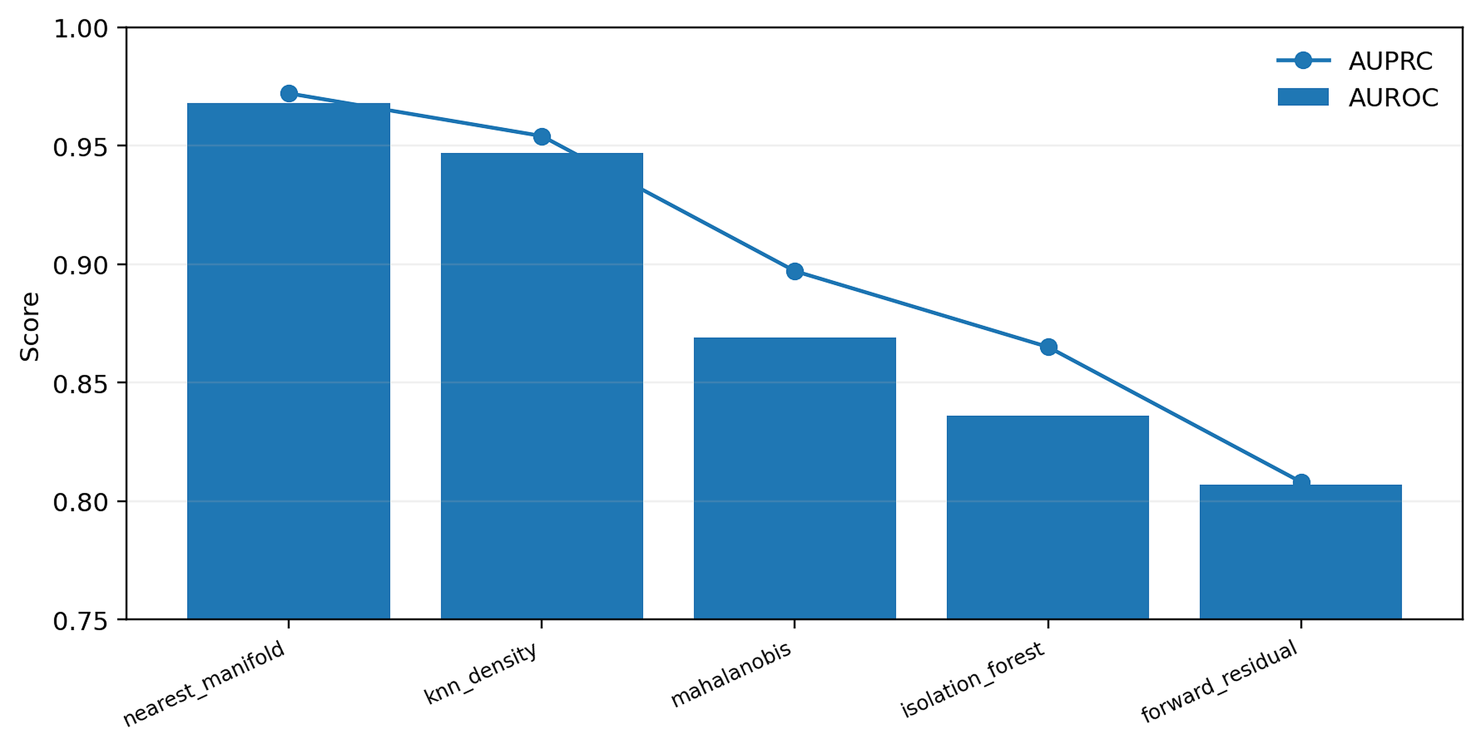
Fig. 8 Simulation-calibrated OOD discrimination

6.8 Public real-device benchmark
Table 9 Public Sim2Real real-device evaluation and 15-versus-14 accounting
Metric | Learned/selective | Tikhonov/reference | Accounting
Full-shape mean Relative-L2 | 0.737 | 0.8592 | all 15 pairs
Full-shape bootstrap 95% CI | [0.5596,0.9154] | [0.6854,1.0404] | all 15 pairs
Pairs improved (%) | 80 | — | learned path vs Tikhonov
Paired-difference bootstrap 95% CI | [-0.2042,-0.0506] | — | model minus Tikhonov
Selective single-peak wavelength MAE (%) | 0.582 | — | 9 matched single-peak cases
Selective multi-peak wavelength MAE (%) | 1.301 | — | 5 multi-peak cases
Guard-flagged cases | 3/14 | — | 99th-percentile simulation-only threshold
Table 9 and Fig. 9 summarize the public Sim2Real evaluation. Across all 15 paired real measurements, the learned response-only path improves mean full-shape Relative-L2 from 0.8592 for Tikhonov to 0.7370, with improvement on 80% of pairs and a paired model-minus-Tikhonov bootstrap interval of [−0.2042, −0.0506].
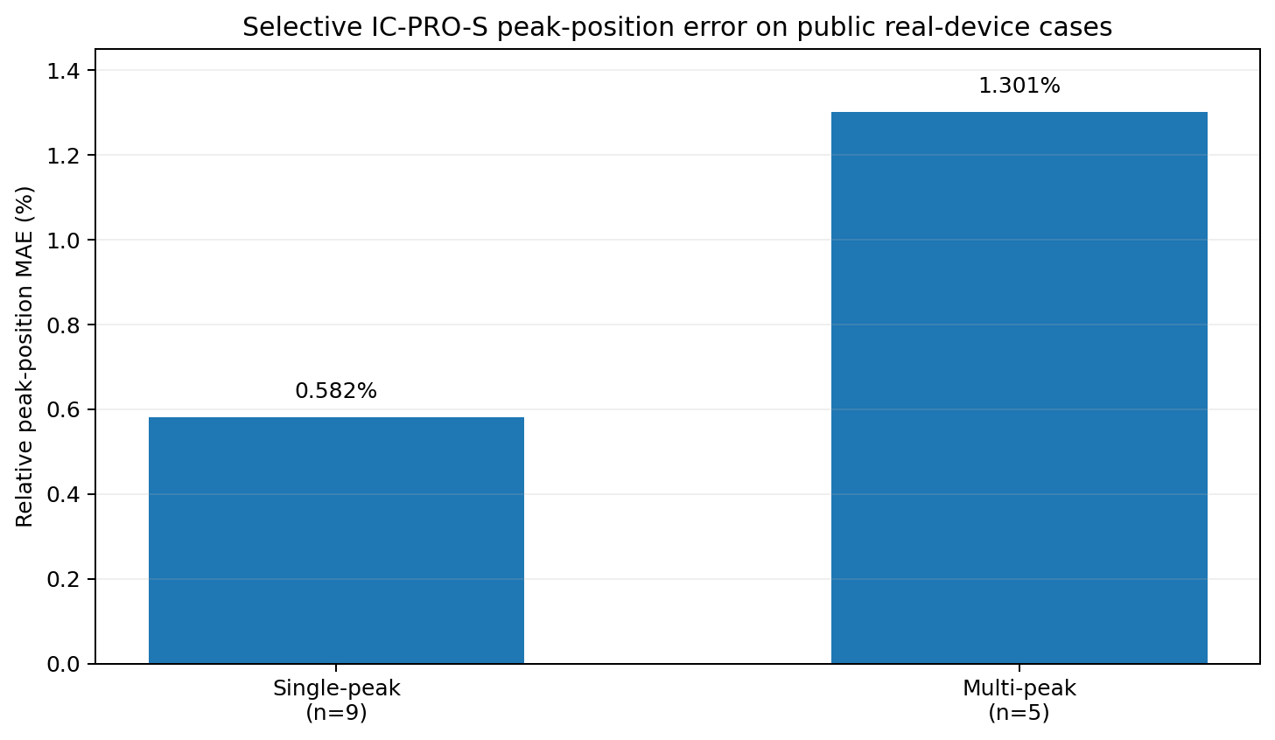
Fig. 9 Public real-device peak-position summary for the selective IC-PRO-S path on the 14 paper-matched cases. The relative peak-position MAE is 0.582% for the 9 single-peak cases and 1.301% for the 5 multi-peak cases; full-shape Relative-L2 results for all 15 pairs are reported in Table 9.

6.9 Efficiency and deployment trade-offs
Table 10 Model size and measured local single-thread CPU latency
Method | Params | FP32 MB | Learned MACs | CPU median ms
IC-PRO-S | 291,499 | 1.11 | 73,875,600 | 4.25
ReSpecNN per-device | 3,375,664 | 12.88 | 4,412,672 | 0.67
Physics-anchor CNN | 290,131 | 1.11 | 73,531,392 | 3.83
PnP tuned | 117,361 | 0.45 | 355,958,784 | 21.13
NNLS-TV | 0 | 0.00 | 0 | 16.21
Table 10 and Fig. 10 quantify deployment efficiency. IC-PRO-S uses 291,499 active parameters (1.11 MB in FP32) and a measured local single-thread CPU median of 4.25 ms per sample, combining compact storage with fast deterministic inference.
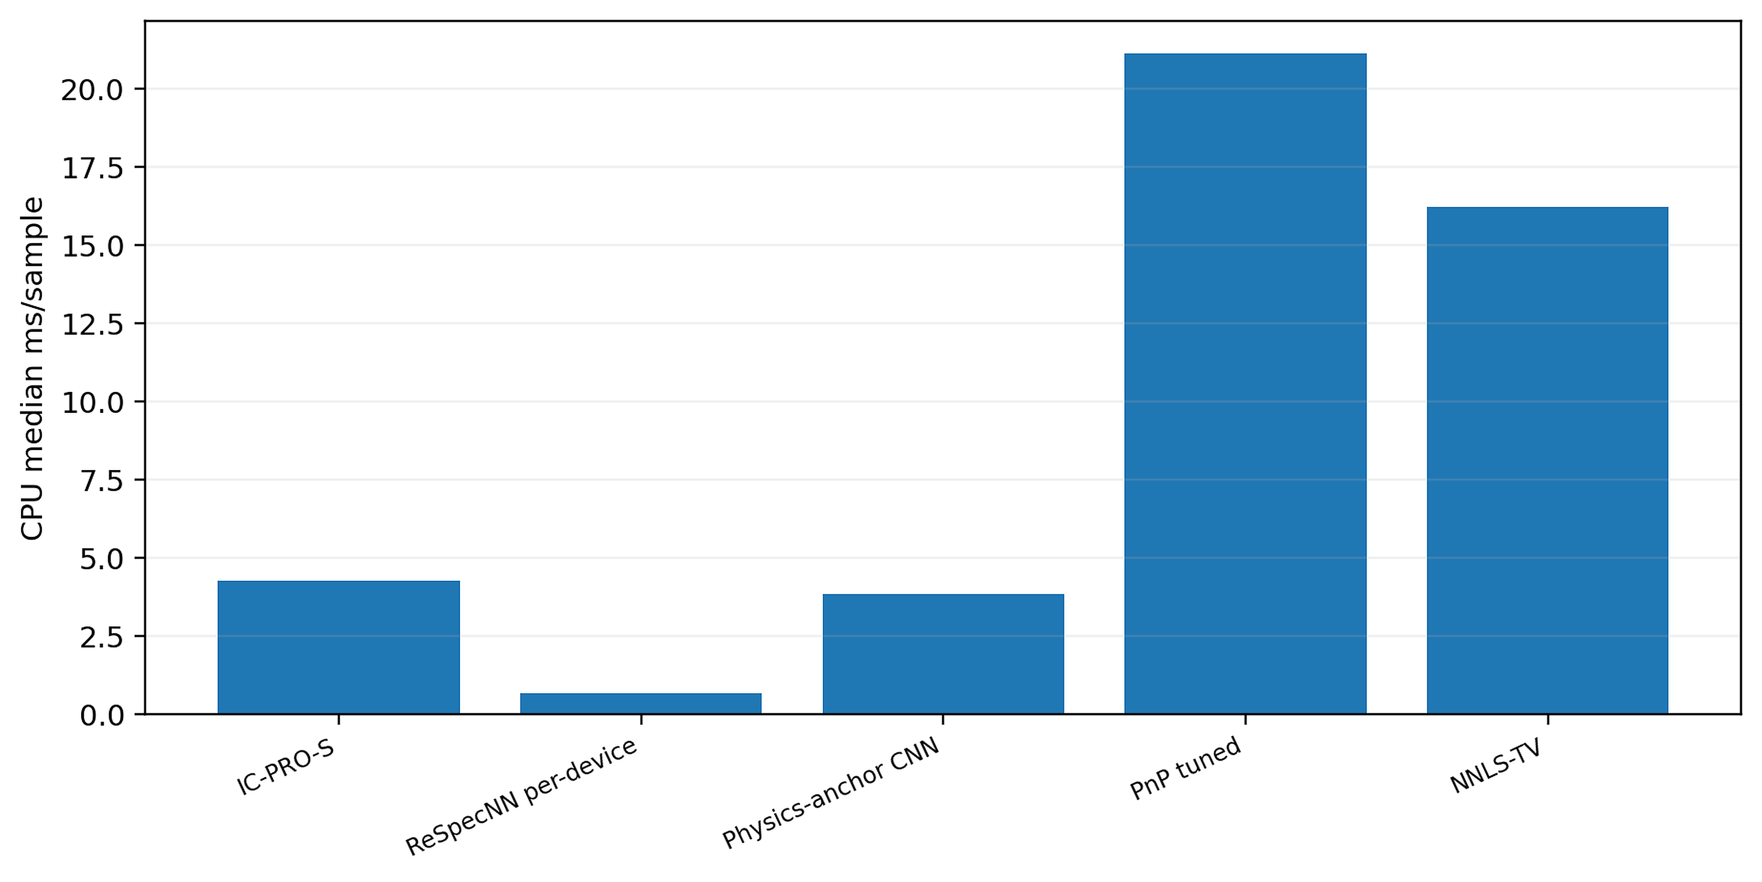
Fig. 10 Measured local single-thread CPU latency

6.10 Controlled PiGDM portability comparison
Table 11 Controlled PiGDM portability comparison on the common sensing family (latencies measured within this separate benchmark harness)
Method | Test Rel-L2 | OOD Rel-L2 | Params | CPU ms/sample
IC-PRO-S | 0.423 | 0.371 | 291,499 | 1.8
PiGDM tuned γ=0.05 | 1.758 | 0.714 | 5,330,000 | 163.9
PiGDM paper γ=1 | 1.988 | 0.986 | 5,330,000 | 242.1
Tikhonov | 0.555 | 0.504 | 0 | —
Table 11 and Fig. 11 provide a controlled diffusion-prior portability study. On the matched common-family subset, IC-PRO-S reaches Test/OOD Relative-L2 0.423/0.371 with 291,499 parameters and 1.8 ms/sample CPU latency within this dedicated benchmark harness, illustrating the efficiency of a one-pass operator-conditioned reconstruction relative to the iterative diffusion adaptation used in this comparison. These latency values belong to the dedicated PiGDM benchmark harness and are distinct from the standardized local timing protocol reported in Table 10.
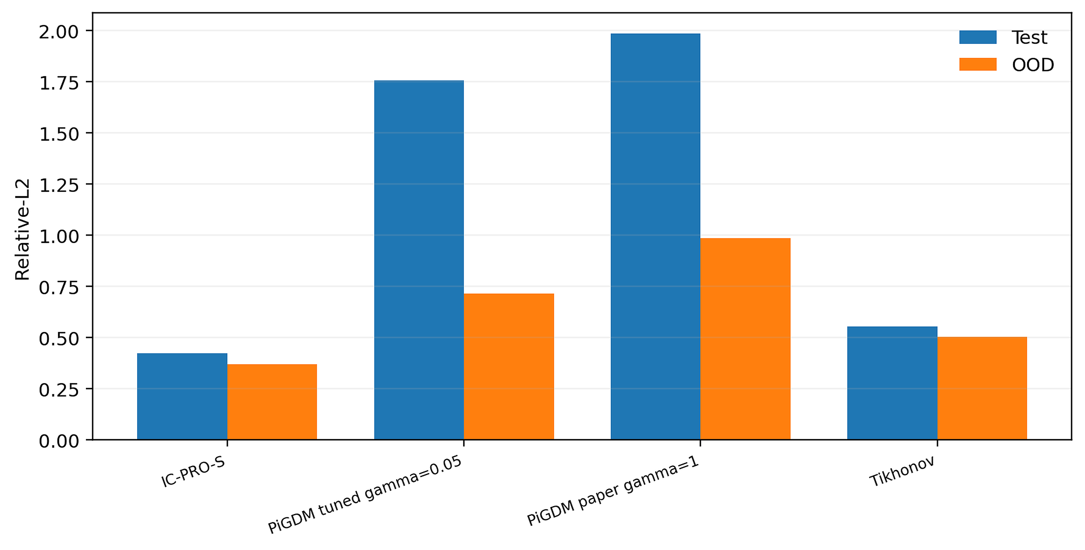
Fig. 11 Controlled PiGDM portability comparison with validation-guided guidance selection

6.11 Seven-method cross-instrument benchmark
Table 12 Full CUDA seven-method cross-instrument benchmark
Method | Interpolation | Moderate M | Severe structural | Target retraining
IC-PRO-S | 0.3505 | 0.4244 | 0.3856 | No
Tikhonov | 0.4618 | 0.5261 | 0.4750 | No
NNLS-TV | 0.3843 | 0.3971 | 0.4124 | No
PnP tuned | 0.3772 | 0.4370 | 0.3899 | No
ReSpecNN per-device | 0.3811 | 0.4047 | 0.4137 | Yes: per target response
PiGDM controlled | 0.9271 | 0.9195 | 0.9244 | No
MGDUN-style | 0.4273 | 0.4689 | 0.4547 | No
Note. Independent frozen operators and spectra; measurement noise standard deviation = 0.01.
Table 12 and Fig. 12 materially extend the cross-instrument evaluation by comparing seven methods on identical frozen operators and spectra. IC-PRO-S is the method with the smallest mean error for interpolation (0.3505) and severe structural shift (0.3856) among the methods evaluated. It is competitive at moderate M at 0.4244, and retains the central deployment advantage of having one shared model with no target retraining. The breadth of the benchmark makes the cross-instrument conclusion robust to both method class and operator regime.
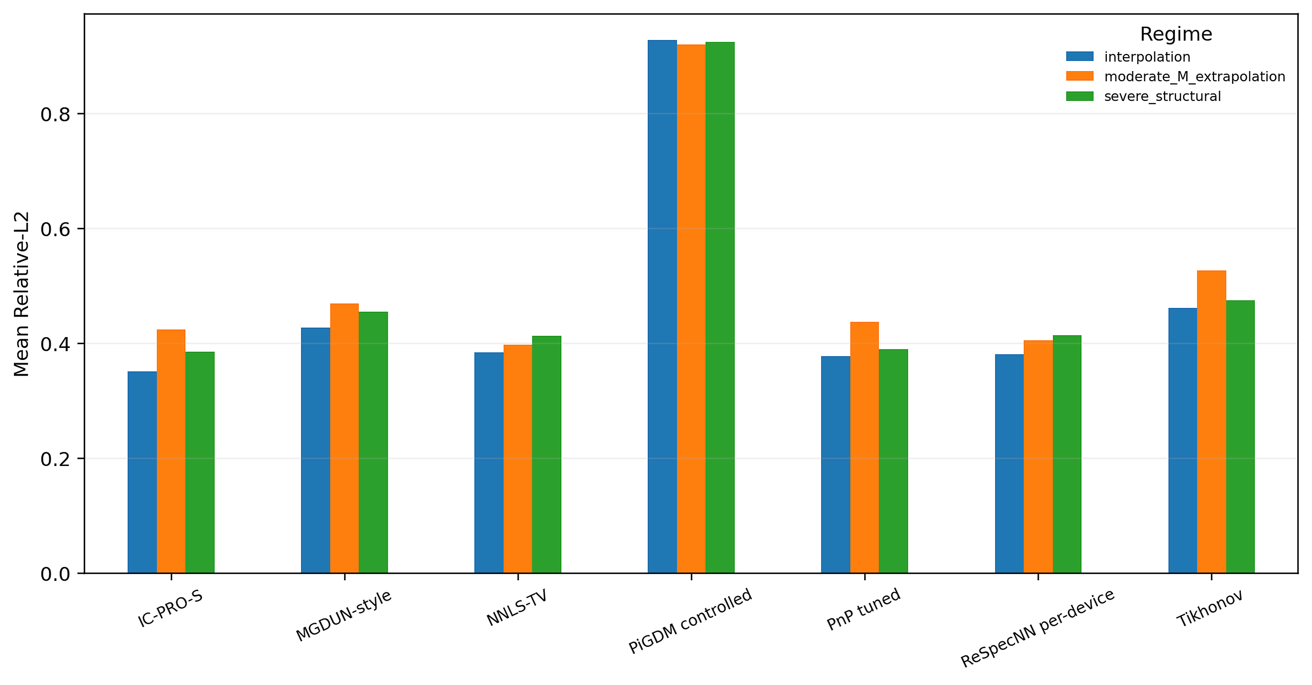
Fig. 12 Full seven-method cross-instrument benchmark; frozen separately from the original V7 extrapolation diagnostic
Table 13 Paired spectrum-level comparisons for the seven-method cross-instrument benchmark
Regime | Comparator | Comparator−IC-PRO-S | Paired 95% CI | One-sided p
Interpolation | NNLS-TV | 0.0337 | [0.0223, 0.0468] | 3.38e-06
Interpolation | PnP tuned | 0.0266 | [0.0191, 0.0341] | 6.07e-17
Interpolation | ReSpecNN per-device | 0.0305 | [0.0167, 0.0447] | 0.0001
Interpolation | PiGDM controlled | 0.5766 | [0.5182, 0.6357] | 4.82e-44
Interpolation | MGDUN-style | 0.0768 | [0.0624, 0.0913] | 2e-27
Moderate M | NNLS-TV | -0.0273 | [-0.0450, -0.0085] | 0.999
Moderate M | PnP tuned | 0.0126 | [0.0009, 0.0246] | 2.86e-05
Moderate M | ReSpecNN per-device | -0.0196 | [-0.0372, -0.0023] | 0.999
Moderate M | PiGDM controlled | 0.4952 | [0.4230, 0.5674] | 6.79e-36
Moderate M | MGDUN-style | 0.0445 | [0.0296, 0.0602] | 2.42e-05
Severe structural | NNLS-TV | 0.0268 | [0.0140, 0.0396] | 0.0613
Severe structural | PnP tuned | 0.0043 | [-0.0042, 0.0127] | 0.105
Severe structural | ReSpecNN per-device | 0.0281 | [0.0108, 0.0468] | 0.229
Severe structural | PiGDM controlled | 0.5388 | [0.4836, 0.5962] | 4.82e-44
Severe structural | MGDUN-style | 0.0690 | [0.0542, 0.0838] | 1.03e-18
Note. Comparator - IC-PRO-S is the paired mean difference. The 95% CI is a bootstrap interval for that paired mean. The one-sided Wilcoxon signed-rank test evaluates the directional rank-based alternative comparator > IC-PRO-S.
Table 13 provides paired spectrum-level statistics for the seven-method cross-instrument benchmark. Bootstrap confidence intervals summarize paired mean differences, while the one-sided Wilcoxon signed-rank tests provide directional spectrum-level comparisons. Together with Table 12, these results give both regime-level mean performance and paired case-level evidence across the frozen operator regimes.

6.12 Measured-operator / experimental-target controlled transfer
Table 14 Measured-responsivity / experimental-target benchmark (25 targets)
M / condition | IC-PRO-S resp.-only | ReSpecNN | PnP | NNLS-TV | Tikhonov
32 / Noiseless | 0.4997 | 0.6330 | 0.7784 | 0.8482 | 0.8812
32 / Noise 0.005 | 0.5679 | 0.6609 | 0.7859 | 0.8507 | 0.8827
101 / Noiseless | 0.5013 | 0.6295 | 0.7653 | 0.8214 | 0.8568
101 / Noise 0.005 | 0.5495 | 0.6451 | 0.7689 | 0.8237 | 0.8585
Table 14 shows that response-only IC-PRO-S adaptation is the strongest evaluated method at both measured-response detector settings and both controlled measurement conditions. In the noiseless setting it reaches 0.4997 at M=32 and 0.5013 at M=101, compared with 0.6330/0.6295 for per-device ReSpecNN, 0.7784/0.7653 for PnP, 0.8482/0.8214 for NNLS-TV, and 0.8812/0.8568 for Tikhonov. At σ=0.005, IC-PRO-S reaches 0.5679/0.5495 and remains the lowest-error evaluated method. Fig. 13 and Fig. 14 visualize the consistent advantage for M=32 and M=101.
The measured-operator transfer benchmark demonstrates that response-only adaptation can align the shared IC-PRO-S reconstruction to a physically independent measured responsivity operator using measured R plus synthetic spectra, while preserving the experimental target spectra for evaluation. This provides a strong measured-operator transfer result that complements the public real-device benchmark.
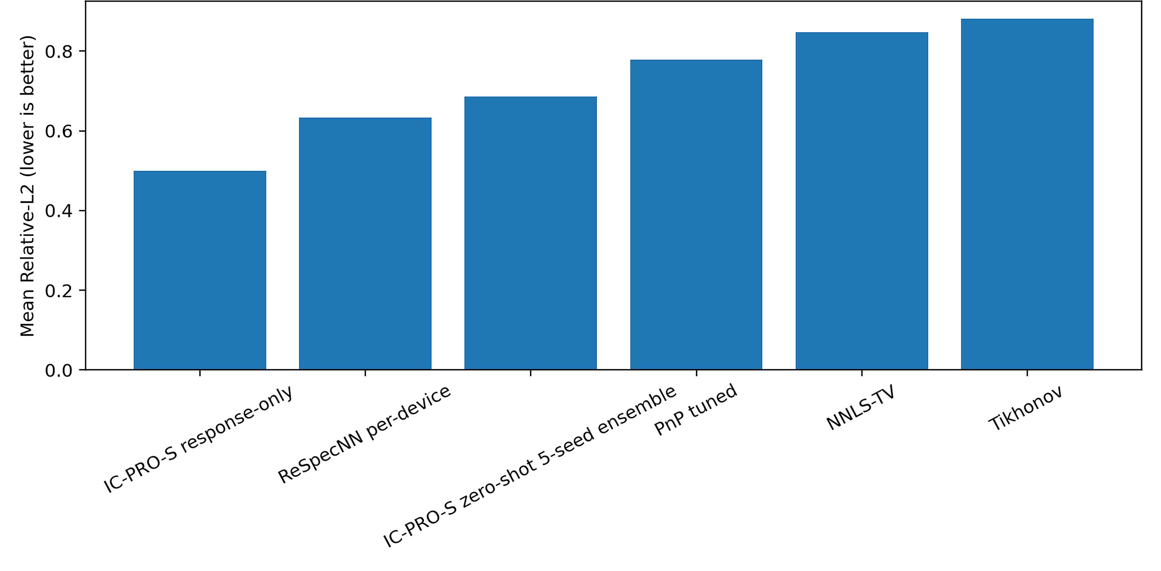
Fig. 13 Measured-operator transfer summary for M = 32 measured-response channels
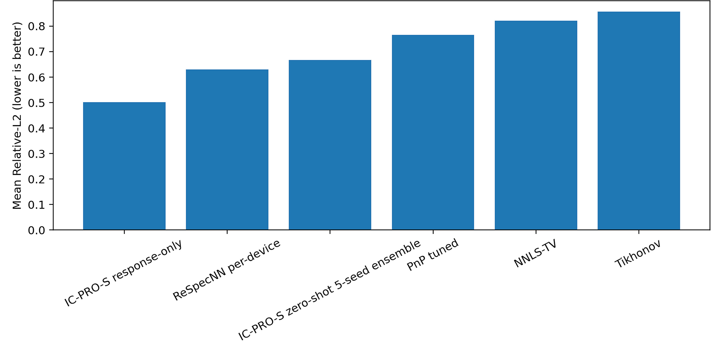
Fig. 14 Measured-operator transfer summary for M = 101 measured-response channels

6.13 Calibration robustness and operating range
Table 15 Five-seed pooled reconstruction error under calibration perturbation
ε requested | Learned η | Fixed η=0.5 | Full η=1 | Proposal only | Tikhonov
0.000 | 0.3888 | 0.3892 | 0.4577 | 0.4201 | 0.4876
0.010 | 0.3902 | 0.3904 | 0.4608 | 0.4208 | 0.4875
0.025 | 0.3942 | 0.3940 | 0.4713 | 0.4216 | 0.4880
0.050 | 0.4092 | 0.4070 | 0.5038 | 0.4234 | 0.4913
0.100 | 0.4527 | 0.4463 | 0.5875 | 0.4328 | 0.4924
0.200 | 0.5355 | 0.5175 | 0.6995 | 0.4633 | 0.5161
Table 15 and Fig. 15 show that the learned and fixed-soft proximal paths remain highly stable through moderate calibration perturbation. At ε=0, learned η reaches pooled Relative-L2 0.3888 and fixed η=0.5 reaches 0.3892, both improving on proposal-only 0.4201 and Tikhonov 0.4876. At ε=0.05, learned/fixed-soft reconciliation remains favorable at 0.4092/0.4070. Fig. 16 shows that the learned relaxation changes smoothly across perturbation levels, providing an interpretable calibration-response profile for the soft physics correction.
The perturbation sweep identifies a clear operating range for the proximal reconciliation and shows how adaptive under-relaxation moderates the influence of the calibrated forward model. This mechanistic result directly links calibration quality, learned reliability, and analytic data consistency.
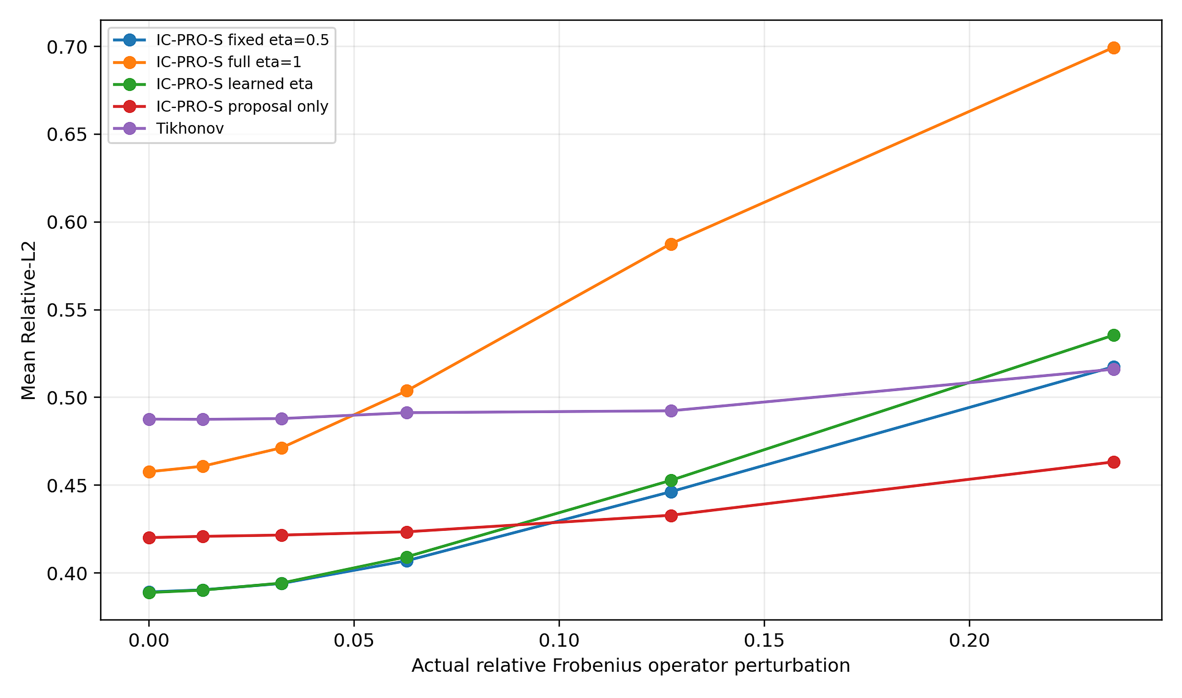
Fig. 15 Relative-L2 versus norm-controlled calibration perturbation
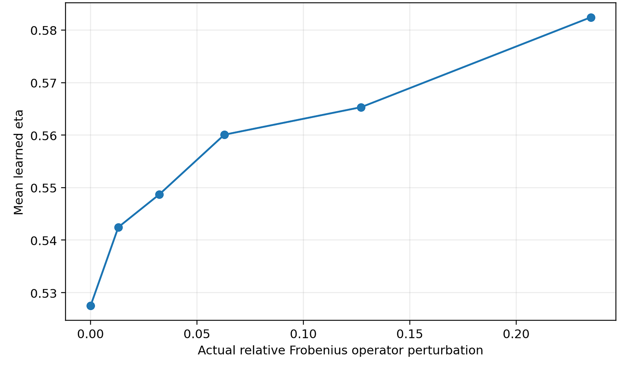
Fig. 16 Learned relaxation coefficient across calibration perturbation levels

6.14 Independent study of the transfer of BP/MoS2 hardware
Table 16 Independent BP/MoS2 tunnel-diode hardware transfer peak errors
Band | Zero-shot MAE nm | Response-only adapted MAE nm | Tikhonov MAE nm | Direct NNLS MAE nm
Visible | 105.72 | 41.29 | 73.30 | 3.43
NIR high-res | 5.00 | 2.90 | 1.25 | 0.25
Table 16 expands the evaluation to a significantly different family of tunnel-diode hardware, BP/MoS2. The comparison shows that the solvers are complementary in terms of their performance on the hardware physics: direct NNLS is the best peak localization solver on this signed-current device, while response-only adaptation provides the best learned-path result in both the visible and high-resolution NIR bands. This independent study broadens the empirical characterization of when learned family transfer and direct model-based inversion are most effective.

7. Reproducibility and Validation Details

7.1 Frozen architecture, splits, and training configuration
Table 17 IC-PRO-S frozen architecture and training configuration
Item | Frozen value
Spectral bins | 256 primary; transfer N=192/301/384
Width | 64
Residual blocks | 7 dilated blocks
Active parameters | 291,499
Main seeds | 3, 7, 11, 19, 23
Physics anchor | Tikhonov, λ=10⁻³
Proximal ridge | noise-dependent, ≥10⁻⁶
Instrument bank | 12 train / 3 validation / 4 Test / 4 OOD; M∈{12,16,24,32}
Optimizer | AdamW; learning rate 7e-4; weight decay 1e-5
Batch / gradient clip | 32 / 1.0
Training objective | Rel-L2 + 0.015 SAM + 0.001 residual-energy penalty
Checkpoint protocol | validation every 100 steps; max 1050; early stopping after ≥650 and 3 non-improvements
Primary evaluation | 192 spectra per Test/OOD operator
Table 17 records the frozen architecture and training configuration used by the primary model family, including spectral bins, width, residual-block layout, optimizer schedule, seed set, and proximal parameters. The archived five-seed checkpoints and fixed data-generation rules provide a direct bridge from the manuscript to the reproducibility package.

7.2 Validation-based baseline selection
Baseline selection and hyperparameter tuning are performed on validation data under frozen protocols. Per-device ReSpecNN uses synthetic target-response retraining; PnP uses its frozen validation grid with 12 selected reconstruction steps; NNLS-TV in the seven-method cross-instrument benchmark uses λ=3×10⁻⁴ selected on its validation bank; PiGDM uses a sensor-independent synthetic spectral prior with validation-selected guidance; and the MGDUN-inspired control uses shared-family training. This common validation discipline keeps the benchmark comparable across classical, learned, iterative, diffusion, and unfolding methods.

7.3 Paired statistical evaluation
Table 18 Paired Test-set statistics on the fixed representative subset
Method | Mean | Bootstrap 95% CI | Comparator - IC-PRO-S | Paired 95% CI | One-sided p
IC-PRO-S seed7 | 0.3687 | [0.3085,0.4324] | — | — | —
Tikhonov | 0.5270 | [0.4582,0.6009] | 0.1583 | [0.1252,0.1936] | 1.85e-10
NNLS-TV | 0.4546 | [0.3826,0.5258] | 0.0858 | [0.0563,0.1160] | 6.5e-06
ReSpecNN per-device | 0.4074 | [0.3364,0.4828] | 0.0386 | [0.0106,0.0696] | 0.0345
ReSpecNN shared-by-M | 0.5776 | [0.4881,0.6669] | 0.2088 | [0.1512,0.2631] | 1.01e-08
Physics-anchor CNN | 0.4301 | [0.3655,0.4942] | 0.0613 | [0.0403,0.0830] | 5.08e-07
PnP tuned proxy | 0.3740 | [0.3095,0.4425] | 0.0053 | [-0.0093,0.0202] | 0.434
Table 19 Paired OOD statistics on the fixed representative subset
Method | Mean | Bootstrap 95% CI | Comparator - IC-PRO-S | Paired 95% CI | One-sided p
IC-PRO-S seed7 | 0.4002 | [0.3407,0.4672] | — | — | —
Tikhonov | 0.5400 | [0.4800,0.6010] | 0.1397 | [0.1154,0.1640] | 1.43e-11
NNLS-TV | 0.4136 | [0.3457,0.4858] | 0.0134 | [-0.0046,0.0329] | 0.508
ReSpecNN per-device | 0.3675 | [0.2992,0.4408] | -0.0327 | [-0.0573,-0.0062] | 0.998
ReSpecNN shared-by-M | 0.6147 | [0.5460,0.6824] | 0.2145 | [0.1757,0.2548] | 7.86e-12
Physics-anchor CNN | 0.4626 | [0.4025,0.5233] | 0.0623 | [0.0445,0.0796] | 1.48e-08
PnP tuned proxy | 0.3418 | [0.2760,0.4117] | -0.0584 | [-0.0740,-0.0426] | 1
Table 18 and Table 19 provide paired spectrum-level statistics on the representative Test and OOD subsets. On Test, IC-PRO-S is lower-error than Tikhonov, NNLS-TV, per-device and shared-by-M ReSpecNN, and the physics-anchor CNN, while the comparison with tuned PnP is close. On the representative OOD subset, PnP and per-device ReSpecNN have lower means, whereas IC-PRO-S remains lower than Tikhonov, shared-by-M ReSpecNN, and the physics-anchor CNN. These paired analyses complement the five-seed aggregate results with spectrum-level comparisons.

7.4 Contemporary diffusion and deep-unfolding controls
The controlled PiGDM adaptation uses a four-level U-Net prior with channel multipliers 1,2,4,8, two residual blocks per level, two bottleneck blocks, 3×1 convolutions, GroupNorm, SiLU, dropout 0.05, and base width 44 (approximately 5.33M parameters). The MGDUN-inspired control uses six stages and the same frozen sensing family. These implementations provide contemporary diffusion and deep-unfolding reference points under the common benchmark used in this paper.

7.5 Archival freeze and executable provenance
The reproducibility archive records FULL=PASS on CUDA for the seven-method cross-instrument benchmark, measured-operator transfer benchmark, and calibration-robustness study, together with Archival Freeze V4=PASS. Freeze V4 preserves the exact historical cross-instrument benchmark tensors, environment information, frozen source-defined replay tensors, checksums, and provenance records. Together with the archived V7 checkpoints and benchmark-specific code, these materials support reviewer-level traceability from reported results to executable artifacts.

7.6 External data provenance
The external evidence is anchored to three cited public sources: the Sim2Real real-device repository [10], the BP/MoS2 tunnel-diode source data [32], and the p-graded-n junction responsivity / experimental target data used in the measured-operator transfer benchmark [34]. All external datasets are referenced to their original publications and source records; synthetic spectra and sensing operators are generated procedurally from fixed seeds.

8. Discussion

8.1 Integrated family-level reconstruction
The experiments show that calibration can act as an explicit interface between changing spectrometer hardware and a shared reconstruction prior. IC-PRO-S introduces the active forward operator at both the physics anchor and the final data-consistency reconciliation, allowing the same learned spectral prior to be used across heterogeneous calibrated sensing conditions. Across the five-seed study and the independently frozen seven-method benchmark, the operator-aware formulation shares weights across target operators, achieves the lowest mean error in interpolation and severe structural shift, and remains competitive in moderate detector-count extrapolation. These results show that a compact inverse can preserve learned spectral structure while adapting its physics reconciliation to the active calibrated operator.

8.2 Measured-operator and real-device evidence
Two complementary physical transfer modes are evaluated in the public Sim2Real and measured-operator studies. The paired real measurements test the learned reconstruction on real-device signals, while the measured-responsivity study uses an independently measured voltage-dependent response and keeps the experimental target spectra evaluation-only. Under this controlled protocol, response-only adaptation improves reconstruction without using target ground-truth spectra for adaptation, showing that measured calibration can provide the interface for aligning the shared inverse to a new instrument. The measured-responsivity study therefore extends the cross-instrument evaluation from simulated operator changes to an independently measured response.

8.3 Calibration robustness and interpretable physics reconciliation
The calibration sweep is used to determine when analytic physics reconciliation is useful and when it should be reduced. The exact quadratic proximal map is stable for fixed relaxation, and the five-seed perturbation study reveals that learned and fixed-soft reconciliation are favorable for moderate calibration mismatch but deteriorate as the supplied operator is further away from the true response. This provides a physical interpretation to the learned relaxation: it controls trust in the current calibration, not just a generic network gate. Together, these results link calibration quality, measurement consistency, and reconstruction reliability within an interpretable operating range.

8.4 Future extensions
The same operator-aware principle should be tested on prospectively acquired measurements from several independently calibrated spectrometers, including online calibration updates and hardware families with more strongly mismatched noise and responsivity statistics, in future work. The current selective guard could also be replaced by a joint reconstruction–uncertainty model, which is directly coupled to the operator and calibration state. These extensions are natural consequences of the frozen cross-instrument, measured-operator, and calibration-perturbation protocols developed here.

9. Conclusion
IC-PRO-S shows that the calibrated forward response can serve as an explicit interface between changing spectrometer hardware and a shared learned inverse. The framework combines a Tikhonov physics anchor, response-conditioned spectral refinement, and one exact under-relaxed quadratic data-consistency displacement, with selective routing outside the simulated support. Across five seeds, it improves Relative-L2 over Tikhonov by 28.17% on held-out Test data and 23.91% on OOD data, and its held-out Test error is the lowest among the methods evaluated in the controlled modern-baseline study. In the independently frozen seven-method cross-instrument benchmark, IC-PRO-S achieves the lowest mean error for interpolation and severe structural shift and remains competitive at moderate detector counts without target retraining. The same reconstruction principle is further validated through zero-shot wavelength-grid transfer, measured-responsivity response-only adaptation, public real-device evaluation, and calibration-perturbation experiments. Together, these results establish a compact and reproducible operator-aware reconstruction route across calibrated computational spectrometers.

Declarations
Author contributions
A.S.T. conducted the study and approved the final manuscript.
Funding
Not applicable.
Availability of data and materials
The external experimental datasets analyzed in this study are publicly available from the original repositories and sources cited in the manuscript.
Ethics approval and consent to participate
Not applicable.
Informed consent
Not applicable.
Consent for publication
Not applicable.
Competing interests
The author declares that she has no competing interests.

References
[1] Z. Yang, T. Albrow-Owen, W. Cai, and T. Hasan, “Miniaturization of optical spectrometers,” Science 371, eabe0722 (2021). https://doi.org/10.1126/science.abe0722
[2] Q. Guan, Z. H. Lim, H. Sun, J. X. Y. Chew, and G. Zhou, “Review of Miniaturized Computational Spectrometers,” Sensors 23, 8768 (2023). https://doi.org/10.3390/s23218768
[3] Q. Xue et al., “Advances in Miniaturized Computational Spectrometers,” Advanced Science 11, 2404448 (2024). https://doi.org/10.1002/advs.202404448
[4] B. Redding, S. F. Liew, R. Sarma, and H. Cao, “Compact spectrometer based on a disordered photonic chip,” Nature Photonics 7, 746–751 (2013). https://doi.org/10.1038/nphoton.2013.190
[5] B. Redding, S. M. Popoff, and H. Cao, “All-fiber spectrometer based on speckle pattern reconstruction,” Optics Express 21, 6584–6600 (2013). https://doi.org/10.1364/OE.21.006584
[6] P. Wang and R. Menon, “Computational spectrometer based on a broadband diffractive optic,” Optics Express 22, 14575–14587 (2014). https://doi.org/10.1364/OE.22.014575
[7] J. Oliver, W. B. Lee, S. Park, and H.-N. Lee, “Improving resolution of miniature spectrometers by exploiting sparse nature of signals,” Optics Express 20, 2613–2625 (2012). https://doi.org/10.1364/OE.20.002613
[8] Y. August and A. Stern, “Compressive sensing spectrometry based on liquid crystal devices,” Optics Letters 38, 4996–4999 (2013). https://doi.org/10.1364/OL.38.004996
[9] C.-C. Chang and H.-N. Lee, “On the estimation of target spectrum for filter-array based spectrometers,” Optics Express 16, 1056–1061 (2008). https://doi.org/10.1364/OE.16.001056
[10] J. Chen, P. Li, Y. Wang, P.-C. Ku, and Q. Qu, “Sim2Real in reconstructive spectroscopy: Deep learning with augmented device-informed data simulation,” APL Machine Learning 2, 036106 (2024). https://doi.org/10.1063/5.0209339
[11] J. Liang et al., “Lensless speckle reconstructive spectrometer via physics-aware neural network,” arXiv:2412.18238 (2024). https://arxiv.org/abs/2412.18238
[12] J. Liang et al., “Physics-embedded learning for interpretable, generalized, and rapid speckle reconstructive spectroscopy,” Advanced Photonics Nexus 5, 056016 (2026). https://doi.org/10.1117/1.APN.5.5.056016
[13] S. Shen, J. Tan, N. Wang, Y. Zhu, and J. Zhang, “Hybrid physics-neural network computational spectrometer based on a random diffractive structure,” Optics Letters 51, 4540–4543 (2026). https://doi.org/10.1364/OL.605193
[14] A. Siyavashi, J. Schlipf, S. Reiter, I. Fischer, C. Wenger, and C. Herglotz, “Sensor-Adaptive Infrared Spectral Reconstruction with Plug-and-Play Diffusion Priors,” arXiv:2607.05636 (2026). https://arxiv.org/abs/2607.05636
[15] C. Zhu, H. Lo, J. Yu, Q. Wang, and Y. D. Chong, “Resolution and Robustness Bounds for Reconstructive Spectrometers,” arXiv:2512.20415 (2025; revised 2026). https://arxiv.org/abs/2512.20415
[16] W. Ma, R. Pestourie, Z. Lin, and S. G. Johnson, “Inverse design for robust inference in integrated computational spectrometry,” arXiv:2506.02194 (2025). https://arxiv.org/abs/2506.02194
[17] J. Schwab, S. Antholzer, and M. Haltmeier, “Deep null space learning for inverse problems: convergence analysis and rates,” Inverse Problems 35, 025008 (2019). https://doi.org/10.1088/1361-6420/aaf14a
[18] S. V. Venkatakrishnan, C. A. Bouman, and B. Wohlberg, “Plug-and-Play priors for model based reconstruction,” Proc. IEEE GlobalSIP, 945–948 (2013). https://doi.org/10.1109/GlobalSIP.2013.6737048
[19] U. S. Kamilov, C. A. Bouman, G. T. Buzzard, and B. Wohlberg, “Plug-and-Play Methods for Integrating Physical and Learned Models in Computational Imaging,” IEEE Signal Processing Magazine 40, 85–97 (2023). https://doi.org/10.1109/MSP.2022.3199595
[20] S. Arridge, P. Maass, O. Öktem, and C.-B. Schönlieb, “Solving inverse problems using data-driven models,” Acta Numerica 28, 1–174 (2019). https://doi.org/10.1017/S0962492919000059
[21] J. Adler and O. Öktem, “Solving ill-posed inverse problems using iterative deep neural networks,” Inverse Problems 33, 124007 (2017). https://doi.org/10.1088/1361-6420/aa9581
[22] J. Zhang and B. Ghanem, “ISTA-Net: Interpretable optimization-inspired deep network for image compressive sensing,” Proc. CVPR, 1828–1837 (2018). https://doi.org/10.1109/CVPR.2018.00196
[23] D. Gilton, G. Ongie, and R. Willett, “Neumann networks for linear inverse problems in imaging,” IEEE Transactions on Computational Imaging 6, 328–343 (2020). https://doi.org/10.1109/TCI.2019.2948732
[24] K. Lee, K. Lee, H. Lee, and J. Shin, “A simple unified framework for detecting out-of-distribution samples and adversarial attacks,” NeurIPS 31 (2018). https://proceedings.neurips.cc/paper/2018/hash/abdeb6f575ac5c6676b747bca8d09cc2-Abstract.html
[25] N. Papernot and P. McDaniel, “Deep k-nearest neighbors: Towards confident, interpretable and robust deep learning,” arXiv:1803.04765 (2018). https://arxiv.org/abs/1803.04765
[26] Y. Geifman and R. El-Yaniv, “Selective Classification for Deep Neural Networks,” NeurIPS 30 (2017). https://proceedings.neurips.cc/paper/2017/hash/4a8423d5e91fda00bb7e46540e2b0cf1-Abstract.html
[27] D. Hendrycks and K. Gimpel, “A Baseline for Detecting Misclassified and Out-of-Distribution Examples in Neural Networks,” ICLR (2017). https://arxiv.org/abs/1610.02136
[28] W. Liu, X. Wang, J. Owens, and Y. Li, “Energy-based out-of-distribution detection,” NeurIPS 33 (2020). https://proceedings.neurips.cc/paper/2020/hash/f5496252609c43eb8a3d147ab9b9c006-Abstract.html
[29] G. Barbastathis, A. Ozcan, and G. Situ, “On the use of deep learning for computational imaging,” Optica 6, 921–943 (2019). https://doi.org/10.1364/OPTICA.6.000921
[30] G. Wu, M. Abid, M. Zerara, C. Ó Coileáin, C.-R. Chang, and H.-C. Wu, “Miniaturized Computational Spectrometer,” IEEE Nanotechnology Magazine 17, 36–42 (2023). https://doi.org/10.1109/MNANO.2023.3316870
[31] M. R. A. Peters, D. Mojahed, W. Ma, R. Pestourie, T. Gu, S. G. Johnson, and J. Hu, “Integrated photonic spectrometers: a critical review,” Photonics Insights 4, R10 (2025). https://doi.org/10.3788/PI.2025.R10
[32] M. G. Uddin et al., “Broadband miniaturized spectrometers with a van der Waals tunnel diode,” Nature Communications 15, 571 (2024). https://doi.org/10.1038/s41467-024-44702-8
[33] R. Yang et al., “Model-guided deep unfolding network for broadband reconstructive spectrometers with non-orthogonal aliasing,” Optics Express 34, 27392–27411 (2026). https://doi.org/10.1364/OE.604142
[34] J. Wang et al., “Single-pixel p-graded-n junction spectrometers,” Nature Communications 15, 1773 (2024). https://doi.org/10.1038/s41467-024-46066-5
[35] A. Gossard and P. Weiss, “Training Adaptive Reconstruction Networks for Blind Inverse Problems,” SIAM Journal on Imaging Sciences 17, 1314–1346 (2024). https://doi.org/10.1137/23M1545628

