IC-PRO-S: Operator-Aware Proximal Reconstruction for Cross-Instrument Computational Spectroscopy

Amira Samy Talaat
Computers and Systems Department, Electronics Research Institute, Cairo 12622, Egypt
amtalat@yahoo.com ORCID: 0000-0002-9413-3079

Abstract
Computational spectrometers reconstruct spectra from measurements governed by instrument-specific calibrated operators. We evaluate IC-PRO-S, a shared response-conditioned reconstruction model that combines a Tikhonov initialization, a learned spectral proposal, and one under-relaxed displacement from an exact quadratic proximal map. In a paired seven-method synthetic benchmark, IC-PRO-S achieved the lowest mean Relative-L2 in interpolation (0.3505) and severe structural-shift (0.3856) conditions, but nonnegative least squares with total-variation regularization (NNLS-TV) and per-device ReSpecNN had lower mean errors in detector-count extrapolation. The severe-shift mean advantages over plug-and-play (PnP), NNLS-TV and per-device ReSpecNN were not significant in the reported directional Wilcoxon tests. Across 15 public real-device measurement/reference pairs, the learned reconstruction reduced mean Relative-L2 from 0.8592 (Tikhonov) to 0.7370. A separate measured-responsivity study used response-only adaptation and a controlled numerical forward surrogate; it does not constitute prospective multi-device measurement validation. These findings suggest a compact route to using calibrated operators in shared spectral reconstruction, while highlighting limits under operator shift and the need for broader physical validation.

Keywords: reconstructive spectroscopy; computational spectroscopy; optical spectroscopy; inverse problems; operator-aware reconstruction; proximal data consistency; cross-instrument transfer; response conditioning; calibration robustness; selective deployment.

1. Introduction
Miniaturized and computational spectrometers replace part of the conventional dispersive optical train with a calibrated encoding device and numerical inverse reconstruction [1–9]. The instrument therefore cannot be separated from its reconstruction: a detector response vector y is meaningful through the calibrated forward operator A that maps an unknown spectrum to the measured channels. This coupling enables compact optical hardware, but it also creates a strongly ill-conditioned or underdetermined inverse problem, particularly when the number of detector channels M is much smaller than the spectral dimension N. Classical regularization provides explicit measurement consistency and stability, whereas learned spectral priors can represent structure that is difficult to encode with a fixed penalty [10–23].
For practical deployment across instruments, the central physics problem is not only reconstruction accuracy on one calibrated device but whether the inverse remains useful when the calibrated operator itself changes. Variations in responsivity, detector count, calibration, or wavelength discretization alter the forward physics seen by the decoder. A device-specific learned inverse can therefore require retraining or redesign even when the underlying spectral structure is unchanged. This motivates an operator-aware reconstruction in which the current calibration is an explicit input to inference, allowing shared learned spectral structure to be reconciled with the measurement physics of each instrument. A complementary deployment layer should also identify measurements that lie outside the support represented by the simulated operator family. Recent Sim2Real, physics-aware and physics-embedded, hybrid physics-neural, sensor-adaptive diffusion, robustness, and model-guided unfolding studies provide important foundations for this direction [10–16,33].
IC-PRO-S is evaluated as a particular integration of established inverse-problem ingredients, rather than as the first method to use operator information or proximal corrections. Its distinguishing testable design is a shared variable-operator spectral proposal followed by a single analytic quadratic proximal displacement, with a separately calibrated support-routing policy. The study tests what this integration delivers, and where it does not, under held-out simulated response operators, detector-count and spectral-grid changes, measured responsivity, and calibration perturbations.

1.1 Contributions
- Shared operator-dependent inference: a convolutional spectral proposal uses the current calibrated response through the analytic anchor and auxiliary operator-derived features. Within the tested synthetic response families, the learned weights are shared across held-out operators and detector counts; this is not a claim that operator conditioning itself is new.
- Analytic data-fidelity reconciliation: the displacement is computed from the exact quadratic proximal map for the active response, then under-relaxed and projected. The full learned-relaxation, projected update is not itself an exact proximal minimizer. Matched retraining attributes a 2.92% Test error reduction and 11.00% forward-residual reduction to the correction.
- Regime-dependent cross-instrument performance: the frozen seven-method study reports the lowest mean error for interpolation (0.3505) and severe structural shift (0.3856), but not moderate detector-count extrapolation (0.4244 versus 0.3971 for NNLS-TV); differences against several severe-shift comparators are not significant in the recorded directional tests.
- Simulation-derived support routing: a nearest-manifold score identifies out-of-family measurements (AUROC 0.968 in a simulated ID/OOD comparison). This discrimination metric alone does not establish selective reconstruction reliability; risk-coverage and routing-outcome validation are required.
- Matched but implementation-specific baseline evaluation: we compare Tikhonov, NNLS-TV, per-device and shared-by-M ReSpecNN, a physics-anchor CNN, validation-tuned PnP, a controlled PiGDM adaptation, and an MGDUN-inspired six-stage model. Modified implementations are not described as exact reproductions of published canonical methods.
- Limited physical-data checks: a public set of 15 paired real measurements gives mean Relative-L2 0.7370 versus 0.8592 for Tikhonov. A separate measured-responsivity benchmark uses measured operator data and 25 evaluation-only target spectra within a normalized numerical measurement surrogate; response-only adaptation is not zero-shot.
- Calibration limits and relaxation: a five-seed perturbation study compares learned, fixed-soft, full, and no-proximal updates. Learned relaxation is not uniformly better than fixed η=0.5, and at larger calibration perturbations proposal-only can perform better.
- Reproducibility scope: frozen A12 inputs, per-case outputs, training scripts, and five archived V7 checkpoints are preserved. Historical raw V7 synthetic input tensors were not archived; source-defined V7 replay inputs must be identified separately rather than represented as bitwise historical inputs. A persistent repository DOI is required for the revision.

2. Related Work and Positioning
Computational spectrometry spans disordered photonics, speckle, diffractive optics, filter arrays, compressive sensing, electrically tunable junctions, and integrated photonics [1–9,30–32,34]. Recent reconstruction work increasingly combines learned priors with explicit forward models. Sim2Real uses device-informed simulation for real-device transfer [10]. PhyspeNet and physics-embedded speckle reconstruction connect physical models and neural inference [11,12]. Shen et al. combine a regularized Tikhonov estimate with neural fusion [13]. In pseudoinverse-guided diffusion inference [14] the calibrated responsivity is used in PiGDM. Yang et al. develop model-guided deep unfolding for broadband reconstructive spectrometers [33]. In general, adaptive reconstruction networks illustrate the benefits of training on families of forward operators in inverse problems [35] and selective prediction and OOD methods offer proven tools for support-aware deployment [24–29].
Relative to hybrid physics-neural fusion [13], plug-and-play approaches [17–23], diffusion guidance [14], unfolding [33] and general adaptive inverse networks [35], IC-PRO-S does not claim priority for conditioning on A. The technical distinction tested here is the combination of a variable-operator shared proposal, a single exact quadratic proximal displacement followed by learned under-relaxation and nonnegativity projection, and a separately simulation-calibrated support-routing policy. Table 1 compares the specific implemented benchmarks rather than asserting that unavailable features are absent from all prior versions.
Table 1. Explicit operator handling, weight sharing, adaptation, solver structure and support routing in the implementations evaluated here. The table compares study-specific implementations, not all published variants of the named methods.
Method | Operator conditioning | Weight sharing | Target retraining | Inference and data consistency / support handling
Tikhonov | Uses active calibrated A analytically | No learned weights | No | Single regularized solve; no separately evaluated guard
NNLS-TV | Uses active calibrated A in constrained optimization | No learned weights | No | 120 ADMM iterations; explicit nonnegativity/TV; no separately evaluated guard
PnP (tuned) | Uses active A in data-consistency steps | Shared spectral prior | No | 12 solver iterations; iterative data consistency; no separately evaluated guard
PiGDM (controlled adaptation) | Uses active A through guided reverse process | Shared prior | No | 50 reverse steps; approximate guided consistency; no separately evaluated guard
MGDUN-style adaptation | Uses A in operator-aware backprojection | One family model in A12 | No in A12 | Six unfolded stages; adapted implementation, not the canonical published code
ReSpecNN per-device | Implicit through device-specific training | No: separate model per response | Yes | One neural forward pass; no analytic reconciliation; no separately evaluated guard
ReSpecNN shared-by-M | Indirect fixed-input response regime per M | One model per detector count M | Not per target within M | One neural forward pass; not shared across different detector counts
IC-PRO-S | Explicit A in anchor, CNN-derived channels and proximal displacement | One trained family model in A12 | No in A12 | One learned proposal + one analytic displacement and projection; guard separately simulated

2.1 Distinctive methodological positioning
PnP and diffusion-based guidance already use the current forward operator at reconstruction time, and operator-conditioned inverse models predate IC-PRO-S [14,17–23,35]. We therefore position the contribution at the level of architecture-and-protocol integration: a shared response-conditioned 1-D proposal followed by one analytic proximal displacement, versus iterative learned-prior or multi-stage inference in the evaluated implementations. The main assessment is empirical and regime-specific. The physical datasets remain too limited to support a universal claim of superior cross-instrument reconstruction.

3. Problem Formulation
Let x ∈ ℝⁿ₊ be the unknown nonnegative spectrum, y ∈ ℝᵐ the detector vector, and A ∈ ℝᵐˣⁿ the calibrated response matrix. The forward model is y = Ax + ε, A has size M×N, x ≥ 0, M ≪ N. We want to find a reconstruction map x̂ = Fθ(A,y) that explicitly depends on the current calibrated operator and keeps one set of learned weights fixed when A, detector count M, response structure or wavelength discretization N is changed. The design incorporates learned spectral structure, an analytic measurement-consistency step, and a simulation-calibrated support score for deployment.

4. IC-PRO-S Method

4.1 Physics anchor
x₀ = Aᵀ (A Aᵀ + λI)⁻¹ y, λ = 10⁻³.
The Tikhonov anchor is computed using an M×M solve, which is computationally inexpensive in the target regime M << N, and couples each reconstruction with the current instrument response prior to learning.

4.2 Response-conditioned spectral proposal
The learned residual receives four one-dimensional channels: the Tikhonov anchor x₀; a deterministically normalized backprojection Aᵀy; a centered local gradient of x₀; and a standardized response-energy/observability profile derived from the current operator and noise scale. The preprocessing applied to these response-derived channels is fixed by the training configuration and does not use Test or OOD statistics; the exact implementation-level scaling constants are frozen with the code/reproducibility archive. A width-64 stem is followed by seven residual blocks with dilation pattern 1-2-4-8-4-2-1 and a zero-initialized 1×1 output head. A tanh-bounded residual with learned global amplitude forms the proposal z = x₀ + Δθ. The observability channel supplies compact operator information that improves the response-conditioned reconstruction, as quantified by the matched ablation in Table 5 and Fig. 5.
L = RelL2(x̂,x) + 0.015·SAM(x̂,x) + 0.001·mean(Δθ²).

4.3 Exact quadratic proximal physics reconciliation
For g(x)=½||Ax−y||₂² and step γ>0, the exact proximal point at z is obtained from the first-order condition (I+γAᵀA)x = z+γAᵀy. Using the push-through identity gives
P(A,y; z) = z + Aᵀ(AAᵀ + γ⁻¹I)⁻¹(y − Az).
Let c denote the proximal displacement and let η∈(0,1) be predicted from compact operator statistics and the normalized measurement residual. The final update is
c = Aᵀ(A Aᵀ + ρI)⁻¹(y−Az), x̂ = [z + η(A,y,z)c]₊.
The displacement c is obtained from the exact quadratic proximal map for the specified least-squares objective. IC-PRO-S subsequently scales c by the state-dependent coefficient η(A,y,z) and applies nonnegative projection; consequently the final deployed update is not, in general, the exact proximal minimizer of that quadratic objective. The correction ridge is ρ=γ⁻¹=max(σ²,10⁻⁶). In matched three-seed retraining, use of the correction lowered Test Relative-L2 by 2.92% and forward residual by 11.00%.

4.4 Stability and calibration-aware relaxation
For fixed A and y and constant η in [0,1], let P(A,y;z) denote the quadratic proximal map and Tη(z)=Π₊[(1−η)z+ηP(A,y;z)]. The quadratic proximal map is firmly nonexpansive in z; its convex combination with the identity is nonexpansive for constant η, and the orthant projection Π₊ is nonexpansive. Therefore ||Tη(z₁)−Tη(z₂)||₂ ≤ ||z₁−z₂||₂ for fixed A, y and constant η. This argument does not establish nonexpansiveness of the deployed state-dependent gate η(A,y,z), because variations of η with z introduce additional terms.
For the fixed-relaxation map, H(A)=I+γAᵀA satisfies ‖H(A)⁻¹‖₂≤1. A measurement perturbation δy therefore obeys ‖P(A,y+δy;z)−P(A,y;z)‖₂≤γ‖A‖₂‖δy‖₂, and a constant η scales the corresponding correction envelope. For B=A+E, an operator perturbation satisfies ‖P(B,y;z)−P(A,y;z)‖₂≤γ‖E‖₂[(‖A‖₂+‖B‖₂)‖P(A,y;z)‖₂+‖y‖₂].
The deployed relaxation η(A,y,z) depends on the proposal and residual, so no global nonexpansiveness guarantee is claimed for the learned update. Five-seed calibration perturbations characterize its behavior empirically; the results indicate an operating range rather than a guarantee under arbitrary mismatch.

4.5 Compact deployment path
Post-hoc architecture diagnostics support a streamlined deployment path built directly from the active response-conditioned residual and proximal components. On the archived representative seed-7 checkpoint, the streamlined and exact evaluation paths agree to within 1.54×10⁻⁴ on Test and 7.7×10⁻⁵ on OOD. The resulting deployed path contains 291,499 active parameters.

4.6 Simulation-calibrated selective deployment
A 12,000-sample simulated nominal measurement bank defines a nearest-manifold distance in the deterministically preprocessed measurement representation. A separate 600-sample simulation set selects the 99th-percentile routing threshold; examples above the threshold are sent to NNLS-TV rather than the learned reconstruction. The simulation ID/OOD discrimination scores do not, on their own, quantify calibration of reconstruction confidence, selective error after routing, or out-of-family measurements that pass the threshold. These operational quantities remain to be evaluated.

4.7 Implementation-level reconstruction sequence
For a calibrated operator A and measurement y, the implemented reconstruction first computes the analytic Tikhonov anchor x₀. Fixed preprocessing of x₀ and the response-derived channels defines the input to a shared residual CNN, which produces z=x₀+Δθ. The active operator then gives the exact quadratic proximal displacement c=Aᵀ(AAᵀ+ρI)⁻¹(y−Az), and the network returns x̂=Π₊(z+η(A,y,z)c). A separately simulation-calibrated nearest-manifold test can route measurements beyond its frozen support threshold to NNLS-TV. The novelty is not the Tikhonov solve, proximal identity, CNN or OOD score individually; the testable design question is whether their particular one-proposal/one-displacement configuration offers a useful operator-family accuracy–adaptation trade-off against the implementations in Table 1. Neither the state-dependent projected update nor support routing has a general error guarantee.

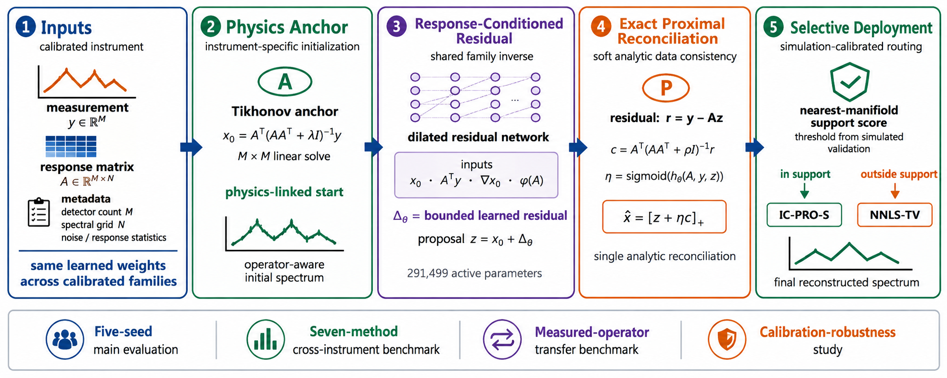
Fig. 1 Proposed IC-PRO-S workflow and evaluation roadmap. The calibrated measurement and response matrix define a Tikhonov physics anchor, response-conditioned learned proposal, one displacement computed by an exact quadratic proximal map, followed by learned relaxation and projection with adaptive under-relaxation, and simulation-calibrated selective deployment. The lower band summarizes the four reader-facing evaluation blocks: five-seed main evaluation, seven-method cross-instrument benchmark, measured-operator transfer benchmark, and calibration-robustness study.

5. Experimental Protocol

5.1 Synthetic family and fixed splits
The source generator samples nonnegative spectra on a normalized wavelength coordinate u∈[0,1]. Narrow, doublet and mixed families use Gaussian peaks with width drawn log-uniformly from 0.004 to 0.07 and amplitude from 0.25 to 1; doublet separation spans 0.008–0.05 in normalized coordinates. Broad spectra include a low-order nonnegative background. Absorption-like spectra subtract one to three Gaussian dips (width 0.01–0.06; amplitude 0.05–0.25) from a nonnegative background and are subsequently clipped to nonnegative intensity and max-normalized. The response generator sums 3–7 Gaussian terms for ordinary train/validation/test operators (width 0.02–0.20), and 7–10 terms for the OOD bank (width 0.008–0.10), with distinct modulation-frequency ranges; each response row is max-normalized. The main N=256 split uses 12 training, 3 validation, 4 held-out Test and 4 OOD operators, M∈{12,16,24,32}, and five training seeds {3,7,11,19,23}. These procedural families are controlled surrogates for calibrated instruments; their realism and potential resemblance between draws are limitations requiring dedicated checks.
All target spectra in the described generator are modeled as nonnegative intensity, including absorption-like spectra represented as downward dips from a nonnegative continuum and clipped to nonnegative values. Therefore, nonnegativity is compatible with this synthetic target convention but does not test signed absorbance, background-subtracted negative values, or signed detector-response physics; the separate BP/MoS2 transfer results highlight the associated generalization limitation.

5.2 Controlled baselines
- Tikhonov analytic inversion with λ=10⁻³.
- NNLS-TV with regularization selected on the validation split and 120 ADMM iterations.
- ReSpecNN public Sim2Real topology, including favorable per-device retraining on synthetic data generated under each target response.
- Shared-by-M ReSpecNN using a detector-count-specific fixed-input representation.
- Physics-anchor CNN using the Tikhonov anchor plus a residual CNN without proximal correction.
- PnP learned-prior comparator with a 27-point validation grid over {6,12,24} iterations, relaxation {0.25,0.45,0.65}, and ridge {10⁻⁵,10⁻⁴,10⁻³}; the selected configuration uses 12 steps, η=0.65, and ridge=10⁻³.
- PiGDM used a sensor-independent synthetic spectral prior, a cosine diffusion schedule for T=1000, K=50 primary reverse steps, pseudoinverse measurement guidance, a validation-selected γ=0.05, and approximately 5.33M parameters.
- The MGDUN-style comparator is a six-stage operator-aware vector-domain adaptation inspired by [33], not an unchanged implementation of the published optical architecture. It is trained with seeds {3,7,11}; its table mean and paired comparisons average the three matched-seed predictions/errors per spectrum. Its results should be interpreted as those of this controlled adaptation only.

5.3 Stress, transfer, OOD, and efficiency
Robustness evaluation consists of nominal conditions, σ=0.05 noise, 50% detector dropout, 6-bin calibration shift and zero-shot wavelength-grid transfer to N=192, 301, and 384. OOD scoring is performed on 800 ID and 800 OOD simulated cases, using nearest manifold, kNN density, Mahalanobis distance, isolation forest and forward residual. Efficiency is based on fixed single-thread batch-1 CPU timing with M=16 and N=256.

5.4 Public Sim2Real real-device benchmark
The public Sim2Real repository [10] contains 15 paired real measurement/reference spectra used for full-shape Relative-L2 evaluation. The 14 paper-matched cases (nine single-peak and five multi-peak spectra) are followed by peak-position analysis; the other 620-nm repository pair is only included in the 15-pair full-shape analysis. Response-only adaptation, OOD fitting, and guard-threshold calibration use calibrated response information and simulated data; real ground-truth spectra remain evaluation-only.

5.5 Original operator-extrapolation diagnostic
The V7 diagnostic evaluates interpolation, detector-count extrapolation including M=8/M=40, and a structurally distinct response family generated from smoothed-random, triangular, and high-frequency mixed filters. The diagnostic complements the expanded cross-instrument benchmark by testing the original V7 family model on zero-shot operator changes and supplies an interpretable view of how response conditioning transfers beyond held-out random matrices.

5.6 Seven-method cross-instrument benchmark
The frozen A12 protocol uses N=256, σ=0.01, two operators per regime, 128 Test spectra and 64 validation spectra per operator. Regimes are interpolation (M=16,24), moderate M extrapolation (M=8,40), and severe structural shift (M=16,32). Every method sees matched Test spectra/operators. The primary IC-PRO-S paired comparison uses archived seed-7 predictions; all five recovered checkpoints are reported separately for seed sensitivity. MGDUN-style results aggregate three seeds; other methods use their protocol-selected fitted or analytic implementation. Consequently the three regime means in Table 12 are not identical in seed averaging. These 256 paired spectra per regime represent only two test operators, and statistical inference over spectra should not be interpreted as proof of generalization over a broad population of instruments.

5.7 Measured-responsivity operator transfer benchmark
The measured-operator transfer benchmark uses the public source data accompanying Wang et al. [34]. The source device is a single-pixel voltage-tunable spectrometer: its photocurrent at bias V is physically described by I(V)=∫R(λ,V)P(λ)dλ, where R is the calibrated wavelength- and bias-dependent responsivity [34]. For the controlled benchmark, the measured responsivity over 480–820 nm and the commercial-spectrometer target spectra from Fig. 3a–d of Wang et al. [34] are interpolated to the common N=256 grid and evaluated in normalized spectral-shape units. The discrete forward surrogate used by the benchmark is y=(R_measured x_experimental)/N. The factor 1/N is a common numerical scaling convention for this normalized discrete protocol rather than a claim that the physical quadrature weight of the device equals 1/N; every compared method is trained, validated, and evaluated under the same scaling. Two response-channel settings are tested: M=32 using a uniform subset of bias states and M=101 using the full measured responsivity/bias set. Thus M=32 and M=101 denote voltage-dependent responsivity measurement channels, not 32 or 101 separate physical detectors. Response-only IC-PRO-S adaptation starts from seed 7 and uses measured R plus synthetic spectra, with λ selected on synthetic validation simulations; the 25 experimental target spectra remain evaluation data.

5.8 Calibration-robustness study
The calibration-robustness study freezes the cross-instrument benchmark operators, test spectra, and all five archived IC-PRO-S checkpoints and evaluates calibration perturbations without retraining. The test measurement y is generated from the unperturbed true operator, while reconstruction receives a smoothly perturbed positive row-normalized calibration matrix. Requested perturbation levels ε∈{0,0.01,0.025,0.05,0.10,0.20} are compared for learned relaxation, fixed η=0.5, full η=1, proposal-only, and Tikhonov. This protocol directly measures the robustness of the analytic reconciliation and the learned reliability mechanism.
An exploratory post-hoc case-level analysis of the archived A14 results additionally summarizes the distribution of predicted η, its change under increasing perturbation, and η–reconstruction-error associations within each operator and training seed. These descriptive analyses do not measure predictive uncertainty and are not a substitute for a support-score risk–coverage evaluation.

5.9 Evaluation metrics and paired statistics
Relative-L2 is computed per spectrum as ||x̂−x||₂/||x||₂, and SAM is the spectral-angle mapping metric used in training. Bootstrap 95% intervals summarize paired mean differences on common spectra; directional one-sided Wilcoxon signed-rank tests address paired rank distributions, a different estimand. Table 13 contains 15 non-Tikhonov comparisons across three regimes; Holm-adjusted p-values are provided in the reviewer audit accompanying this working revision. The tests are exploratory rather than confirmatory, and sample-level dependence within two operators per regime limits population-level inference.
The A12 seven-method experiment contains two independently frozen response operators per regime, but the exact same 128 test spectra are repeated on both. Thus 256 operator–spectrum evaluations are not 256 independently sampled spectra. In Table 13 the two observations for each spectrum are first averaged and statistical tests use 128 paired distinct-spectrum units per regime. Reported confidence intervals reflect variation over these spectra under the frozen operator pair, not the distribution of as-yet-unseen physical instruments. No inference of statistical equivalence is drawn from nonsignificant rank tests. Independence from the full training history and absence of near-duplicate spectral shapes are not established by an exact validation/test identity check alone.
The frozen A12 design deliberately uses exactly the same 128 test spectra at each of two distinct response operators within every regime. Thus there are 256 operator–spectrum evaluations but only 128 unique input spectra per regime. For Table 13 we therefore first average each method's reconstruction error over the two operators for each test-spectrum identifier; the 128 resulting paired per-spectrum differences are the units for Wilcoxon tests and 20,000-sample paired bootstrap confidence intervals. Holm-adjusted p-values across 15 non-Tikhonov comparisons are displayed alongside the raw directional tests. This is a fixed-operator-pair analysis, not uncertainty over an instrument population. Exact tensor comparisons verified the within-regime repeated-spectra design; no exact duplicated spectrum was found between the validation and test arrays of the same regime. This exact-equality check does not establish the absence of near-duplicate spectral shapes or rule out every possible training-data overlap.

5.9.1 Protocol accounting and terminology
Protocol accounting (distinct evaluation units and adaptation rules): The primary five-seed V7 experiment uses 12 training, 3 validation, 4 held-out test and 4 simulated OOD response operators, with five independently trained checkpoints. Its original raw simulated input tensors were not preserved, so exact historical V7 input replay cannot be claimed. The frozen A12 seven-method experiment uses 2 operators and 128 paired spectra per operator in each of 3 regimes (256 spectrum cases per regime); the primary IC-PRO-S comparison uses seed 7, and the MGDUN-style comparator aggregates 3 seeds per case. The original nearest-manifold discrimination experiment uses 800 simulated in-distribution and 800 simulated OOD cases, with separate 12,000-member support and 600-member threshold-calibration banks as described in Section 4.6; reconstruction risk after routing has not been verified. The public Sim2Real evaluation comprises 15 real paired measurements for full-shape error and 14 for peak-position summaries. The measured-responsivity benchmark uses 25 experimental reference spectra as evaluation targets within a controlled numerical forward surrogate, with adaptation on measured R and synthetic spectra only. The A14 calibration perturbation study uses 6 frozen simulated operators, 5 trained checkpoints and 6 requested ε values without retraining. The BP/MoS2 study is a separate signed-current hardware transfer diagnostic. Accordingly, measured-operator surrogate evaluation, actual measured y evaluation, training-seed repeats and independent hardware-operator repeats must not be conflated.
Abbreviations: CNN, convolutional neural network; OOD, out-of-distribution; ID, in-distribution; PnP, plug-and-play; NNLS-TV, nonnegative least squares with total-variation regularization; SAM, spectral angle mapper; ADMM, alternating direction method of multipliers; AUROC, area under the receiver-operating-characteristic curve; AUPRC, area under the precision–recall curve; FPR95, false-positive rate at 95% true-positive rate (the positive-class convention must be verified against the archived OOD analysis); MAE, mean absolute error; NIR, near-infrared; MACs, multiply–accumulate operations. IC-PRO-S, PiGDM, MGDUN, and ReSpecNN denote the method names used in the cited papers and the present implementation protocols.

5.9.2 Newly trained matched-capacity CNN feature control
An additional controlled CNN input-feature ablation was trained from scratch on the frozen V7 source-defined replay tensors, which are not identical to the unavailable historical V7 raw input tensors. Three independent training seeds (3, 7, 11) and a maximum of 1,050 optimization steps were used, with validation selection of checkpoints. Each arm used the same full FiRNO architecture (291,620 parameters), optimizer, frozen source-defined validation/test arrays, and seed-matched batch schedule. The full arm retained the anchor, normalized backprojection, anchor gradient, and Fisher/response-energy channel. The no-Fisher arm replaced the Fisher channel by a fixed cosine spectral coordinate; the anchor-plus-gradient arm additionally replaced the normalized backprojection by a fixed linear spectral coordinate. The first convolution retained four nonconstant channels in all arms. The analytic operator-dependent anchor, singular-mode gate, and quadratic proximal correction were unchanged in all arms. Thus, this experiment probes incremental CNN input response features at fixed network capacity; it is not a completely operator-free inverse. These full-model 291,620-parameter ablation variants should not be confused with the 291,499-active-parameter streamlined deployment path described in Section 4.5.

5.10 Code availability
Custom algorithms, synthetic generators, evaluation scripts, archived checkpoints and exact A12 benchmark inputs are required for reproducing the principal analyses. [REVISION ACTION REQUIRED BEFORE SUBMISSION: deposit the complete, verified code and reproducibility record in a recognized DOI-assigning repository; insert the persistent DOI, license, instructions and exact archive contents here.] Historical raw V7 simulated input tensors are not preserved; the available V7 source-defined replay tensors are a distinct regeneration and must not be described as original bitwise inputs.

6. Results
To aid navigation without removing experiments, the results are organized by scientific question. Sections 6.1–6.4 (Tables 2–5; Figs. 2–5) evaluate primary accuracy, matched baselines, stress tests and components; Sections 6.5–6.7 (Tables 6–8; Figs. 6–8) cover transfer and simulated OOD discrimination; Sections 6.8–6.10 (Tables 9–11; Figs. 9–11) cover public-device evidence, efficiency and diffusion-prior control; Sections 6.11–6.13 (Tables 12–15; Figs. 12–16) cover the frozen seven-method comparison, experimental-target transfer and calibration perturbations; Section 6.14 (Table 16) reports an independent hardware-family stress case; and Section 7 (Tables 17–19) documents training configuration and paired statistics. These analyses use distinct sample sets and do not establish a universal method ranking.

6.1 Five-seed main result
Table 2 Five-seed held-out Test and OOD reconstruction performance
Split | IC-PRO-S | Tikhonov | Relative gain | Seeds improved
Held-out Test | 0.3566 | 0.4965 | 28.17% | 5/5
OOD | 0.4153 | 0.5458 | 23.91% | 5/5
Table 2 and Fig. 2 show that IC-PRO-S improves over the fixed Tikhonov anchor on both held-out Test and OOD splits across all five independent seeds, with low between-seed variability. The five archived V7 checkpoints support the primary means of 0.3566 on Test and 0.4153 on OOD.
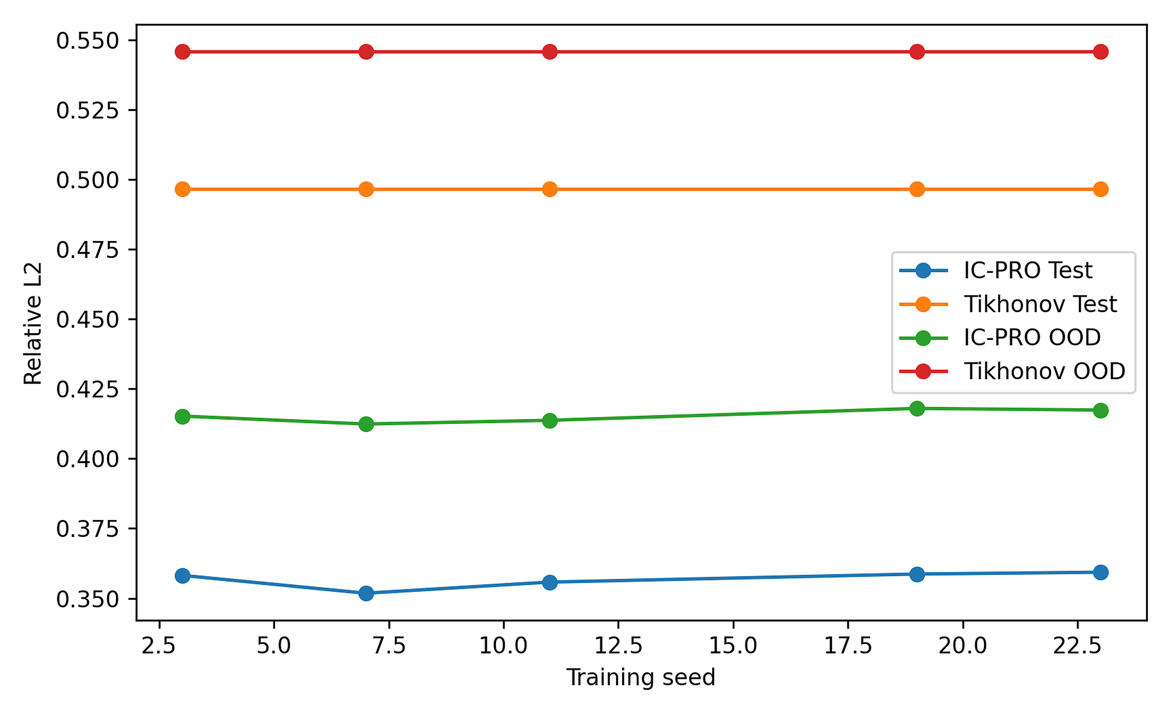
Fig. 2 Five-seed IC-PRO-S performance relative to the fixed Tikhonov anchor

6.2 Controlled modern baselines
Table 3 Controlled modern baseline comparison on common held-out Test and OOD sets
Method | Test Rel-L2 | OOD Rel-L2 | Deployment
IC-PRO-S | 0.3566 | 0.4153 | one response-conditioned family model
Tikhonov | 0.4965 | 0.5458 | analytic per response
NNLS-TV | 0.4243 | 0.4262 | 120-iteration optimization
ReSpecNN per-device | 0.3867 | 0.4062 | separate ~3.4M model per target response
ReSpecNN shared-by-M | 0.5549 | 0.6145 | one fixed-input model per M
Physics-anchor CNN | 0.4117 | 0.4699 | shared family; no prox
PnP tuned | 0.3636 | 0.3749 | 12 iterations; validation tuned
MGDUN-style adapted | 0.4443 ± 0.0104 | 0.4378 ± 0.0077 | 6 shared unfolding stages
On the original held-out Test split, IC-PRO-S has the lowest reported mean (0.3566) among the methods in Table 3, but the difference relative to tuned PnP (0.3636) is small and should not be treated as established superiority absent the matching statistical test. In the separately defined OOD split, tuned PnP (0.3749) and per-device ReSpecNN (0.4062) have lower means than IC-PRO-S (0.4153). The pertinent trade-off is shared-operator deployment without target-specific retraining under the tested synthetic family, not universal OOD dominance.
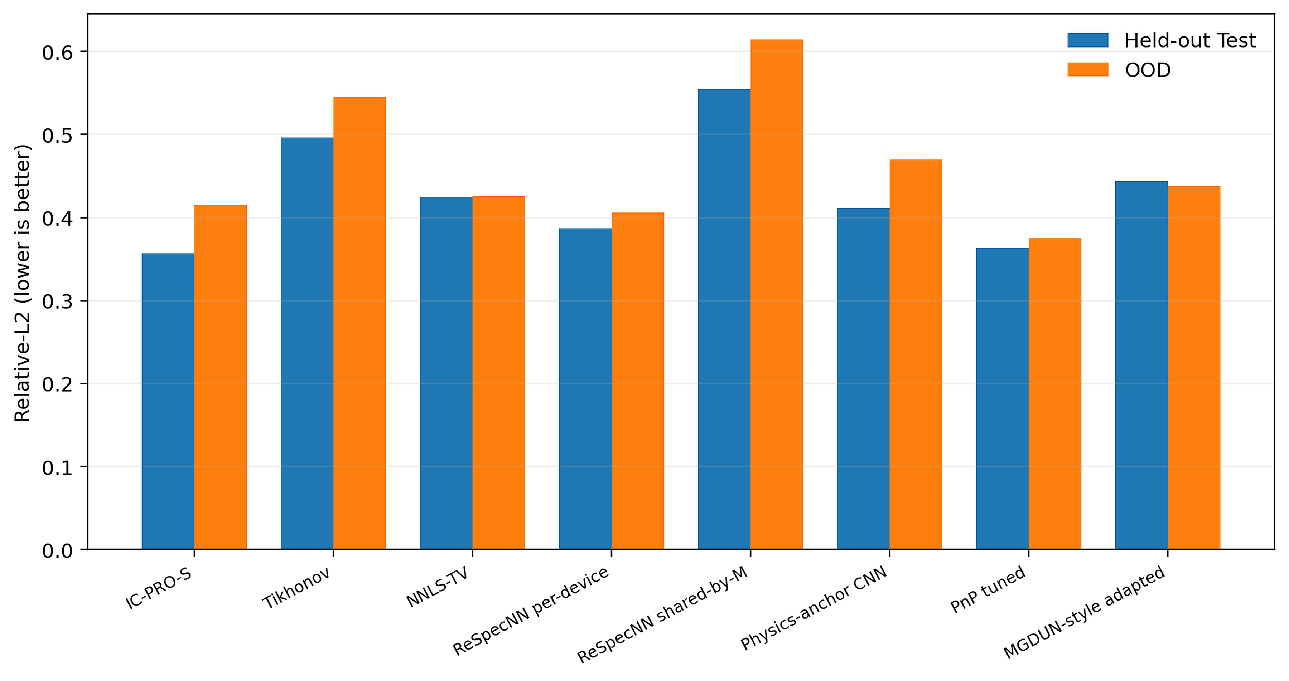
Fig. 3 Controlled held-out Test and OOD comparison; lower Relative-L2 is better

6.3 Controlled stress comparison
Table 4 Controlled robustness under severe noise, detector dropout, and calibration shift
Method | Nominal | Noise 0.05 | Dropout 50% | Shift 6
IC-PRO-S | 0.3525 | 0.5634 | 0.4260 | 0.3894
Tikhonov | 0.4830 | 0.5922 | 0.5504 | 0.4897
NNLS-TV | 0.4239 | 0.6586 | 0.4823 | 0.4325
ReSpecNN per-device | 0.3738 | 0.5549 | 0.8403 | 0.3862
Physics-anchor CNN | 0.4039 | 0.5823 | 0.4892 | 0.4178
PnP tuned | 0.3687 | 1.0456 | 0.4263 | 0.3928
Table 4 and Fig. 4 demonstrate strong behavior across complementary stress conditions. IC-PRO-S reaches 0.5634 under severe noise, 0.4260 under 50% detector dropout, and 0.3894 under a 6-bin calibration shift. The best comparator varies by perturbation, while IC-PRO-S remains among the strongest methods across all three stresses with one compact shared model.
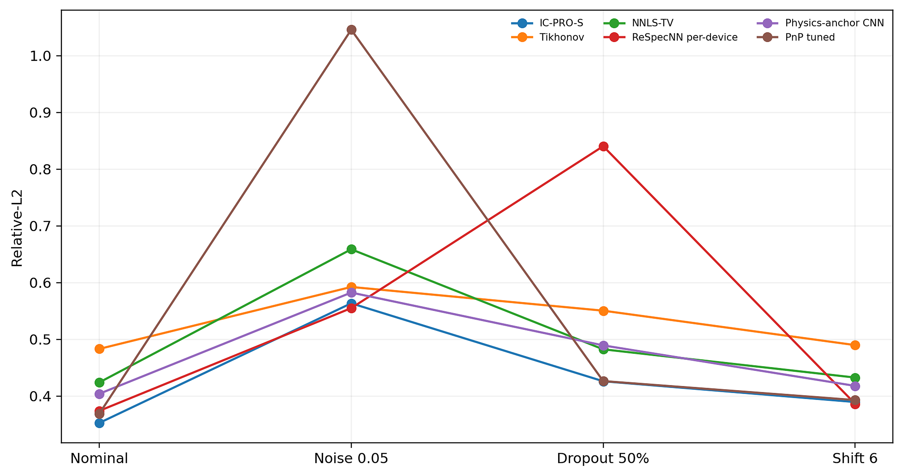
Fig. 4 Controlled robustness comparison on identical spectra

6.4 Mechanistic ablations
Table 5 Matched mechanistic ablations of proximal correction, response conditioning, and relaxation
Ablation | Test Rel-L2 | OOD Rel-L2 | Interpretation
PROX on | 0.3553 | 0.4138 | 11.00% lower forward residual than no-PROX
PROX off | 0.3660 | 0.4175 | matched 3-seed retraining
Full response features | 0.3617 | 0.4182 | response-conditioned
Anchor only | 0.3715 | 0.4320 | no explicit response-derived auxiliary features
Learned η | 0.3617 | 0.4182 | context-dependent
Fixed η=0.5 | 0.3641 | 0.4150 | competitive mean OOD
The matched studies support modest and component-specific gains: removal of the proximal correction changes Test Relative-L2 from 0.3553 to 0.3660 (2.92% relative difference) and increases forward residual by 11.00%; removing explicit response-derived features changes Test error from 0.3617 to 0.3715 (2.65%). Learned η (0.3617) is slightly better than fixed η=0.5 (0.3641) on Test but not OOD (0.4182 versus 0.4150). These results support soft physics reconciliation but do not establish that a learned gate is essential or consistently superior.
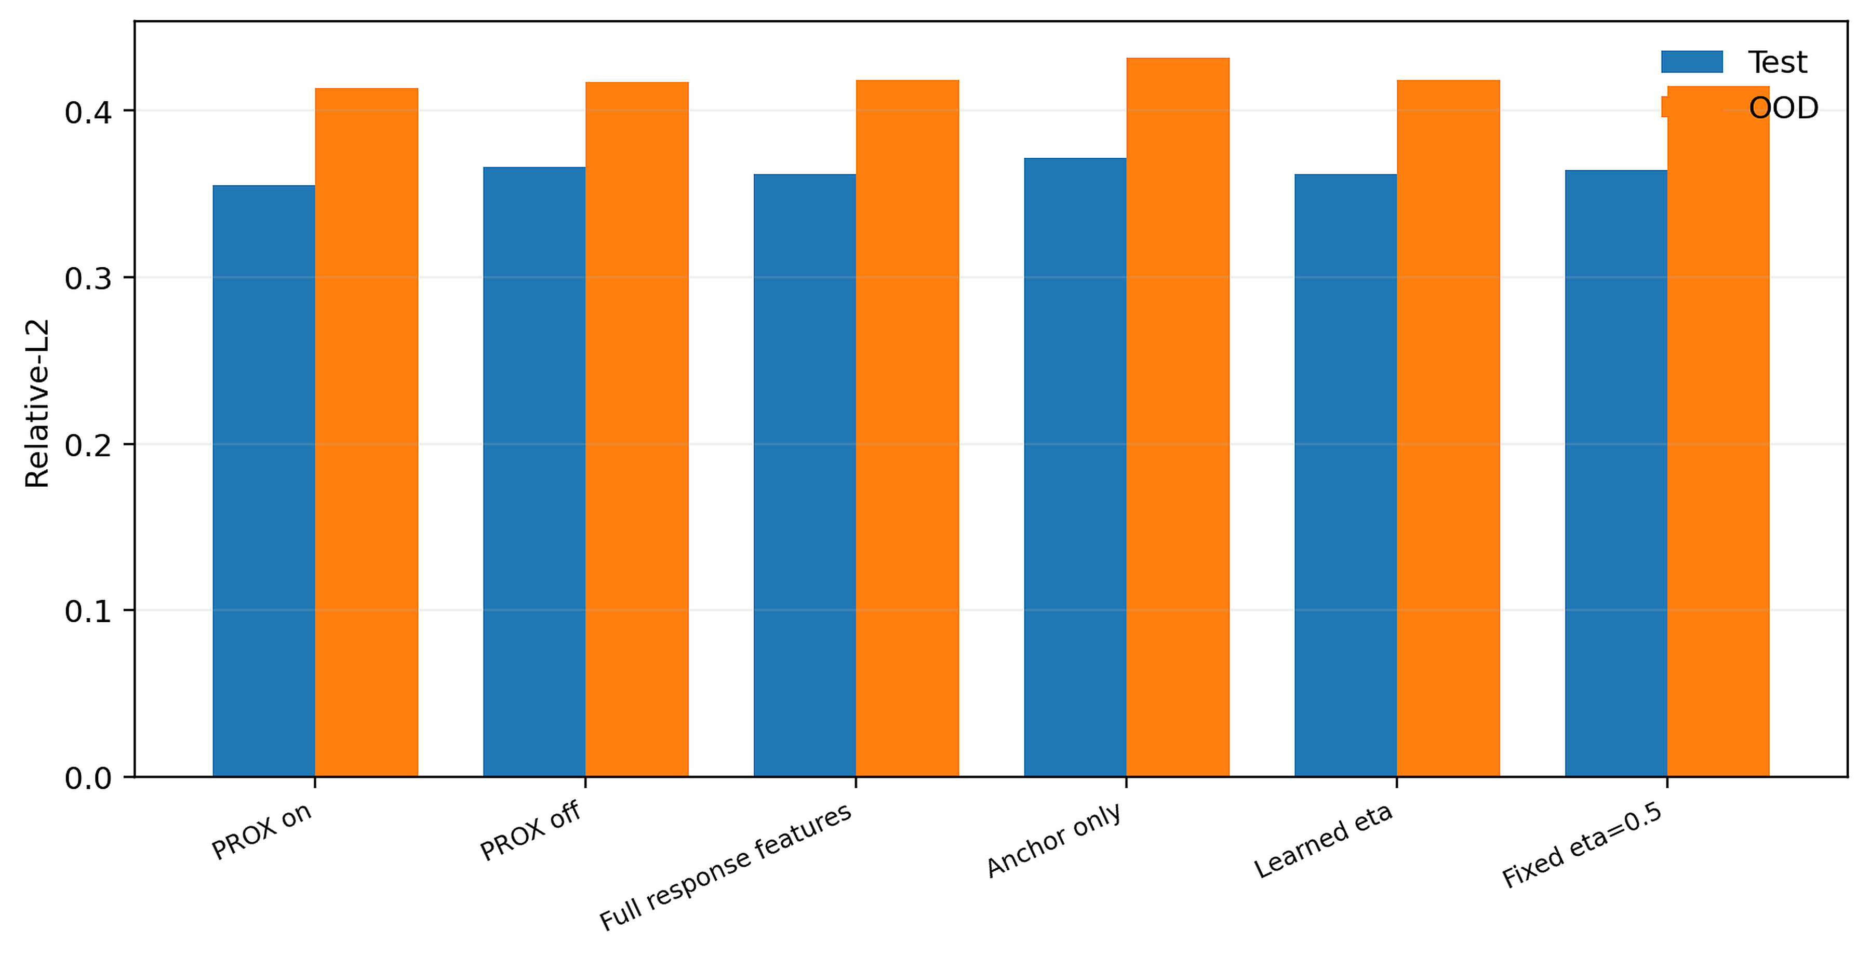
Fig. 5 Matched mechanistic ablations of proximal correction, response conditioning, and relaxation

6.4.1 New matched-capacity feature ablation
In this new matched-capacity control, mean held-out test Relative-L2 across three training seeds was 0.35854 ± 0.00075 for the full input, 0.36199 ± 0.00052 for the no-Fisher control, and 0.37316 ± 0.00248 for the anchor-plus-gradient control (mean ± between-seed SD; see the accompanying GPU experiment audit). The full model had lower test error at each of the three matched seeds. The relative reductions in mean error were 0.95% and 3.92%, respectively. These modest, directionally consistent differences provide evidence that auxiliary response-derived CNN channels contribute beyond a capacity-matched coordinate control within the replay task. They do not establish that the mechanism is novel in isolation, that it is essential, or that it will dominate across independent physical instruments. This new protocol must not be numerically pooled with the historical V7 or frozen A12 results.

6.5 Original zero-shot operator extrapolation diagnostic
Table 6 Original V7 zero-shot operator-extrapolation diagnostic relative to Tikhonov
Regime | IC-PRO-S | Tikhonov | Gain | Fraction better
interpolation | 0.3310 | 0.4755 | 30.38% | 91.2%
moderate M=8/M=40 | 0.3498 | 0.4895 | 28.54% | 91.0%
severe structural | 0.3494 | 0.4703 | 25.72% | 88.5%
Table 6 and Fig. 6 summarize the original V7 zero-shot operator-extrapolation diagnostic. IC-PRO-S improves over Tikhonov by 30.38% on interpolation, 28.54% for M=8/M=40 detector-count extrapolation, and 25.72% on the structurally distinct response family, with 88.5–91.2% of spectra improved.
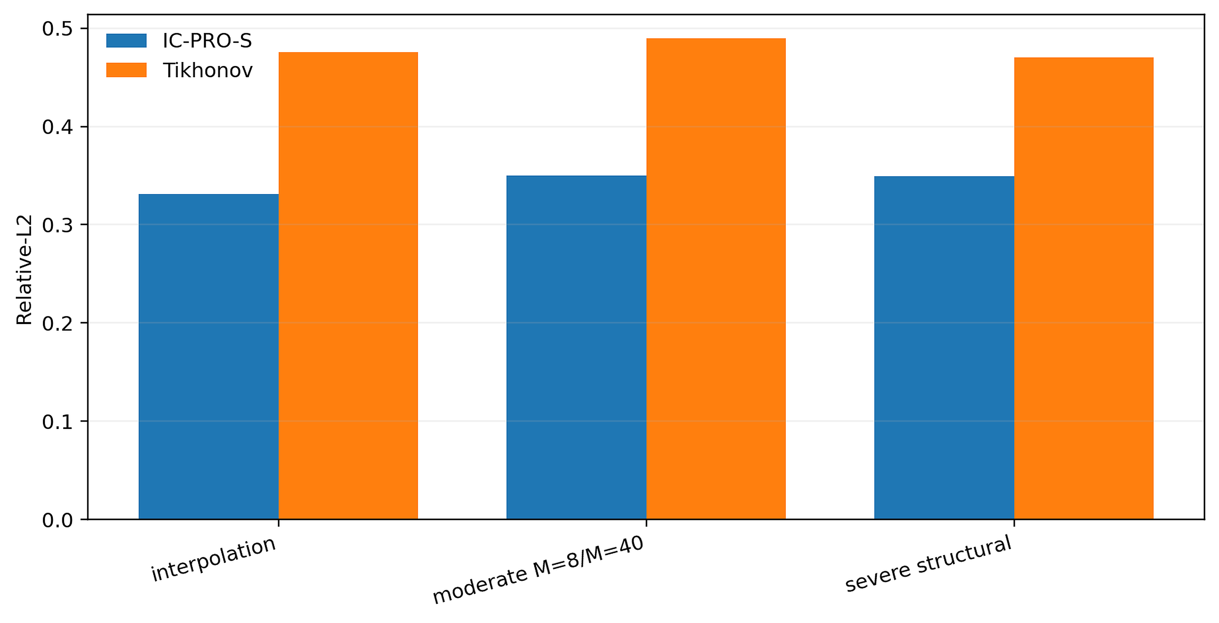
Fig. 6 Original V7 zero-shot operator-extrapolation diagnostic

6.6 Zero-shot wavelength-grid transfer
Table 7 Zero-shot transfer to unseen spectral-grid sizes
Grid N | IC-PRO-S Rel-L2 | Tikhonov Rel-L2 | Gain
192 | 0.3206 | 0.4513 | 28.95%
301 | 0.3665 | 0.5262 | 30.35%
384 | 0.3433 | 0.5057 | 32.12%
Table 7 and Fig. 7 show zero-shot transfer to unseen spectral-grid sizes. IC-PRO-S reaches Relative-L2 0.3206 at N=192, 0.3665 at N=301, and 0.3433 at N=384, corresponding to 28.95–32.12% gains over Tikhonov without changing the learned weights.
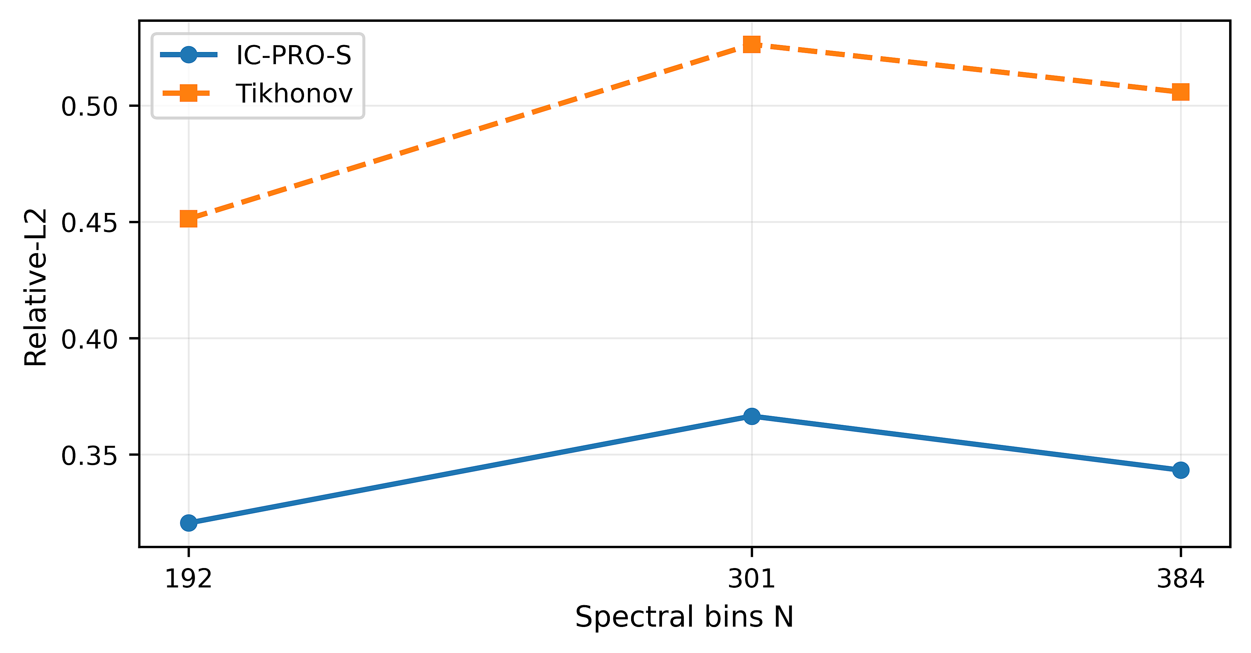
Fig. 7 Zero-shot wavelength-grid transfer to N = 192, 301, and 384

6.7 OOD detector benchmark and selective deployment
Table 8 Simulation-only out-of-distribution (OOD) discrimination benchmark; not reconstruction uncertainty calibration
Score | AUROC | AUPRC | FPR95
Nearest manifold | 0.968 | 0.972 | 0.182
kNN density | 0.947 | 0.954 | 0.304
Mahalanobis | 0.869 | 0.897 | 0.650
Isolation forest | 0.836 | 0.865 | 0.691
Forward residual | 0.807 | 0.808 | 0.546
The simulated ID/OOD nearest-manifold discriminator was reported to achieve AUROC 0.968, AUPRC 0.972 and FPR95 0.182; these are discrimination metrics rather than calibrated spectral-reconstruction uncertainty. As a separate, explicitly exploratory secondary analysis, we evaluated a newly specified, simulation-standardized nearest-manifold PROXY on the frozen A12 operator–spectrum cases (768 evaluations; 384 distinct spectra tested under two operators each within their regime). This proxy is NOT the original guard that generated Table 8. With separate 12,000-member support and 600-member threshold-calibration banks for each of six operators, the simulated 99th-percentile threshold flagged 13/768 cases (1.69%). An offline, paired-error substitution of NNLS-TV in flagged cases changed mean Relative-L2 from 0.38884 to 0.38839 (absolute improvement 0.00045; spectrum-clustered bootstrap 95% CI for improvement [−0.00014, 0.00127], 20,000 resamples). The proxy support score did not predict higher error (pooled normalized-distance Spearman ρ=−0.177); selecting the 50% lowest-distance cases within each operator produced mean error 0.45136 versus 0.38884 over all cases. This does not validate the historical guard, its out-of-family detection threshold, its prospective routing benefit, or uncertainty calibration. The exact archived original guard implementation and case-matched support scores remain necessary for those claims; full protocol and statistical caveats are documented in the accompanying exploratory audit.
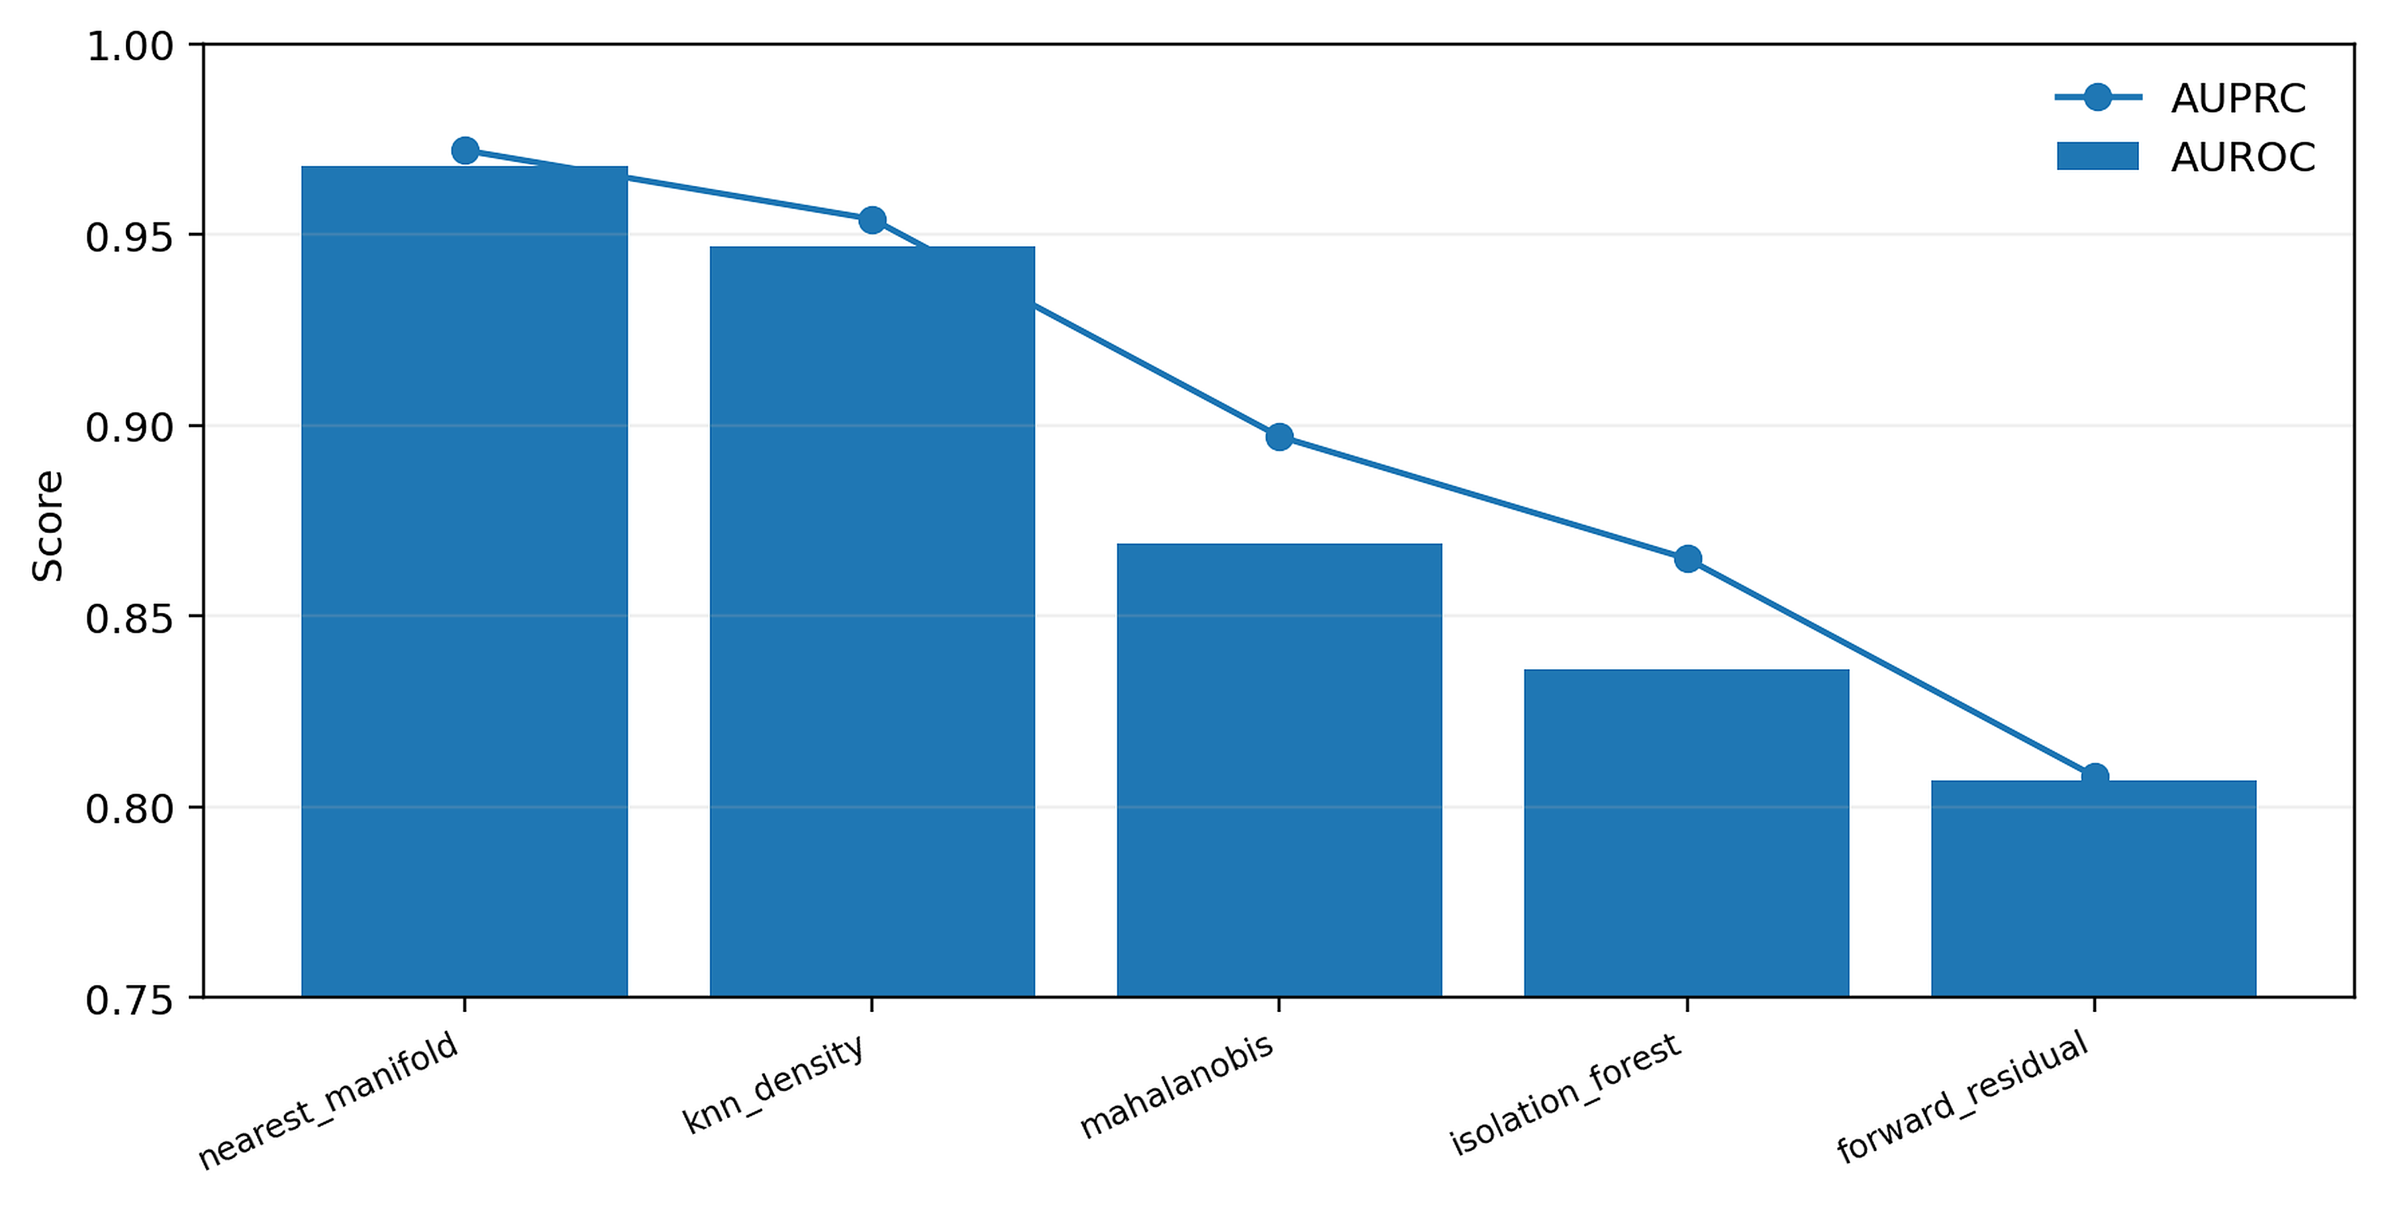
Fig. 8 Simulation-calibrated OOD discrimination

6.8 Public real-device benchmark
Table 9 Public Sim2Real real-device evaluation and 15-versus-14 accounting
Metric | Learned/selective | Tikhonov/reference | Accounting
Full-shape mean Relative-L2 | 0.737 | 0.8592 | all 15 pairs
Full-shape bootstrap 95% CI | [0.5596,0.9154] | [0.6854,1.0404] | all 15 pairs
Pairs improved (%) | 80 | — | learned path vs Tikhonov
Paired-difference bootstrap 95% CI | [-0.2042,-0.0506] | — | model minus Tikhonov
Selective single-peak wavelength MAE (%) | 0.582 | — | 9 matched single-peak cases
Selective multi-peak wavelength MAE (%) | 1.301 | — | 5 multi-peak cases
Guard-flagged cases | 3/14 | — | 99th-percentile simulation-only threshold
In 15 public real-device measurement/reference pairs, the learned pathway had mean Relative-L2 0.7370 versus 0.8592 for Tikhonov, with a paired bootstrap 95% interval for model-minus-Tikhonov of [−0.2042,−0.0506]. The single- and multi-peak location analyses contain only 9 and 5 cases respectively; 3 of the 14 paper-matched cases were flagged by the simulated guard. These small samples and limited hardware diversity warrant treating the findings as preliminary external evidence.
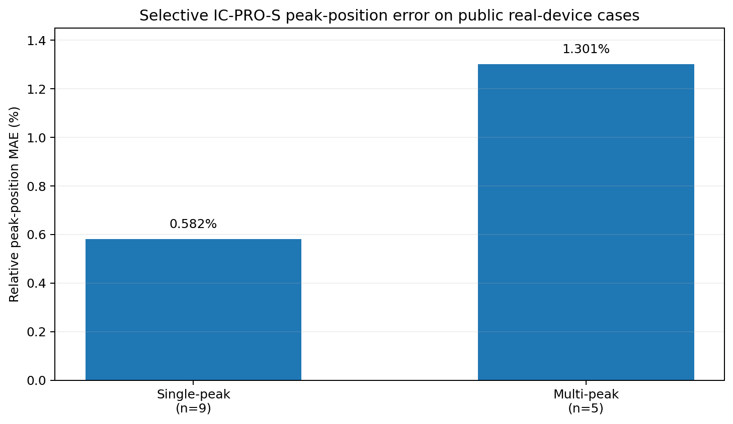
Fig. 9 Public real-device peak-position summary for the selective IC-PRO-S path on the 14 paper-matched cases. The relative peak-position MAE is 0.582% for the 9 single-peak cases and 1.301% for the 5 multi-peak cases; full-shape Relative-L2 results for all 15 pairs are reported in Table 9.

6.9 Efficiency and deployment trade-offs
Table 10 Model size and measured local single-thread CPU latency
Method | Params | FP32 MB | Learned MACs | CPU median ms
IC-PRO-S | 291,499 | 1.11 | 73,875,600 | 4.25
ReSpecNN per-device | 3,375,664 | 12.88 | 4,412,672 | 0.67
Physics-anchor CNN | 290,131 | 1.11 | 73,531,392 | 3.83
PnP tuned | 117,361 | 0.45 | 355,958,784 | 21.13
NNLS-TV | 0 | 0.00 | 0 | 16.21
In the reported local M=16, N=256, batch-1 CPU test, the median latency of IC-PRO-S is 4.25 ms per sample, compared with 0.67 ms for per-device ReSpecNN in that benchmark. The 1.8 ms number from the separate PiGDM study is measured using another timing harness and is not directly comparable. End-to-end timing that separates preprocessing, Tikhonov solve, model inference, proximal solve and routing remains necessary before making a device-level latency claim.
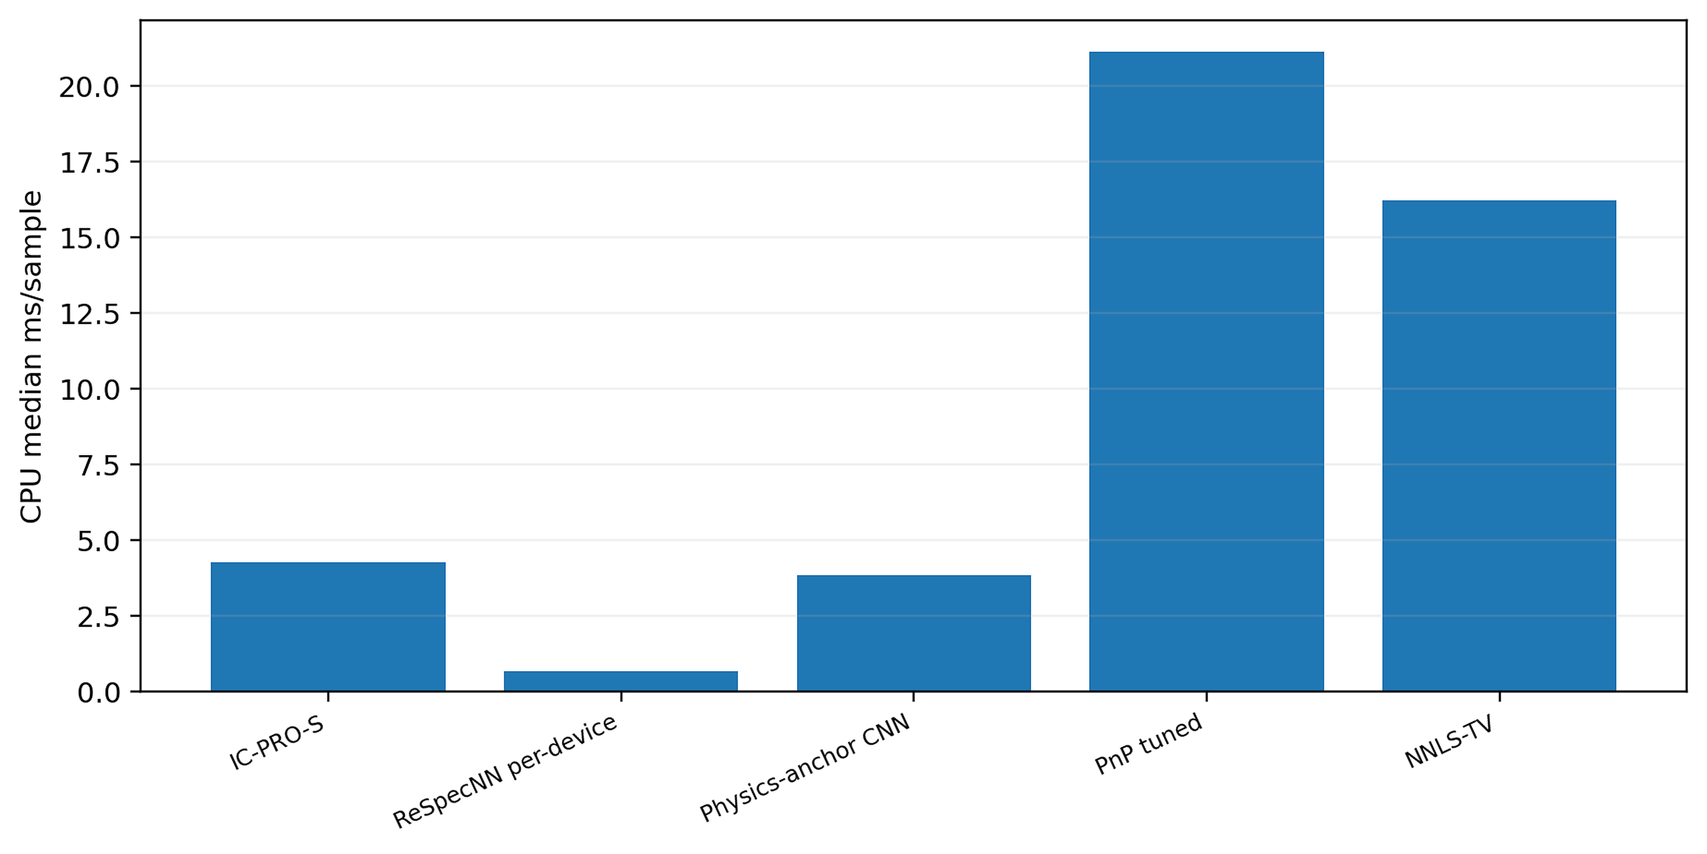
Fig. 10 Measured local single-thread CPU latency

6.10 Controlled PiGDM portability comparison
Table 11. Controlled PiGDM portability comparison (separate timing harness; CPU timings cannot be compared with Table 10).
Method | Test Rel-L2 | OOD Rel-L2 | Params | CPU ms/sample
IC-PRO-S | 0.423 | 0.371 | 291,499 | 1.8
PiGDM tuned γ=0.05 | 1.758 | 0.714 | 5,330,000 | 163.9
PiGDM paper γ=1 | 1.988 | 0.986 | 5,330,000 | 242.1
Tikhonov | 0.555 | 0.504 | 0 | —
Table 11 and Fig. 11 provide a controlled diffusion-prior portability study. On the matched common-family subset, IC-PRO-S reaches Test/OOD Relative-L2 0.423/0.371 with 291,499 parameters and 1.8 ms/sample CPU latency within this dedicated benchmark harness, illustrating the efficiency of a one-pass operator-conditioned reconstruction relative to the iterative diffusion adaptation used in this comparison. These latency values belong to the dedicated PiGDM benchmark harness and are distinct from the standardized local timing protocol reported in Table 10.
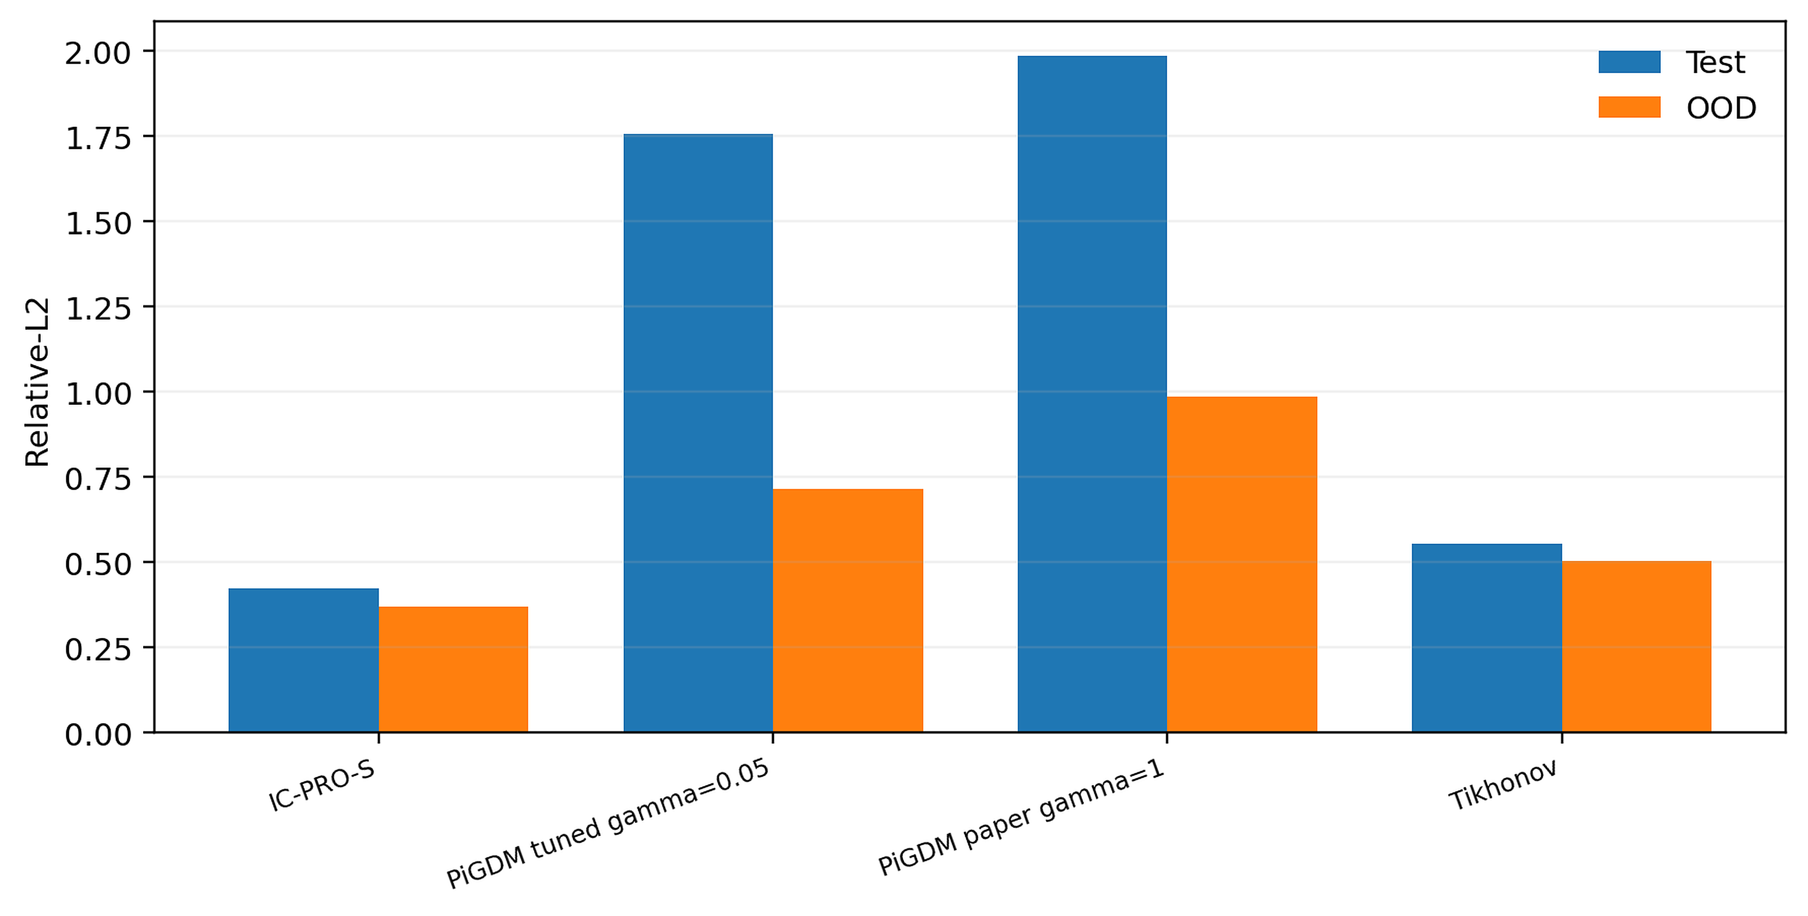
Fig. 11 Controlled PiGDM portability comparison with validation-guided guidance selection

6.11 Seven-method cross-instrument benchmark
Table 12 Full CUDA seven-method cross-instrument benchmark
Method | Interpolation | Moderate M | Severe structural | Target retraining
IC-PRO-S | 0.3505 | 0.4244 | 0.3856 | No
Tikhonov | 0.4618 | 0.5261 | 0.4750 | No
NNLS-TV | 0.3843 | 0.3971 | 0.4124 | No
PnP tuned | 0.3772 | 0.4370 | 0.3899 | No
ReSpecNN per-device | 0.3811 | 0.4047 | 0.4137 | Yes: per target response
PiGDM controlled | 0.9271 | 0.9195 | 0.9244 | No
MGDUN-style | 0.4273 | 0.4689 | 0.4547 | No
Note. The same 128 unique spectra are evaluated on two distinct frozen response operators in each regime, yielding 256 operator–spectrum evaluations per regime. Measurement-noise standard deviation = 0.01. Mean errors average both operators and therefore remain identical under unique-spectrum aggregation.
The frozen A12 benchmark compares seven methods using the same synthetic response operators and matched spectra. Seed-7 IC-PRO-S has the lowest reported mean Relative-L2 for interpolation (0.3505) and severe structural shift (0.3856), but not moderate detector-count extrapolation, where NNLS-TV (0.3971) and per-device ReSpecNN (0.4047) are lower than IC-PRO-S (0.4244). Because the two operators in each regime reuse the same 128 spectra, Table 13 now uses one paired difference per distinct spectrum after operator averaging; the strong-baseline severe-shift advantages do not survive Holm correction for the 15 exploratory tests. These results identify conditional performance on the fixed benchmark, not universal superiority across independent spectrometer hardware.
Operator-resolved exploratory analysis of the frozen A12 case-level results shows that the seed-7 IC-PRO-S model has the lowest mean Relative-L2 among seven evaluated implementations for four of six synthetic test operators: interpolation M=16 (0.3684), interpolation M=24 (0.3327), moderate extrapolation M=40 (0.2931), and structural shift M=16 (0.4018). At M=8 it performs worse than NNLS-TV (0.5556 versus 0.4690) and per-device ReSpecNN (0.4565); at structural-shift M=32 its error is close to but higher than PnP (0.3695 versus 0.3688). Across five IC-PRO-S checkpoints, M=40 remains lower-error than NNLS-TV, PnP and ReSpecNN in five of five seed comparisons, whereas M=8 loses to NNLS-TV and ReSpecNN for all five seeds. These operator-wise descriptions are a sensitivity analysis within the same frozen synthetic benchmark, not new physical-instrument validation or statistically independent replication. Operator-specific details and reproduction code are provided in the reviewer audit.
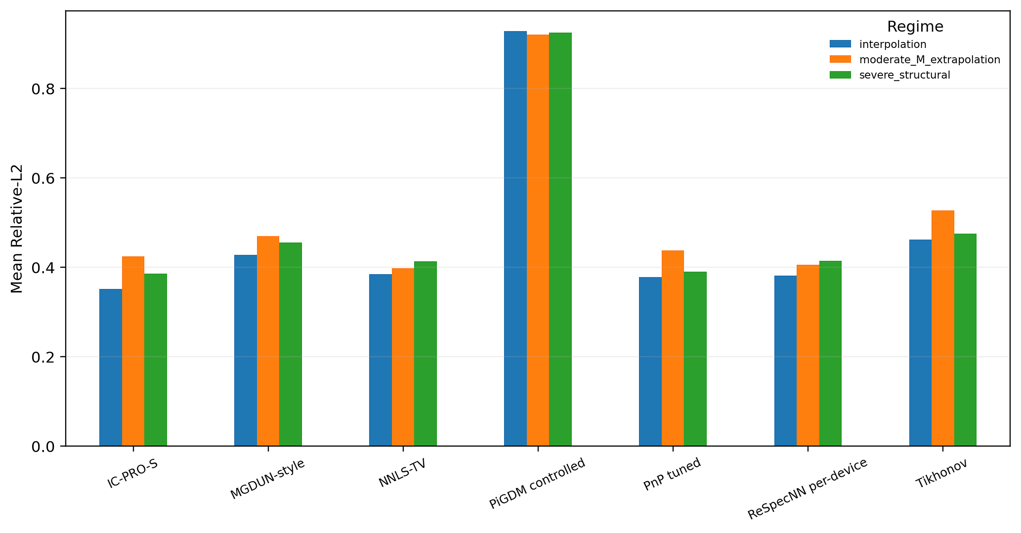
Fig. 12 Full seven-method cross-instrument benchmark; frozen separately from the original V7 extrapolation diagnostic
Table 13 Unique-spectrum clustered paired comparisons in A12 (128 distinct test spectra per regime, each evaluated under two fixed response operators)
Regime | Comparator | Comparator−IC-PRO-S | Spectrum-cluster 95% CI | One-sided p / Holm p
Interpolation | NNLS-TV | 0.0337 | [0.0214, 0.0468] | 2.5e-06 / 2.3e-05
Interpolation | PnP tuned | 0.0266 | [0.0189, 0.0341] | 5.2e-11 / 5.2e-10
Interpolation | ReSpecNN per-device | 0.0305 | [0.0167, 0.0452] | 0.00011 / 0.0008
Interpolation | PiGDM controlled | 0.5766 | [0.5064, 0.6526] | 4.8e-23 / 7.1e-22
Interpolation | MGDUN-style | 0.0768 | [0.0607, 0.0939] | 1.7e-18 / 2e-17
Moderate M | NNLS-TV | -0.0273 | [-0.0443, -0.0094] | 1 / 1
Moderate M | PnP tuned | 0.0126 | [0.0012, 0.0235] | 0.001632 / 0.00979
Moderate M | ReSpecNN per-device | -0.0196 | [-0.0360, -0.0028] | 0.9995 / 1
Moderate M | PiGDM controlled | 0.4952 | [0.4157, 0.5832] | 4.8e-23 / 7.1e-22
Moderate M | MGDUN-style | 0.0445 | [0.0293, 0.0605] | 6.8e-06 / 5.5e-05
Severe structural | NNLS-TV | 0.0268 | [0.0124, 0.0420] | 0.04277 / 0.1711
Severe structural | PnP tuned | 0.0043 | [-0.0044, 0.0129] | 0.02077 / 0.1039
Severe structural | ReSpecNN per-device | 0.0281 | [0.0081, 0.0486] | 0.1407 / 0.422
Severe structural | PiGDM controlled | 0.5388 | [0.4717, 0.6108] | 4.8e-23 / 7.1e-22
Severe structural | MGDUN-style | 0.0690 | [0.0509, 0.0882] | 1.1e-11 / 1.2e-10
Note. Differences are comparator minus IC-PRO-S seed 7, averaging the two operators for each distinct test spectrum. Positive mean differences favor IC-PRO-S. Paired bootstrap 95% intervals use 20,000 resamples of the 128 distinct spectra (seed 20261015). The one-sided Wilcoxon signed-rank test evaluates whether the comparator-minus-IC-PRO-S paired difference is greater than zero; each displayed p is followed by its Holm-adjusted value across the 15 non-Tikhonov contrasts. MGDUN-style case error averages the three archived seeds before forming pairs. Inference is conditional on these two operators per regime; no operator-population test is implied.
Archived A12 per-case inputs confirm that both operators within each regime were evaluated on precisely the same 128 test spectra. We first reproduced the historical 21 benchmark means and all 15 reported raw per-evaluation paired comparisons. Table 13 then replaces the per-evaluation test with spectrum-clustered reanalysis to avoid treating duplicated spectral inputs as independent draws. In the severe-structural regime, Holm-adjusted p-values are 0.171 (NNLS-TV), 0.104 (PnP) and 0.422 (per-device ReSpecNN), so none of these three mean advantages is significant at familywise 0.05. For interpolation the differences against these three baselines remain significant conditional on the fixed response pair. Bootstrap intervals for paired means and Wilcoxon directional p-values are different inferential summaries; near-zero p-values against weak controls should not be used to establish methodological novelty.

6.12 Measured-operator / experimental-target controlled transfer
Table 14 Measured-responsivity / experimental-target benchmark (25 targets)
M / condition | IC-PRO-S resp.-only | ReSpecNN | PnP | NNLS-TV | Tikhonov
32 / Noiseless | 0.4997 | 0.6330 | 0.7784 | 0.8482 | 0.8812
32 / Noise 0.005 | 0.5679 | 0.6609 | 0.7859 | 0.8507 | 0.8827
101 / Noiseless | 0.5013 | 0.6295 | 0.7653 | 0.8214 | 0.8568
101 / Noise 0.005 | 0.5495 | 0.6451 | 0.7689 | 0.8237 | 0.8585
In a controlled numerical surrogate using independently measured wavelength-dependent responsivity and 25 evaluation-only experimental reference spectra, response-only IC-PRO-S adaptation reached the smallest mean Relative-L2 among the tested adaptations in Table 14 for both response-channel counts and both noise conditions. The measurements were synthesized using the measured response and a normalized forward model; this is measured-operator transfer rather than an independent prospective measurement reconstruction trial.
Response-only adaptation uses the measured responsivity R and synthetic training spectra while withholding the 25 experimental target spectra from optimization. It should not be described as zero-shot transfer, and the normalized y=(Rx)/N surrogate is a benchmark convention rather than an experimentally validated noise-and-quadrature model. It tests the adaptability of the pipeline to measured operators, not universal real-device robustness.
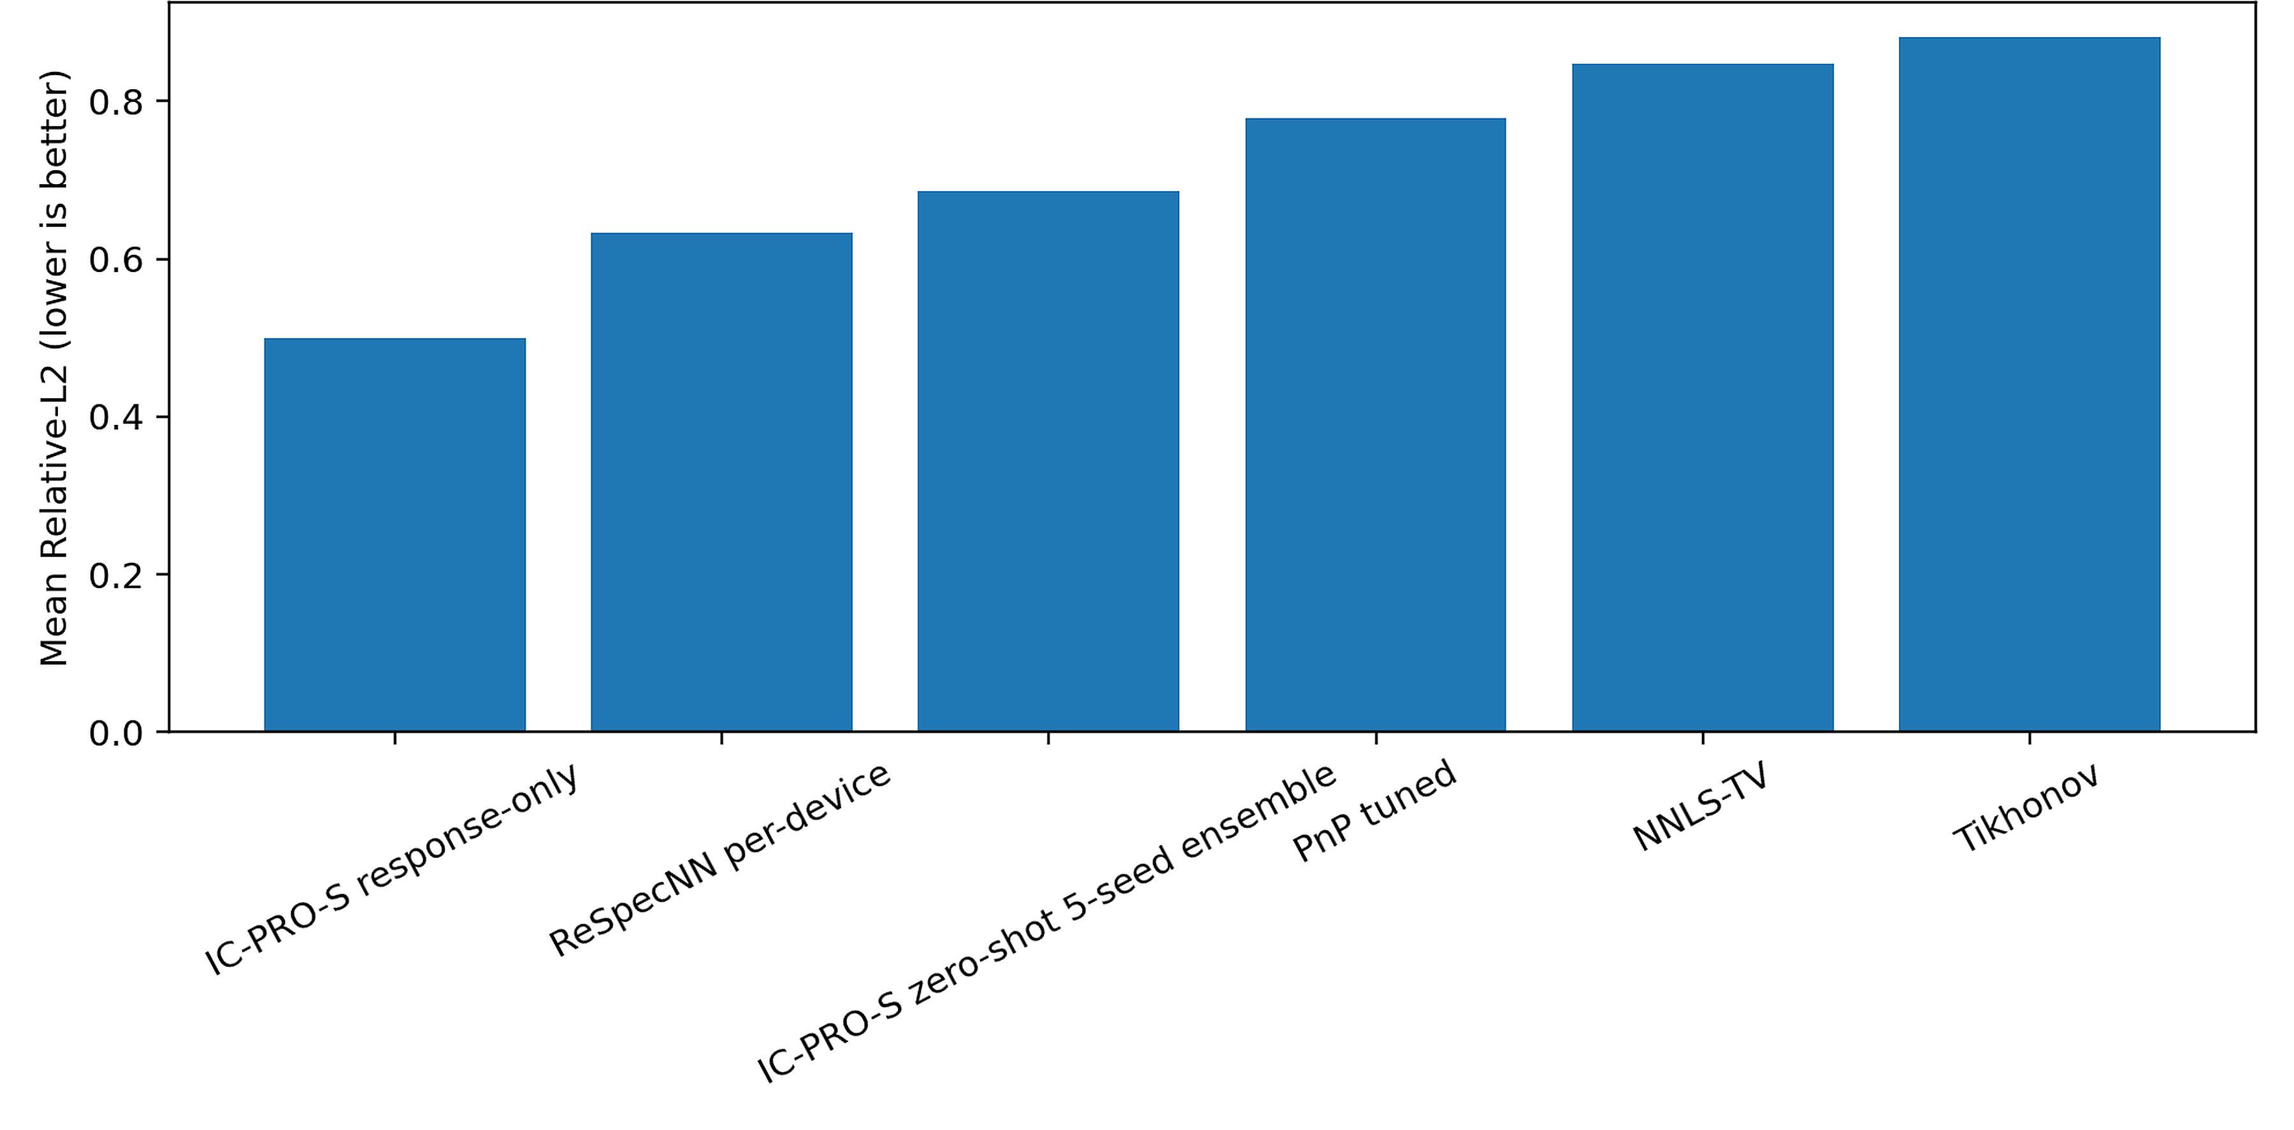
Fig. 13 Measured-operator transfer summary for M = 32 measured-response channels
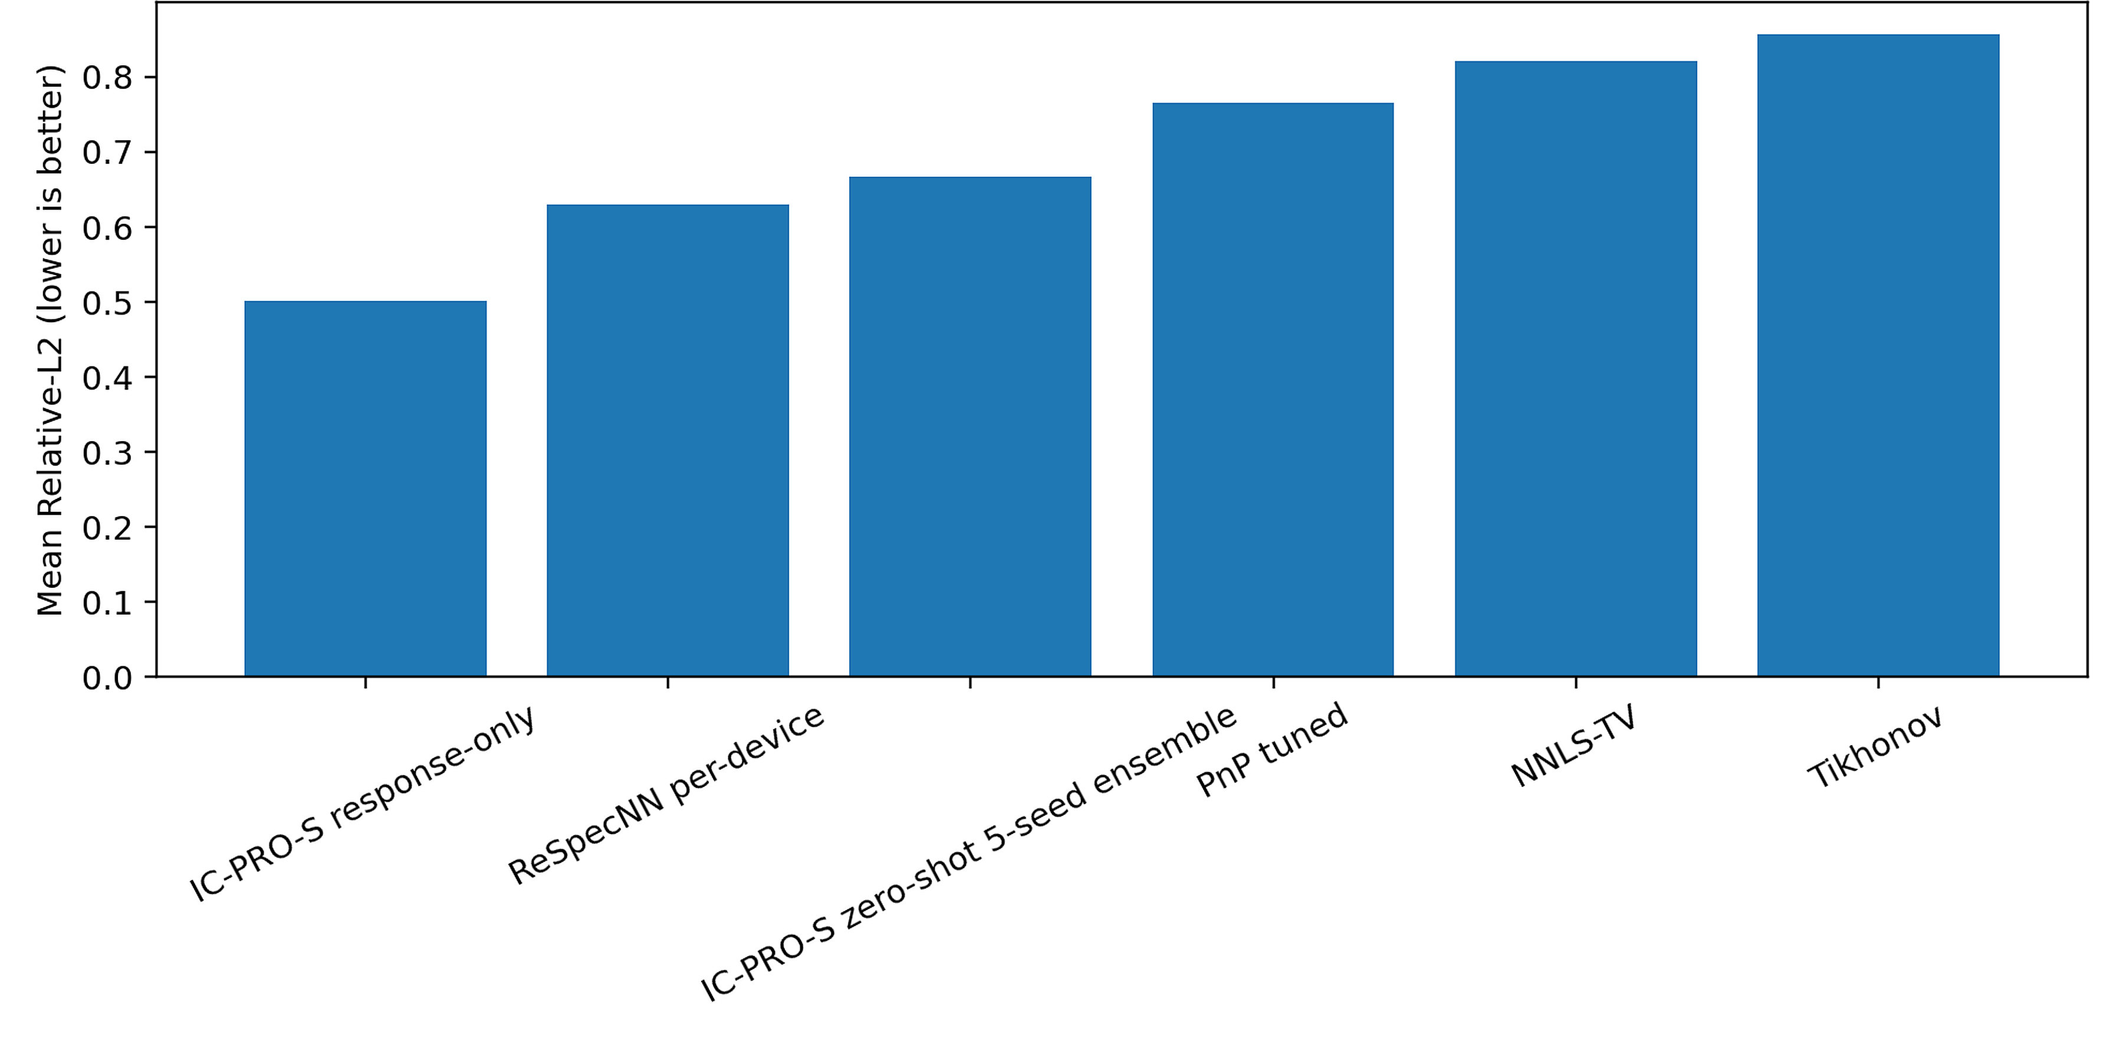
Fig. 14 Measured-operator transfer summary for M = 101 measured-response channels

6.13 Calibration robustness and operating range
Table 15 Five-seed pooled reconstruction error under calibration perturbation
ε requested | Learned η | Fixed η=0.5 | Full η=1 | Proposal only | Tikhonov
0.000 | 0.3888 | 0.3892 | 0.4577 | 0.4201 | 0.4876
0.010 | 0.3902 | 0.3904 | 0.4608 | 0.4208 | 0.4875
0.025 | 0.3942 | 0.3940 | 0.4713 | 0.4216 | 0.4880
0.050 | 0.4092 | 0.4070 | 0.5038 | 0.4234 | 0.4913
0.100 | 0.4527 | 0.4463 | 0.5875 | 0.4328 | 0.4924
0.200 | 0.5355 | 0.5175 | 0.6995 | 0.4633 | 0.5161
Learned and fixed-soft proximal corrections had similar pooled error at ε=0 (0.3888 and 0.3892) and ε=0.05 (0.4092 and 0.4070). At ε=0.10, proposal-only (0.4328) was better than learned η (0.4527), and at ε=0.20 the learned η pathway (0.5355) was worse than proposal-only (0.4633) and Tikhonov (0.5161). Thus learned relaxation is not uniformly superior; ε is a norm-controlled synthetic perturbation, not a directly calibrated physical tolerance.
The sweep supplies an empirical operating-range analysis for a particular smooth positive row-normalized perturbation process. Its ε levels should not be equated to an instrument manufacturer's calibration specification without independent calibration data; detector gain drift, wavelength-axis misalignment, signed response and other physical deviations remain outside this perturbation model.
In a post-hoc analysis of the 23,040 archived learned-η case-level rows (six synthetic operators, five checkpoints and six perturbation levels; 3,840 rows per level), mean η increased from 0.5275 at ε=0 to 0.5824 at ε=0.20. In 97.3% of the 3,840 matched sample–operator–checkpoint comparisons, η increased between these endpoints. The mean within-operator-and-seed Spearman correlation between η and Relative-L2 was 0.801 at ε=0 and 0.580 at ε=0.20; this association may reflect spectral difficulty and is not an uncertainty calibration result. Mean Relative-L2 was lower for fixed η=0.5 than for learned η at ε=0.05, 0.10 and 0.20 by 0.0022, 0.0065 and 0.0180, respectively. These observations do not support interpreting learned η as a uniformly beneficial or monotonically calibration-attenuating reliability coefficient. The checkpoint comparison remains exploratory and is not a new independently trained ablation.
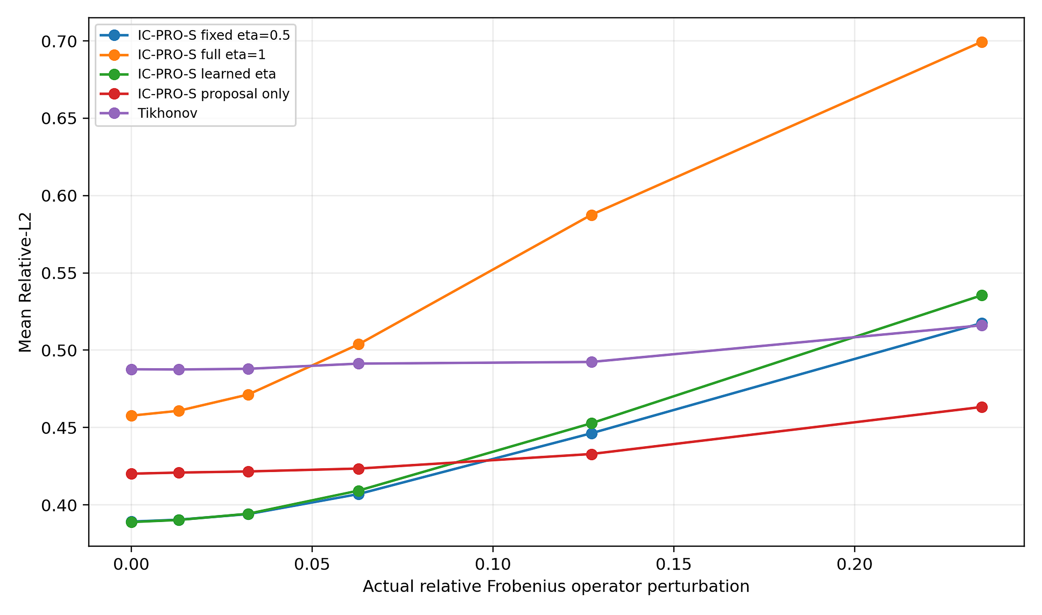
Fig. 15 Relative-L2 versus norm-controlled calibration perturbation
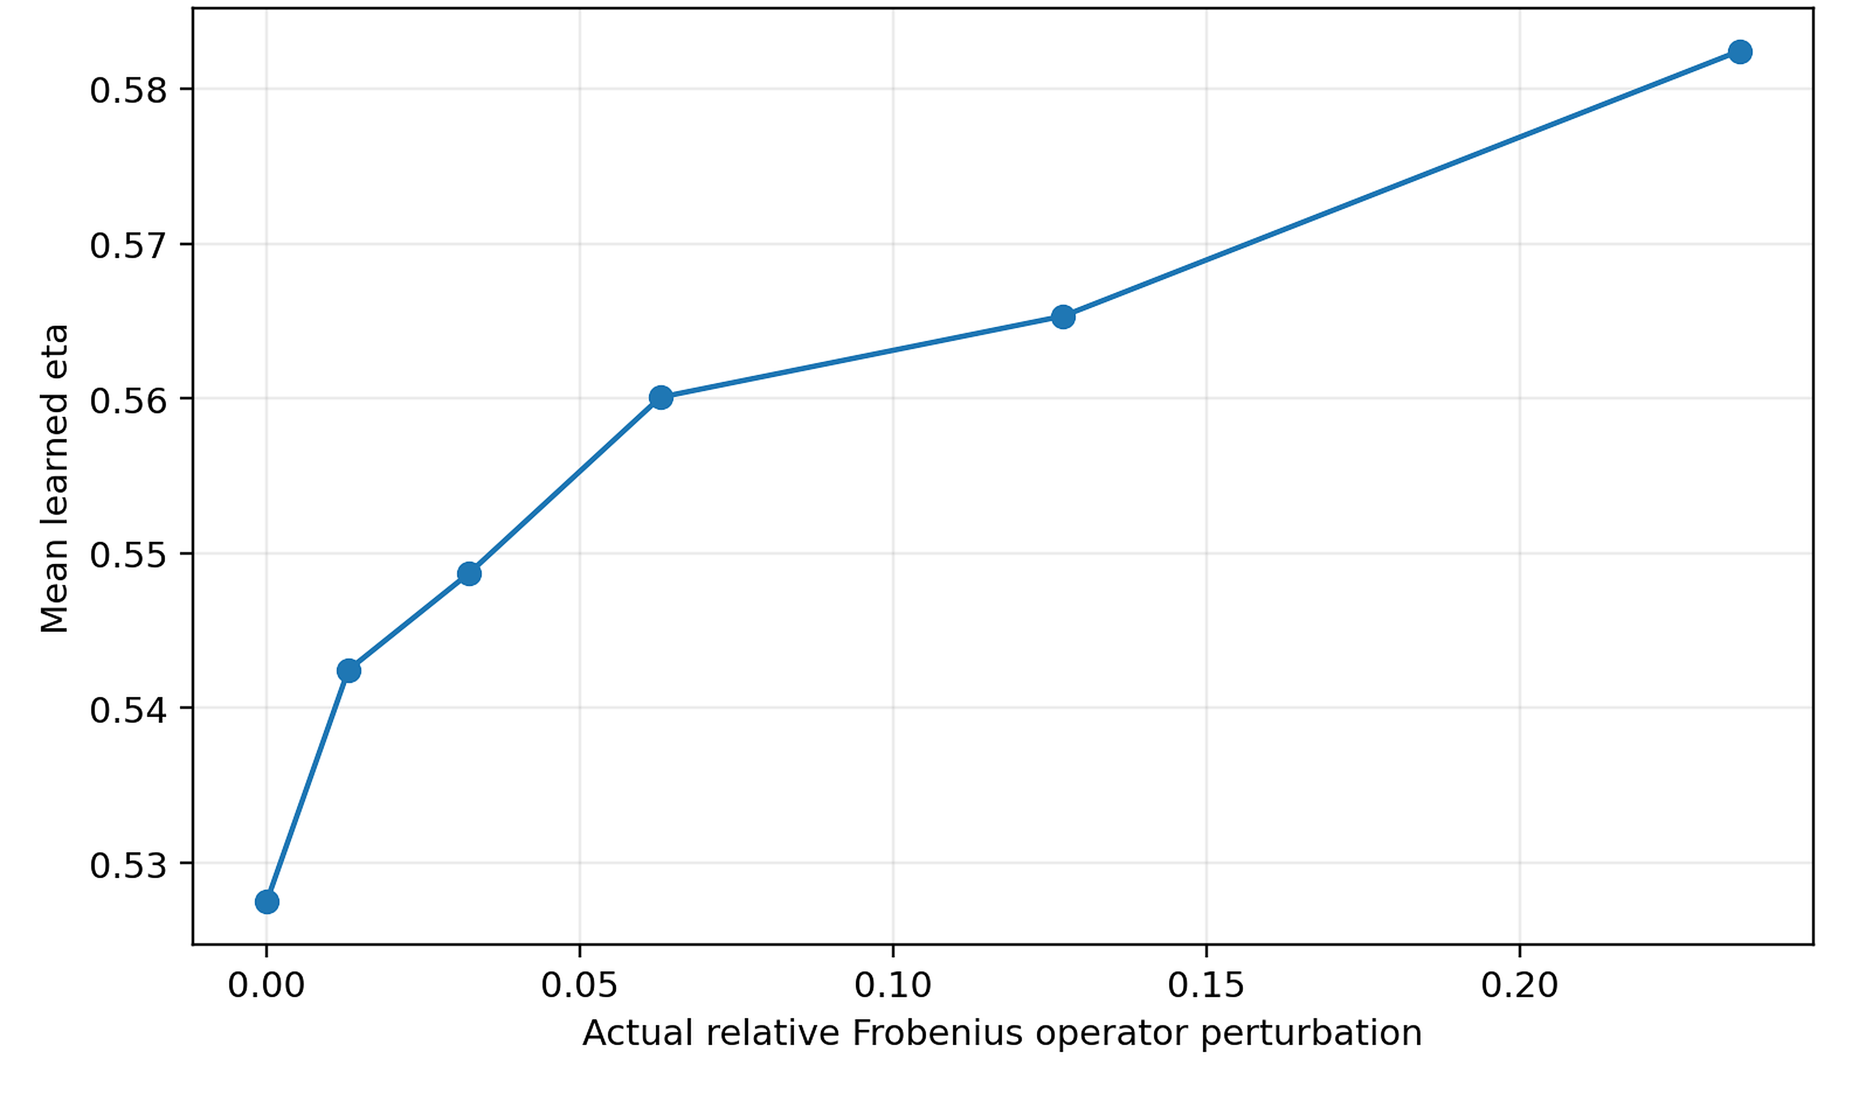
Fig. 16 Learned relaxation coefficient across calibration perturbation levels

6.14 Independent study of the transfer of BP/MoS2 hardware
Table 16 Independent BP/MoS2 tunnel-diode hardware transfer peak errors
Band | Zero-shot MAE nm | Response-only adapted MAE nm | Tikhonov MAE nm | Direct NNLS MAE nm
Visible | 105.72 | 41.29 | 73.30 | 3.43
NIR high-res | 5.00 | 2.90 | 1.25 | 0.25
The independent BP/MoS2 signed-current study is a limitation for generalized learned reconstruction: direct NNLS had much smaller peak localization error than either the zero-shot or response-adapted learned pathway in both reported bands. This illustrates that the physics and response sign structure of certain instruments can favor direct model-based estimation. No universal cross-hardware dominance is claimed.

7. Reproducibility and Validation Details

7.1 Frozen architecture, splits, and training configuration
Table 17 IC-PRO-S frozen architecture and training configuration
Item | Frozen value
Spectral bins | 256 primary; transfer N=192/301/384
Width | 64
Residual blocks | 7 dilated blocks
Active parameters | 291,499
Main seeds | 3, 7, 11, 19, 23
Physics anchor | Tikhonov, λ=10⁻³
Proximal ridge | noise-dependent, ≥10⁻⁶
Instrument bank | 12 train / 3 validation / 4 Test / 4 OOD; M∈{12,16,24,32}
Optimizer | AdamW; learning rate 7e-4; weight decay 1e-5
Batch / gradient clip | 32 / 1.0
Training objective | Rel-L2 + 0.015 SAM + 0.001 residual-energy penalty
Checkpoint protocol | validation every 100 steps; max 1050; early stopping after ≥650 and 3 non-improvements
Primary evaluation | 192 spectra per Test/OOD operator
Table 17 records the frozen architecture and training configuration used by the primary model family, including spectral bins, width, residual-block layout, optimizer schedule, seed set, and proximal parameters. The archived five-seed checkpoints and fixed data-generation rules provide a direct bridge from the manuscript to the reproducibility package.

7.2 Validation-based baseline selection
Baseline selection and hyperparameter tuning are performed on validation data under frozen protocols. Per-device ReSpecNN uses synthetic target-response retraining; PnP uses its frozen validation grid with 12 selected reconstruction steps; NNLS-TV in the seven-method cross-instrument benchmark uses λ=3×10⁻⁴ selected on its validation bank; PiGDM uses a sensor-independent synthetic spectral prior with validation-selected guidance; and the MGDUN-inspired control uses shared-family training. This common validation discipline keeps the benchmark comparable across classical, learned, iterative, diffusion, and unfolding methods.

7.3 Paired statistical evaluation
Table 18 Paired Test-set statistics on the fixed representative subset
Method | Mean | Bootstrap 95% CI | Comparator - IC-PRO-S | Paired 95% CI | One-sided p
IC-PRO-S seed7 | 0.3687 | [0.3085,0.4324] | — | — | —
Tikhonov | 0.5270 | [0.4582,0.6009] | 0.1583 | [0.1252,0.1936] | 1.85e-10
NNLS-TV | 0.4546 | [0.3826,0.5258] | 0.0858 | [0.0563,0.1160] | 6.5e-06
ReSpecNN per-device | 0.4074 | [0.3364,0.4828] | 0.0386 | [0.0106,0.0696] | 0.0345
ReSpecNN shared-by-M | 0.5776 | [0.4881,0.6669] | 0.2088 | [0.1512,0.2631] | 1.01e-08
Physics-anchor CNN | 0.4301 | [0.3655,0.4942] | 0.0613 | [0.0403,0.0830] | 5.08e-07
PnP tuned proxy | 0.3740 | [0.3095,0.4425] | 0.0053 | [-0.0093,0.0202] | 0.434
Table 19 Paired OOD statistics on the fixed representative subset
Method | Mean | Bootstrap 95% CI | Comparator - IC-PRO-S | Paired 95% CI | One-sided p
IC-PRO-S seed7 | 0.4002 | [0.3407,0.4672] | — | — | —
Tikhonov | 0.5400 | [0.4800,0.6010] | 0.1397 | [0.1154,0.1640] | 1.43e-11
NNLS-TV | 0.4136 | [0.3457,0.4858] | 0.0134 | [-0.0046,0.0329] | 0.508
ReSpecNN per-device | 0.3675 | [0.2992,0.4408] | -0.0327 | [-0.0573,-0.0062] | 0.998
ReSpecNN shared-by-M | 0.6147 | [0.5460,0.6824] | 0.2145 | [0.1757,0.2548] | 7.86e-12
Physics-anchor CNN | 0.4626 | [0.4025,0.5233] | 0.0623 | [0.0445,0.0796] | 1.48e-08
PnP tuned proxy | 0.3418 | [0.2760,0.4117] | -0.0584 | [-0.0740,-0.0426] | 1
Table 18 and Table 19 provide paired spectrum-level statistics on the representative Test and OOD subsets. On Test, IC-PRO-S is lower-error than Tikhonov, NNLS-TV, per-device and shared-by-M ReSpecNN, and the physics-anchor CNN, while the comparison with tuned PnP is close. On the representative OOD subset, PnP and per-device ReSpecNN have lower means, whereas IC-PRO-S remains lower than Tikhonov, shared-by-M ReSpecNN, and the physics-anchor CNN. These paired analyses complement the five-seed aggregate results with spectrum-level comparisons.

7.4 Contemporary diffusion and deep-unfolding controls
The controlled PiGDM adaptation uses a four-level U-Net prior with channel multipliers 1,2,4,8, two residual blocks per level, two bottleneck blocks, 3×1 convolutions, GroupNorm, SiLU, dropout 0.05, and base width 44 (approximately 5.33M parameters). The MGDUN-inspired control uses six stages and the same frozen sensing family. These implementations provide contemporary diffusion and deep-unfolding reference points under the common benchmark used in this paper.

7.5 Archival freeze and executable provenance
Preserved records support replay of the A12 synthetic case-level means, paired comparisons and source-defined V7 evaluation, but these scopes must be distinguished. A12 historical inputs are present with a recorded hash match; historical V7 input tensors were not serialized, and subsequent source-defined V7 tensors are regenerated rather than identical historical originals. Full training reproducibility and the final DOI-deposited package still require integrity and one-command execution verification.

7.6 External data provenance
The external evidence is anchored to three cited public sources: the Sim2Real real-device repository [10], the BP/MoS2 tunnel-diode source data [32], and the p-graded-n junction responsivity / experimental target data used in the measured-operator transfer benchmark [34]. All external datasets are referenced to their original publications and source records; synthetic spectra and sensing operators are generated procedurally from fixed seeds.

8. Discussion

8.1 Integrated family-level reconstruction
The main evidence is an implementation-specific trade-off: within the tested synthetic operator family, a shared response-conditioned inverse with one analytic reconciliation step has low mean error in interpolation and severe structural shift, while the no-target-retraining constraint matters operationally. The mean advantage is not universal and, in severe shift, is not significant over several strong comparators under the archived Wilcoxon tests. Detector-count extrapolation and OOD results identify regimes where classical or iterative approaches can outperform the shared model.

8.2 Measured-operator and real-device evidence
The physical evidence remains limited. The public Sim2Real analysis involves 15 real paired measurements, while the separate measured-responsivity experiment evaluates 25 reference spectra through a controlled numerical forward surrogate after response-only adaptation. Both provide useful external checks but do not constitute validation across many independent prospectively measured spectrometers.

8.3 Calibration robustness and interpretable physics reconciliation
The exact quadratic proximal displacement has an analytic nonexpansiveness result under fixed A, y and constant η, not for the full learned gate. Empirically, soft reconciliation can reduce error under moderate smooth synthetic perturbations but deteriorates at larger mismatch; fixed relaxation can be as effective as or better than learned relaxation. This limits conclusions about automatic trust calibration by η.
Post-hoc case-matched A14 results show that the learned relaxation factor tends to increase—not decrease—as the synthetic operator perturbation grows, so η is a state-dependent update weight, not a calibrated measure of operator trust. The separate A12 exploratory nearest-manifold PROXY analysis found no positive support-score/reconstruction-error association; its small computed routing benefit was not distinguishable from zero under spectrum-clustered bootstrap resampling. Because this proxy is not the published guard and the synthetic evaluation includes only six fixed response operators, these results identify an unverified reliability component rather than establish the behavior of the original deployment mechanism.

8.4 Future extensions
Future work should evaluate the method on prospectively acquired measurements from multiple independent calibrated instruments, audit spectral peak-width and weak-feature behavior, model gain drift and wavelength-axis offsets, and quantify reconstruction risk against the nearest-manifold support score. More complete operator-independent capacity controls, and verified end-to-end routing outcomes, remain needed to isolate all mechanism contributions and establish deployment reliability. Future reliability work requires matched evaluation of the original guard on independent OOD and physical measurements.

9. Conclusion
IC-PRO-S integrates a shared response-conditioned spectral proposal with a displacement computed by an exact quadratic proximal map, followed by learned under-relaxation and nonnegativity projection. In controlled synthetic comparisons, it achieved the lowest mean error for interpolation and severe structural shift, but not detector-count extrapolation, and its severe-shift advantage was not statistically supported over several strong alternatives in the reported directional tests. Small public real-device samples and a separate measured-responsivity surrogate provide preliminary physical relevance, not comprehensive independent instrument validation. The approach is therefore a reproducible design candidate for calibration-aware cross-instrument reconstruction, with its reliability and deployment boundaries requiring further evaluation. A separate three-seed capacity-matched replay experiment found a modest, consistent test-error benefit from retaining auxiliary operator-derived CNN channels over fixed-coordinate controls; this does not establish a novel operator-conditioning principle.

Declarations
Author contributions
A.S.T. conducted the study and approved the final manuscript.
Funding
Not applicable.
Availability of data and materials
The external experimental datasets analyzed in this study are publicly available from the original repositories and sources cited in the manuscript.
Ethics approval and consent to participate
Not applicable.
Informed consent
Not applicable.
Consent for publication
Not applicable.
Competing interests
The author declares that she has no competing interests.

References
[1] Z. Yang, T. Albrow-Owen, W. Cai, and T. Hasan, “Miniaturization of optical spectrometers,” Science 371, eabe0722 (2021). https://doi.org/10.1126/science.abe0722
[2] Q. Guan, Z. H. Lim, H. Sun, J. X. Y. Chew, and G. Zhou, “Review of Miniaturized Computational Spectrometers,” Sensors 23, 8768 (2023). https://doi.org/10.3390/s23218768
[3] Q. Xue et al., “Advances in Miniaturized Computational Spectrometers,” Advanced Science 11, 2404448 (2024). https://doi.org/10.1002/advs.202404448
[4] B. Redding, S. F. Liew, R. Sarma, and H. Cao, “Compact spectrometer based on a disordered photonic chip,” Nature Photonics 7, 746–751 (2013). https://doi.org/10.1038/nphoton.2013.190
[5] B. Redding, S. M. Popoff, and H. Cao, “All-fiber spectrometer based on speckle pattern reconstruction,” Optics Express 21, 6584–6600 (2013). https://doi.org/10.1364/OE.21.006584
[6] P. Wang and R. Menon, “Computational spectrometer based on a broadband diffractive optic,” Optics Express 22, 14575–14587 (2014). https://doi.org/10.1364/OE.22.014575
[7] J. Oliver, W. B. Lee, S. Park, and H.-N. Lee, “Improving resolution of miniature spectrometers by exploiting sparse nature of signals,” Optics Express 20, 2613–2625 (2012). https://doi.org/10.1364/OE.20.002613
[8] Y. August and A. Stern, “Compressive sensing spectrometry based on liquid crystal devices,” Optics Letters 38, 4996–4999 (2013). https://doi.org/10.1364/OL.38.004996
[9] C.-C. Chang and H.-N. Lee, “On the estimation of target spectrum for filter-array based spectrometers,” Optics Express 16, 1056–1061 (2008). https://doi.org/10.1364/OE.16.001056
[10] J. Chen, P. Li, Y. Wang, P.-C. Ku, and Q. Qu, “Sim2Real in reconstructive spectroscopy: Deep learning with augmented device-informed data simulation,” APL Machine Learning 2, 036106 (2024). https://doi.org/10.1063/5.0209339
[11] J. Liang et al., “Lensless speckle reconstructive spectrometer via physics-aware neural network,” arXiv:2412.18238 (2024). https://arxiv.org/abs/2412.18238
[12] J. Liang et al., “Physics-embedded learning for interpretable, generalized, and rapid speckle reconstructive spectroscopy,” Advanced Photonics Nexus 5, 056016 (2026). https://doi.org/10.1117/1.APN.5.5.056016
[13] S. Shen, J. Tan, N. Wang, Y. Zhu, and J. Zhang, “Hybrid physics-neural network computational spectrometer based on a random diffractive structure,” Optics Letters 51, 4540–4543 (2026). https://doi.org/10.1364/OL.605193
[14] A. Siyavashi, J. Schlipf, S. Reiter, I. Fischer, C. Wenger, and C. Herglotz, “Sensor-Adaptive Infrared Spectral Reconstruction with Plug-and-Play Diffusion Priors,” arXiv:2607.05636 (2026). https://arxiv.org/abs/2607.05636
[15] C. Zhu, H. Lo, J. Yu, Q. Wang, and Y. D. Chong, “Resolution and Robustness Bounds for Reconstructive Spectrometers,” arXiv:2512.20415 (2025; revised 2026). https://arxiv.org/abs/2512.20415
[16] W. Ma, R. Pestourie, Z. Lin, and S. G. Johnson, “Inverse design for robust inference in integrated computational spectrometry,” arXiv:2506.02194 (2025). https://arxiv.org/abs/2506.02194
[17] J. Schwab, S. Antholzer, and M. Haltmeier, “Deep null space learning for inverse problems: convergence analysis and rates,” Inverse Problems 35, 025008 (2019). https://doi.org/10.1088/1361-6420/aaf14a
[18] S. V. Venkatakrishnan, C. A. Bouman, and B. Wohlberg, “Plug-and-Play priors for model based reconstruction,” Proc. IEEE GlobalSIP, 945–948 (2013). https://doi.org/10.1109/GlobalSIP.2013.6737048
[19] U. S. Kamilov, C. A. Bouman, G. T. Buzzard, and B. Wohlberg, “Plug-and-Play Methods for Integrating Physical and Learned Models in Computational Imaging,” IEEE Signal Processing Magazine 40, 85–97 (2023). https://doi.org/10.1109/MSP.2022.3199595
[20] S. Arridge, P. Maass, O. Öktem, and C.-B. Schönlieb, “Solving inverse problems using data-driven models,” Acta Numerica 28, 1–174 (2019). https://doi.org/10.1017/S0962492919000059
[21] J. Adler and O. Öktem, “Solving ill-posed inverse problems using iterative deep neural networks,” Inverse Problems 33, 124007 (2017). https://doi.org/10.1088/1361-6420/aa9581
[22] J. Zhang and B. Ghanem, “ISTA-Net: Interpretable optimization-inspired deep network for image compressive sensing,” Proc. CVPR, 1828–1837 (2018). https://doi.org/10.1109/CVPR.2018.00196
[23] D. Gilton, G. Ongie, and R. Willett, “Neumann networks for linear inverse problems in imaging,” IEEE Transactions on Computational Imaging 6, 328–343 (2020). https://doi.org/10.1109/TCI.2019.2948732
[24] K. Lee, K. Lee, H. Lee, and J. Shin, “A simple unified framework for detecting out-of-distribution samples and adversarial attacks,” NeurIPS 31 (2018). https://proceedings.neurips.cc/paper/2018/hash/abdeb6f575ac5c6676b747bca8d09cc2-Abstract.html
[25] N. Papernot and P. McDaniel, “Deep k-nearest neighbors: Towards confident, interpretable and robust deep learning,” arXiv:1803.04765 (2018). https://arxiv.org/abs/1803.04765
[26] Y. Geifman and R. El-Yaniv, “Selective Classification for Deep Neural Networks,” NeurIPS 30 (2017). https://proceedings.neurips.cc/paper/2017/hash/4a8423d5e91fda00bb7e46540e2b0cf1-Abstract.html
[27] D. Hendrycks and K. Gimpel, “A Baseline for Detecting Misclassified and Out-of-Distribution Examples in Neural Networks,” ICLR (2017). https://arxiv.org/abs/1610.02136
[28] W. Liu, X. Wang, J. Owens, and Y. Li, “Energy-based out-of-distribution detection,” NeurIPS 33 (2020). https://proceedings.neurips.cc/paper/2020/hash/f5496252609c43eb8a3d147ab9b9c006-Abstract.html
[29] G. Barbastathis, A. Ozcan, and G. Situ, “On the use of deep learning for computational imaging,” Optica 6, 921–943 (2019). https://doi.org/10.1364/OPTICA.6.000921
[30] G. Wu, M. Abid, M. Zerara, C. Ó Coileáin, C.-R. Chang, and H.-C. Wu, “Miniaturized Computational Spectrometer,” IEEE Nanotechnology Magazine 17, 36–42 (2023). https://doi.org/10.1109/MNANO.2023.3316870
[31] M. R. A. Peters, D. Mojahed, W. Ma, R. Pestourie, T. Gu, S. G. Johnson, and J. Hu, “Integrated photonic spectrometers: a critical review,” Photonics Insights 4, R10 (2025). https://doi.org/10.3788/PI.2025.R10
[32] M. G. Uddin et al., “Broadband miniaturized spectrometers with a van der Waals tunnel diode,” Nature Communications 15, 571 (2024). https://doi.org/10.1038/s41467-024-44702-8
[33] R. Yang et al., “Model-guided deep unfolding network for broadband reconstructive spectrometers with non-orthogonal aliasing,” Optics Express 34, 27392–27411 (2026). https://doi.org/10.1364/OE.604142
[34] J. Wang et al., “Single-pixel p-graded-n junction spectrometers,” Nature Communications 15, 1773 (2024). https://doi.org/10.1038/s41467-024-46066-5
[35] A. Gossard and P. Weiss, “Training Adaptive Reconstruction Networks for Blind Inverse Problems,” SIAM Journal on Imaging Sciences 17, 1314–1346 (2024). https://doi.org/10.1137/23M1545628

