Welcome to Forza Selector for Horizon 5

# What is Forza Selector?

Forza Selector is a tool to manage your car collection. It doesn’t hook to file games in any way, it’s all manual entry.

The main feature of Forza Selector is that you can select a random vehicle from your collection, based on a set of filters.

# Cars and Models

The prime thing to understand is the concept of Cars and Models. Simply put, the Model is the data sheet for the stock vehicle, the Car is your own exemplar of a Model.

Models represent stock vehicles that you can purchase or unlock. Each model has a manufacturer, name, year of make, base stats, and a few other information. The collection of Models is called the Stock.

Cars are a specific instance of a Model. A Car is of a certain Model, and inherits the data from its Model, however it can then be modified independently of its Model, and independently of other Cars of the same Model, or of any other Model. The collection of Cars is called the Garage.

The Stock should be common to all players, since all models should be identical from game to game.

The Garage should be unique to each player, since all players may have a different set of cars.

# First startup

At first, your garage is empty, and so there are no cars selected. The first thing to do then is to add your first car by clicking the “Edit Car / Garage Data” button or pressing F1.

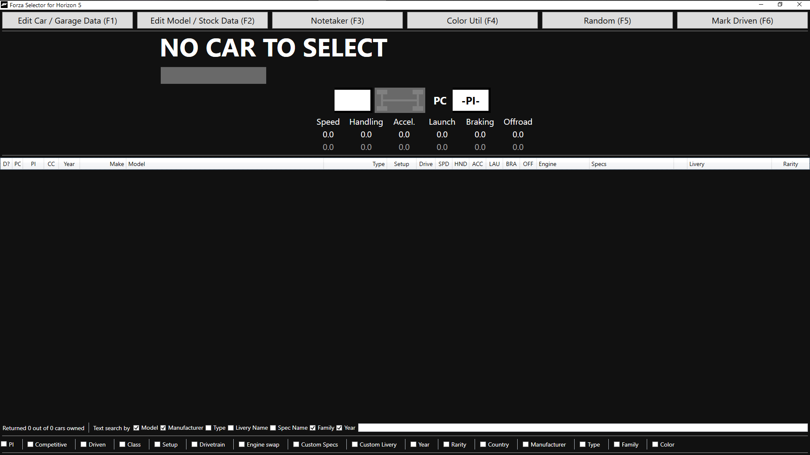

The Car Edition window then appears. Click on the “New” button to switch to creation mode.

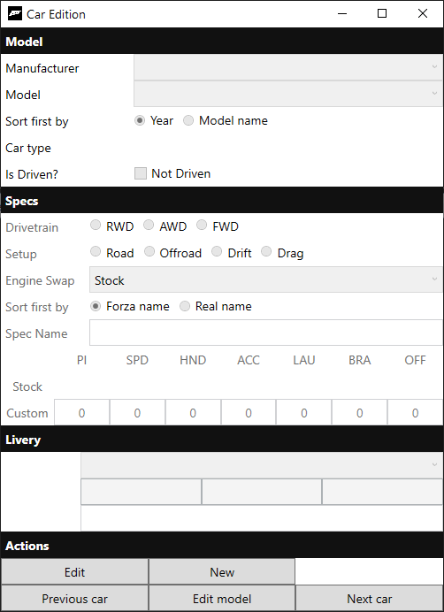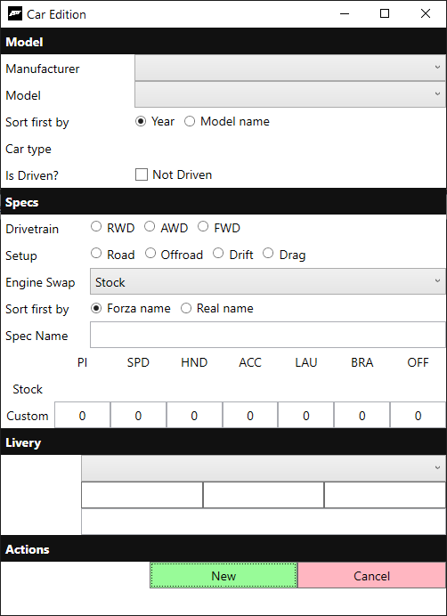

Select a manufacturer and a model (or a model directly), for instance the 2020 Chevrolet Corvette Stingray Coupé. By default, models are sorted by year, but they can be sorted by model name instead.

When you select a model, some information is filled up. Note: Drivetrain and Setup always default to RWD and Road, Livery defaults to empty.

Enter all the information you wish to enter about your car, custom specs, livery, engine swap, drivetrain, setup, etc. Then, click on “New” again. You may also cancel creation by clicking on “Cancel”.

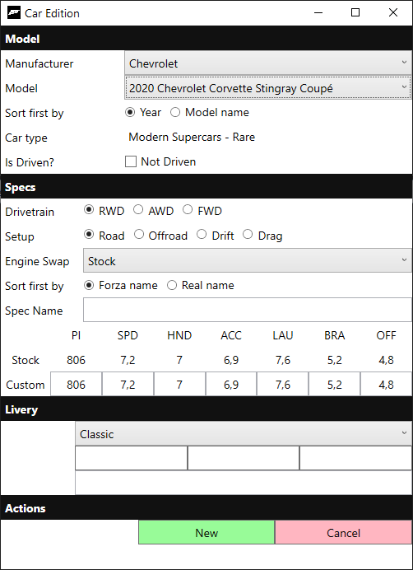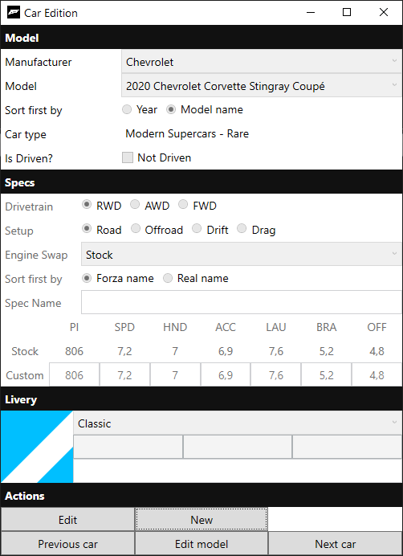

Your first car is ready. You can now edit it with the “Edit” button, or create a new car with the “New” button. Once you’re done adding cars, close the window.

The car now appears in the list, but isn’t selected. To select, double click on it in the list, or right-click and “Select”.

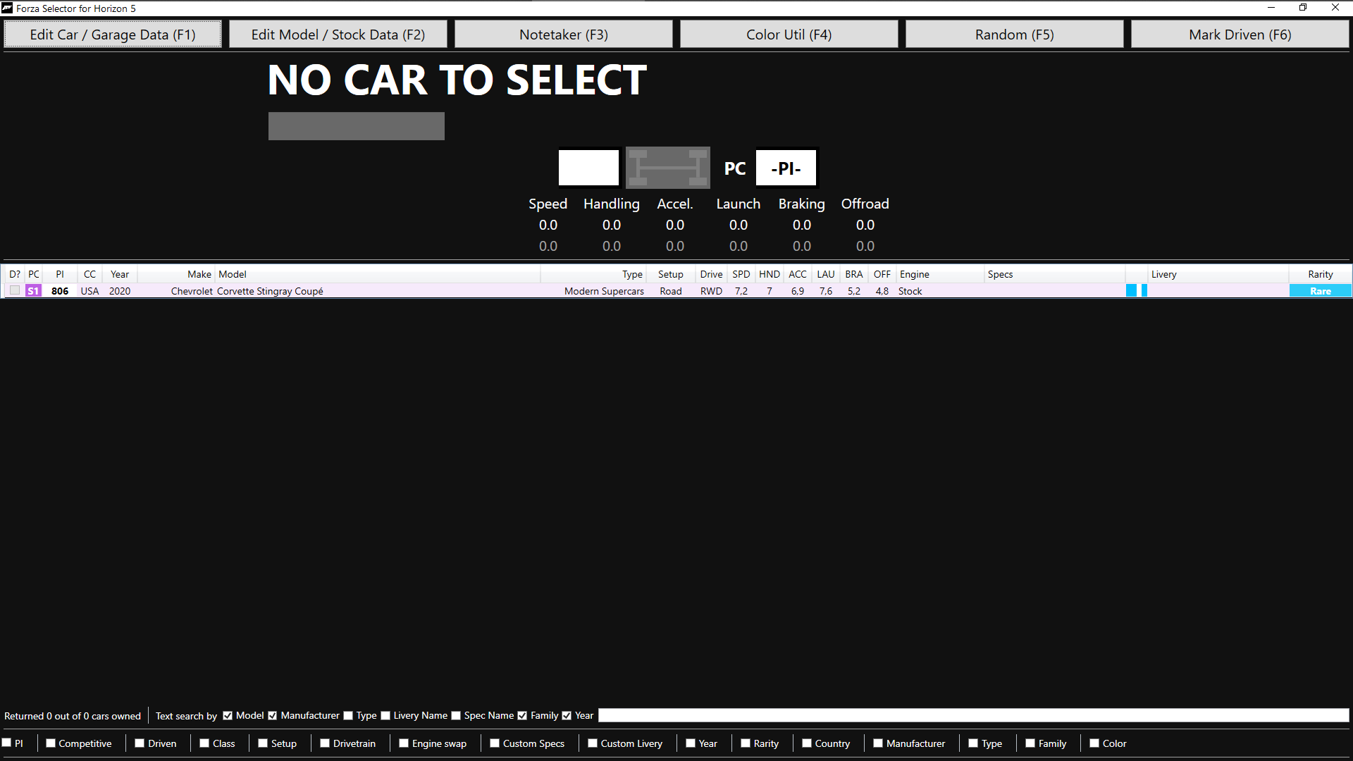

Once selected, information about the car will appear.

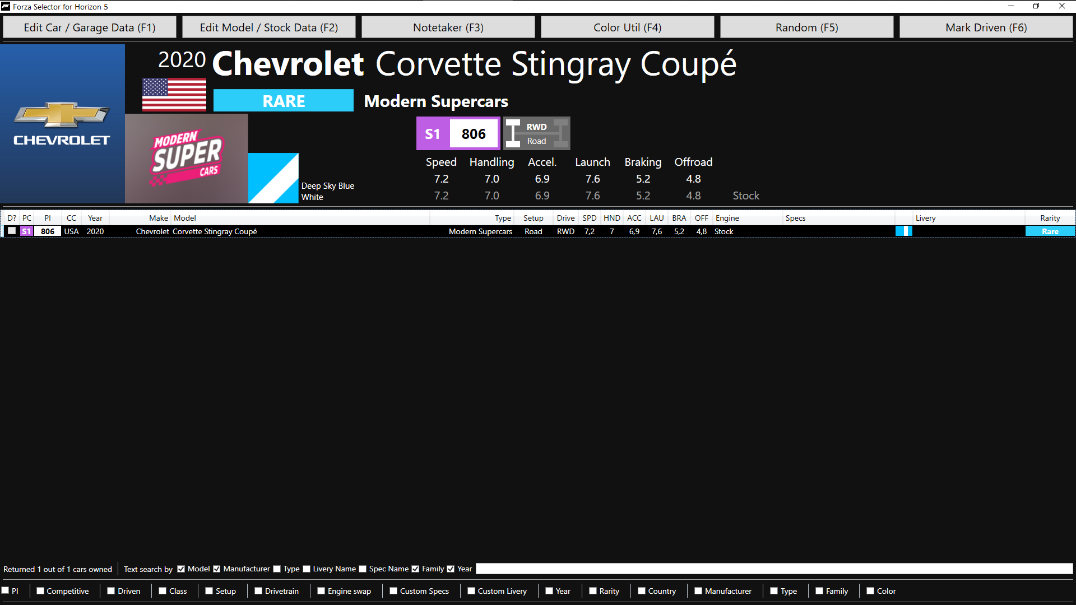

# The Showcase

The Showcase is the main window, and contains a bunch of information.

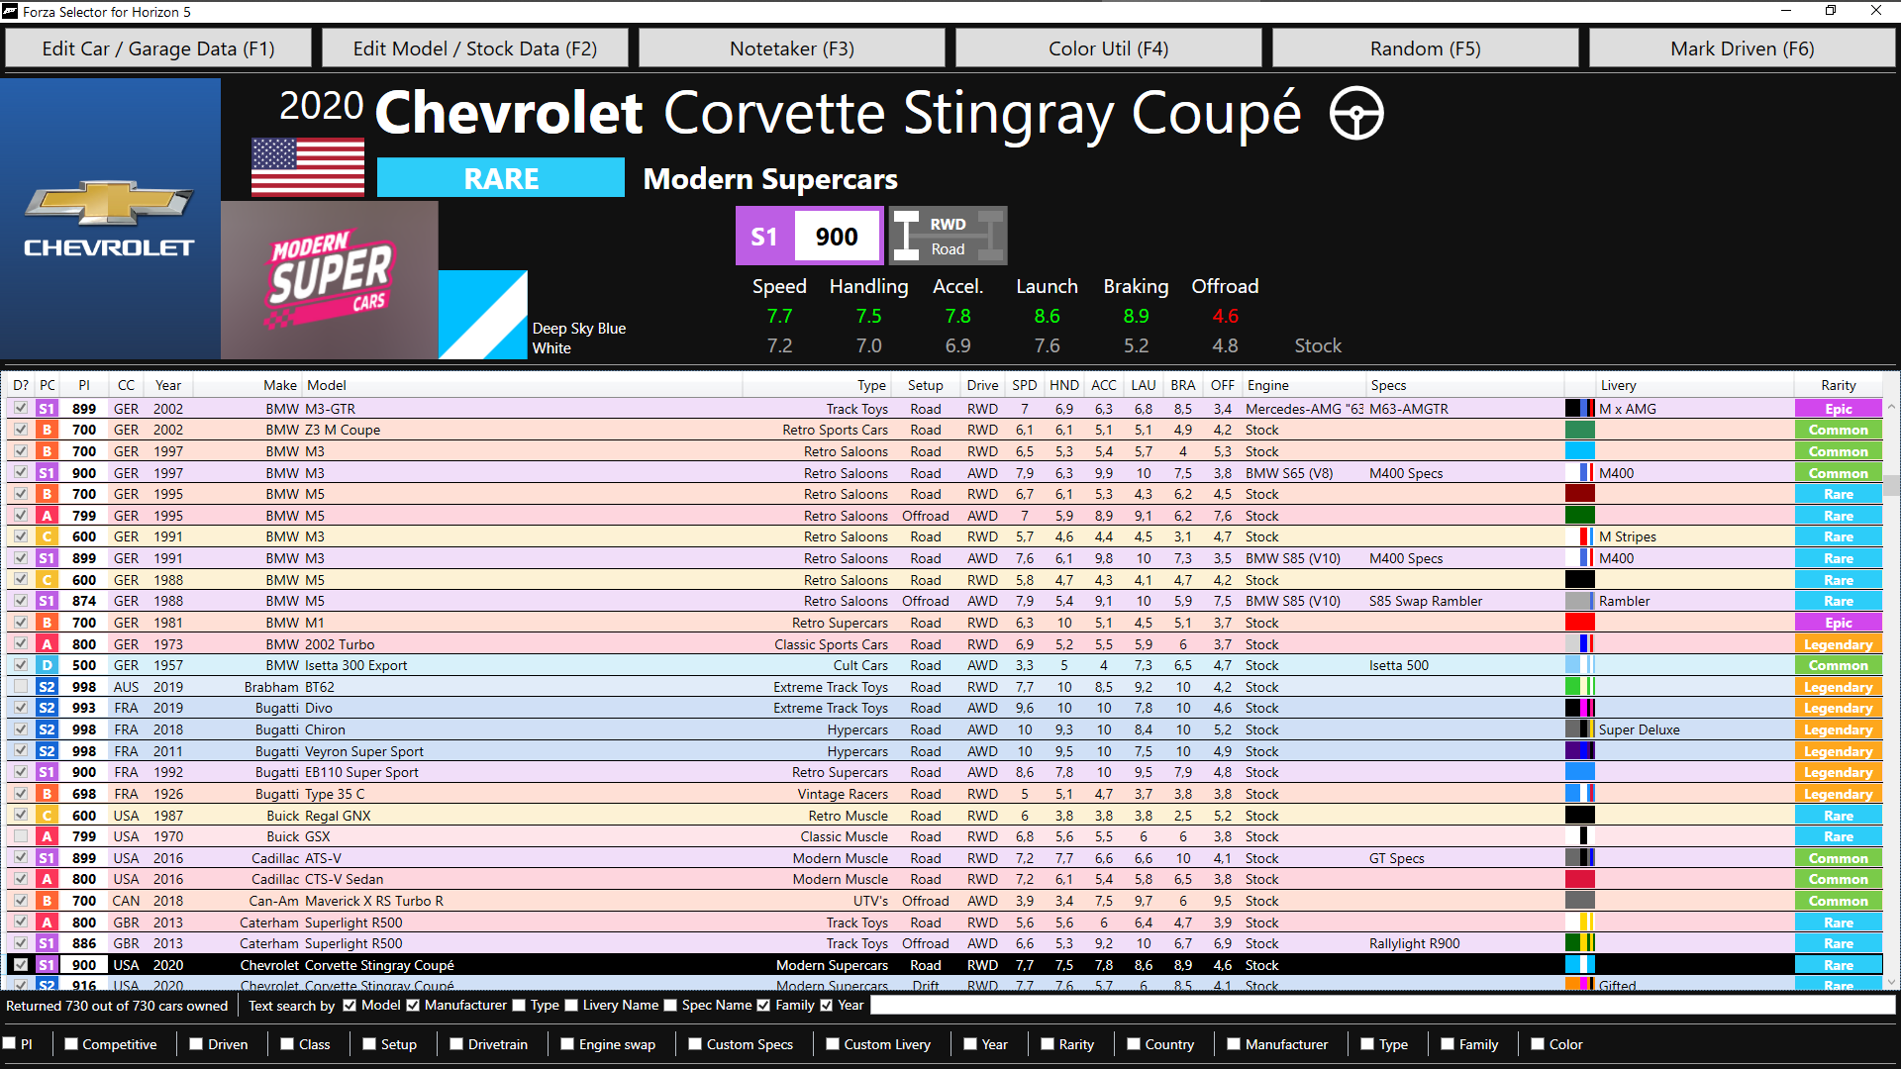

At the very top are the action buttons.

The “Random” action picks a car at random from the garage, based on active filters. The “Mark Driven” action marks the currently selected car as driven. Other actions are described in their own section.

Below, information about the currently selected car is displayed, including make, model, year, country, rarity, specs, or logos.

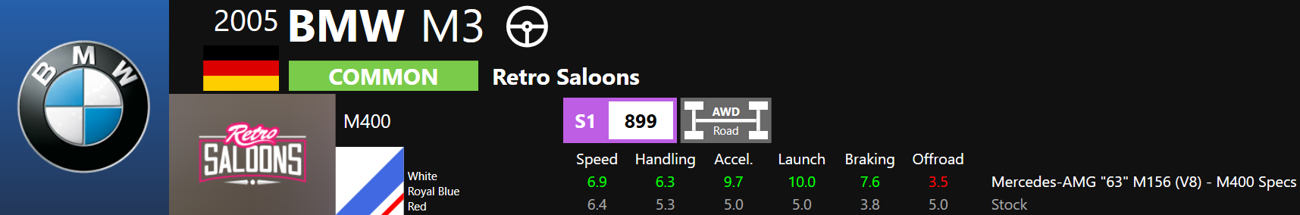

In the middle is your garage list. All the cars you own are there. You can double-click on a car to select it. You can start typing the name of a manufacturer to start jumping to it. Type “por” to load up the first Porsche for instance.



You can right-click on any car to bring up the contextual menu. You can select a car, compare it with the currently selected car, edit the car, edit the model of the car, undo the comparison, or delete the car. Deleting the car is permanent, there is no going back (but there is a confirmation pop-up).

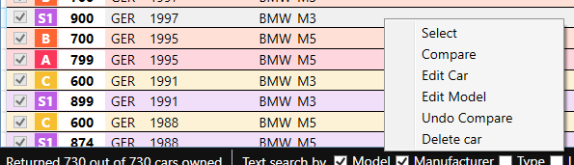

When you compare a car, its characteristics appear instead of those of the stock model of the selected car. When you ‘undo compare’, you return the display to its default state of showing stock model data.

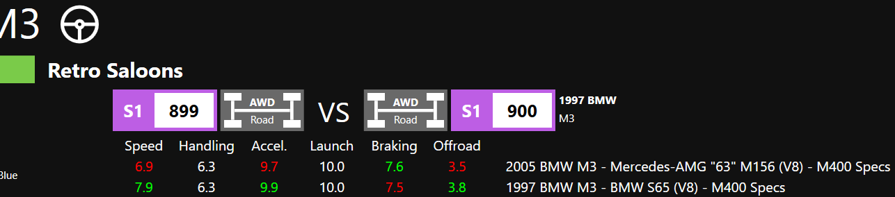

At the bottom of the window, there are filters. When filters are activated, they update the garage list.



A text search bar allows you to search for text on different parameters, that can be activated via the checkboxes. Enter text and press enter to filer. Enter no text and press enter to cancel that filter.



All other filters can be activated by clicking on their checkbox, and filter parameters will appear.







Number filters (PI and Year) are inclusive, meaning the min and max values are included in the filter.

Checked filters (Class, Setup, Drivetrain, Rarity) are OR filter, meaning for instance that checking the D, C, B, A class will filter in cars of either the D, C, B, or A class, and filter out any other. So will all options checked, there is effectively no filtering.

Exclusive filters (Competitive, Driven, Custom Specs, Engine Swap, Custom Livery) can only be set to one value, meaning for instance either you can filter cars that have an engine swap, or cars that don’t have an engine swap. To display both, you must deactivate the filter.



List filters (Country, Manufacturer, Type, Family) show a list of all their existing values. These are OR filters as well. You can click the “Check all” box to check or uncheck all items for the filter (e.g. all the countries). The respective lists will appear underneath, and you can manually select or unselect any and all items you want.



The color filter is a special list filter that can be set to filter based on either primary color alone, or to filter based on any color.

# Edit Car / Garage Data

When you have a vehicle selected and open the Car Edition window, the car is automatically selected and loaded.

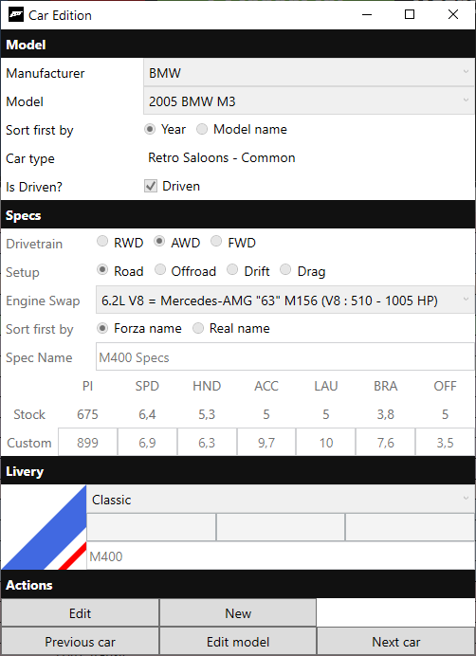

In the Model section, you’ll find the make and model of the car, its type and rarity, and you can specify whether you’ve driven this car. You will need to select a model when creating a car, but it’s also possible to change the model for an existing car, and the car will be updated to the new model. Information related to the stock model should update immediately.

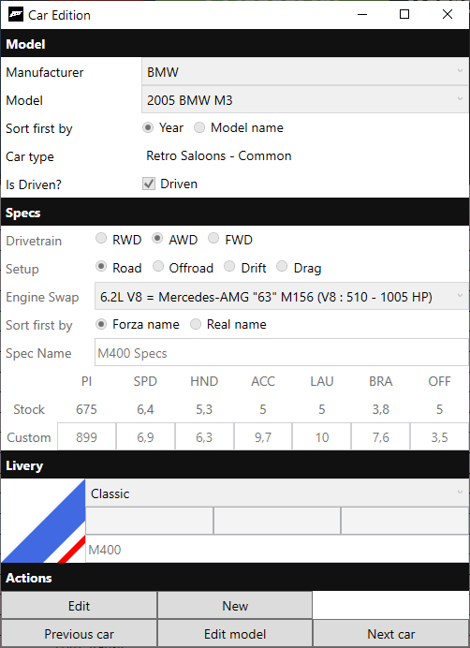

In the Specs section, you’ll find the drivetrain, setup, engine swap, spec name, stock model specs and custom car specs. Since drivetrain and setup are not automatically updated with the model, it’s up to you to keep it up to date. The engine swap list includes all the engine swap options in the game, with their in-game names and their real name. ‘Spec Name’ is simply a name you wish to give to this setup, if any. Custom specs (PI, speed, handling and other stats) car be entered and compared with the base model.



In the Livery section, you’ll find the colors and livery. Colors are only visible in Edit or New mode, but the preview of the livery is always visible. Three options for liveries are available: classic, racing, or gradient. You’re free to pick the option was speaks the most to your car.

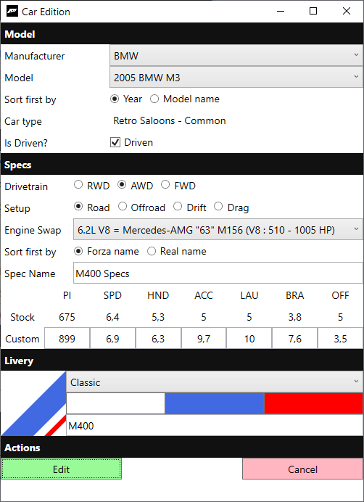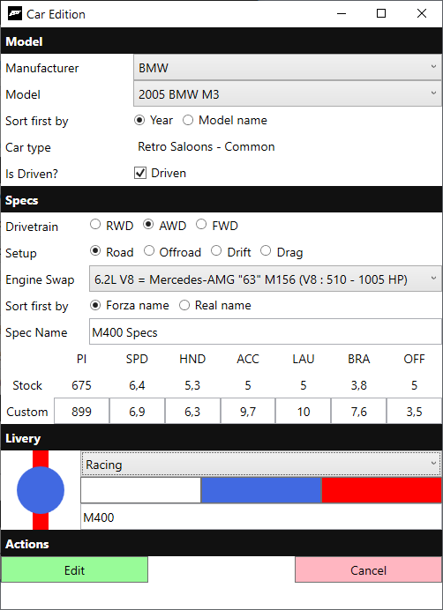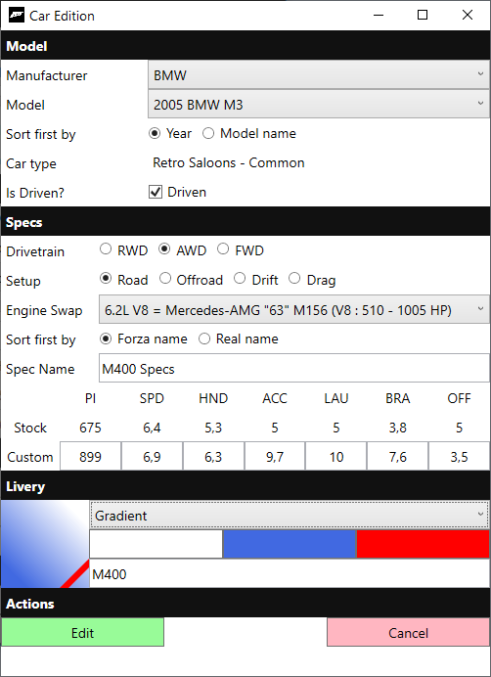

Each livery can support up to three colors, a primary, secondary and ternary. In the Edit or New mode, you can click the colors to pick a new color. Colors are limited to a set, aimed to cover most bases. If your favorite color isn’t in there, you can pick the closest one. Click on a color to select it, or close the window to unselect the current color.

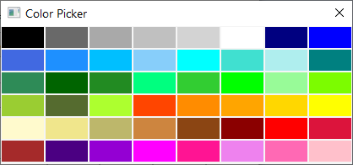



In the Actions section, you’ll find all the actions.

“Edit” switches to Edit mode and allows you to edit the current car. When in Edit mode, clicking on the “Edit” button again will save changes and overwrite the current car. Otherwise, you can click the “Cancel” button to revert any change.

“New” switches to the New mode and allows you to create a new car. Be careful that information of the currently selected car might remain until you pick a different model or change them yourself. When in New mode, clicking on the “New” button again will save changes and create a new car. Otherwise, you can click the “Cancel” button and no car is created.

The “Previous car” and “Next car” show the previous and next car in your garage, if any.

The “Edit model” button will open the model edit window for the model of the currently selected car.

# Edit Model / Stock Data

By default, you’ll land on the Models tab. Here you’ll find all information related to models.

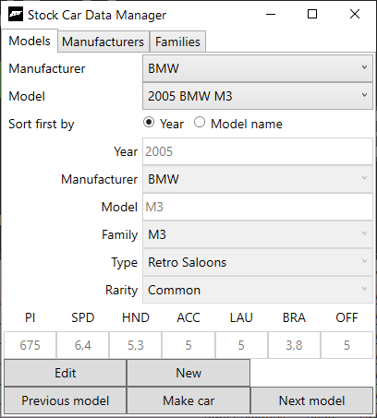

In New or Edit mode, you can modify all the data relating to the model, and these changes will be applied to all cars of this model. It’s important to note this only applies to model data, and not to custom car data. For instance, the stock PI of a car will be updated, but not its custom PI.

Do note that logos for types are found in the “data/fh5/types” folder, and new logos can be added. Images must be a png, and the name must match the type name.

On the bottom of the Models tabs, you will find much of the same actions as with the Car Edition window.

“Edit” switches to Edit mode and allows you to edit the current model. When in Edit mode, clicking on the “Edit” button again will save changes and overwrite the current model. Otherwise, you can click the “Cancel” button to revert any change.

“New” switches to the New mode and allows you to create a new model. Be careful that information of the currently selected model might remain until you pick a different model or change them yourself. When in New mode, clicking on the “New” button again will save changes and create a new model. Otherwise, you can click the “Cancel” button and no model is created.

The “Previous model” and “Next model” show the previous and next model available.

The “Make car” button will open the car edit window in creation mode with the currently selected model.

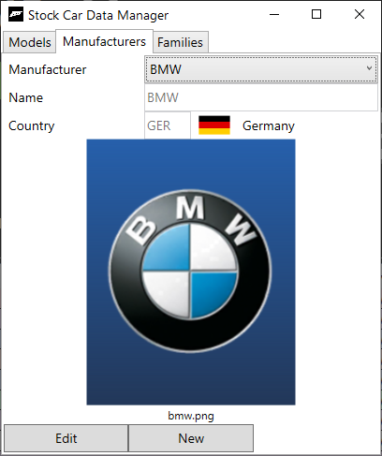

The Manufacturers tab contains the two information about manufacturers: their name and country. A flag and icon will be displayed if files are found.

If a logo is missing, you can add it to the “data/fh5/manf” folder. Images must be a png, and the name must match the manufacturer name. The expected name is shown in the Manufacturer tab, and it is the name of the manufacturer without invalid characters if any.

If a flag is missing, you can add it to the “data/flags” folder. Images must be a png, and the name must match the country code

If a country is missing, you can add it to the “data/country.csv” file. Simply edit the file with notepad, add a new line with a country code and a country name, separated by a comma. By default, IOC country codes are used. Modifying existing country data may break the manufacturer list.

It’s possible to manually update the manufacturers list by editing the “data/fh5/manf.csv” file. Any modification may break other things.

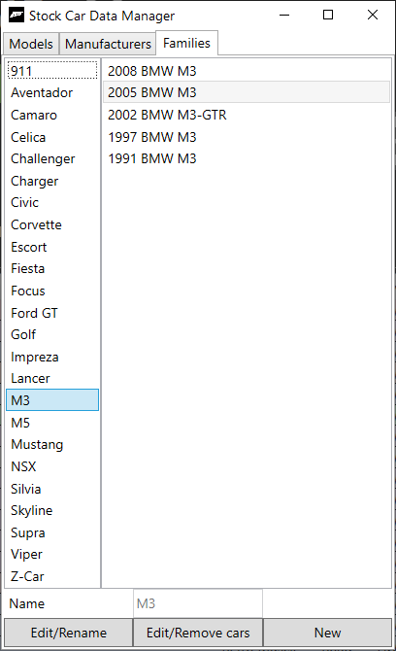

The Families tab contains the list of existing model families and members of each family. Families are user-defined, and a few families are provided by default. Each model may only be added to one family at a time. Families are optional, and allow you to group cars by a theme.

The “Edit/Rename” button allow you to rename the family.

The “Edit/Remove cars” button allow you to remove cars from the selected family.

The “New” button allows you to create a new family.

To add a model to a family, you must edit the model in the Models tab and select the family.

Families with no members are forgotten at the end of the session.

# Notetaker

The notetaker is a tool for taking notes. You can enter text in the field, and it will be saved as a text file.

Notes can be separated into individual sections. To create a new section, start a line with >>

When saving by clicking “Save” or pressing Ctrl+S, or when clicking the “Reload” button, the section will be created.

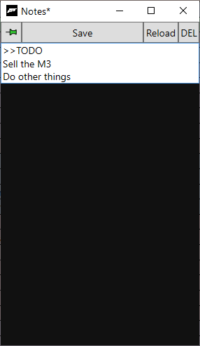 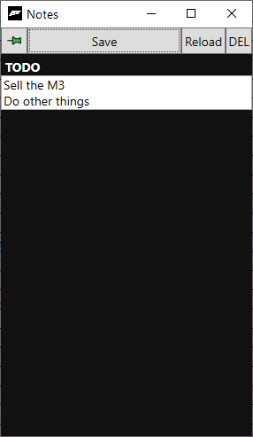

You can create as many sections as you want. Click on the section header to hide/show a section.

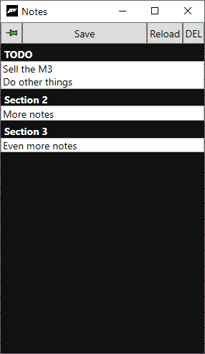 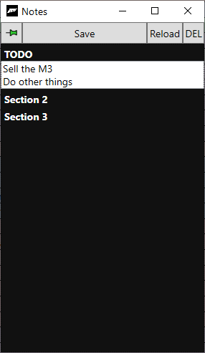

Click the “DEL” button to switch to delete mode. In delete mode, you delete the sections you click. To exit delete mode, click “DEL” again. Deleting a header does not delete the notes in that section. The notes remain unless you click on the note section itself to delete it.

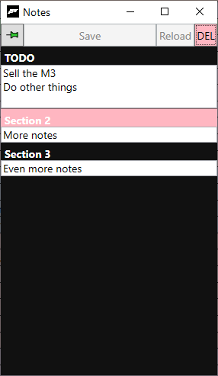 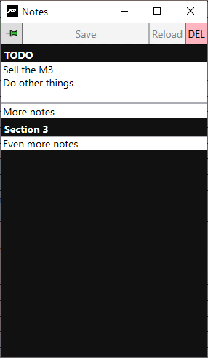

If you don’t delete it, it will merge with previous note section when you exit delete mode.

Finally, the pin button allows you to pin or unpin the window on top of other windows. By default, the notetaker is pinned in the foreground.

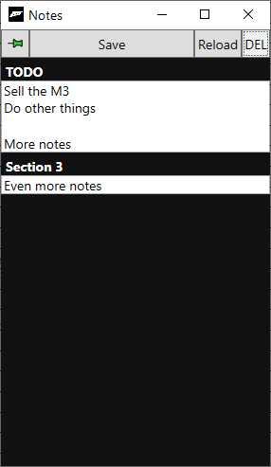 

# Color Util

The Color Util allows you to convert colors to the Forza color space.

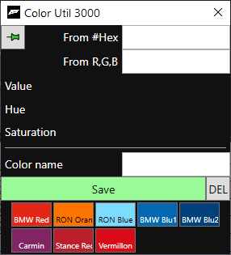

You can enter a color as a hex value or RGB value.

Hex values may be entered with or without the # sign, but must be 6-characters (or 7 with the #).

RGB values may be entered coma-separated, as integer from 0 to 255.

When a valid input is entered, the color will be previewed, and the values to enter in the Forza editor will appear. Values are display with two decimal places, and a third one in parenthesis.

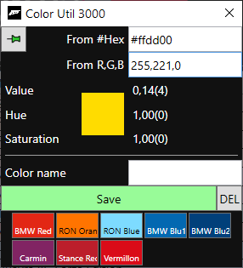

You can enter a color name and save it to reuse later. Simply click the “Save” button, and it will appear in the list.

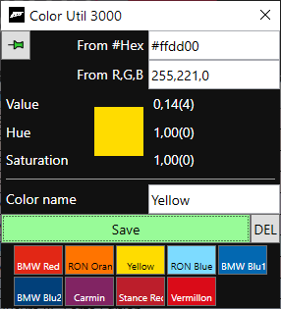

Click on a saved color to recall it.

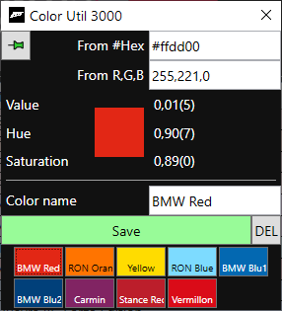

Click on the “DEL” button to enter delete mode. In delete mode, any color you click will be deleted. Click on “DEL” again to exit delete mode.

