Work Without Fear Reform — Data & Evidence Pack
Prepared by: Amir Mohammad Ehtiatkar Soumehsaraei • 07 November 2025
Gmail: Gmail: Mohammad.ek700@gmail.com

Executive cover note (EN)
Purpose:
This document bundles the statistical assessment and evidence that support the policy proposal 'Work Without Fear Reform'. It is intended to be sent alongside the full proposal, executive summary, annex and cover letter to relevant stakeholders (MP, Work & Pensions Committee, DWP).

Key message:
Allow PIP/LCWRA awardees to undertake work without automatic removal of support; use medical-based scheduled reviews (2→3→5 years) and consented HMRC checks to prevent abuse. This increases lawful participation and tax revenue while maintaining protections for vulnerable claimants.

Statistical summary (EN)
Unique target cohort (estimated): 4,940,000 persons (based on approximate PIP & LCWRA counts and 40% overlap).

Scenario results (EN):

Sensitivity (overlap) — highlights:
- Overlap 30% -> target cohort: 5,130,000 | 6% workers -> revenue £423,594,360
- Overlap 40% -> target cohort: 4,940,000 | 6% workers -> revenue £407,905,680
- Overlap 50% -> target cohort: 4,750,000 | 6% workers -> revenue £392,217,000

Charts (EN):
Figure 1 — Approximate annual revenue by scenario.
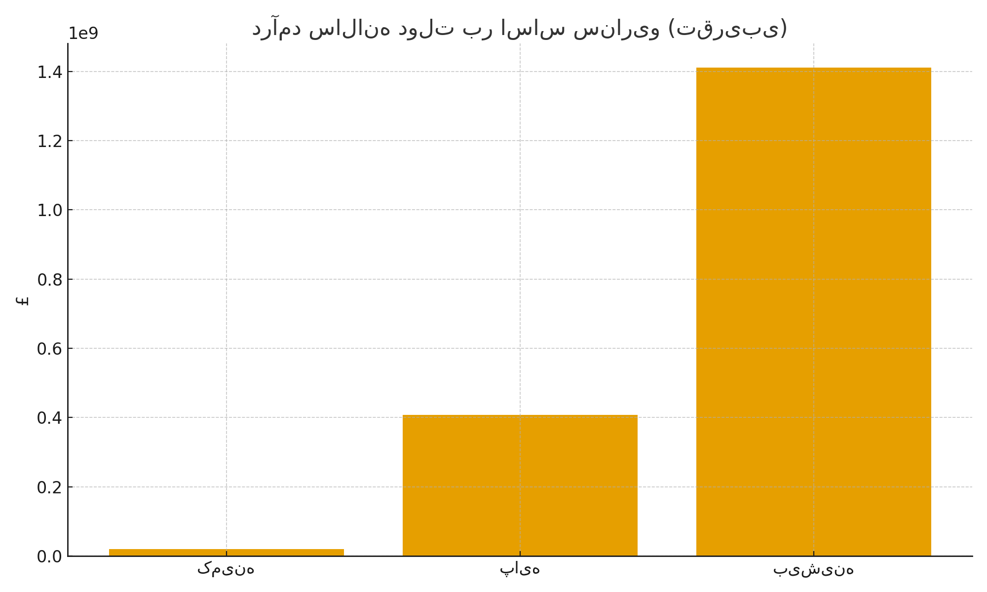

Figure 2 — Per-worker revenue breakdown (base scenario).
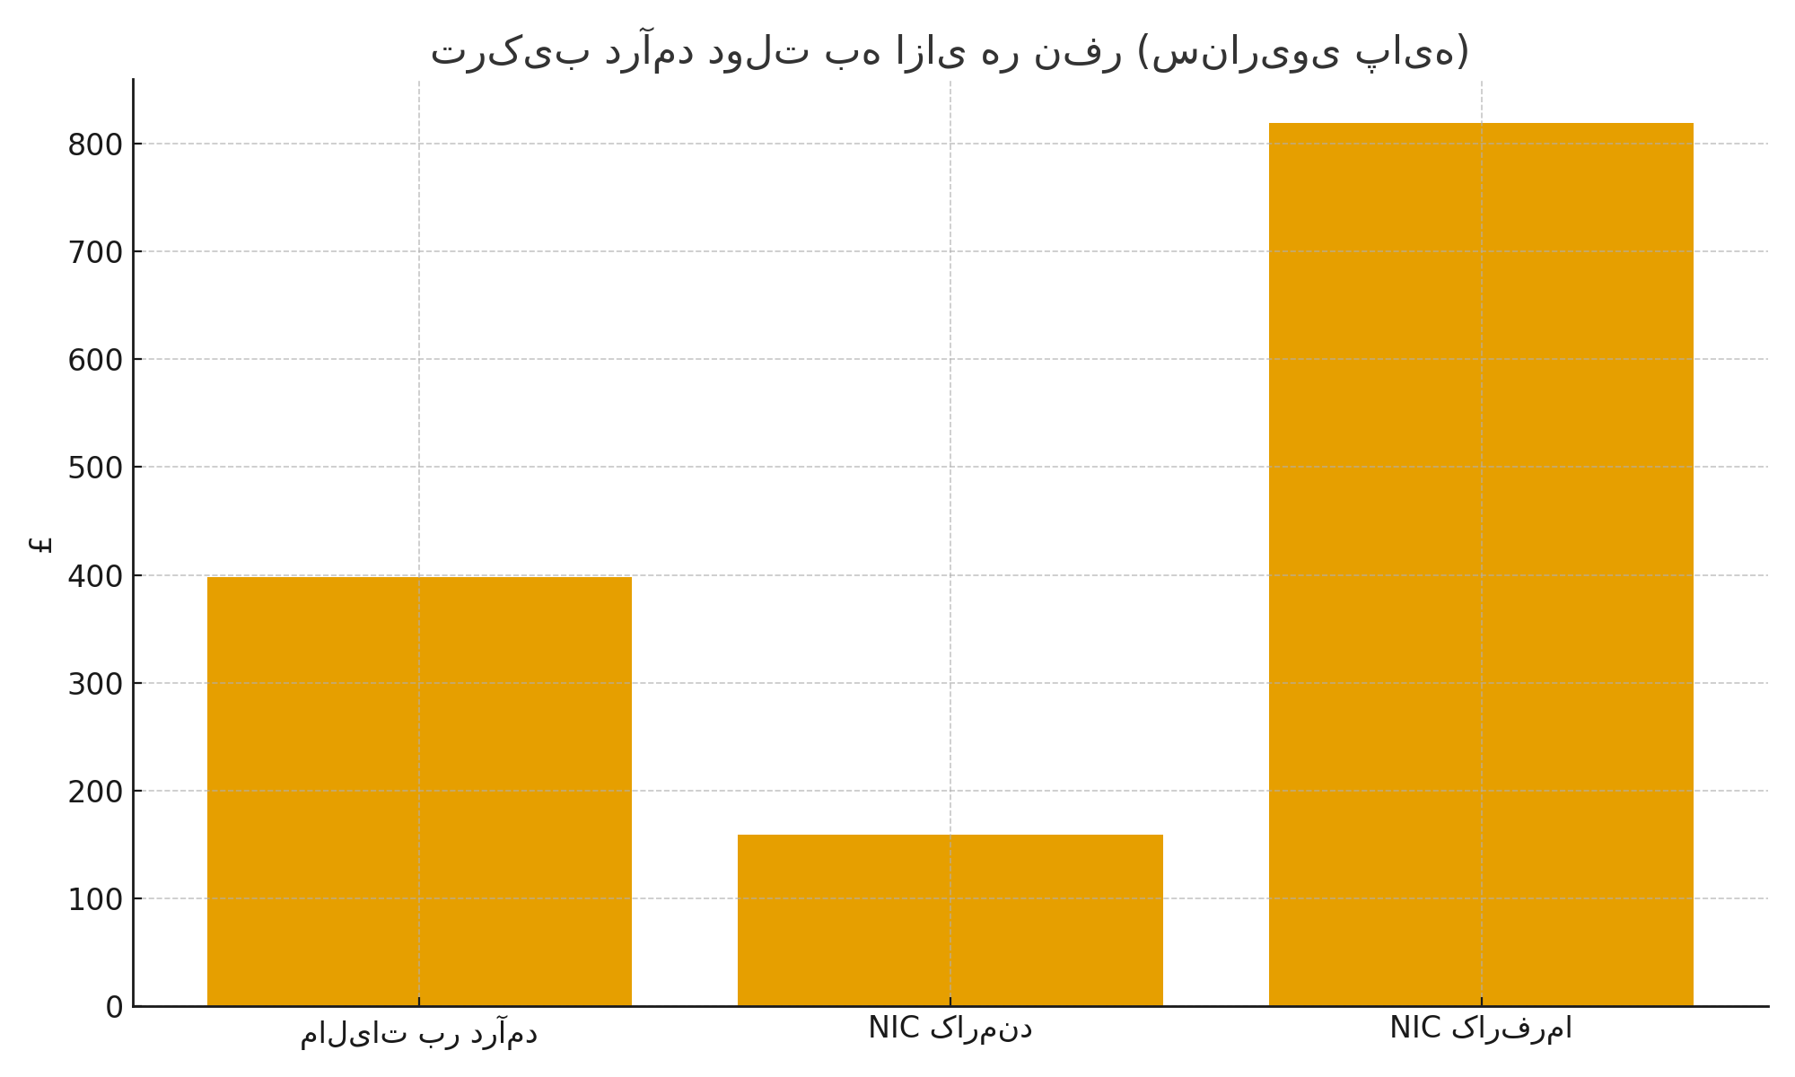

Implications & Recommendations (EN)
1) Financial impact: Even conservative take-up rates (3–6%) produce meaningful additional tax + NICs revenue (tens to hundreds of millions GBP), depending on earnings assumptions and cohort size.
2) Behavioral impact: Removing the automatic penalty for working reduces disincentives, encouraging legal work and reporting of income.
3) Safeguards: Use GP evidence for medical context, keep DWP decision authority, and require consent for HMRC data-sharing to detect abuse.
4) Pilot: Recommend a 12-month pilot in a single region (e.g., Merseyside) to gather real-world outcomes before national rollout.

Suggested next steps for recipients:
- Accept and register receipt; consider short internal policy review.
- Commission a 12-month pilot with outcome metrics (employment take-up, tax revenue, claimant wellbeing).
- Engage local GPs and HMRC for data-flow design and consent procedures.

