Team Name: Frustrated Parkers

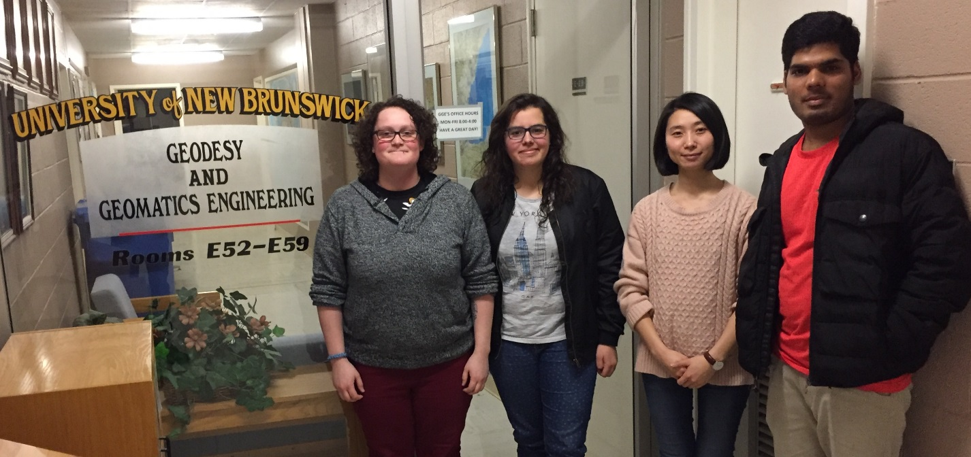

Wen Jiang (centre right)

Wen is second year grad student in Geodesy and Geomatics Engineering department, University of New Brunswick. She achieved her bachelor degree in land planning and management in China. After two years working for a real-estate appraisal company, she applied and enrolled with UNB for a further study. Her current project focus on geocoding study. The paper < What3Words Geocoding Extensions > has been published recently with the Journal of Geovisualization and Spatial Analysis.

Marissa Hamilton (left)

Marissa Hamilton is an undergraduate student achieving a degree in the Bachelor of Science in Geodesy and Geomatics Engineering at the University of New Brunswick. Prior to attending UNB, she gained a Diploma in the Geomatics Engineering Technologist at the Southern Alberta Institute of Technology. During her breaks between studies, she worked in the Geomatics industry, conducting various types of Geomatics related projects.

Marta Padilla Ruiz (centre left)

Marta is a graduate student in Geodesy and Geomatics Engineering at the University of New Brunswick. Her interest in Geomatics originates from the period she was participating in orienteering competitions as part of the Spanish National team. Then, she completed a Bachelors Degree in Geomatics Engineering and a MSc in Topography and Geodesic Engineering in Spain. During the completion of her first Masters degree, she got an opportunity to come to Canada and start another Master at the University of New Brunswick, where she has been living for the past two years. The research for her MSc thesis is focused on User-Centered Design of Geomatics applications, understanding user needs and including their feedback in the design process.

Rajesh Tamjlmani (right)

I, Rajesh Tamilmani have moved to Fredericton, Canada from India for doing Masters in Geodesy and geomatics Engineering at University of New Brunswick. I was a Systems Engineer at Infosys Limited (An International IT company) for two years before moving to Canada. I am a resourceful individual with a positive and proactive attitude to take up challenges and diligently working in a team to deliver requisites. I am passionate about implementing ideas that utilize geo-information and use technology as a medium to generate solutions to broadly relevant problems. My research interests are spatial data infrastructures and web mapping. Previously, I worked as a research intern for two months (June 2013 – July 2013) at Concordia University in the department of geography and urban planning. I did my Bachelor of Engineering in geoinformatics from Anna university, Chennai, India. I was awarded with the GOLD MEDAL for having secured FIRST RANK in B.E., Geoinformatics degree program among the candidates who have graduated based on my academic performance.