**Team San Diego**

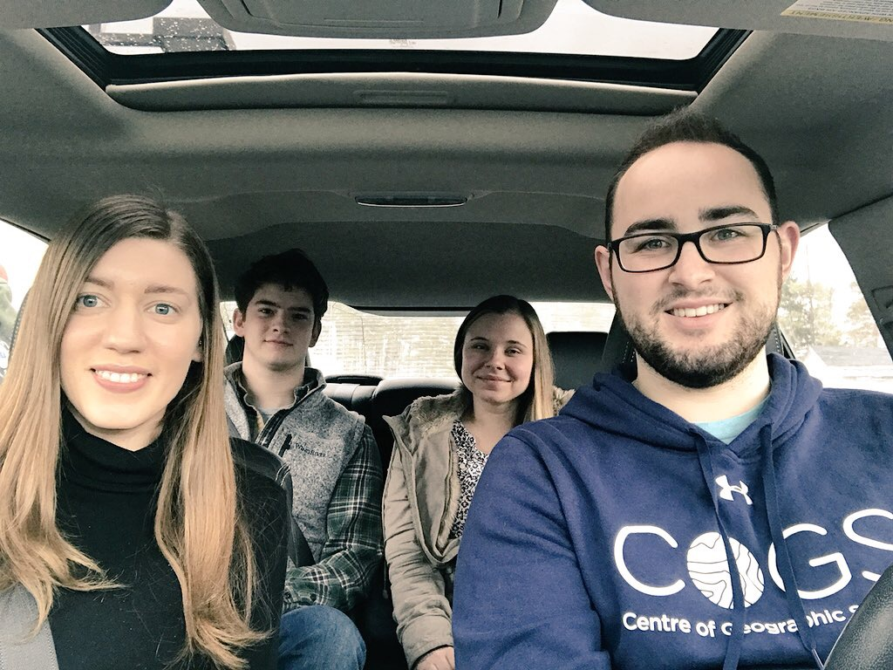

Brief descriptions from left to right:

**Erica Corbett**

Erica is a Memorial University Alumni where she studied Geography as a Science. She also volunteered with Mount Pearl Sr. High School where she worked as an assistant world geography teacher. She then moved on to teach ESL in South Korea for three years, and is now back in Eastern Canada in the process of completing her Advanced GIS diploma at COGS. She is also completing a research project in collaboration with Dalhousie University’s Food Policy Lab doing a spatio-temporal analysis of Nova Scotia’s food environment. Erica’s future goals are to be able to combine her love of teaching and GIS in a rewarding career.

**Colin Werle**

Colin is a Saint Mary’s University Graduate with a Geography Major and Economics Minor. He has recently traveled to Arctic Norway where he studied on exchange for five months at the University of Tromso. Following his graduation at Saint Mary’s, he completed a co-op work-term at the Canada Centre for Remote Sensing in Ottawa, Ontario in the summer of 2017. He now goes to COGS studying Advanced GIS and is part of the school hockey team and a member of the ECCE. His future goals are to enter the GIS market in Europe, travel to more countries and learn new languages.

**Andrea Becker**

Andrea is a University of Waterloo Alumni where she studied Geography and Environmental Management. She did an exchange in England studying Geography at the University of Sheffield. She now attends COGS studying Advanced GIS where she is part of the ECCE program and is working on a term-long project developing an application to monitor food environments for the Food Policy Lab at Dalhousie University. Her future goals are to have a career combining her passion of Geography and programming in the field of GIS.

**Harrison Smith**

Harry graduated from St Mary’s University with a Geography Major in 2017 where he completed a field course studying Environmental and Anthropogenic Issues of the Bay of Fundy. He was a research assistant at Saint Mary’s collecting data pertaining to inventory on Halifax retail stores. He now goes to COGS taking Advanced GIS and is part of the school hockey team. His future goals are to work with mobile applications in the GIS industry collecting real-time data.