# Team Name: West Coast, Best Coast

## App Name: Sport Logic - Map it, Find it, Play it, Love it

Alexander Smith, Kendra Munn, Danielle Derrick

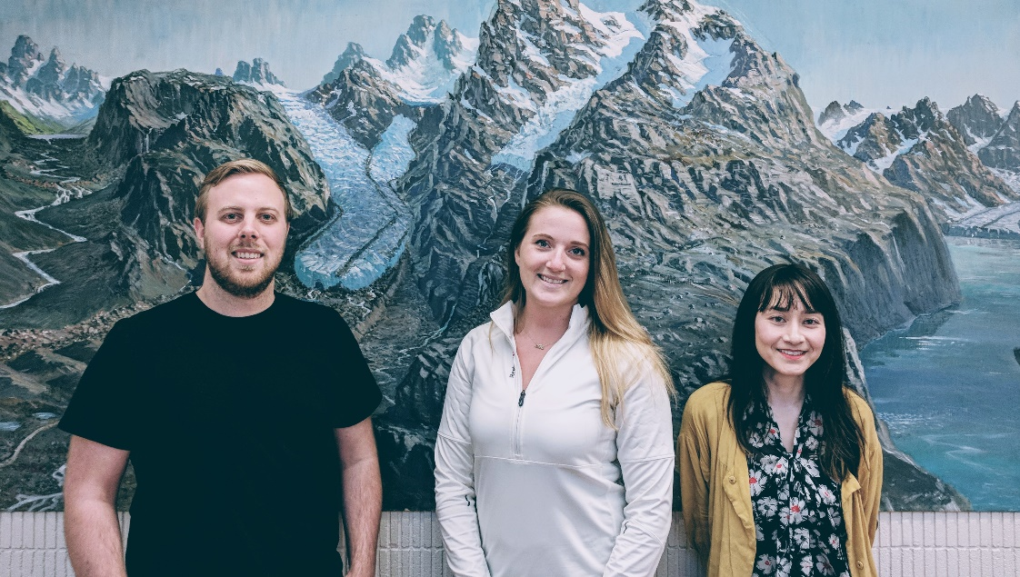

**Alexander Smith;**

Alex Smith (left) is a PhD student at Simon Fraser University studying Agent-Based Geospatial Modelling in the Department of Geography. He received his Bachelor of Environmental Studies and a Master of Science in Geography from the University of Waterloo in 2015 and 2017, respectively. His research interests include agent-based modelling, 4D complex systems, and GIScience. During his free time, Alex enjoys ultimate Frisbee, baseball, and board games.

**Kendra Munn;**

Kendra Munn (right) is an undergraduate student in her final year of pursuing a bachelor's degree in Environmental Science, Applied Biology at Simon Fraser University. Although her primary platform to study is the Environment, her interest in GIS led her to obtain a certificate in Spatial Information Systems on the side. Developing from that, Kendra spent the summer of 2017 researching novel spatial analysis methods in 3D, provided through NSERC funding. In the future, she plans to return to school for a Master's degree in Geography.

**Danielle Derrick;**

Danielle (centre) is a MSc. Candidate at Simon Fraser University in British Columbia, where she previously obtained by undergraduate in Biology at Carleton University in Ontario. She focuses primarily on sharks, rays and chimeras (class Chondrichtyes), and will be taking advantage of newly available maps of their distributions to develop geospatial analyses exploring the underlying environmental and geological drivers of species. This could provide a greater understanding in the fundamental drivers of species richness, and she anticipates that this new knowledge will provide a firm foundation for developing spatial priorities for marine conservation. From a GIS point of view, Danielle hope to find a career in which she can manipulate and analyze spatial data to help answer current conservation concerns and aid in understanding more about our world’s oceans.