# **Team Profiles**

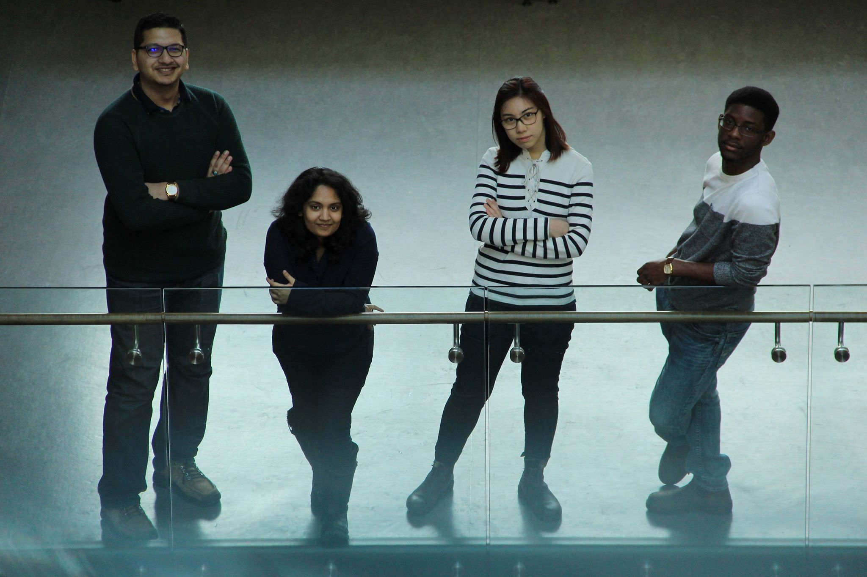

**Aujas Bandlish - Developer**

Aujas (left) is in his final year of Geomatics at the University of Waterloo. Through the coop program, he gained a variety of experiences, working for Federal government (Statistics Canada), Municipal government (York Region and Region of Waterloo), and private sector (BlueDot Global and Zayo Canada). These experiences have helped him in honing his GIS, data management and coding skills. In addition to that, he has taken part in the first National Geomatics Competition in New Brunswick and ranked second. These, coupled with personal projects and his academic career, have given him an opportunity to learn and experience the depths of GIS.

**Candy Lee – Website and UX Designer**

Candy (centre-right) is a Geography and Environmental Management undergraduate, with a specialization in Geomatics at the University of Waterloo. Her interests lies with sustainable transportation and infrastructure planning with the use of spatial analysis tools such as Geographic Information Systems (GIS) and Remote Sensing. Equipped with the knowledge and experience from the technical, physical, and human side of geography, she hopes to enrich society's quality of life through the balanced aspirations of the public and private institutions. When Candy doesn't have her head wrapped around transportation and geomatics, she enjoys urban exploration, street photography, taking on challenges and suffers from chronic multi-tabs syndrome.

**Netzach Straker - Developer**

Netzach (right) is an Undergraduate student at the University of Waterloo studying Geomatics with a Computer Science minor. His passion lies with understanding the repercussions of land cover change by utilizing Geographic Information Systems and Remote Sensing. His purpose is to continue to advance the knowledge and experience so as to become proficient in his craft. During his free time Netzach enjoys reading, eating delicious foods, warm weather, and interacting with others through witty banter.

**Yuvna Apajee – Data finder and Documentation**

Yuvna (centre-left) is a third-year Honours Geomatics student at the University of Waterloo. She is also completing a minor in Urban Studies, with a focus in Urban Activity and the Environment. For her Coop, Yuvna worked for the City of Toronto, as a GIS analyst in the Transportation Division, dealing with the management and programming of Infrastructure and other Assets. Her free time is devoted to the Fifth generation of Transportation, which is being referred as, Hyperloop. She is part of the Infrastructure team and contributes towards maintaining government relations, as well as integrating GIS and Hyperloop in the many projects. Moreover, her world revolves around soccer !