Sabrina Lee:

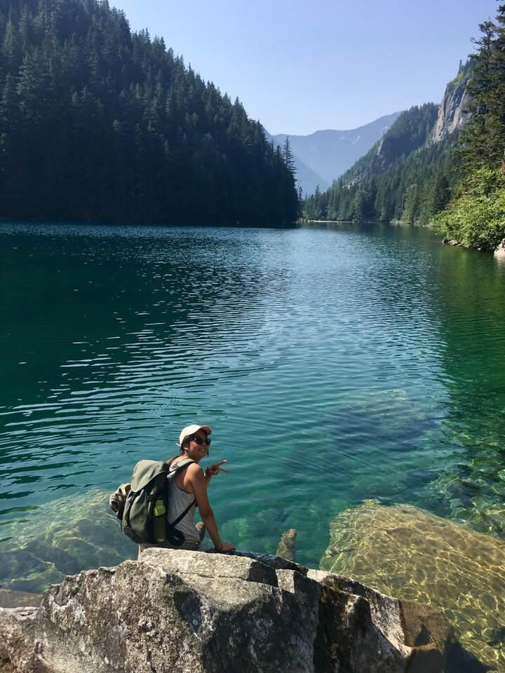Currently studying Environmental Science and majoring in the Earth Systems. What I want to do with GIS in the future is to combine GIS and environmental needs to help with city planning, park systems and make an impact on our current environmental progress.

Matthew Bond:

Human geography student at Simon Fraser University with a focus in Economic Geography and Urban Planning. I hope to work in the local government as a town planner post-graduation and help design the communities of tomorrow to be more sustainable and accessible for people of all social classes.

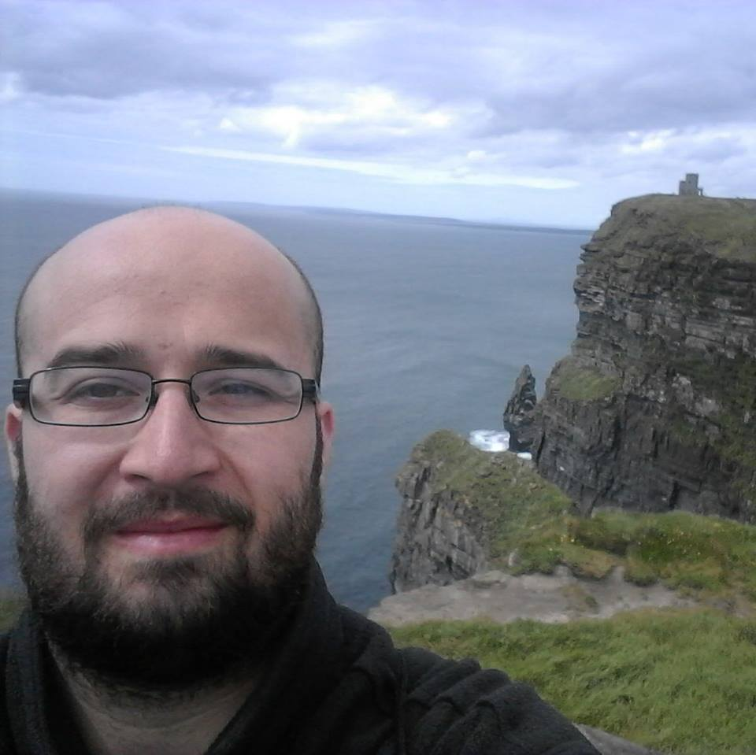

Alex Thrower

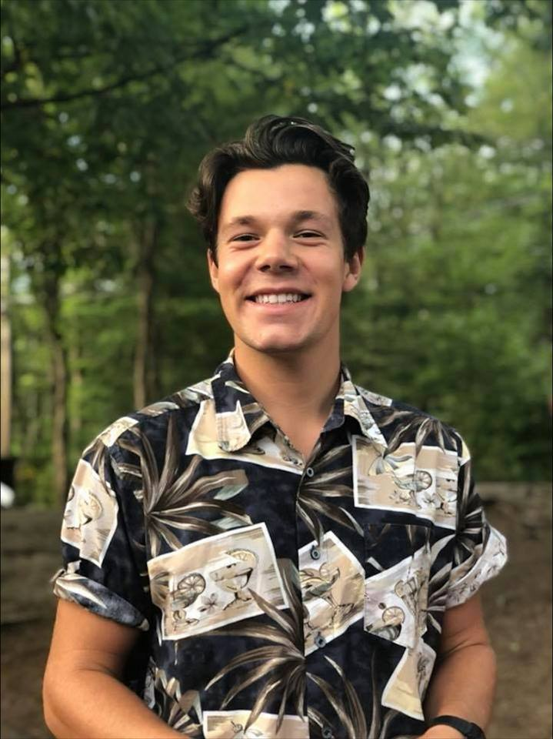Currently studying Global Environmental Systems and Resource & Environment Management. Primarily interested in Natural Resource Management; Forestry and Fisheries as well as Natural Hazard Risk Management. It is my aim to blend my outdoor interests and passions with the GIS and natural resource research.

Maria Beskromnova

A Global Environmental Systems major at SFU also studying for the Spatial Information Systems certificate. She is interested in connecting GIS to help with risk management and mitigation for natural hazards.

