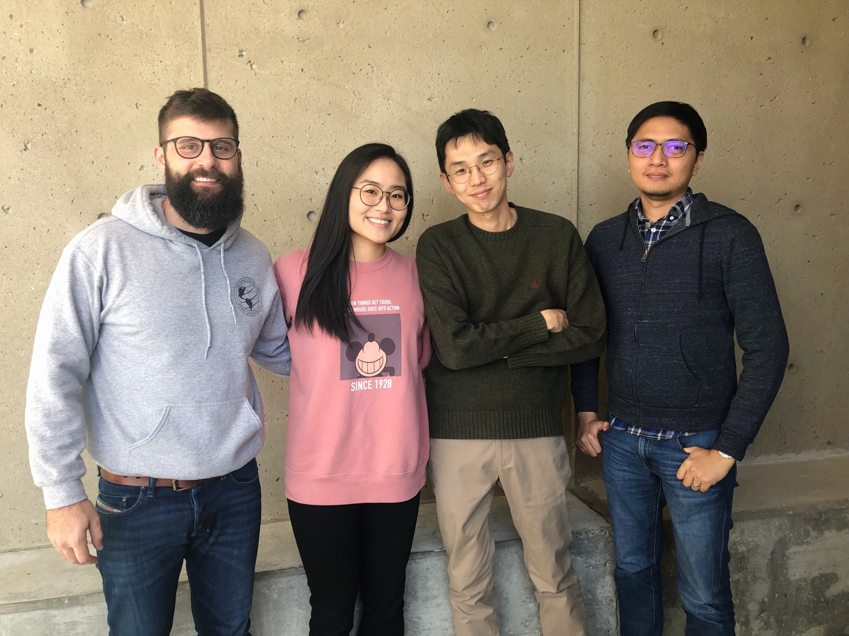

OUR BIOS:

Hey there, I am a fourth year Geomatics Engineering student at York University. Although I come from a land surveying background, I enjoy topics in Geodesy, Computer Vision, Remote Sensing, Photogrammetry, 3D modelling and LiDAR data processing. When I am not thinking about Geomatics (which is rare), I am thinking about the Toyota 4Runner. [Left]

Hi, my name is Sun Park! I am a fourth year Geography and Urban Studies student at York University. I enjoy topics surrounding Urban Design, Architecture, and 3D modelling. I also love photography, and I am excited to learn more about application design and GIS through this challenge! [Middle-Left]

Seungho Yang is a Postdoctoral Fellow in the Department of Civil Engineering at York University, Canada. He got his Ph.D. in engineering from Seoul National University in South Korea, and had a three-year career in the private and public sector. His main research topic is smart city and smart transportation. [Middle-Right]

Hi, I'm Pio from York University. I'm interested in topics like computer graphics and map visualization. I watch NBA and a few times I made data vis for it too. [Right]