**The Four Mapsketeers**

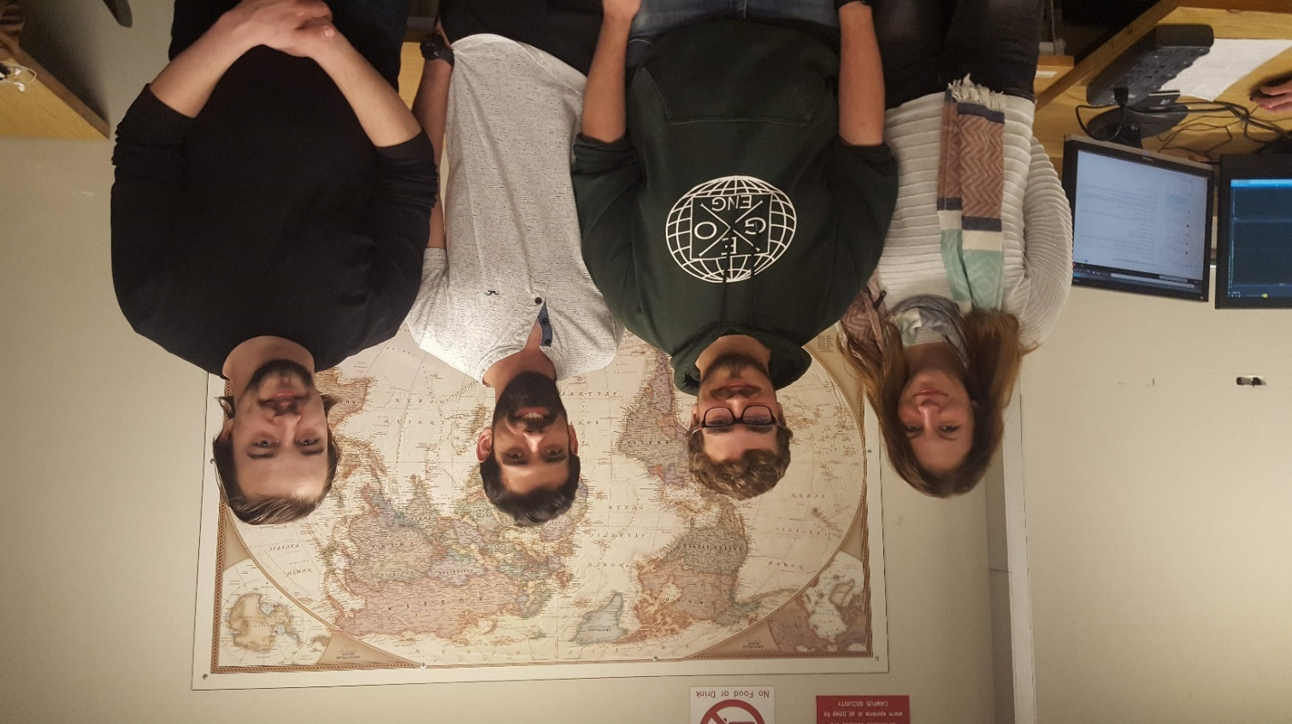

From left to right: Sandra Simeonova, Dillon Pullano, Rodrigo Silva, and David Jarron.

Sandra Simeonova is a first-year MSc student in the Geomatics Engineering department at University of Calgary. She is a Department of Geomatics Alumni. Her research is focused in the area of digital imaging systems, mainly focusing on unmanned aerial vehicles (UAV’s). Prior to her return to higher education in 2011, she worked as a travel agent, were her passion for travel and education evolved.

Dillon Pullano is a second year MSc graduate student in Geomatics Engineering at the University of Calgary with a specialization in Land Tenure and GIS. His research topic is related to the development of a 3D cadastre. It focuses on spatial data structures and processes that could be implemented to digitally perform topological analysis between 2D and 3D objects. He completed his BSc degree in Geomatics Engineering from the University of Calgary in 2017.

For more information on Dillon’s research you can visit the University of Calgary’s Land Tenure and Cadastral Systems Research Group homepage at the following link: <https://www.ucalgary.ca/mikebarry/team>

Rodrigo Silva is a second year MSc student in the Geomatics Engineering department at University of Calgary. He received his BSc in Computer Engineering from University of Pernambuco, Brazil. His current research is related to personalized route recommendation with the use of collaborative filtering techniques.

David Jarron is a second year MSc student in the Department of Geomatics Engineering at the University of Calgary. His specialization is in Mobile mapping systems and image metrology, although he is interested at testing his skills in GIS application development. He completed his BSc in Geomatics engineering at the University of Calgary in 2017 and interned at the City of Calgary working on GIS legal survey data.