

**Faculty of engineering - Shoubra**

**Benha University**

**Research Project**

in fulfillment of the requirements of

|  |  |
| --- | --- |
| **Department** | **Engineering Mathematics and Physics** |
| **Division** | **-----------------** |
| **Academic Year** | **2019-2020 Preparatory** |
| **Course name** | **Computer** |
| **Course code** | **ECE006** |

**Title: -**

By:

|  |  |  |  |
| --- | --- | --- | --- |
|  | Name | Edu mail | B.N |
| 1 | امير إبراهيم إبراهيم حسن عطيه | amir195232@feng.bu.edu.eg | 218 |

**Approved by:**

|  |  |
| --- | --- |
| Examiners committee | Signature |
| Dr.Ahmed Bayoumi |  |
| Dr.Shady Elmashad |  |
| Dr. Abdelhamid Attaby |  |

**Table of contents**

|  |  |
| --- | --- |
| **Subject / section** | **Page** |
| Links | 1 |
| Application brief | 2 |
| Screenshots | 3 |

**Links**

|  |  |
| --- | --- |
| **Github-link** |  |
| **Gitub-page (published webpage)** |  |

**Application brief**

Big data is a combination of structured, semi structured and unstructured data, collected by organizations that can be mined for information and used in machine learning projects, predictive modeling and other advanced analytics applications.

Big data demands a set of new types of integration techniques and technologies to reveal insights from various complex and massive data sets.

There are several characteristics of big data, such

**(Volume – variety – velocity)**

The importance of big data exists in many fields, such;

**Companies and marketing:**  big data can provide companies with valuable insights into their customers that can be used to refine marketing campaigns and techniques in order to increase customer engagement and conversion rates. The use of big data allows companies to become increasingly customer-centered.

**Health researchers:** use big data to determine risk factors for diseases, and physicians to better diagnose diseases and disorders in individual patients.

**Oil and gas companies**: helps to identify potential drilling locations and monitor pipeline operations in the energy industry; likewise, utilities use this to track electrical grids.

There are many examples of big data, such

**(Web data – text data – smart grad and sensor data – social network data)**

**Screenshots**

Fig.2 (source code of webpage 1)

Fig.1 (webpage 1)

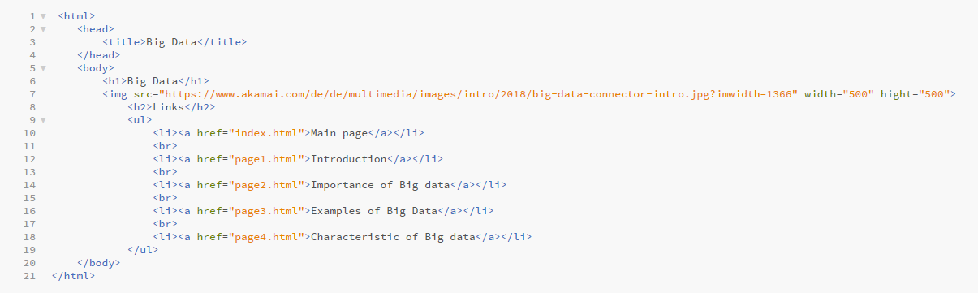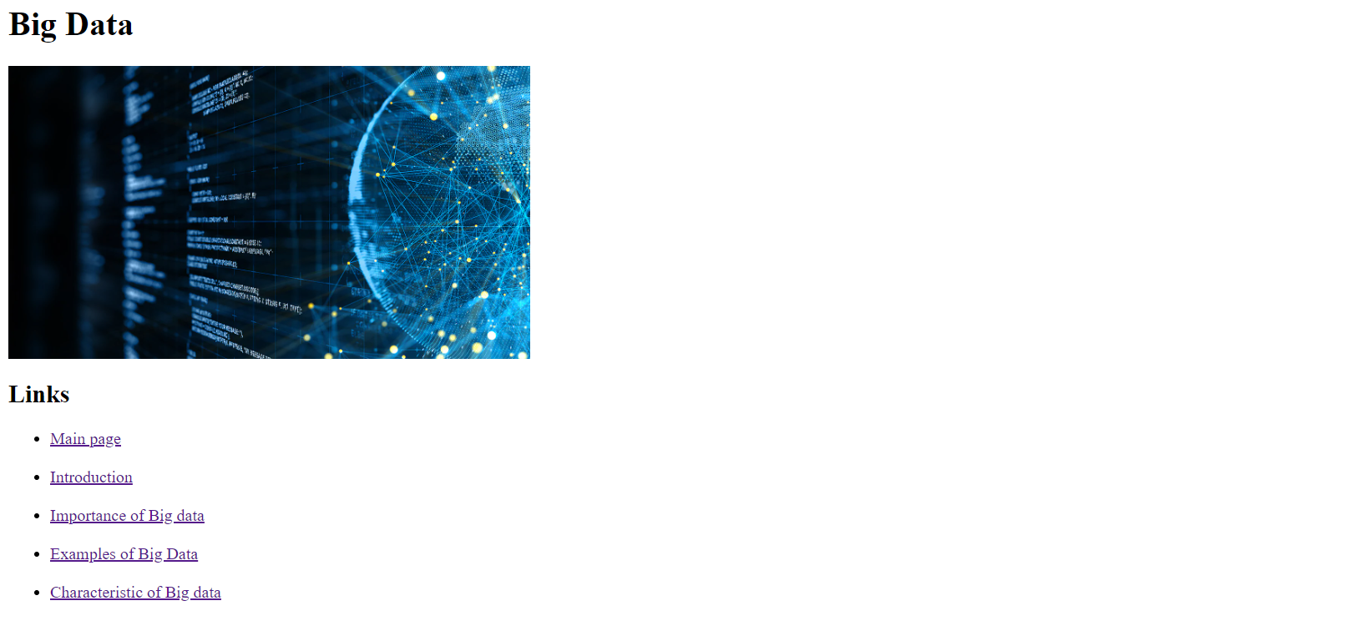

Fig.4 (source code of webpage 2)

Fig.3 (webpage 2)

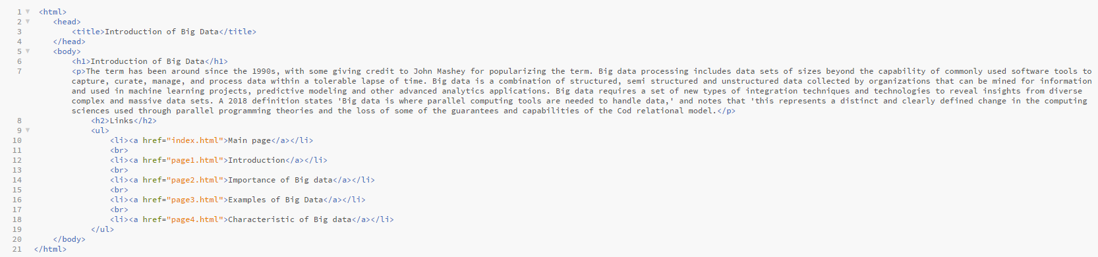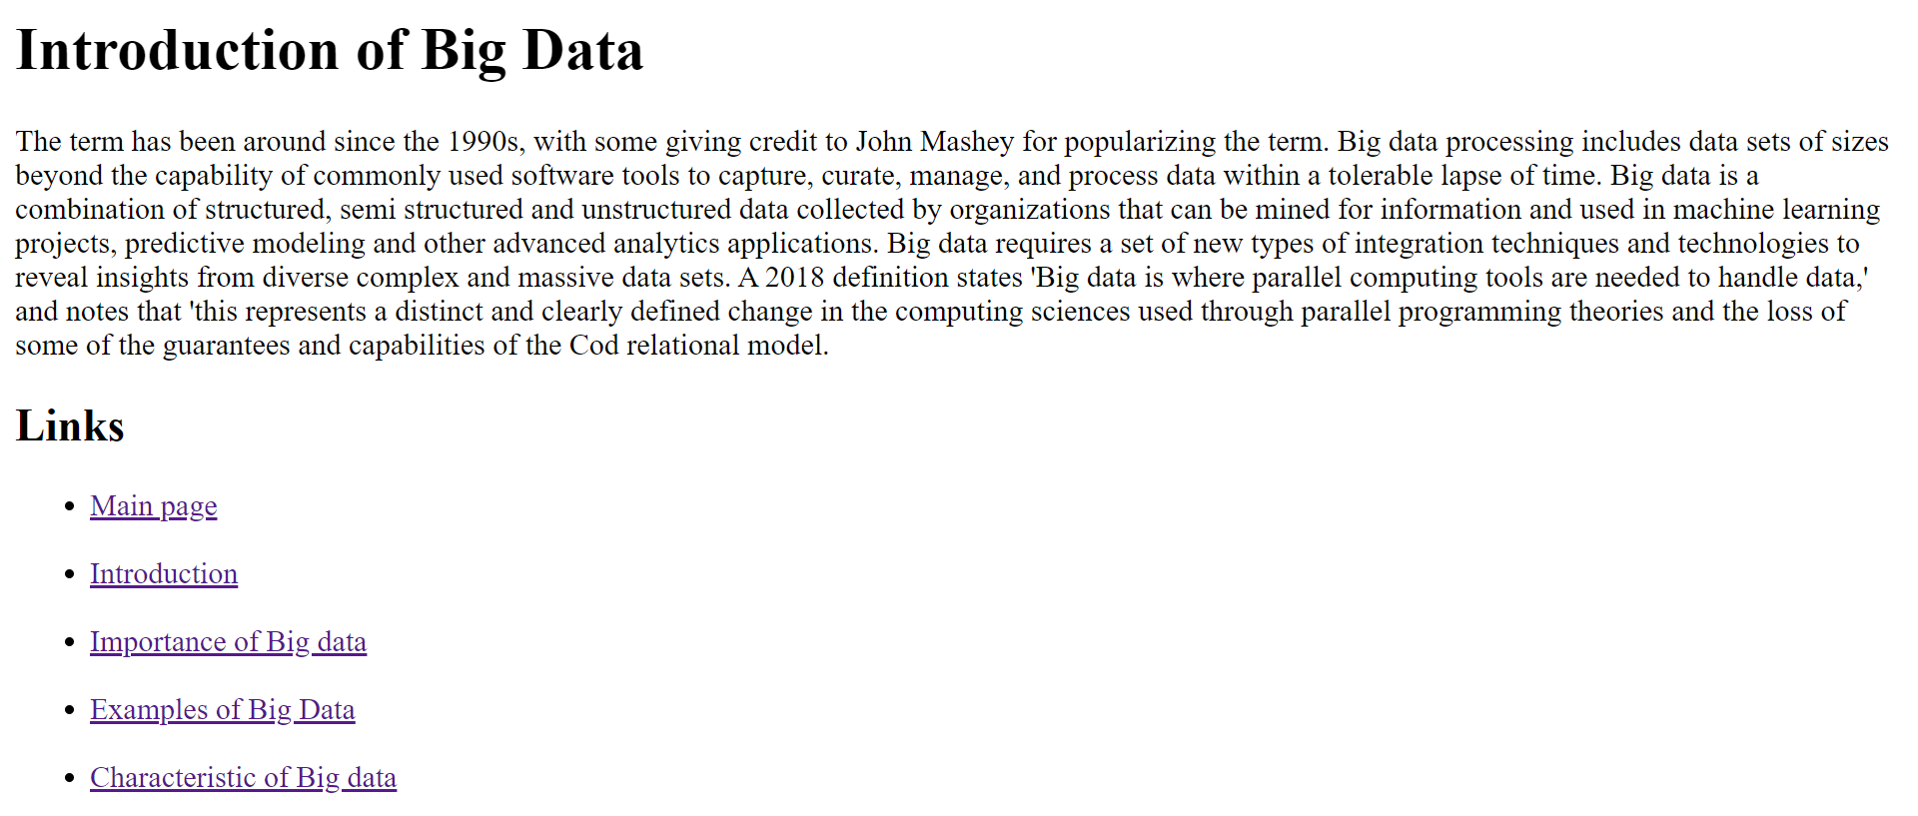

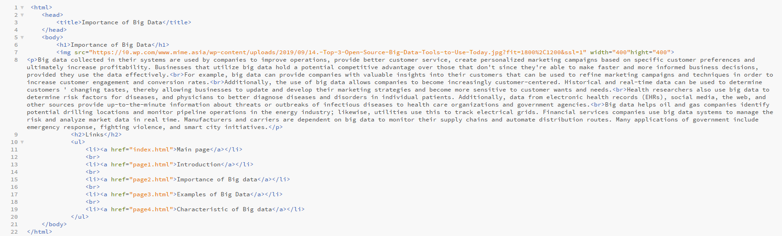

Fig.6 (source code of webpage 3)

Fig.5 (webpage 3)

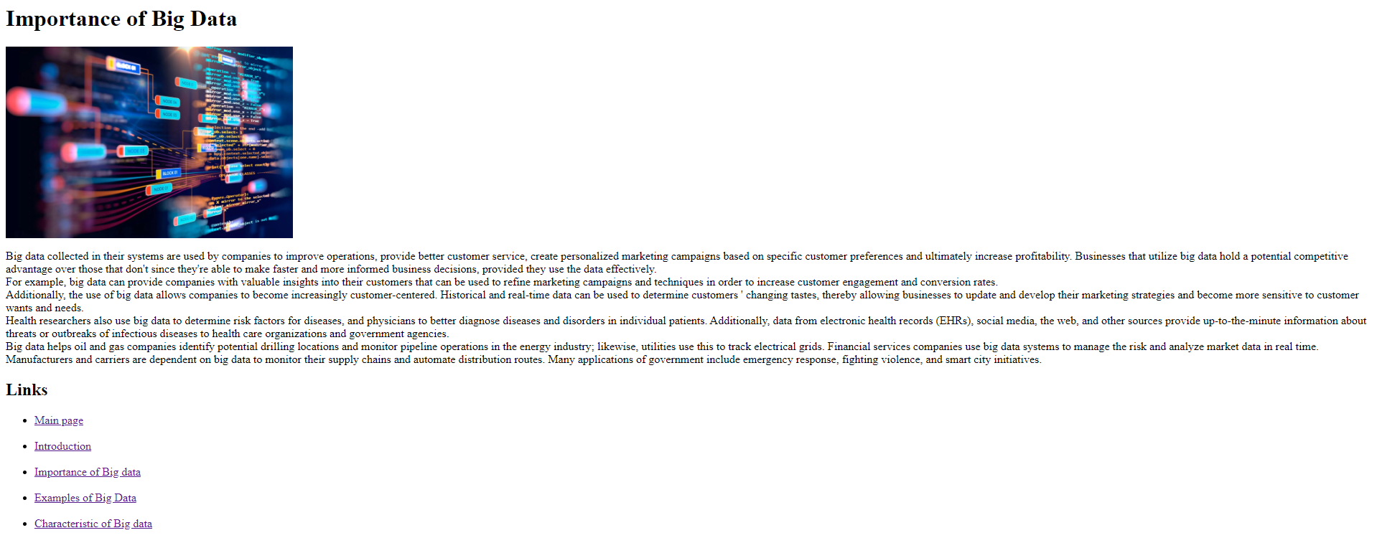

Fig.8 (source code of webpage 4)

Fig.7 (webpage 4)



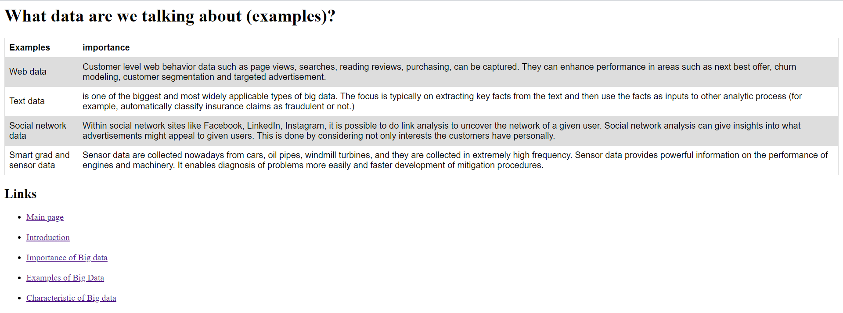

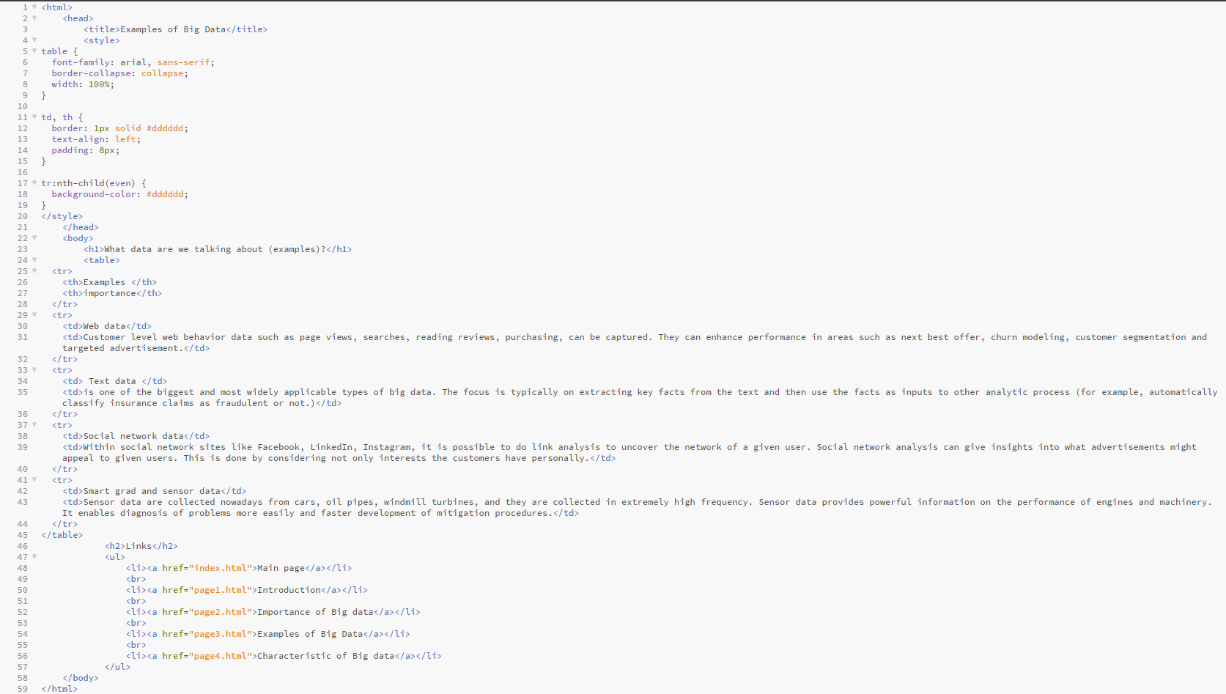

Fig.9 (webpage 5)

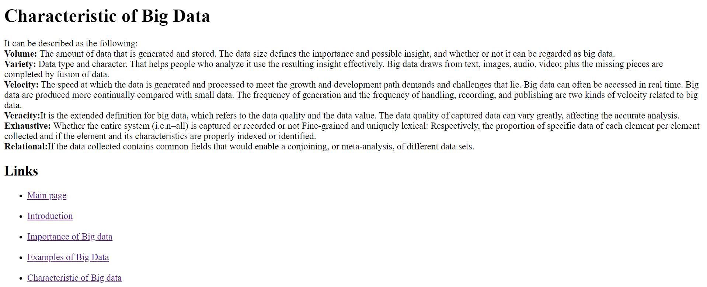

Fig.10 (source code of webpage 5)

