WEEK 1
Workforce Data Analysis
People analytics foundations and workforce planning
Academic project report | Prepared 18 October 2026
All people, organisations, measures, and outcomes in the worked examples are fictional.
Conceptual learning exercise only; no live SAP system was configured.

Executive Summary
This report presents a reproducible workforce analytics exercise using 120 fictional employee records. It explains the distinct roles of SAP HCM, Personnel Administration (PA), Organizational Management (OM), SAP SuccessFactors Employee Central, and analytics tooling. A 30 September 2026 snapshot and FY2025 indicators are calculated from synthetic hires, exits, demographics, department, attendance, learning, and ratings. The sample produces a headcount of 99, mean recorded absence of 2.4 days, mean training of 29.5 hours, and mean performance rating 3.46/5. These figures describe only this generated dataset; they are not benchmarks or evidence about a real employer. The report defines measures, describes limitations and governance, and translates the patterns into responsible workforce-planning actions.

Contents
1. Scope, SAP HR landscape, and analytical question
2. Data collection, synthetic cohort, and methodology
3. Findings and interpretation
4. KPI catalogue and analytical controls
5. Workforce planning recommendations and limitations
6. Conclusion
7. Decision use, data quality, and responsible follow-up
Tables, figures, and references follow the relevant discussion.

1. Scope, SAP HR landscape, and analytical question
Workforce analytics combines reliable people data with a clearly defined decision question. SAP HCM is the established human-capital-management application family used in SAP ERP environments. Its Personnel Administration (PA) functions maintain employee master data and employment actions; Organizational Management (OM) represents organizational units, jobs, positions, reporting relationships, and validity periods. These are related but distinct structures: a person assignment is not identical to an organisation chart object. Exact component scope depends on the licensed release and implementation.
SAP SuccessFactors Employee Central is SAP's cloud core-HR system of record for employee and organisational data, with effective-dated records and configurable business processes. It is not simply a renamed on-premise PA/OM screen. Customers may use Employee Central with other SuccessFactors products, integrate it with SAP payroll or other enterprise applications, or operate a hybrid landscape. SAP ERP HCM and HCM for SAP S/4HANA deployment options must be evaluated against SAP's current product strategy, release, maintenance, licensing, and customer-specific architecture; moving an ERP database to S/4HANA does not by itself establish which HR application is in use.
Analytics may be supplied through operational reports, embedded product reporting, SAP Analytics Cloud or a data platform depending on the architecture and entitlements. The analytical layer should not become an uncontrolled shadow master. This exercise asks: what does a small, de-identified, point-in-time synthetic cohort suggest about workforce composition and indicators that merit follow-up?
- Use a documented business definition and reference date for every KPI.
- Keep operational correction workflows separate from aggregate decision reporting.
- Use access controls and aggregation thresholds for sensitive or small demographic groups.

2. Data collection, synthetic cohort, and methodology
The reproducible generator creates 120 fictional records using a fixed random seed. Each record includes a pseudonymous employee identifier, department, job family title, location, a coarse demographic category, age, hire and possible termination dates, salary, recruitment source, FY2025 absence days, training hours, and performance rating. All dates are generated between 2019 and 30 September 2026. The file is explicitly synthetic and must not be combined with production employee data. No person-level inference is appropriate.
The point-in-time headcount counts records hired on or before the reference date and not terminated before that date. FY2025 attrition is defined as FY2025 terminations divided by the arithmetic mean of headcount at 1 January and 31 December, multiplied by 100. This simplified convention is transparent but not universal: organizations may define voluntary, regrettable, internal, or rolling attrition differently. Absence days and training hours are arithmetic means among employees active at the snapshot, not rates per scheduled workday or exposure. Performance ratings are a 1–5 ordinal scale; averaging them is an exploratory summary, not proof of equal distances between rating levels.
The analysis uses pandas to produce counts, proportions, means, median salary, turnover estimate, quarterly headcount snapshots, and graphics. Missingness is represented only where explicitly generated; the compact simulation has no realistic data-entry errors, duplicate identifiers, leaves, part-time fractions, transfers, or changing job assignments. Real collection would require purpose limitation, lawful basis, notice, minimisation, retention rules, access controls, data-quality stewardship, and reconciliation to source systems.

Department snapshot
Table 1. Department snapshot
Department | Active headcount | Share
Finance | 26 | 26.3%
People | 20 | 20.2%
Technology | 16 | 16.2%
Sales | 14 | 14.1%
Customer Support | 12 | 12.1%
Operations | 11 | 11.1%

3. Findings and interpretation
The generated sample contains 120 total employee records and 99 active records at the reference date across 6 departments. Active cohort mean age is 40.3 years; median annual salary is INR 1,440,000; women represent 48.5% of the active sample. The distributions in the accompanying tables and charts describe this seed and should not be interpreted as population estimates. Department size differences can reflect the sampling method, not business demand or productivity.
The 2025 attrition estimate is 8.0% (7 generated departures; opening and closing headcounts 83 and 91). A small numerator and denominator make the result unstable. A chart of headcount over time can show net movement only; it does not distinguish hiring, exits, transfers, or changes in FTE. Recruitment-source counts show the source values attached to the whole employee file and are not a valid channel conversion or hiring-efficiency measure because failed applicants, time-to-fill, costs, and offer acceptance are absent.
Current-cohort mean recorded FY2025 absence is 2.4 days, training is 29.5 hours, and performance is 3.46/5. These aggregates cannot establish whether workload, health, manager practices, programme quality, or rating bias explains variation. Averages conceal distributions, tenure, role mix, leave eligibility, seasonality, and uncertainty. Statistical comparisons are deliberately not presented as causal effects.

Demographic snapshot
Table 2. Demographic snapshot
Recorded category | Employees | Share
Man | 48 | 48.5%
Woman | 48 | 48.5%
Undisclosed | 3 | 3.0%

Recruitment source sample
Table 3. Recruitment source sample
Recorded source | Records
Employee referral | 34
Internal move | 25
Agency | 24
Career site | 23
Campus | 14

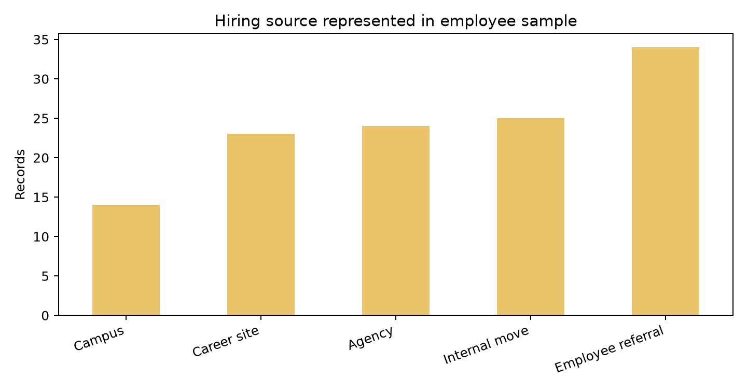
Figure 3. Recruitment source labels in synthetic records; not channel effectiveness.

4. KPI catalogue and analytical controls
The KPI table states the formulas and caveats. Headcount is a count at a specified date; FTE is a separate measure requiring contracted hours and work schedules. Representation should be reported by a carefully defined population and category, alongside privacy safeguards and intersectional suppression rules. A useful absence-rate numerator may be absence hours while the denominator is scheduled hours, but approved leave and policy context determine the definition. Training measures should separate assigned, started, completed, and competency-demonstrated learning.
For robust operational reporting, version metric definitions, effective dates, source lineage, population filters, refresh cadence, owner, quality checks, and permitted use. Reconcile counts between HR, payroll, and analytics after agreed treatment of contingent workers and concurrent employments. Test validity, uniqueness, completeness, timeliness, and referential integrity. Compare aggregates with source control totals; document exceptions rather than silently substituting zero. Preserve only fields needed for the approved question and restrict row-level exports.

5. Workforce planning recommendations and limitations
Start with decision-specific follow-up, not individual ranking. Validate critical roles and forecast demand with business leaders; compare required capabilities to current capacity; monitor recruitment funnel stages and realistic attrition cohorts; and scenario-plan capacity, skills, and internal mobility. Establish monthly headcount and vacancy reconciliation, quarterly workforce reviews, and a documented action owner for each material gap. For absence, examine policy-compliant aggregate patterns with occupational-health and employee-relations context; never infer an individual's health condition from an absence count. For training, evaluate transfer through skills demonstrations and manager follow-up instead of attendance alone. Review rating distributions for calibration fairness before using them for workforce decisions.
Limitations include small sample size, random synthetic sampling, no full applicant pipeline, only one annual absence/training/rating period, no FTE or leave eligibility, no cost or productivity measures, no age bands chosen for legal/privacy review, and no causal design. The illustrative dataset omits real-world uncertainty and is unsuitable for compensation decisions, hiring selection, disciplinary decisions, legal compliance assessments, or benchmarking. A live project needs stakeholder-defined questions, privacy impact assessment where appropriate, data minimisation, governed access, and reproducible validated extracts.
- Validate an agreed HR and finance headcount definition before publication.
- Add applicant, offer, requisition, and vacancy data only under an approved purpose and access model.
- Report small groups only when disclosure risk is acceptably controlled.
- Use trends and scenarios to trigger discussion, not automated employment decisions.

KPI definitions and sample results
Table 4. KPI definitions and sample results
Measure | Formula / definition | Synthetic value | Interpretation caveat
Active headcount | Count active at 30 Sep 2026 | 99 | Snapshot; not a time series by itself
2025 attrition | 2025 leavers ÷ average 2025 headcount × 100 | 8.0% | Small, simulated population; annualised rate is volatile
Absence days | Mean FY2025 absence days per active person | 2.4 | No exposure-adjusted rate or leave-type split
Training hours | Mean FY2025 recorded hours per active person | 29.5 | Completion is not evidence of skill transfer
Performance | Mean FY2025 rating on 1–5 scale | 3.46 | Ratings need calibration and context
Women representation | Women ÷ active population × 100 | 48.5% | Categories are self-identification fields in mock data

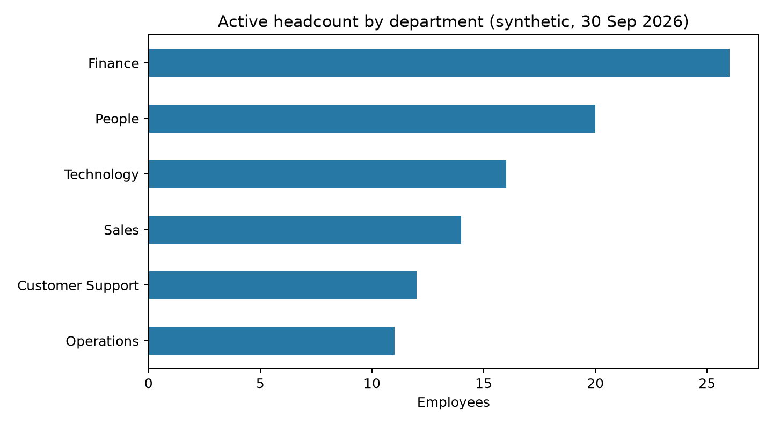
Figure 1. Active headcount by department; generated synthetic snapshot.

6. Conclusion
A basic analytics workflow can produce useful descriptive summaries when the question, dates, formula, and limitations are explicit. SAP HCM PA and OM data structures, Employee Central cloud core HR, and analytics products occupy different roles in the HR information landscape. The synthetic demonstration illustrates reproducible calculation and presentation, not a configuration or organizational finding. Its strongest practical lesson is governance: trustworthy workforce planning depends on complete definitions, data quality, privacy-preserving access, and human review.
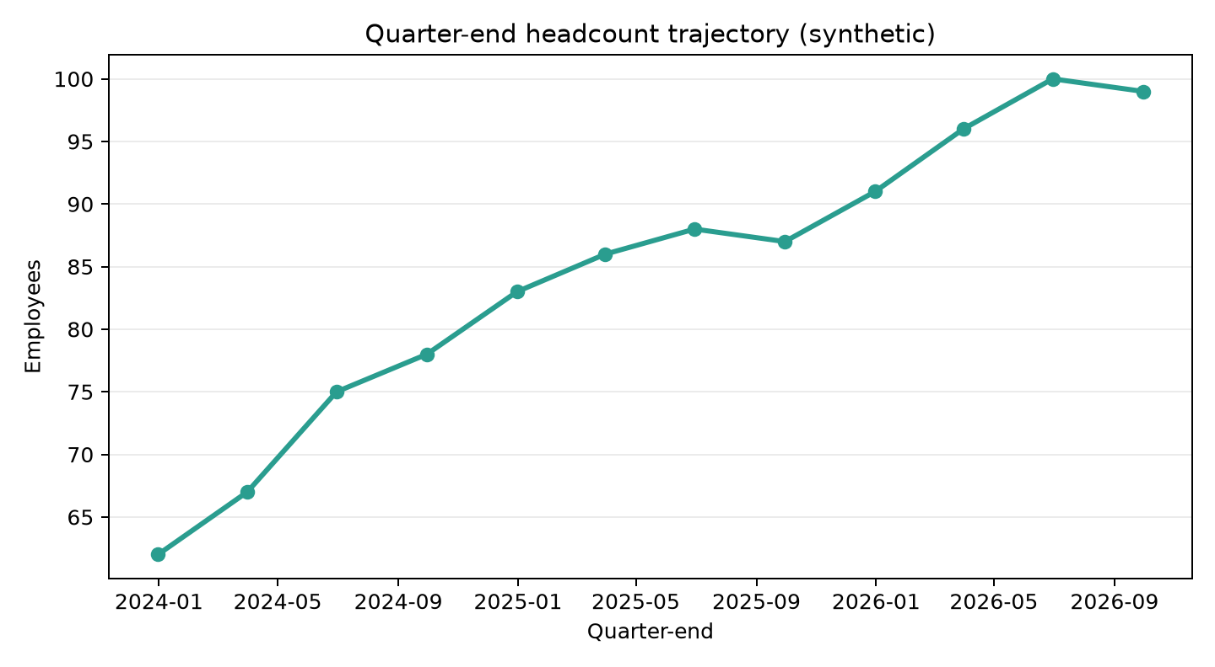
Figure 2. Synthetic quarter-end headcount counts; net totals do not explain underlying flows.

7. Decision use, data quality, and responsible follow-up
A production-ready workforce analysis would establish a governed data dictionary before building a dashboard. For each field, record the business meaning, source system, system-of-record owner, effective-date convention, allowed values, sensitivity, retention, and downstream transformations. Employee identity resolution needs an explicit rule for rehires, concurrent assignments, contingent workers, and transfers. A worker can hold more than one assignment, so a person count and an assignment count are different. For headcount, define treatment of unpaid leave, notice periods, part-time employees, and workers whose termination is effective on the snapshot date. Version that logic and test it against a set of anonymized known cases approved by HR and finance.
The current simulation uses a fixed seed and a closed cohort, but a real collection plan would be purpose-specific. A recruitment-funnel question needs requisitions and applicant-stage transitions, including rejected, withdrawn, offer, accepted, and start dates. Without those exposures, the employee recruitment-source chart only reports labels among people who appear in the staff file. A learning-effectiveness question requires learning objectives, pre/post evidence or workplace demonstration, and an appropriate comparison; training-hour totals alone show participation, not capability change. Absence analysis requires policy-approved absence categories, scheduled work exposure, and protections that prevent managers from inferring diagnoses. These requirements should be assessed before any new source is joined.
Data-quality checks should run at ingestion and refresh. Examples include valid date ordering, a unique and stable employee key, allowed department and location values, plausible employment intervals, missing required fields by process, and reconciliation to approved HR control totals. Investigate rather than silently coerce malformed dates or blanks to zero. Maintain an exception log with data owner, severity, resolution, and impact on published measures. Refreshes should be reproducible from a versioned script and immutable source extract or controlled query, with a recorded run date and formula version.
Decision use should be proportionate to evidence. Aggregate trends can inform hiring capacity, skills investment, and scenario planning, but no single indicator should trigger an individual adverse action. A decision memo should explain the population, uncertainty, alternative explanations, privacy assessment, and owner for follow-up. Before publishing a small subgroup, assess re-identification risk and apply a documented threshold or broader aggregation. Invite employee-representative or privacy input when required by policy or law. Review whether each recurring report still has a valid purpose, remove fields and recipients no longer needed, and retire stale extracts safely.

8. References
Official source portals were checked on 18 October 2026 where automated access was available; some government legal pages restrict automated retrieval. Product details and applicable legal obligations should be confirmed against the current official documentation and the organisation's jurisdiction before implementation.
[1] SAP Help Portal, SAP SuccessFactors Employee Central documentation landing area: https://help.sap.com/docs/SAP_SUCCESSFACTORS_EMPLOYEE_CENTRAL
[2] SAP Help Portal, SAP SuccessFactors Platform documentation landing area: https://help.sap.com/docs/SAP_SUCCESSFACTORS_PLATFORM
[3] SAP Help Portal, SAP ERP documentation landing area (including Human Capital Management topics): https://help.sap.com/docs/SAP_ERP
[4] SAP Analytics Cloud documentation portal: https://help.sap.com/docs/SAP_ANALYTICS_CLOUD

