WEEK 3
Performance Management
Objectives, evidence, feedback, and employee development
Academic project report | Prepared 18 October 2026
All people, organisations, measures, and outcomes in the worked examples are fictional.
Conceptual learning exercise only; no live SAP system was configured.

Executive Summary
This report designs a conceptual, employee-centred performance process using SAP SuccessFactors Performance & Goals as a capability reference. It distinguishes SMART objectives, key performance indicators (KPIs), objectives and key results (OKRs), competencies, and behaviours; proposes a weighted scorecard and fictional calculated example; and outlines the appraisal workflow, continuous feedback, learning plans, bias controls, change management, and implementation. SAP capabilities and tenant entitlements depend on the licensed release and configuration. All scores and examples are synthetic and cannot be used for real employment decisions.

Contents
1. Performance concepts and SAP SuccessFactors context
2. Cycle design and evidence standards
3. Weighted scorecard and fictional calculations
4. Workflow, calibration, and bias prevention
5. Development, learning, change, and implementation
6. Conclusion
7. Goal quality, development evidence, and process evaluation
Tables, figures, and references follow the relevant discussion.

1. Performance concepts and SAP SuccessFactors context
Performance management is a recurring conversation linking role expectations, observable outcomes, capabilities, employee support, and organisational priorities. SMART objectives are specific, measurable, achievable, relevant, and time-bound. KPIs are selected measures of progress or outcome, not objectives by themselves. OKRs express an objective and a set of measurable key results; they are a goal-setting method rather than a rating scale. Competencies describe capabilities or behaviours expected in a role. A good system distinguishes output from controllable effort, context, teamwork, learning, and conduct.
SAP SuccessFactors Performance & Goals is part of the cloud talent-management portfolio. Depending on the product generation, licence, configuration, and release, capabilities can support goals, performance forms, review cycles, competencies, feedback, calibration and development processes. SAP SuccessFactors Learning may support learning assignment and completion. These are product capabilities to evaluate, not guarantees that a particular tenant has a feature enabled. Employee Central supplies core employment context and role data; integration and data permissions require design. This conceptual system does not configure a tenant.

2. Cycle design and evidence standards
A balanced cycle starts with strategy translation and role-specific goal setting, followed by employee-manager alignment, periodic check-ins, evidence capture, self-reflection, manager assessment, calibration, discussion, development planning, and process evaluation. Check-in frequency should suit job cadence; quarterly is an example, not a universal prescription. Continuous feedback is timely, specific, respectful, and actionable. Year-end review should synthesise the full period rather than over-weight recent events.
Goals must identify scope, baseline, target, deadline, data source, owner, dependencies, and controllability. An example objective: reduce average customer case resolution time by 10% by 31 December without worsening the agreed quality metric, using the approved case system. The goal owner should clarify how cases are counted and handle demand mix. A manager should not change goals retrospectively without documenting the reason and discussing it with the employee. Define permitted evidence sources and avoid collecting unrelated personal or sensitive data.
- Set role-aligned objectives with measurable outcomes and relevant quality or risk guardrails.
- Agree baseline, targets, support, dependencies, and check-in timing with each employee.
- Hold documented check-ins and update goals when business priorities legitimately change.
- Gather balanced evidence from the full review period and invite employee self-reflection.
- Complete manager assessment, calibration with safeguards, and a feedback conversation.
- Agree development commitments, learning resources, and a follow-up date.

3. Weighted scorecard and fictional calculations
The sample scorecard weights outcome objectives at 60%, competencies at 25%, and values/behaviours at 15%. The example contributions are 80 × 0.60 = 48.0, 84 × 0.25 = 21.0, and 78 × 0.15 = 11.7, producing 80.7/100. The component values are fictional and converted to 0–100 solely for demonstration. A valid design needs descriptors, evidence expectations, role relevance, accessibility, and a clear method for goals that become obsolete or are blocked by external dependencies.
Weighted composites create trade-offs and should not hide unacceptable risks. Consider minimum standards for safety, compliance, and conduct rather than allowing high output to offset a serious breach. Ratings are not precision measurements; decimal output can imply greater accuracy than the evidence supports. Use the composite as a conversation aid, not an automatic pay, promotion, or termination rule. If linked to compensation, disclose the process, validate equity impacts, and follow applicable law and collective arrangements.

Weighted scorecard
Table 1. Weighted scorecard
Dimension | Weight | Fictional score | Weighted contribution
Outcome objectives | 60% | 80 / 100 | 48.0
Competencies | 25% | 84 / 100 | 21.0
Values / behaviours | 15% | 78 / 100 | 11.7
Total | 100% | — | 80.7 / 100

Illustrative rating bands
Table 2. Illustrative rating bands
Composite score | Interpretation | Required manager action
90–100 | Exceptional contribution | Validate evidence and sustainability; agree growth plan
75–89.9 | Strong / effective | Recognise impact; target one or two development priorities
60–74.9 | Partially meets | Diagnose barriers; specific support and check-ins
Below 60 | Needs focused improvement | Fair evidence review, clear expectations, support, and follow-up

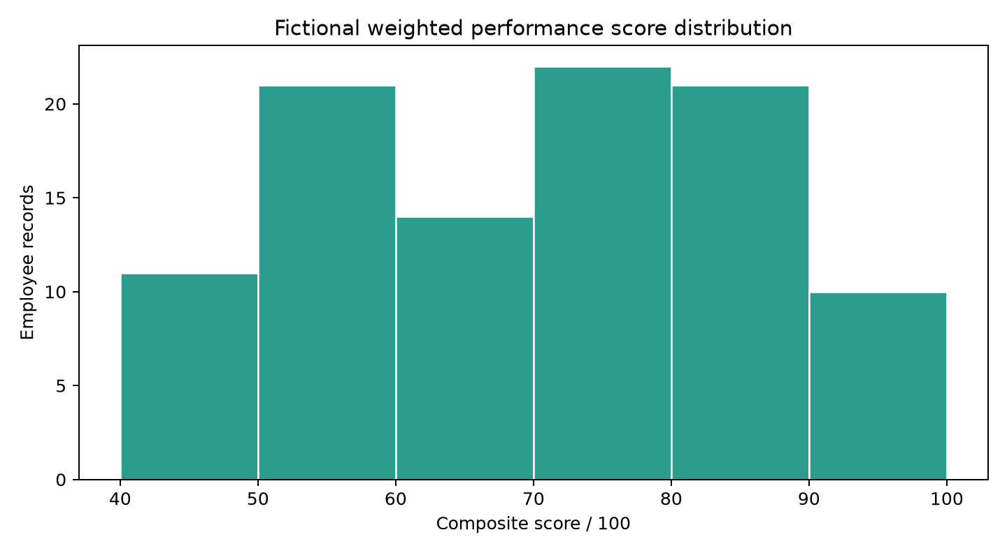
Figure 1. Distribution of fictional composite performance scores among active records.

4. Workflow, calibration, and bias prevention
A configured workflow could assign a review form, employee self-review, manager review, optional second-level review, calibration meeting, final discussion, acknowledgement, and development follow-up. The process should state what acknowledgement means; acknowledgement of receipt is not necessarily agreement. Participants need role-appropriate access to forms and supporting evidence. Apply the data-minimisation and retention rules established for performance data.
Bias safeguards include structured behaviourally anchored criteria, consistent opportunities to set goals, accessible process design, review of rating distributions by relevant groups where lawful and privacy-protective, calibration notes based on evidence rather than reputation, guidance on recency/halo/similarity bias, and an appeal or correction route. Calibration should improve consistency, not force a predetermined distribution or erase individual context. Managers should disclose conflicts and avoid using protected traits, leave, or accommodation as negative proxies. Small group analysis needs suppression and careful interpretation.
- Train managers to separate observed behaviour from personality labels.
- Audit objective quality and review completion, not just rating distributions.
- Provide employee access to their review record and a transparent correction mechanism.
- Restrict calibration materials and establish retention and export controls.

5. Development, learning, change, and implementation
Development plans convert feedback into action. Each action should name a capability, practice activity, support, evidence of progress, and review date. Examples include shadowing a senior colleague, a stretch assignment with bounded risk, mentoring, peer learning, a course, or a task rotation. Training completion is an input; demonstrated transfer to work is the outcome. Avoid punitive or unrealistic development plans and agree workload and manager support.
Implementation should begin with sponsor alignment, listening sessions, role/competency design, policy and privacy review, workflow and integration design, accessibility testing, pilot cohorts, manager and employee training, communications, controlled launch, and post-cycle evaluation. Define change ownership, configuration approval, form versioning, role permissions, data retention, support channels, and rollback or correction processes. Pilot measures may include goal quality, on-time check-ins, employee understanding, completion, evidence quality, appeal volume, and perceived fairness. Interpret scores alongside qualitative feedback and business context.
- Avoid equating an employee's score with potential, value, or future readiness.
- Provide manager enablement, employee guides, examples, and accessible support.
- Evaluate fairness, trust, and learning transfer before expanding a pilot.

Illustrative rating bands
Table 3. Illustrative rating bands
Composite score | Interpretation | Required manager action
90–100 | Exceptional contribution | Validate evidence and sustainability; agree growth plan
75–89.9 | Strong / effective | Recognise impact; target one or two development priorities
60–74.9 | Partially meets | Diagnose barriers; specific support and check-ins
Below 60 | Needs focused improvement | Fair evidence review, clear expectations, support, and follow-up

6. Conclusion
A credible performance system sets expectations collaboratively, reviews meaningful evidence, gives continuous feedback, and funds realistic development. SuccessFactors Performance & Goals can provide configurable workflow and goal-management capabilities, but process quality, local policy, licensed features, data access, and human judgement determine whether the system is fair and usable. The calculated scorecard demonstrates arithmetic only; it is not a validated rating model.

7. Goal quality, development evidence, and process evaluation
A useful SMART objective is not merely a numeric target. Specificity states the outcome and scope; measurability states the evidence and baseline; achievability considers resources and dependencies; relevance links the outcome to a team or enterprise priority; and time-bound means a clear end date or review interval. A KPI supports monitoring but can distort behaviour when used without a quality, risk, or customer guardrail. For example, a target on cases closed should be balanced with quality and reopened-case evidence. Employees should understand which measures they can influence and how exceptional external factors will be treated.
OKRs usually work best as a transparent alignment and learning mechanism with a short cycle. An objective describes a meaningful direction; key results are measurable outcomes that indicate progress. A key result should avoid becoming a list of tasks. OKRs do not automatically translate into individual ratings or compensation. If an organisation chooses to connect them to an appraisal, explain that relationship, prevent double counting, and account for shared results and dependencies. A person may contribute to a key result without being solely accountable for it. Teams should review progress and adjust assumptions rather than retroactively redefining success to match an outcome.
Competency assessment needs behavioural anchors appropriate to job level and opportunity. Evidence might include a documented customer outcome, a peer collaboration example, a quality review, or observed decision-making in a stretch assignment. Avoid inferring competencies from confidence, visibility, or similarity to the assessor. Employees need an opportunity to provide context and identify structural barriers. Where a role changed materially during the cycle, preserve the original goal history and agree a fair replacement instead of rating an obsolete target as if circumstances were unchanged.
Development planning should be jointly owned. Convert one priority into a practice-based commitment—for example, lead a scoped project review, receive a mentor's feedback on a defined skill, or demonstrate a new tool capability on a suitable work task. Identify budget, workload, accessibility, manager support, and a measurable demonstration date. Review progress at the next check-in and revise the plan when the opportunity is unavailable. Learning content completion can be recorded, but the effectiveness measure should examine whether the employee can apply the skill in the job.
After each cycle, evaluate completion and quality together: objective clarity, on-time conversation, employee understanding, manager training coverage, appeal and correction themes, perceived fairness, development follow-through, and differences in opportunity. Treat group comparisons carefully, protect small cells, and investigate rather than assume a causal explanation. Use findings to improve guidance and manager support. A pilot should include representative roles and accessibility needs, a support channel, change ownership, a clear data-retention rule, and a decision gate for whether to continue or redesign.

8. References
Official source portals were checked on 18 October 2026 where automated access was available; some government legal pages restrict automated retrieval. Product details and applicable legal obligations should be confirmed against the current official documentation and the organisation's jurisdiction before implementation.
[1] SAP Help Portal, SAP SuccessFactors Employee Central documentation landing area: https://help.sap.com/docs/SAP_SUCCESSFACTORS_EMPLOYEE_CENTRAL
[2] SAP Help Portal, SAP SuccessFactors Platform documentation landing area: https://help.sap.com/docs/SAP_SUCCESSFACTORS_PLATFORM
[3] SAP Help Portal, SAP ERP documentation landing area (including Human Capital Management topics): https://help.sap.com/docs/SAP_ERP
[4] SAP Help Portal, SAP SuccessFactors Performance & Goals documentation entry point: https://help.sap.com/docs/SAP_SUCCESSFACTORS_PERFORMANCE_AND_GOALS

