WEEK 4
Succession Planning
Critical-role continuity, talent development, and readiness
Academic project report | Prepared 18 October 2026
All people, organisations, measures, and outcomes in the worked examples are fictional.
Conceptual learning exercise only; no live SAP system was configured.

Executive Summary
This report defines a governed succession-planning method for a fictional organisation. It covers critical-role identification, talent reviews, competency mapping, readiness categories, succession matrices, nine-box assessment, skills gaps, leadership development, mentoring, job rotation, retention, risk, and continuity. The accompanying matrix contains six fictional critical roles and candidates; the nine-box counts are illustrative. SAP SuccessFactors Succession & Development is discussed as a configurable capability family, subject to current licensing and release. Succession nominations are confidential planning hypotheses—not guarantees, promises, or employment decisions.

Contents
1. Purpose, critical-role identification, and governance
2. Talent review, competency maps, and readiness levels
3. Nine-box assessment and skills-gap analysis
4. Development roadmaps and leadership pipeline
5. Risk, contingency, metrics, and SAP capabilities
6. Conclusion
7. Role-specific roadmaps and continuity scenarios
Tables, figures, and references follow the relevant discussion.

1. Purpose, critical-role identification, and governance
Succession planning reduces continuity risk for roles whose vacancy would materially impair strategy, safety, regulatory obligations, customer delivery, or scarce expertise. Criticality is role-based, not a judgement that one incumbent is more valuable as a person. Define criteria such as decision authority, replacement lead time, knowledge concentration, external talent scarcity, control ownership, and consequence of interruption. Confirm role boundaries, interim delegation authority, required credentials, and segregation-of-duties constraints before naming a successor.
Governance should include an accountable executive sponsor, HR talent team, business leaders, and risk/control owners. Establish a consistent review cadence, evidence standards, access-limited records, correction and challenge routes, retention period, and decision log. Candidates must not be told that a nomination guarantees promotion. Nomination should be based on role-relevant evidence and development interest, with an equitable process and documented uncertainty.

2. Talent review, competency maps, and readiness levels
A talent review compares demonstrated role outcomes, competencies, experiences, aspirations, mobility constraints, and development needs with future-role requirements. Competency maps should be specific and observable: strategic judgement, financial stewardship, people leadership, operational resilience, privacy/security governance, or technical expertise where relevant. Define proficiency levels and acceptable evidence. Current performance and future potential are distinct questions; exceptional performance in a current role does not automatically establish readiness for a different role.
Use readiness labels with operational meaning, such as ready now, ready in 1–2 years, ready in 3–5 years, emergency cover only, or no identified successor. Time bands are planning estimates that must be validated periodically against experience and role needs. Distinguish an interim deputy from a fully qualified permanent successor. The fictional matrix identifies gaps and a development or contingency action for each role. The names and role codes are fictional labels, not actual people.

Fictional succession matrix
Table 1. Fictional succession matrix
Critical role | Role code | Fictional candidate | Readiness | Key gap | Next experience / contingency
Chief People Officer | CPO-01 | Candidate A | Ready now | Executive stakeholder influence | Board simulation; sponsor mentoring
Payroll Operations Lead | PAY-04 | Candidate B | Ready in 1-2 years | Multi-country payroll governance | Cross-functional payroll rotation
HRIS Product Owner | HRIS-02 | Candidate C | Ready in 1-2 years | Roadmap prioritisation | Lead a scoped HRIS release
Regional Operations Director | OPS-07 | Candidate D | Ready in 3-5 years | P&L and strategy experience | Regional assignment; leadership mentor
Head of Talent Acquisition | TA-03 | Candidate E | Emergency cover only | Strategic workforce planning | Interim delegation drill; capability plan
Data Protection Officer | DPO-01 | Candidate F | No identified successor | Independent privacy expertise | External interim cover; develop internal bench

3. Nine-box assessment and skills-gap analysis
A nine-box grid crosses performance with potential to structure discussion, but it is not an objective test or a self-validating algorithm. Potential criteria should be transparent, job-related, and evidence-based, such as learning agility demonstrated in new contexts, ability to operate at greater scope, and motivation for the role. Assessors need common anchors and calibration training. A low or high box is not a permanent label, and development access should not be restricted only to high-potential employees.
The chart uses a fictional cohort distribution across developing, effective, and exceptional performance and potential categories. Counts are generated solely for illustration and do not come from the workforce ratings or a validated assessment. Skills-gap analysis compares the future-role competency profile with the candidate's verified evidence. Mark each gap with confidence and source; separate a genuine gap from missing evidence. Prioritise gaps by role criticality and time to build, and identify whether learning, experience, hiring, knowledge capture, or contingency can close the risk.
- Use multiple evidence sources and structured calibration, not intuition alone.
- Document uncertainty, candidate interest, mobility and accessibility context, and conflicts of interest.
- Review representation and access to development without exposing small-group personal data.
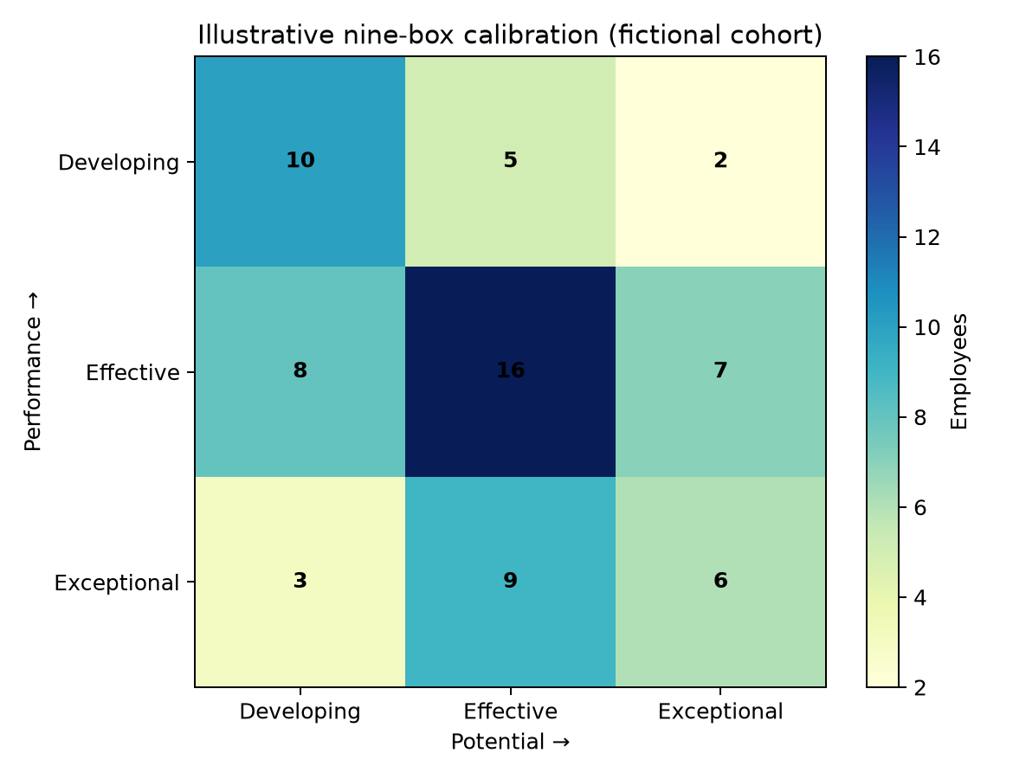
Figure 1. Synthetic nine-box distribution; cells are fictional counts and are not a validated potential measure.

4. Development roadmaps and leadership pipeline
A roadmap links a named role requirement to learning through experience, exposure, and education. For a payroll-operations lead, a bounded rotation through payroll controls, finance reconciliation, and incident management may test cross-functional readiness. For an HRIS product owner, leading a scoped release can develop prioritisation and change governance. Senior leadership candidates may receive sponsor mentoring, executive simulations, budget responsibility, and stakeholder feedback. Each assignment needs an explicit objective, supervisor, risk boundary, success evidence, and review date.
Mentoring supports reflection and networks but does not replace accountable line management or role competence. Job rotation should not disrupt critical operations, expose restricted data unnecessarily, or create segregation-of-duties conflicts. Provide equitable access to stretch work and review workload, accommodation, and employee consent. Retention actions should address meaningful work, development, succession transparency at an appropriate level, and fair reward; avoid treating a person as a retention risk based on protected characteristics.
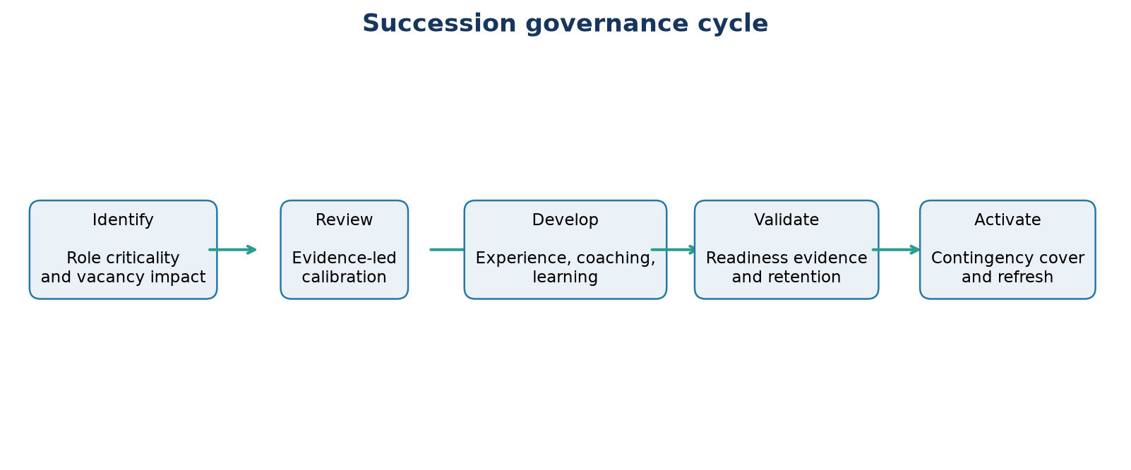
Figure 2. Governance cycle for role identification, talent review, development, validation, and continuity.

5. Risk, contingency, metrics, and SAP capabilities
Continuity planning covers sudden vacancy, candidate departure, readiness delays, undocumented knowledge, security-sensitive access, and stale or biased assessments. Preventive measures include cross-training, documented procedures, approved delegation, access provisioning controls, multiple candidates where appropriate, external-market plans, and tabletop exercises. Contingency steps should identify who can appoint an interim, what controls remain mandatory, who receives notification, and how long the arrangement can continue.
The KPI table offers definitions for critical-role coverage, ready-now coverage, development milestones, internal placements, and successor retention. Establish a baseline and role-specific targets rather than choosing an arbitrary universal percentage. Review both coverage and quality: an inflated coverage measure can conceal weak evidence or over-nomination. Monitor disparities and candidate experience with adequate group sizes and privacy safeguards.
SAP SuccessFactors Succession & Development can support talent profiles, succession org charts, position-based succession planning, talent pools, readiness, and development planning depending on licensing, configuration, and current release. Product terminology and feature availability change; validate in current SAP Help and the customer's tenant. Establish permission roles and confidentiality because succession data can be highly sensitive. A product feature does not replace governance or continuity documentation.

Role risk and continuity plan
Table 2. Role risk and continuity plan
Risk | Likelihood | Impact | Preventive response | Contingency
Single incumbent leaves suddenly | Possible | Major | Identify at least one interim delegate; document knowledge | Cross-trained deputy and authorised interim appointment
Candidate exits before readiness | Possible | Major | Career discussion, retention review, fair mobility | Maintain multiple candidates and external market plan
Critical knowledge is undocumented | Likely | Major | Role-based process maps, access-controlled handover | Time-bound transition and recovery procedure
Readiness label is stale or biased | Possible | Moderate | Evidence-based quarterly refresh and calibration | Reassess candidates; do not treat labels as promises

6. Conclusion
Effective succession planning starts with genuinely critical roles, clarifies the evidence and readiness meaning, develops capability through supported experiences, and maintains credible contingencies. The matrix, roadmap, and nine-box are fictional teaching artefacts. They demonstrate how a succession conversation can be structured; they do not predict career outcomes or identify actual successors. Review decisions periodically, protect the records, and measure resilience as well as development.

Succession KPIs
Table 3. Succession KPIs
Indicator | Definition | Example target for governance discussion
Critical-role coverage | Critical roles with at least one validated successor ÷ total critical roles | Baseline first; improve coverage without forcing nominations
Ready-now coverage | Roles with a validated ready-now option ÷ roles where immediate cover is required | Role-specific; explicitly document emergency-only cover
Development milestone rate | Due roadmap milestones completed with evidence ÷ milestones due | Set cohort-specific target after baseline
Internal placement rate | Critical vacancies filled internally ÷ filled critical vacancies | Monitor alongside fairness and retention
Successor retention | Named candidates retained over period ÷ candidates at period start | Use trend with privacy and cohort-size safeguards

7. Role-specific roadmaps and continuity scenarios
The matrix becomes actionable when each critical role has a concise, current role profile. Include purpose, key decisions, stakeholder relationships, essential capabilities, mandatory credentials, delegated authority, control conflicts, knowledge artifacts, and continuity impact. Review criticality when strategy, regulation, operating model, or technology changes. Avoid marking every leadership job as critical by default: too broad a population dilutes resources and makes emergency readiness difficult to maintain. Include specialist and operational roles where expertise or control ownership is difficult to replace, not only senior executives.
A fictional roadmap for the payroll operations lead can sequence three evidence-building experiences: reconcile a controlled payroll close with finance, lead a simulated statutory change assessment, and coordinate a response exercise for a rejected payment file. Readiness review would consider accuracy, control discipline, stakeholder communication, and ability to lead under time pressure. For the HRIS product owner, a scoped release should demonstrate requirements prioritisation, access/privacy review, test evidence, cutover planning, and measurable adoption. For a regional operations director, a temporary project or rotation can build budget ownership and cross-site leadership without prematurely exposing the candidate to unsupported risk. Each assignment needs a sponsor, a mentor or manager, an end date, and a feedback record.
Contingency planning must work even when no permanent successor is ready. Identify the authorised interim decision-maker, the duration and boundaries of delegated authority, required dual controls, sensitive system roles, essential supplier contacts, and where the approved procedure is stored. A tabletop scenario can simulate a sudden vacancy during payroll cut-off or an incident affecting the data protection lead. Participants test call trees, access requests, approval authority, stakeholder communication, and recovery objectives. Gaps should become time-bound actions with accountable owners. An interim cover plan is not a promise that an employee will be promoted.
Readiness validation should use evidence gathered since the previous review and confirm candidate interest, availability, and development progress through appropriate channels. A label must not be updated solely to improve a KPI. If a candidate leaves, is unavailable, or declines a move, promptly revise the plan and provide a fair career conversation. Track whether development experiences are equitably distributed, while preserving candidate confidentiality and respecting local privacy and employment rules. For small talent cohorts, individual-level reporting should be restricted to the authorised review group and not included in broadly accessible dashboards.
A robust review cycle asks leaders to challenge assumptions: what has changed in the role, what evidence supports readiness, what critical capability remains uncovered, what dependency would block an interim, and what alternative exists if the primary candidate exits? Review both bench depth and role resilience. Where internal readiness cannot be developed in time, consider knowledge transfer, external hiring, service continuity, or role redesign rather than overstating a successor's preparedness.

8. References
Official source portals were checked on 18 October 2026 where automated access was available; some government legal pages restrict automated retrieval. Product details and applicable legal obligations should be confirmed against the current official documentation and the organisation's jurisdiction before implementation.
[1] SAP Help Portal, SAP SuccessFactors Employee Central documentation landing area: https://help.sap.com/docs/SAP_SUCCESSFACTORS_EMPLOYEE_CENTRAL
[2] SAP Help Portal, SAP SuccessFactors Platform documentation landing area: https://help.sap.com/docs/SAP_SUCCESSFACTORS_PLATFORM
[3] SAP Help Portal, SAP ERP documentation landing area (including Human Capital Management topics): https://help.sap.com/docs/SAP_ERP
[4] SAP Help Portal, SAP SuccessFactors Succession documentation entry point: https://help.sap.com/docs/SAP_SUCCESSFACTORS_SUCCESSION

