WEEK 5
HR Data Security
Confidentiality, privacy, access control, and resilience
Academic project report | Prepared 18 October 2026
All people, organisations, measures, and outcomes in the worked examples are fictional.
Conceptual learning exercise only; no live SAP system was configured.

Executive Summary
This report applies confidentiality, integrity, and availability principles to HR records, payroll, performance and succession data. It covers SAP authorization concepts, least privilege, role-based access, segregation of duties, encryption, logs, monitoring, retention, incident response, awareness, GDPR, India's Digital Personal Data Protection Act 2023 and Rules, and recognized security standards. A likelihood-impact matrix and six-row illustrative risk register show inherent and residual risk. Legal applicability and commencement are fact-specific; the report is educational and is not legal advice. The matrix scores and scenarios are fictional.

Contents
1. Scope, data classification, and security objectives
2. Access control, least privilege, and SAP authorization concepts
3. Technical and operational safeguards
4. Privacy law and standards: applicability boundaries
5. Risk assessment, mitigation, and residual risk
6. Incident response, awareness, and audit measures
7. Conclusion
8. Privacy-by-design lifecycle and control assurance
Tables, figures, and references follow the relevant discussion.

1. Scope, data classification, and security objectives
HR systems process identity, contact, employment, organisational, compensation, bank, attendance, performance, learning, and sometimes health or accommodation information. These data types do not all carry the same sensitivity or legal treatment. Classify records, identify owners and processors, document purposes and flows, minimise collection, and define access and retention according to jurisdiction and business need. Confidentiality prevents unauthorised disclosure; integrity preserves accuracy and completeness; availability ensures authorised users and processes can access data when needed. Accountability, privacy, and resilience complement the CIA objectives.
SAP landscapes may include on-premise ERP HCM, SAP HCM for SAP S/4HANA contexts, SuccessFactors cloud services, identity providers, payroll providers, banks, analytics platforms, and local interfaces. Responsibility is shared across customer, SAP, and other providers according to contracts and deployment model. Verify current SAP security documentation, service descriptions, data-processing terms, configuration, and integration boundaries. Do not infer that a cloud service makes customer role design or lawful processing automatic.

2. Access control, least privilege, and SAP authorization concepts
SAP access control commonly combines user identity, roles, authorizations, organizational restrictions, application controls, and auditability. In classic ABAP-based SAP systems, authorization objects and field values are evaluated by authorization checks; role administration and derived/composite role patterns are release and design dependent. Organizational fields can restrict access by company or personnel area when correctly implemented and tested. SuccessFactors uses its own role-based permissions and target-population concepts; do not assume an ABAP authorization design maps one-to-one to cloud roles. Product-specific configuration and identity integration must be reviewed in current documentation.
Least privilege grants only the minimum required access for the shortest appropriate period. Segregation of duties separates incompatible tasks—for example changing bank details, processing payroll, approving results, and releasing payments. A role matrix should identify job function, system, data object, actions, organisational scope, approver, and recertification cadence. Test negative access: a user must not see or alter data outside the authorised population. Control emergency access with approval, time limits, session logs, and independent review.

HR data asset and control map
Table 1. HR data asset and control map
Asset / activity | Primary risk | Illustrative preventive / detective controls
Employee identifiers and demographics | Over-broad access, disclosure, inaccurate use | Purpose limitation, minimisation, role-based field access, aggregation/suppression
Compensation and bank details | Fraud, identity theft, payment diversion | Restricted roles, maker-checker payment change, masking, secure transmission
Performance and succession | Unfair decisions, retaliation, confidential disclosure | Need-to-know access, transparent process, audit trail, retention limit
Payroll integrations and files | Interception, tampering, duplicate payment | Authenticated encrypted interfaces, integrity checks, reconciliation, key management
Privileged configuration and logs | Unapproved change or evidence alteration | Separate admin roles, monitored emergency access, protected central logs

3. Technical and operational safeguards
Protect data in transit with authenticated, current cryptographic protocols and at rest using supported encryption and key management. Confirm which application, database, backup, and interface layers are covered; encryption does not compensate for excessive access or insecure endpoints. Secure secrets and integration credentials, rotate keys, restrict service identities, validate certificates, and monitor failed authentication. Mask or pseudonymise non-production data; synthetic data is preferable for training and routine development.
Audit logs should record who accessed or changed sensitive records, what changed, when, the relevant identity and context, and the approval or reason where appropriate. Protect logs from unauthorised alteration, limit access to security investigators, synchronise time, and define retention. Monitor anomalous exports, privileged access, role changes, bank-detail changes, mass downloads, failed logins, and integration errors with privacy-proportionate alerts. Retention schedules should cover active records, backups, legal holds, and secure disposal. Incident plans should include triage, containment, preservation, impact assessment, notification decisions, recovery, and lessons learned; statutory notification timelines vary.

4. Privacy law and standards: applicability boundaries
The EU General Data Protection Regulation (GDPR) applies when its territorial and material scope tests are met; it is not automatically applicable to every employer. Relevant principles include lawfulness, fairness and transparency, purpose limitation, data minimisation, accuracy, storage limitation, integrity/confidentiality, and accountability. Employment processing also interacts with national law, worker consultation, and restrictions on special-category data. Determine controller/processor roles, lawful basis, notices, rights, international transfers, records, and impact assessment duties with qualified counsel.
India's Digital Personal Data Protection Act, 2023 establishes a framework for digital personal data processing within its scope. The Digital Personal Data Protection Rules and commencement notifications should be checked in the official Gazette for the processing date because commencement and obligations may be phased. Confirm applicability, notices, consent or other permitted grounds, data-principal rights, security safeguards, breach obligations, retention, and any exemptions with counsel. This report does not claim every provision is in force for every entity or date. The Information Technology Act / rules and sector-specific employment or financial obligations may also be relevant depending on facts.
ISO/IEC 27001 provides requirements for an information security management system; NIST SP 800-53 provides a control catalogue, and NIST CSF 2.0 is a cybersecurity risk-management framework. They are not substitutes for privacy law or a jurisdiction-specific compliance assessment. HIPAA in the United States applies to covered entities and business associates in defined contexts; it does not automatically apply to every employer merely because the employer holds health-related information. Specialist counsel should determine role and scope.
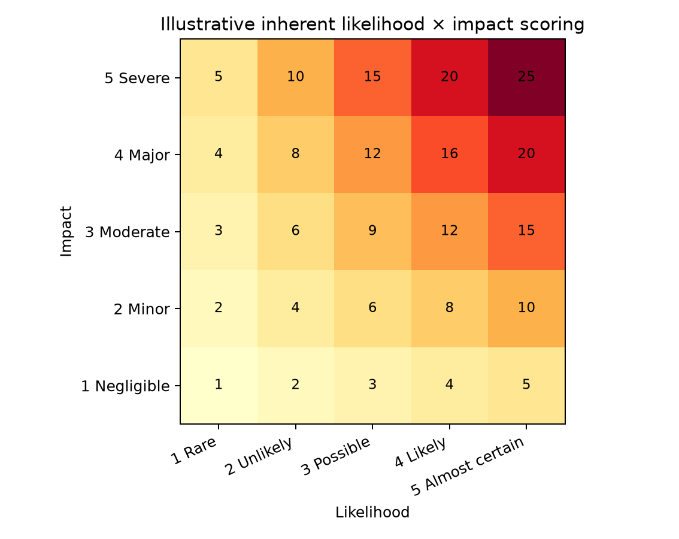
Figure 1. Ordinal likelihood-impact matrix; scores are illustrative and not measured probabilities.

5. Risk assessment, mitigation, and residual risk
The risk matrix multiplies ordinal likelihood and impact scores from 1 to 5 for a simple inherent score from 1 to 25. It is a prioritisation aid, not a statistically calibrated probability. Impact includes confidentiality, employee rights, financial loss, payroll disruption, legal exposure, and trust. The register describes six fictional threats, mitigating controls, and qualitative residual risk. Scores must be recalibrated with asset context, threat intelligence, control effectiveness, vulnerability, and risk appetite.
Residual risk remains after controls: phishing can succeed despite MFA, administrators may misconfigure roles, encrypted files can be misdirected to authorised but unintended recipients, retention deletion can be constrained by backups or legal holds, and vendor outages can exceed recovery assumptions. Assign a risk owner, treatment, due date, evidence, and acceptance authority. Reassess after system changes, incidents, new integrations, acquisitions, or legal changes. Test controls through access samples, negative tests, restore exercises, incident tabletop exercises, and log review.

Inherent and residual risk register
Table 2. Inherent and residual risk register
Threat scenario | Likelihood (1-5) | Impact (1-5) | Inherent score | Controls / mitigation | Residual risk (illustrative)
Payroll bank-detail change fraud | 3 | 5 | 15 | Dual approval, out-of-band verification, change alerts, payment reconciliation | Medium; residual likelihood remains non-zero
Manager views unauthorised performance data | 3 | 4 | 12 | Role-based field permissions, periodic access review, access logs | Low-Medium; misassignment and exports remain
Phishing compromises HR user | 4 | 4 | 16 | MFA, awareness, mail controls, conditional access, response drill | Medium; credential theft and social engineering persist
Unencrypted or misrouted export | 3 | 5 | 15 | Disable unnecessary exports, secure transfer, DLP, encryption, recipient checks | Low-Medium; human error remains
Excessive retention of applicant/employee records | 3 | 4 | 12 | Retention schedule, legal holds, automated deletion, evidence of disposal | Low-Medium; legal holds and backups complicate deletion
Availability disruption to payroll period close | 2 | 5 | 10 | Backups, tested recovery, documented manual contingency, vendor escalation | Medium; recovery and external dependency risks remain

6. Incident response, awareness, and audit measures
An HR incident playbook identifies reporting channels, on-call security and privacy contacts, payroll operations, legal, communications, and business continuity. Initial actions preserve evidence and stop ongoing exposure without destroying logs. Determine affected data, people, systems, countries, recipients, duration, and likelihood of harm. Restrict access, rotate credentials where needed, validate payroll/payment integrity, and use approved notification decision paths. Notification duties and deadlines are determined by applicable law and contract; avoid promising timelines before assessment. After recovery, communicate lessons, remediate root causes, and verify completion.
Awareness training should be role-specific. HR and payroll users need practice spotting payroll diversion attempts, verifying identity changes, handling sensitive exports, and reporting suspicious access. Managers should understand confidentiality of performance and succession data. Administrators need secure configuration and break-glass procedures. Audit KPIs should have an owner, denominator, target, data source, and period. Review exceptions and effectiveness, not just completion percentages. The KPI table contains sample definitions; targets must be approved through governance.
- Report suspected disclosure quickly through an accessible channel; do not investigate by forwarding sensitive data.
- Test joiner, mover, and leaver access events end to end.
- Retest after permission or integration changes and retain evidence securely.
- Review vendor, interface, and business-continuity dependencies in tabletop exercises.

Audit and security KPIs
Table 3. Audit and security KPIs
KPI | Formula | Control interpretation
Privileged access recertification | Reviewed privileged accounts ÷ accounts due for review | Target complete, on time; investigate exceptions
MFA coverage | In-scope users with enforced MFA ÷ in-scope users | Segment privileged and workforce access
Security incident response time | Median time from alert to triage / containment | Measure by severity and clock definition
Access removal timeliness | Leavers disabled within policy SLA ÷ leavers sampled | Reconcile HR events to identity systems
Sensitive export exceptions | Count and rate of unauthorised / unexplained exports | Trend and investigate; zero is not assumed
Restore test success | Successful tested restores ÷ restores planned | Test recoverability and payroll continuity

7. Conclusion
HR security is a lifecycle responsibility covering lawful purpose, data minimisation, identity and role governance, secure processing, monitoring, retention, incident response, and recovery. SAP authorization mechanisms are deployment-specific controls within a wider operating model. GDPR, India's DPDP framework, and security standards have different scope and effect; verify the law and Gazette notifications applicable at the time. The fictional risk register supports discussion, not certification or legal advice.

8. Privacy-by-design lifecycle and control assurance
Privacy-by-design begins before a system field, report, or integration is introduced. Document the purpose, data subjects, categories, sources, recipients, locations, retention, access, and legal basis or other permitted ground applicable to the processing. Collect only data necessary for that purpose and give clear notices in a language and channel employees can understand. Design access so that HR operations, line management, payroll processing, analytics, and security investigation see different minimum subsets. A role that permits viewing an employee record should not automatically permit bulk export, compensation change, or bank-detail maintenance.
A data-flow inventory should include source and destination systems, file and API interfaces, service accounts, subprocessors, analytics copies, backups, and deletion paths. For each flow, record authentication, encryption, integrity checks, error handling, monitoring, data owner, and retention. Test access changes across the full identity lifecycle: joiner provisioning, role or location change, temporary assignment, leave, termination, and emergency access. Coordinate HR events with identity governance so that delayed feeds or failed deprovisioning are visible and escalated. Validate cloud role target populations and classic organizational authorization fields with positive and negative tests after every material change.
Control assurance requires more than a policy document. Sample privileged access quarterly or at a risk-based interval, reconcile the list to actual accounts, inspect exceptions, test that logs reach a protected central store, and replay a restore exercise. Monitor supplier notifications, security advisories, vulnerabilities, and contract changes. For encryption, verify the actual coverage of application traffic, databases, backups, and exported files as well as key custody and rotation. For deletion, test live records and understand how backup expiry, legal hold, and immutable logs are handled. Document residual risks accepted by a named, authorised owner with an expiry or review date.
An incident scenario involving payroll diversion should verify that a bank detail change generates a notification, independent verification uses a known channel rather than the submitted contact, payment release remains segregated, and the employee can report a concern. A privacy disclosure scenario should test containment, log preservation, identification of affected records and recipients, legal review, notification decision authority, and recovery. The playbook must avoid emailing exposed data as evidence. Exercise outcomes should result in assigned corrective actions and retest.
Legal review is an operational dependency. Maintain a register of relevant jurisdictions, entity roles, processing purposes, contracts, notices, retention rules, transfer mechanisms, and regulatory dates. For India, check the official Gazette for the DPDP Rules and commencement notifications in force for the relevant processing and obligation. For GDPR, confirm territorial scope and controller/processor responsibilities. HIPAA analysis depends on covered-entity or business-associate context; employer status alone is not enough. Update security and privacy controls when law, product architecture, or data use changes, and seek qualified counsel where application is uncertain.

9. References
Official source portals were checked on 18 October 2026 where automated access was available; some government legal pages restrict automated retrieval. Product details and applicable legal obligations should be confirmed against the current official documentation and the organisation's jurisdiction before implementation.
[1] SAP Help Portal, SAP SuccessFactors Employee Central documentation landing area: https://help.sap.com/docs/SAP_SUCCESSFACTORS_EMPLOYEE_CENTRAL
[2] SAP Help Portal, SAP SuccessFactors Platform documentation landing area: https://help.sap.com/docs/SAP_SUCCESSFACTORS_PLATFORM
[3] SAP Help Portal, SAP ERP documentation landing area (including Human Capital Management topics): https://help.sap.com/docs/SAP_ERP
[4] European Parliament and Council, Regulation (EU) 2016/679 (General Data Protection Regulation), official text: https://eur-lex.europa.eu/eli/reg/2016/679/oj
[5] Government of India, Ministry of Electronics and Information Technology, Digital Personal Data Protection Act / data protection framework: https://www.meity.gov.in/data-protection-framework
[6] Government of India, e-Gazette of India, authoritative Gazette publication portal (verify applicable DPDP Rules and commencement notifications): https://egazette.gov.in/
[7] NIST, SP 800-53 Rev. 5, Security and Privacy Controls for Information Systems and Organizations: https://csrc.nist.gov/pubs/sp/800/53/r5/upd1/final
[8] NIST, Cybersecurity Framework 2.0: https://www.nist.gov/cyberframework
[9] ISO/IEC 27001:2022, Information security management systems — Requirements (standard overview): https://www.iso.org/standard/27001
[10] U.S. Department of Health and Human Services, HIPAA for Professionals: https://www.hhs.gov/hipaa/for-professionals/index.html

