DATA SCIENCE
FUNDAMENTALS ASSESSMENT
Data Analyst Internship
Task 1:
Data Science Fundamentals Assessment
Internship duration: 02 October 2026 - 27 November 2026
Prepared as a beginner-friendly practical assessment
Dataset: fictional, reproducible student-performance sample

1. Introduction
This report documents a practical introduction to data science using Python. It progresses from language fundamentals to descriptive statistics, NumPy arrays, Pandas data preparation, and visual communication. All examples use a small, fictional student-performance dataset authored for this assignment; no external dataset or citations are used.

2. Objectives
- Demonstrate core Python syntax, data types, collections, control flow, functions, exceptions, and file handling.
- Calculate descriptive statistics and correlations from actual sample records.
- Practice array operations and tabular analysis with NumPy and Pandas.
- Create common charts and apply basic validation, cleaning, reproducibility, and privacy principles.

3. What is Data Science?
Data science combines domain questions, data preparation, computation, and communication. A responsible workflow clarifies the question, checks the data, chooses suitable analysis, and reports limitations alongside findings. A descriptive relationship is not proof of causation.
Workflow used: define fields -> validate records -> summarize -> visualize -> interpret cautiously.

4. Data Science Lifecycle
The lifecycle begins by framing a question and identifying appropriate data. It continues through collection, quality checks, preparation, exploration, analysis, visualization, and communication. In production work, monitoring and revision follow deployment; this assessment focuses on the preparation-to-communication stages.

5. Python Fundamentals
Variables use descriptive names; assignment demonstrates integers, floats, strings, and Booleans. Arithmetic, comparisons, and logical operators support calculations and conditions. if/elif/else select a study band; for and while loops iterate; a function encapsulates a reusable pass-rate calculation.
def calculate_pass_rate(scores, pass_mark=70):
if not scores:
return 0.0
return sum(score >= pass_mark for score in scores) / len(scores)
Lists are ordered and mutable; tuples are ordered and immutable; sets retain unique items; dictionaries map keys to values. A ValueError is caught in a small conversion example. A context manager writes and reads a short CSV so the file is closed reliably.

6. Python Data Types
Example | Type | Use
20 | int | Student count / identifier
5.8 | float | Study hours
"Female" | str | Category / name
True | bool | Logical state
Explicit conversion (int("20")) is appropriate only when the text represents a valid whole number.

7. Python Data Structures
Lists hold ordered mutable values, tuples hold ordered fixed values, sets retain unique values, and dictionaries map keys to values.
scores = [68, 75, 91]
columns = ('Age', 'int64')
tools = {'Python', 'NumPy'}
student = {'Student_ID': 1001, 'Age': 19}

8. Operators
Arithmetic operators calculate values; comparison operators evaluate relationships; logical operators combine Boolean conditions.
total = 8 + 2 * 3
meets_threshold = total >= 10
valid = meets_threshold and True

9. Conditional Statements
if study_hours >= 8:
band = 'high'
elif study_hours >= 4:
band = 'moderate'
else:
band = 'low'

10. Loops
A for loop visits items in a sequence. A while loop repeats while a condition remains true; update its condition each iteration to avoid an infinite loop.
for score in [68, 75, 91]:
print(score)
count = 3
while count > 0:
count -= 1

11. Functions
Functions name a reusable operation, accept inputs, and return a result. The project documents helpers with docstrings and keeps their inputs explicit.
def calculate_pass_rate(scores, pass_mark=70):
if not scores:
return 0.0
return sum(score >= pass_mark for score in scores) / len(scores)

12. Statistical Foundations
The following descriptive measures are calculated from all Exam_Score observations. Variance and standard deviation use the sample convention (ddof=1); percentiles use Pandas' default linear interpolation.
Measure | Calculated value
Mean | 78.10
Median | 77.50
Mode | 75.00
Minimum | 58.00
Maximum | 96.00
Range | 38.00
Variance (sample) | 115.46
Standard deviation (sample) | 10.75
25th percentile | 71.50
75th percentile | 86.25
Pearson correlation between Study_Hours and Exam_Score: 0.994. Correlation describes linear association in this sample, not a causal effect or a guarantee about other students.
exam_scores = data['Exam_Score']
mean_score = exam_scores.mean()
q3 = exam_scores.quantile(0.75)
correlation = data['Study_Hours'].corr(exam_scores)

13. NumPy
NumPy arrays provide compact numerical structures. The analysis creates a one-dimensional array of exam scores and a two-dimensional array of study hours and exam scores. It demonstrates indexing, slicing, arithmetic, reshaping, and mean/minimum/maximum reductions.
scores = data['Exam_Score'].to_numpy()
first_score = scores[0]
first_three = scores[:3]
example = np.arange(1, 7).reshape(2, 3)
shifted = example + 10
Calculated NumPy score mean: 78.10; minimum: 58; maximum: 96.
NumPy sample standard deviation (ddof=1): 10.75.

14. Pandas
A DataFrame is created from records and also exported to CSV, then loaded back for analysis. head(), shape, info(), and describe() inspect records, dimensions, dtypes, and numeric summaries. Column selection, threshold filtering, sorting, and groupby summarize the table.
data = pd.read_csv('student_performance.csv')
print(data.head())
print(data.shape)
print(data.groupby('Gender')['Exam_Score'].mean())
Mean exam score by gender in this sample:
- Female: 79.22
- Male: 75.11
- Non-binary: 86.50

15. Dataset Description
The CSV contains 20 fictional student records and 8 fields. Student_ID is a unique identifier; Age is measured in years; Study_Hours is hours per week; Attendance is a percentage; assignment and exam scores use a 0-100 scale. The records are synthetic and should not be treated as real student evidence.
Column | Meaning
Student_ID | Unique fictional identifier
Name | Fictional first name
Age | Age in years
Gender | Fictional category
Study_Hours | Study hours per week
Attendance | Attendance percentage
Assignments_Score | Assignment score out of 100
Exam_Score | Exam score out of 100

16. Data Cleaning
The published sample is complete and unique. To demonstrate cleaning without silently altering it, a separate copy is deliberately given one missing attendance value and one duplicate record. The example counts these issues, removes the duplicate, and fills missing attendance with the observed median.
cleaned = imperfect.drop_duplicates().copy()
cleaned['Attendance'] = cleaned['Attendance'].fillna(cleaned['Attendance'].median())
- Controlled cleaning check: 1 missing value(s) and 1 duplicate row(s) before cleaning; 0 missing and 0 duplicate rows after.
- Validate required columns, unique identifiers, numeric dtypes, and plausible score/attendance ranges before analysis.
- Keep meaningful variable names, comments for intent, and docstrings for reusable functions.
- Use a fixed seed when randomness is introduced; retain the sample data and explicit package requirements.
- Do not expose identifiable student records; this exercise uses fictional names and IDs only.
- Avoid truncated axes and unsupported causal claims; report sample size, units, and limitations.

17. Data Visualization
Matplotlib and Seaborn generate a bar chart, line chart, histogram, scatter plot, box plot, and correlation heatmap. Axes name the measures and include units. The line chart connects individual observations ordered by study hours; it is descriptive, not a time-series trend. The heatmap scale is fixed from -1 to 1.
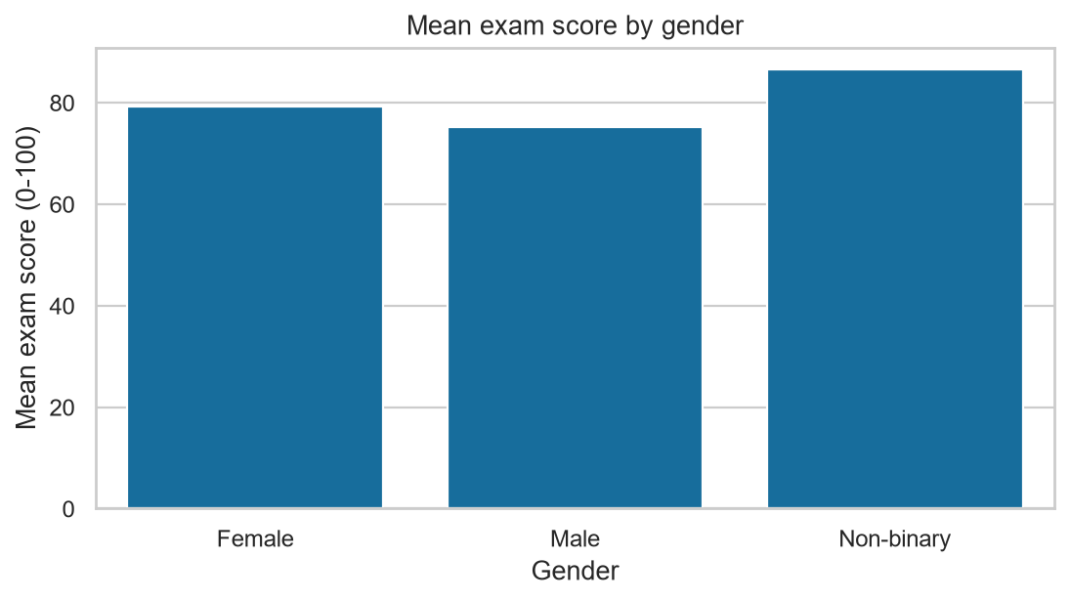
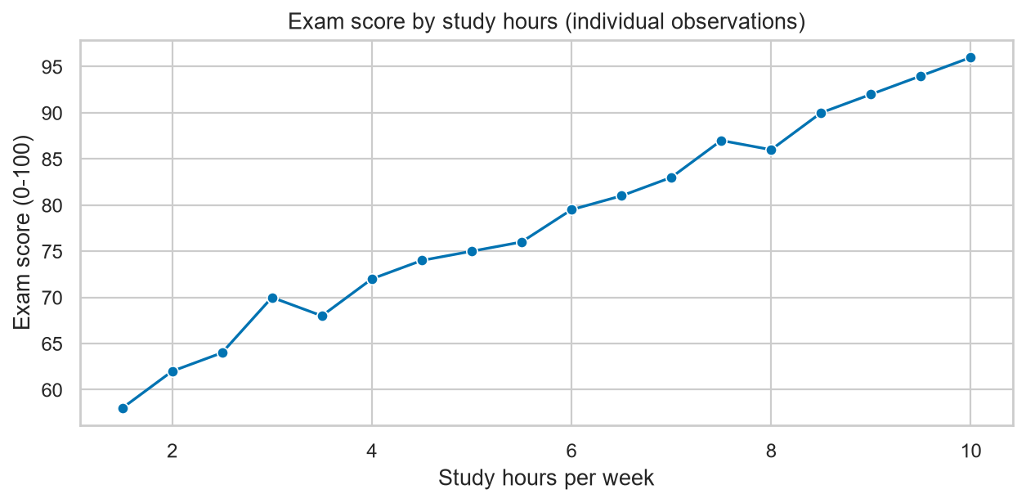
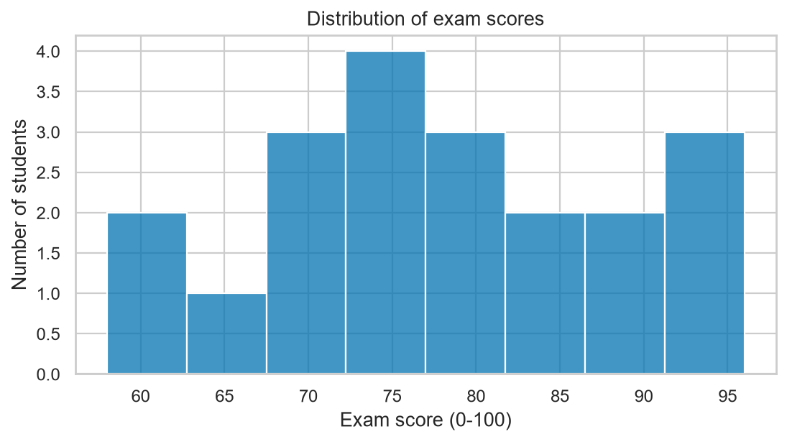

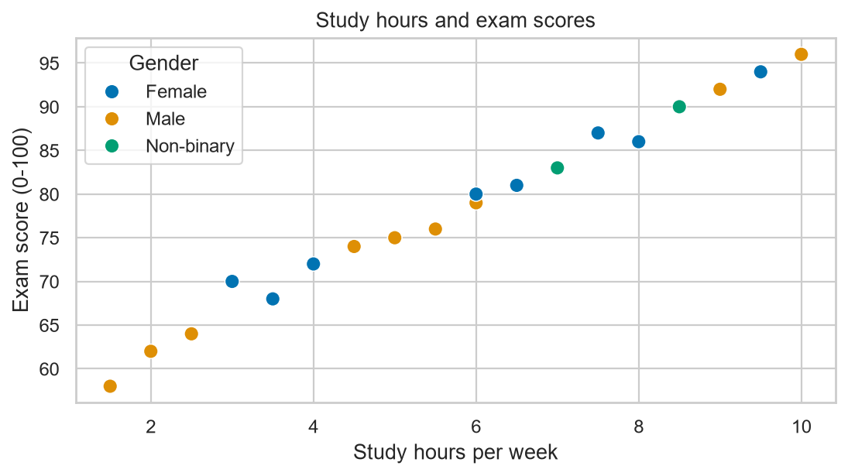
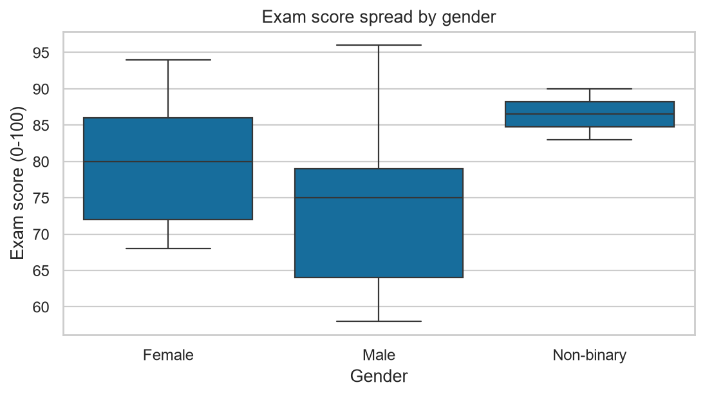
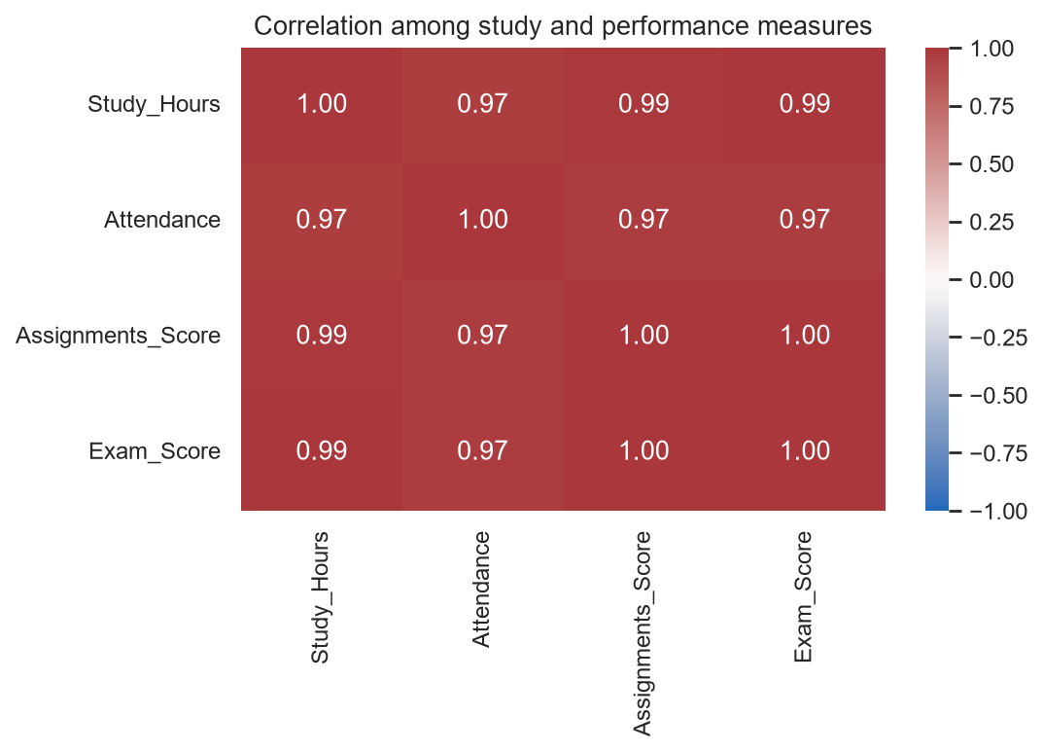

18. Results and Observations
The dataset has 20 students and 8 fields. Exam scores range from 58 to 96, with mean 78.10 and median 77.50. The observed Study_Hours/Exam_Score correlation is 0.994.
These are descriptive results from a small, deliberately constructed teaching sample. They should not be generalized to an actual school population. Differences across groups may reflect the hand-authored records and do not establish causes.

19. Data Science Best Practices
- Reproducibility: keep source data and package requirements explicit; fix random seeds where randomness is used.
- Readable code: use meaningful names, focused functions, comments for non-obvious logic, and documentation.
- Data quality: validate schemas, types, valid ranges, nulls, duplicates, and potential outliers before analysis.
- Privacy: use synthetic or de-identified data and avoid sharing student-level records without authorization.
- Visualization: label units, use honest scales, and make plots answer a clear question.
- Interpretation: report sample scope and uncertainty; association alone does not support causal claims.

20. Challenges
A small sample limits statistical generalization. Sample variance differs from population variance, so ddof=1 is stated explicitly. Missing-value strategies depend on context; median imputation here is solely an introductory demonstration. A correlation heatmap is descriptive and can obscure small-sample uncertainty.

21. Conclusion
This assessment connects Python fundamentals with a reproducible data-analysis workflow. The script, notebook, generated CSV, figures, and report provide a practical reference for basic cleaning, statistics, and visualization. The most important takeaway is to validate data and communicate the scope and limitations of results alongside the numbers.

22. Technologies Used
Python 3.11; NumPy; Pandas; Matplotlib; Seaborn; Jupyter Notebook; python-docx.

23. Project Structure
Task-1-Data-Science-Fundamentals/
fundamentals.py
fundamentals.ipynb
student_performance.csv
requirements.txt
README.md
report/Task_1_Data_Science_Fundamentals_Report.docx
outputs/charts/
outputs/results.txt

24. GitHub Repository Placeholder
GitHub repository URL: [Add the repository URL after publishing]. This placeholder is intentionally left for the intern to complete; no repository is claimed to exist.
Internship task: Data Science Fundamentals Assessment | Duration: 02-Oct-2026 to 27-Nov-2026.

