DATA SCIENCE
FUNDAMENTALS ASSESSMENT
Data Analyst Internship | Task 1
Internship duration: 02 October 2026 - 27 November 2026
Prepared as a beginner-friendly practical assessment
Dataset: fictional, reproducible student-performance sample

1. Introduction
This report documents a practical introduction to data science using Python. It progresses from language fundamentals to descriptive statistics, NumPy arrays, Pandas preparation, and visual communication. All examples use a small fictional student-performance dataset authored for this assessment; no external dataset or citations are used.

2. Objectives
- Demonstrate Python syntax, data types, collections, control flow, functions, exceptions, and file handling.
- Calculate descriptive statistics and correlations from sample records.
- Practice numerical arrays and tabular analysis with NumPy and Pandas.
- Create common visualizations and apply validation, cleaning, reproducibility, and privacy principles.

3. Introduction to Data Science
Data science combines a question, data preparation, computation, and communication. A responsible workflow clarifies the question, checks data quality, selects suitable analysis, and communicates limitations. A descriptive relationship is not proof of causation.
Workflow: define fields -> validate records -> summarize -> visualize -> interpret cautiously.

4. Python Fundamentals
Descriptive variable names make code easier to review. Integers, floats, strings, and Booleans represent different kinds of information. Arithmetic, comparison, and logical operators form expressions; if/elif/else chooses a branch; for and while loops repeat work; functions package reusable behavior.
def calculate_pass_rate(scores, pass_mark=70):
if not scores:
return 0.0
return sum(score >= pass_mark for score in scores) / len(scores)
Lists are ordered mutable sequences; tuples are ordered and immutable; sets retain unique items; dictionaries map keys to values. try/except handles expected conversion errors. Context managers close files reliably.

5. Data Types and Data Structures
Example | Type | Use
20 | int | Count or identifier
5.8 | float | Study hours
"Female" | str | Category
True | bool | Logical state
[68, 75, 91] | list | Mutable sequence
{"rows": 20} | dict | Named values
Explicit conversion such as int("20") is appropriate only when source text represents a valid integer.

6. Statistical Foundations
Measures use all 20 Exam_Score observations. Variance and standard deviation use the sample convention (n-1); percentiles use linear interpolation.
Measure | Calculated value
Mean | 78.10
Median | 77.50
Mode | 75
Minimum | 58.00
Maximum | 96.00
Range | 38.00
Variance (sample) | 115.46
Standard deviation (sample) | 10.75
25th percentile | 71.50
75th percentile | 86.25
Pearson correlation of Study_Hours with Exam_Score: 0.994. This describes linear association within this constructed sample and does not demonstrate cause and effect.
scores = data['Exam_Score']
mean_score = scores.mean()
q3 = scores.quantile(0.75)
r = data['Study_Hours'].corr(scores)

7. NumPy Implementation
NumPy arrays provide compact numerical structures. The analysis creates a 1D exam-score array and a 2D study-hours/score array, then demonstrates indexing, slicing, arithmetic, reshape, and reductions.
scores = data['Exam_Score'].to_numpy()
first_score = scores[0]
first_three = scores[:3]
grid = np.arange(1, 7).reshape(2, 3)
shifted = grid + 10
Calculated array mean: 78.10; minimum: 58; maximum: 96.

8. Pandas Implementation
A DataFrame is created from records, exported to CSV, and loaded back. head(), shape, info(), and describe() inspect observations, dimensions, dtypes, and numerical summaries. Column selection, filtering, sorting, and groupby demonstrate common table operations.
data = pd.read_csv('outputs/student_performance.csv')
print(data.head())
print(data.shape)
print(data.groupby('Gender')['Exam_Score'].mean())
Mean exam score by fictional gender category:
- Female: 79.22
- Male: 75.11
- Non-binary: 86.50

9. Data Visualization
Figures use labeled axes and distinct categories. The line chart joins individual observations sorted by study hours, so it is descriptive and not a time-series trend.
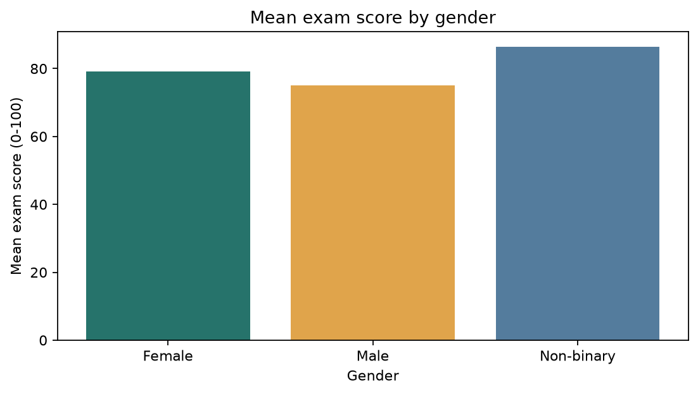
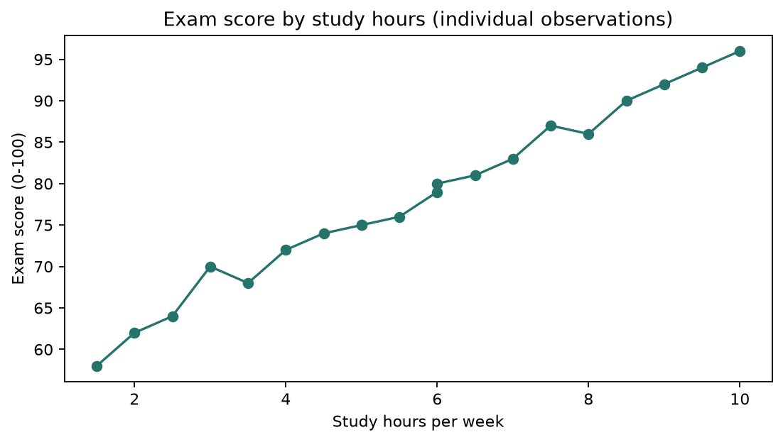
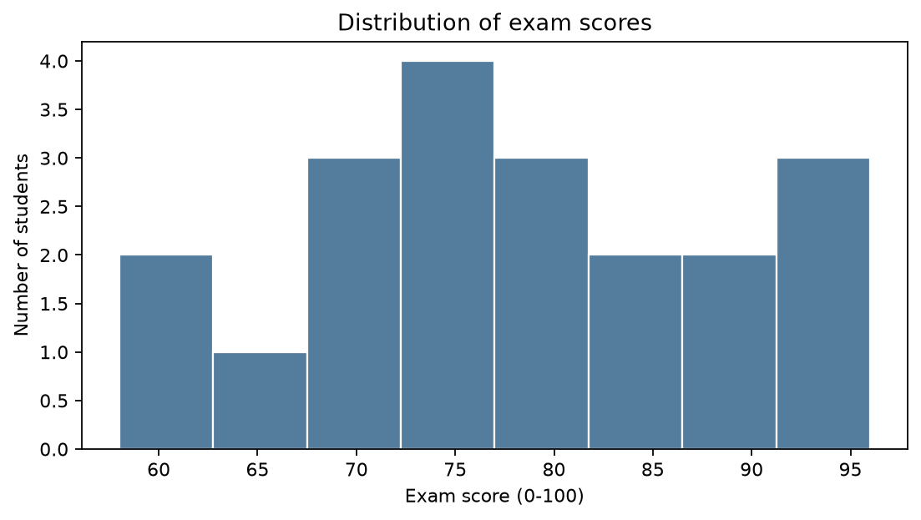

9. Data Visualization (continued)
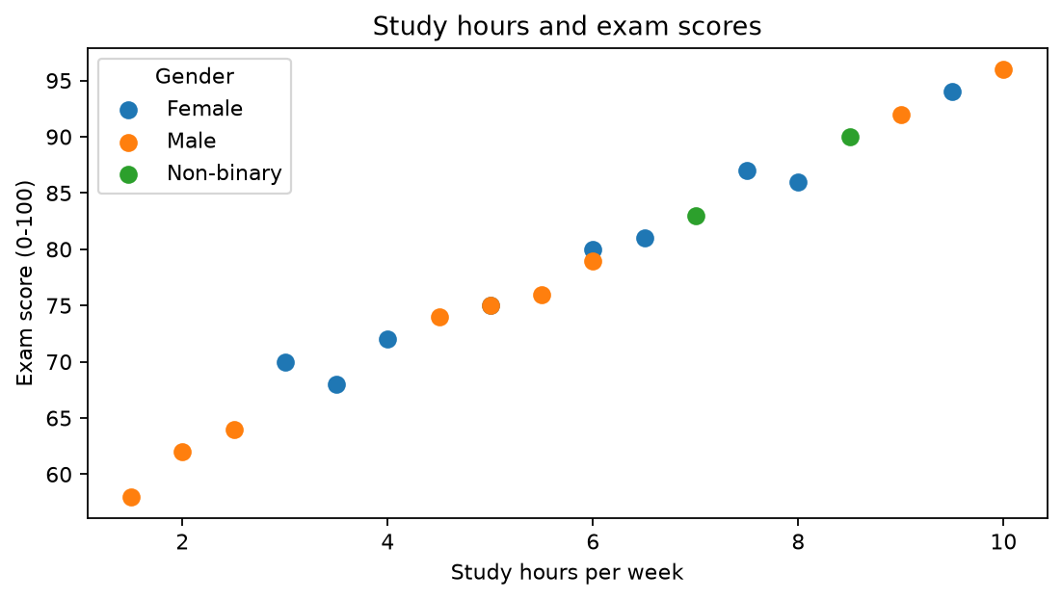
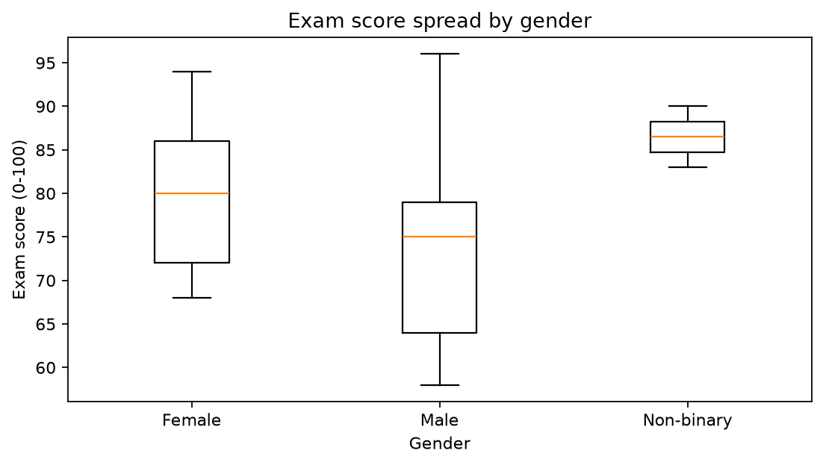
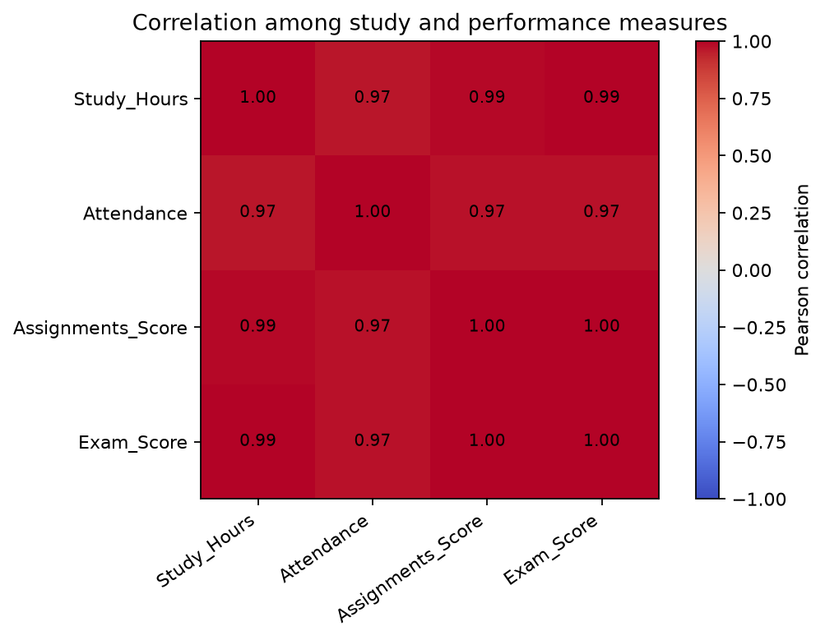

10. Data Cleaning and Best Practices
The source sample has no intentional quality defects. For a transparent demonstration, a separate copy receives one missing Attendance value and one duplicate row. The example drops the duplicate and fills attendance with the median of the imperfect copy.
cleaned = imperfect.drop_duplicates().copy()
cleaned['Attendance'] = cleaned['Attendance'].fillna(cleaned['Attendance'].median())
- Validate required fields, unique identifiers, numeric dtypes, and plausible score and attendance ranges.
- State missing-value rules; preserve original input data.
- Use meaningful names, comments for non-obvious intent, and docstrings for reusable functions.
- Keep fixed data and dependencies; set a seed before random operations.
- Protect privacy: student names and IDs in this report are fictional.
- Use honest axes and avoid causal claims unsupported by the study design.

11. Practical Exercises
Script and notebook exercises include study-band classification, pass-rate calculation, type inspection, filtering, group summaries, array reshaping, descriptive measures, quality checks, and visualizations.

12. Results and Observations
The dataset has 20 students and 8 fields. Exam scores range from 58 to 96, with mean 78.10, median 77.50, and mode 75. The Study_Hours/Exam_Score correlation is 0.994.
These are descriptions of a small, constructed teaching sample, not generalizable population estimates. Group differences reflect these authored records and do not establish causal effects.

13. Challenges
Small sample size limits generalization. Sample variance differs from population variance, so its convention is stated. Median imputation is a basic demonstration and may not suit other contexts. Correlation estimates are uncertain in such a small dataset.

14. Conclusion
This assessment links Python fundamentals to a reproducible analysis workflow. The script, notebook, CSV, figures, and report form a practical reference for basic cleaning, statistics, and visualization. Validate data and report limitations alongside results.

15. Technologies Used
Python 3.11; NumPy; Pandas; Matplotlib; Seaborn; Jupyter Notebook; python-docx.

16. GitHub Project Information
Repository: not yet published. The project is prepared for a repository named Task-1-Data-Science-Fundamentals. Add the actual repository URL after publication; no URL is invented here.
Internship task: Data Science Fundamentals Assessment | Duration: 02-Oct-2026 to 27-Nov-2026.

