Task 2: Hands-On Data Lab Report

1. Executive Summary
This report documents the implementation of the Hands-On Data Lab environment.

2. Statistical Analysis Results
Total Employees Analyzed: 15
Average Salary:
Average Performance Score: 81.23

3. Key Visualizations
Chart: histogram.png
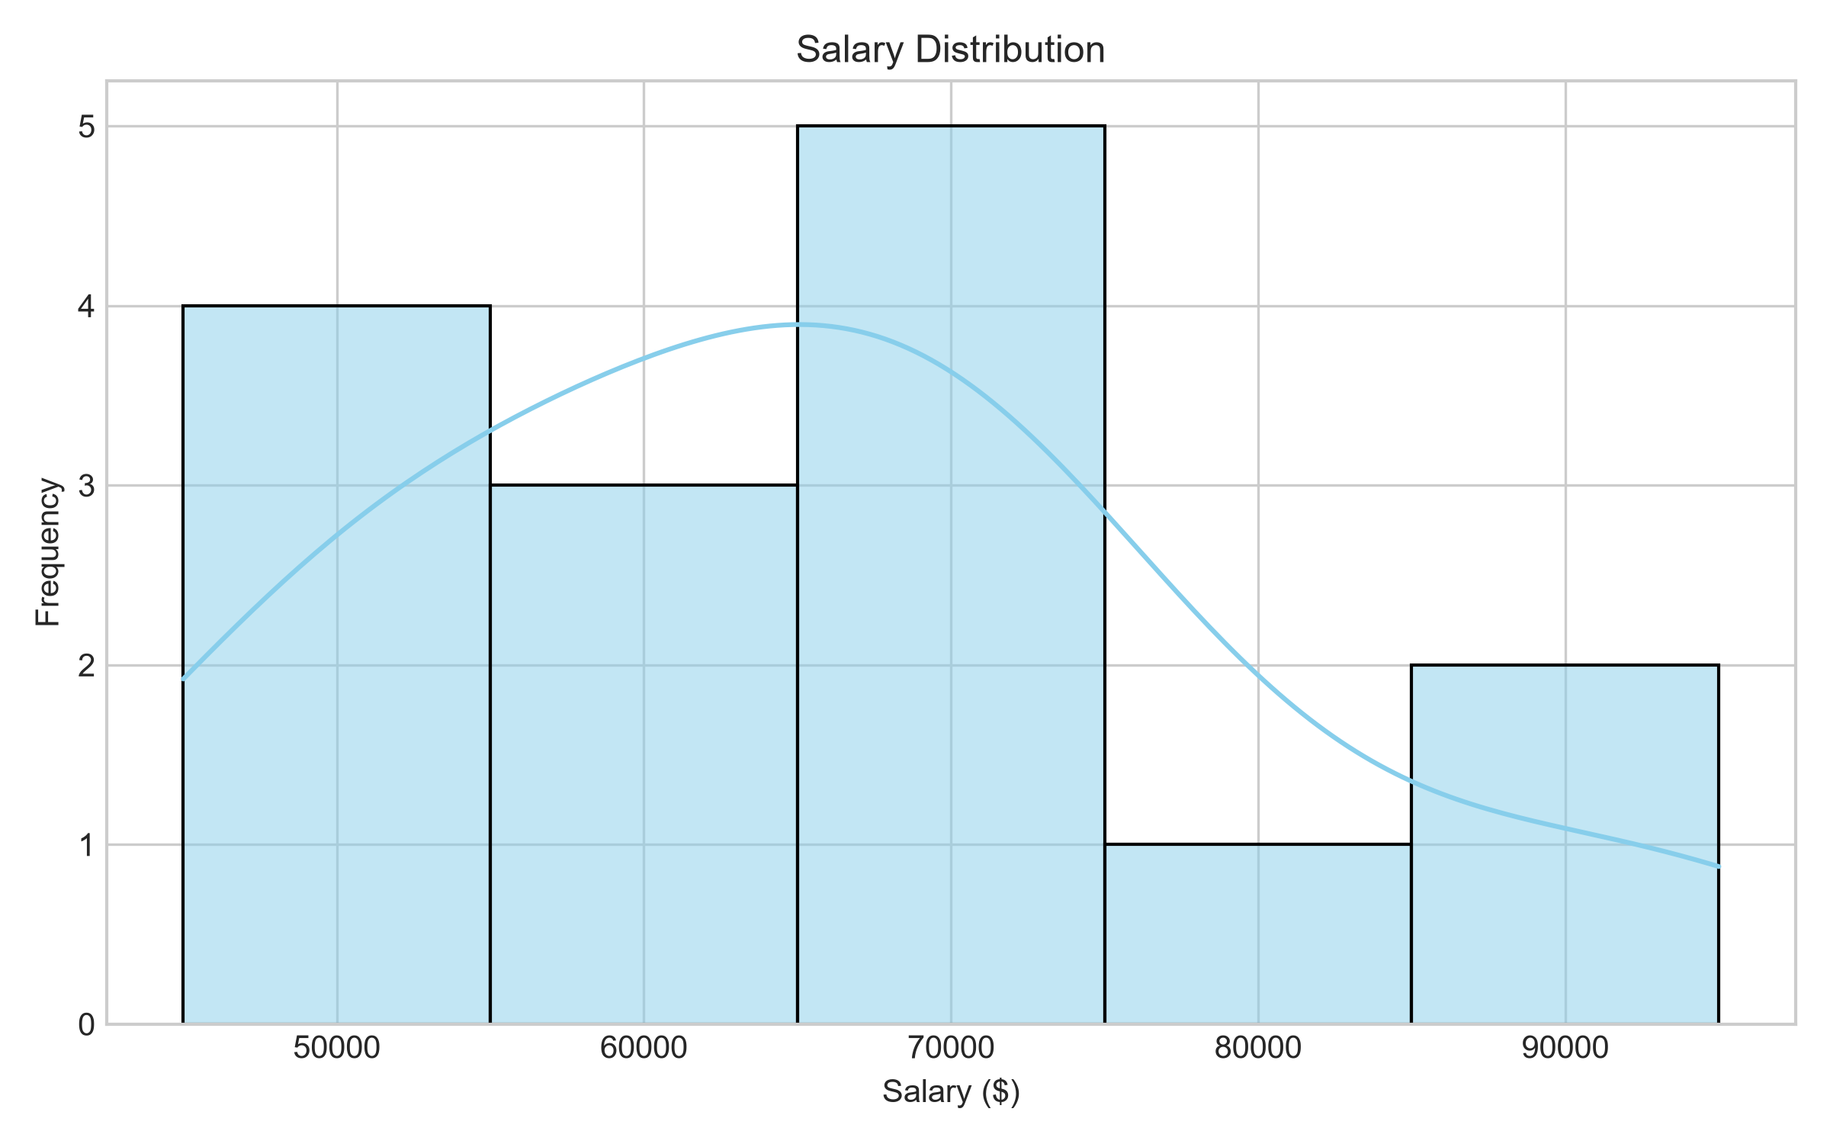
Chart: bar_chart.png
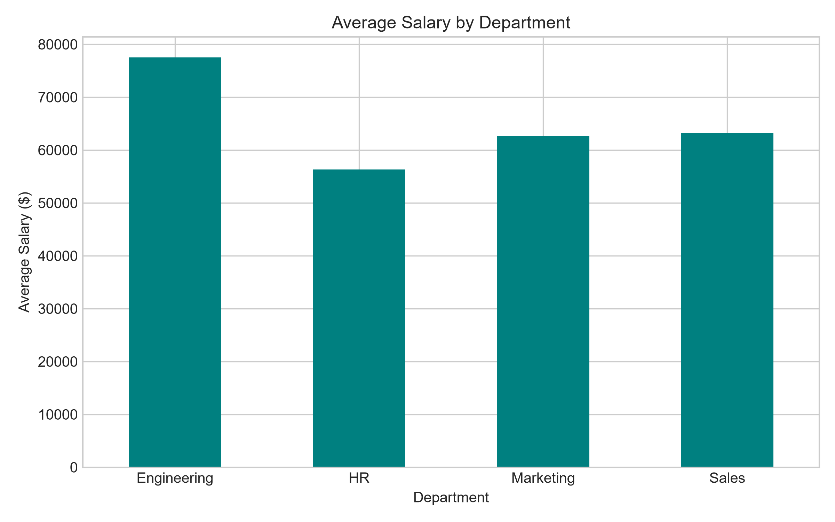
Chart: scatter_plot.png
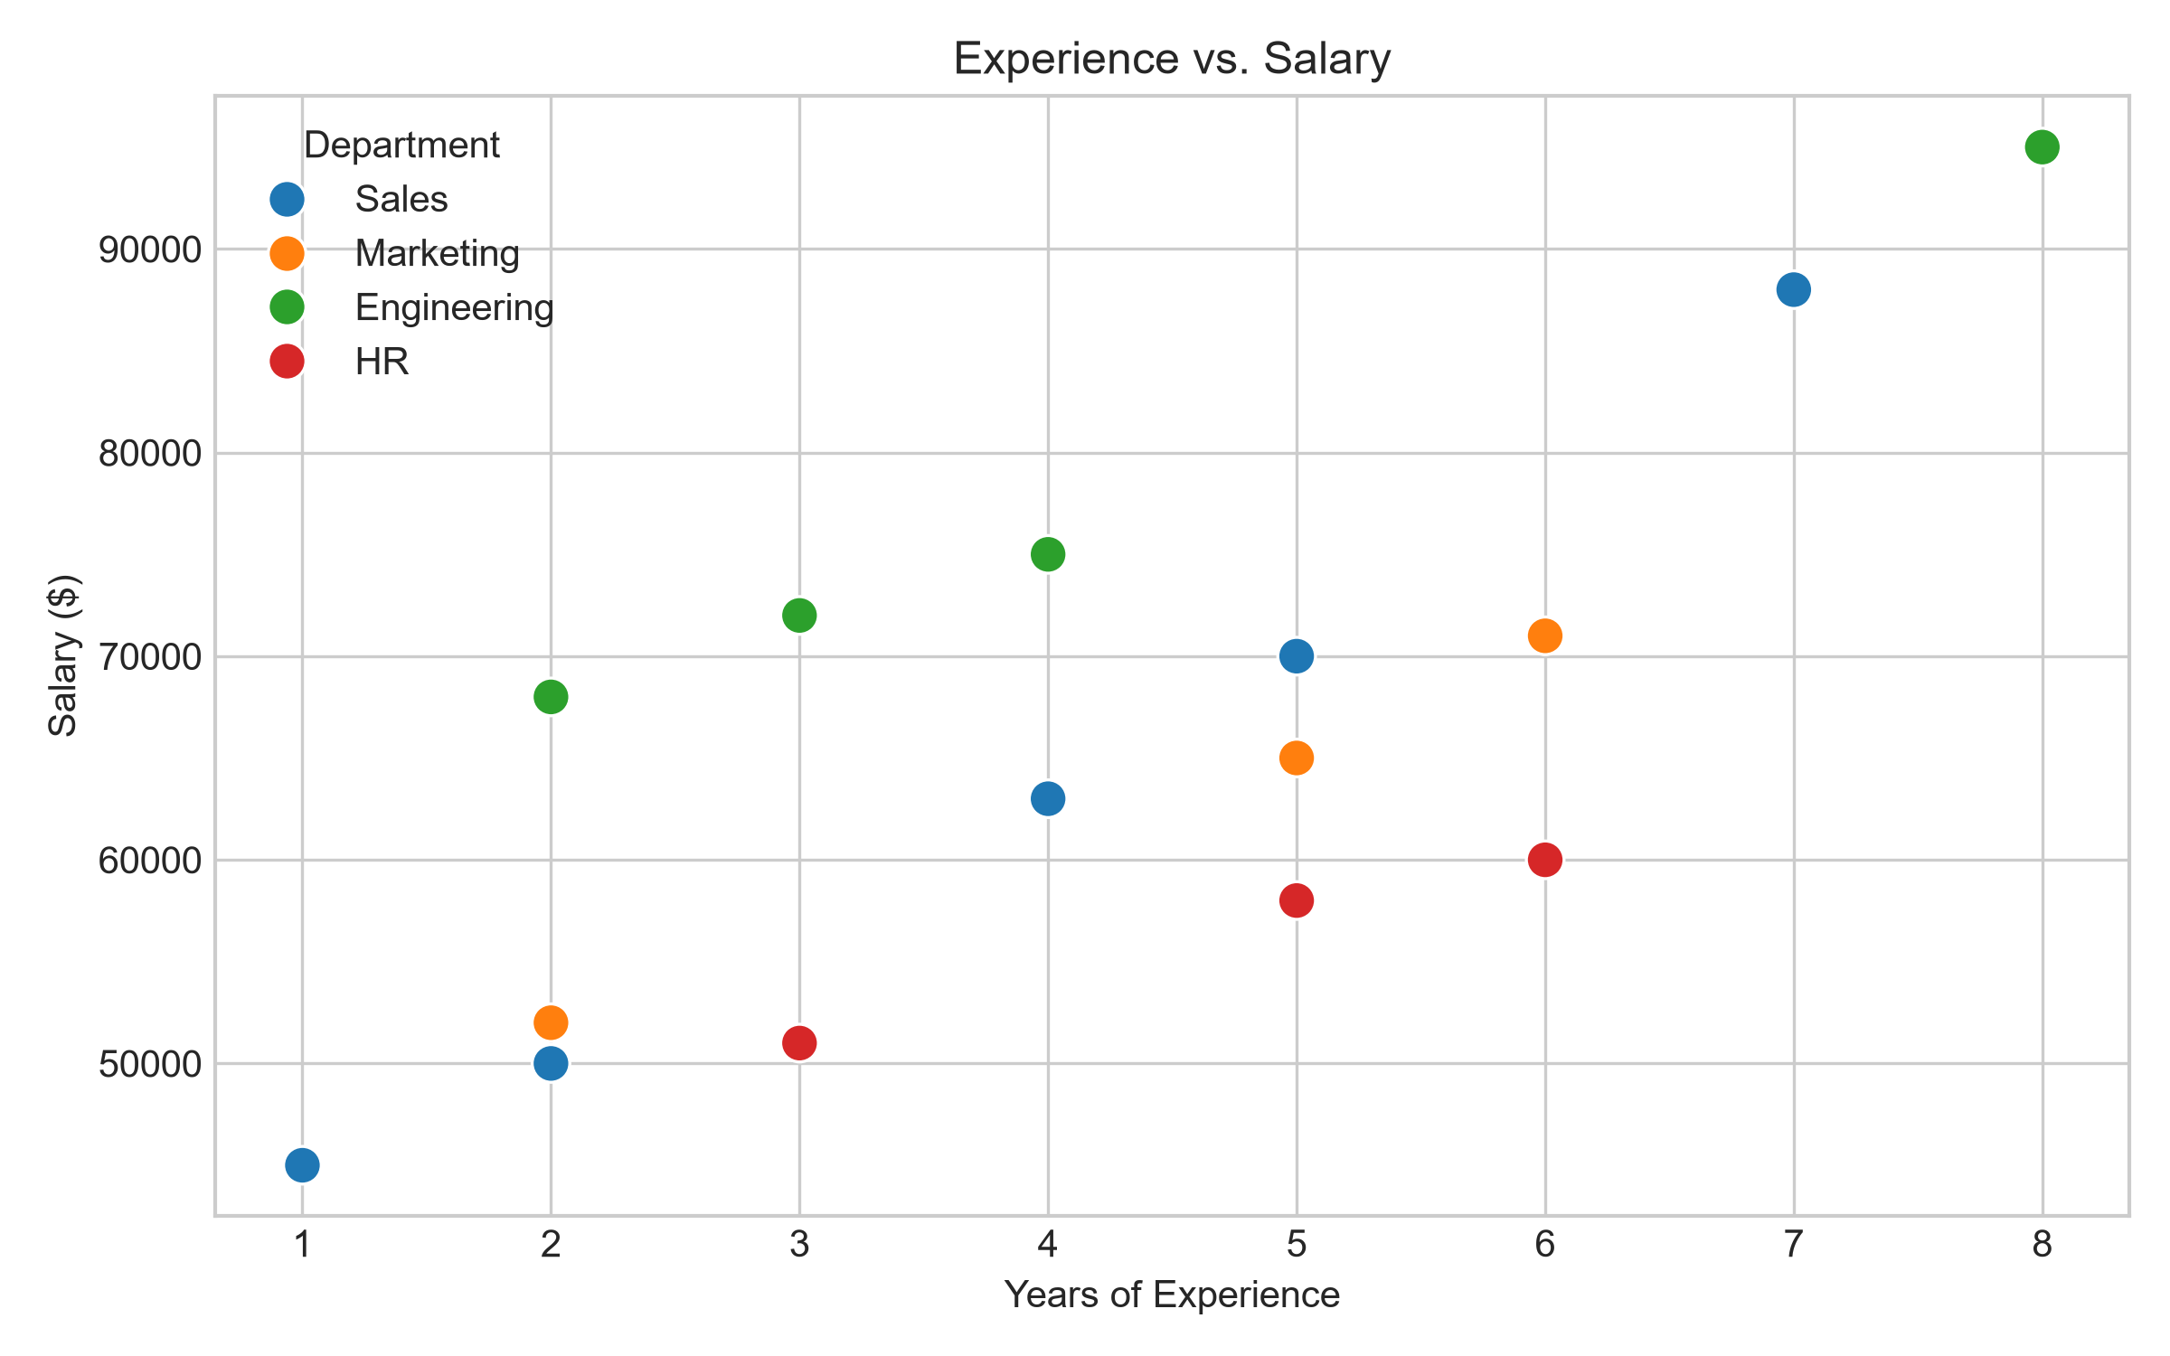
Chart: box_plot.png
