I Built Quill AI to Make Academic Outreach Less Chaotic
A local-first desktop assistant for professor discovery, postdoc applications, research documents, AI-assisted drafting, and interview preparation.
By Amir Moradi
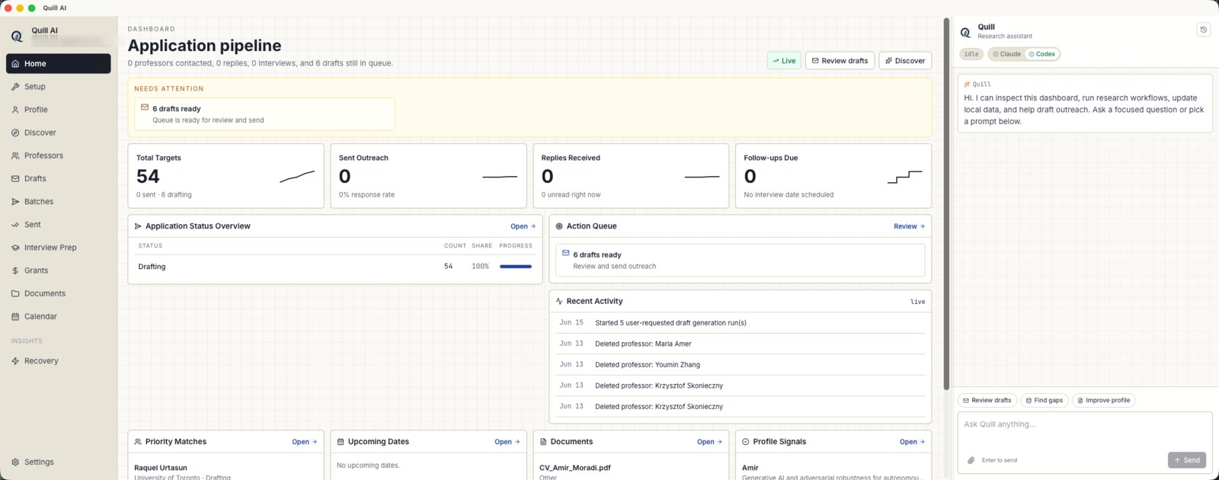
Quill AI starts with an application pipeline and a built-in assistant rail.
Academic outreach looks simple from the outside: find professors, write thoughtful emails, track replies, prepare for meetings. In practice, it becomes a scattered mix of browser tabs, PDFs, spreadsheets, Gmail threads, notes, deadlines, and repeated context switching.
I built Quill AI because I wanted one calm workspace for that process. The goal was not to replace judgment or automate sincerity. It was to remove the operational friction around research-position outreach so the applicant can spend more time understanding people, labs, fit, and opportunity.

The Problem: Academic Applications Are a Pipeline, But We Treat Them Like a Messy Folder
A serious postdoc or graduate-school search is closer to a lightweight CRM than a one-off email task. Each professor has a research profile, fit rationale, papers to read, a status, a draft, attachments, possible follow-up dates, and eventually replies or interviews. Most applicants still manage this with a combination of spreadsheets and memory.
Quill AI treats academic outreach as a local research workflow: discover candidates, score fit, draft carefully, send deliberately, and keep every next step visible.

What Quill AI Is
Quill AI is a local-first desktop app for graduate students, postdoctoral applicants, and early-career researchers. It brings together applicant profile management, professor discovery, outreach drafting, document upload, sent-email tracking, reply management, grants, calendar items, and interview prep.
The app runs on the user's computer with a local database and local document storage. When an AI workflow is needed, Quill uses the user's own installed Codex or Claude Code CLI account, or an API key configured by the user.

The Main Workflows
- Build a structured applicant profile from CV details, research interests, publications, target countries, and target roles.
- Upload CVs, research statements, transcripts, sample papers, and cover-letter templates into local storage.
- Discover faculty candidates and score them against the applicant's research profile.
- Review professor matches, research angles, evidence, and hiring signals before adding anyone to the outreach pipeline.
- Generate, edit, and batch-review outreach drafts before sending through Gmail.
- Track replies, follow-ups, interview preparation, grants, and calendar deadlines in the same workspace.

Candidate Discovery That Starts From Fit
The discovery screen is designed for triage. Quill can search for professor candidates, summarize the fit, assign match scores, surface hiring signals, and let the applicant approve or reject candidates before they enter the main pipeline.
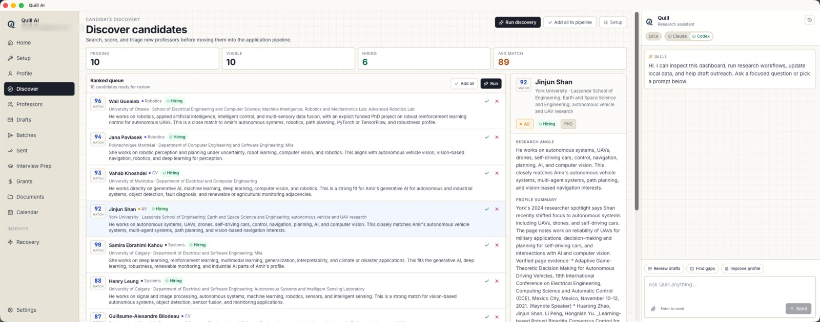
Candidate discovery ranks matches and shows the research angle before a professor enters the pipeline.

A Professor Pipeline Instead of a Spreadsheet
Once candidates become targets, they move into the professor pipeline. This view makes the search visible: who is active, who is high priority, which status each person is in, and what contact information is ready.
This matters because outreach quality depends on pacing. Sending ten thoughtful emails is different from creating fifty generic drafts. Quill is built around review, status, and deliberate action.
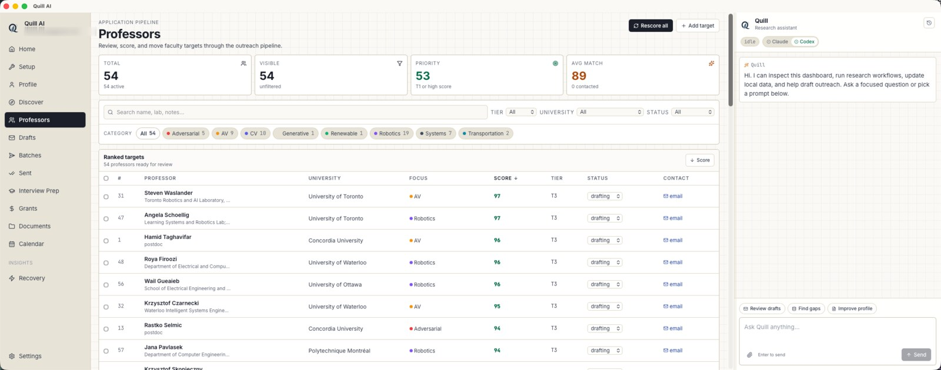
The professor pipeline tracks status, match score, focus area, institution, and contact readiness.

Why Local-First Matters
Academic applications include sensitive material: CVs, transcripts, drafts, private replies, research plans, and sometimes financial or immigration constraints. Quill keeps the database and uploaded documents on the local machine by default. The AI provider only receives context when the user chooses to run a workflow.
This local-first model also makes the app feel like a real desktop tool rather than a web account that owns the user's whole process. The user can see where the data is stored, choose the AI provider, and keep the workflow grounded in their own files.

Codex or Claude: Bring Your Own AI Account
Quill does not ask users to paste a provider password into the app. Instead, it detects local CLI tools. If Codex or Claude Code is installed and signed in on the computer, Quill can use that provider for drafting, research, profile extraction, and workflow assistance.
For Codex, users install the local Codex CLI, run codex login, and choose either ChatGPT sign-in or API-key authentication. For Claude Code, users install the claude CLI, run it once, and complete the browser login. After that, Quill's setup screen can detect the provider and make it selectable.
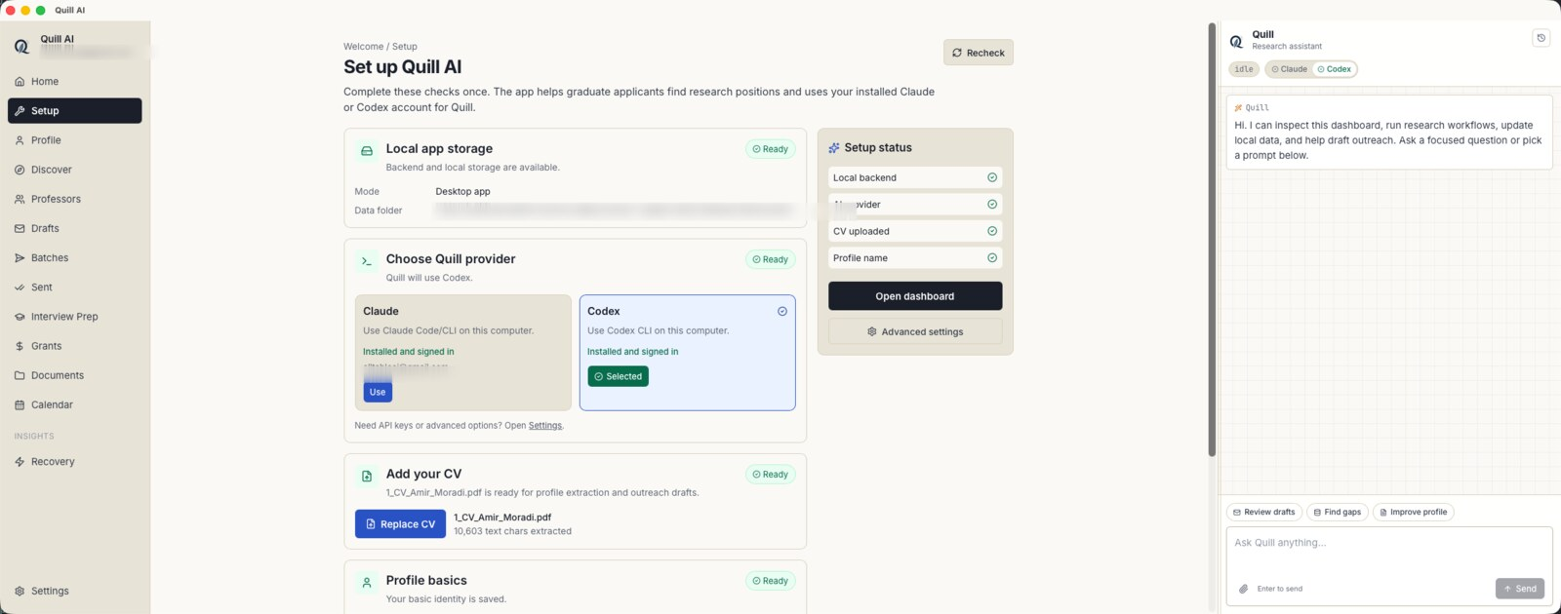
The setup screen verifies local storage, CV upload, and available Claude or Codex providers.

What I Learned Building It
The most important product lesson was that AI is only useful here when it is attached to a clear workflow. A blank chat box can help, but it does not remember which professor is in which stage, which drafts are ready, or which documents should be attached. The application layer matters.
The second lesson was that local-first software is still a strong fit for personal research workflows. Researchers need control, context, and continuity. A desktop app can provide that without turning every private document into a cloud object by default.

Where Quill Goes Next
The current release focuses on the core desktop experience: local data, provider setup, document management, candidate discovery, draft generation, reply tracking, interview prep, and packaging for macOS and Linux. The next layer is polish: smoother onboarding, broader installers, stronger release signing, and deeper workflow automation around replies, follow-ups, and preparation.
The larger idea is simple: academic outreach should feel less like improvising across ten tools and more like running a thoughtful, evidence-based research process.

Try It
Quill AI is available as a prerelease on GitHub: https://github.com/Amirmoradi94/quill-research-assistant
Install the desktop app, complete the setup checklist, connect Codex or Claude Code, upload a CV, and start turning scattered academic outreach into a visible pipeline.

