Zeroleaf: A Local-First LaTeX Editor for the AI Agent Era
A practical look at why a desktop, review-first LaTeX workflow can complement Overleaf rather than simply copy it.
Disclosure: I used AI assistance to draft and edit this article. The product details, screenshots, comparisons, and final editorial decisions should be reviewed by the publisher before posting.
LaTeX has always rewarded people who care about structure. It is precise, portable, and still one of the best ways to produce serious academic and technical documents. But the everyday workflow around LaTeX has split into two camps: collaborative web editors on one side, and local developer-style tooling on the other.
Overleaf made the web side feel natural. It gave researchers a browser-based editor, real-time collaboration, sharing, comments, templates, version history, and a compile button that did not require every collaborator to maintain a TeX installation. For many teams, that is exactly the right answer.
Zeroleaf starts from a different question: what should a local-first LaTeX editor look like now that AI coding agents can read files, propose patches, run tools, and verify results?
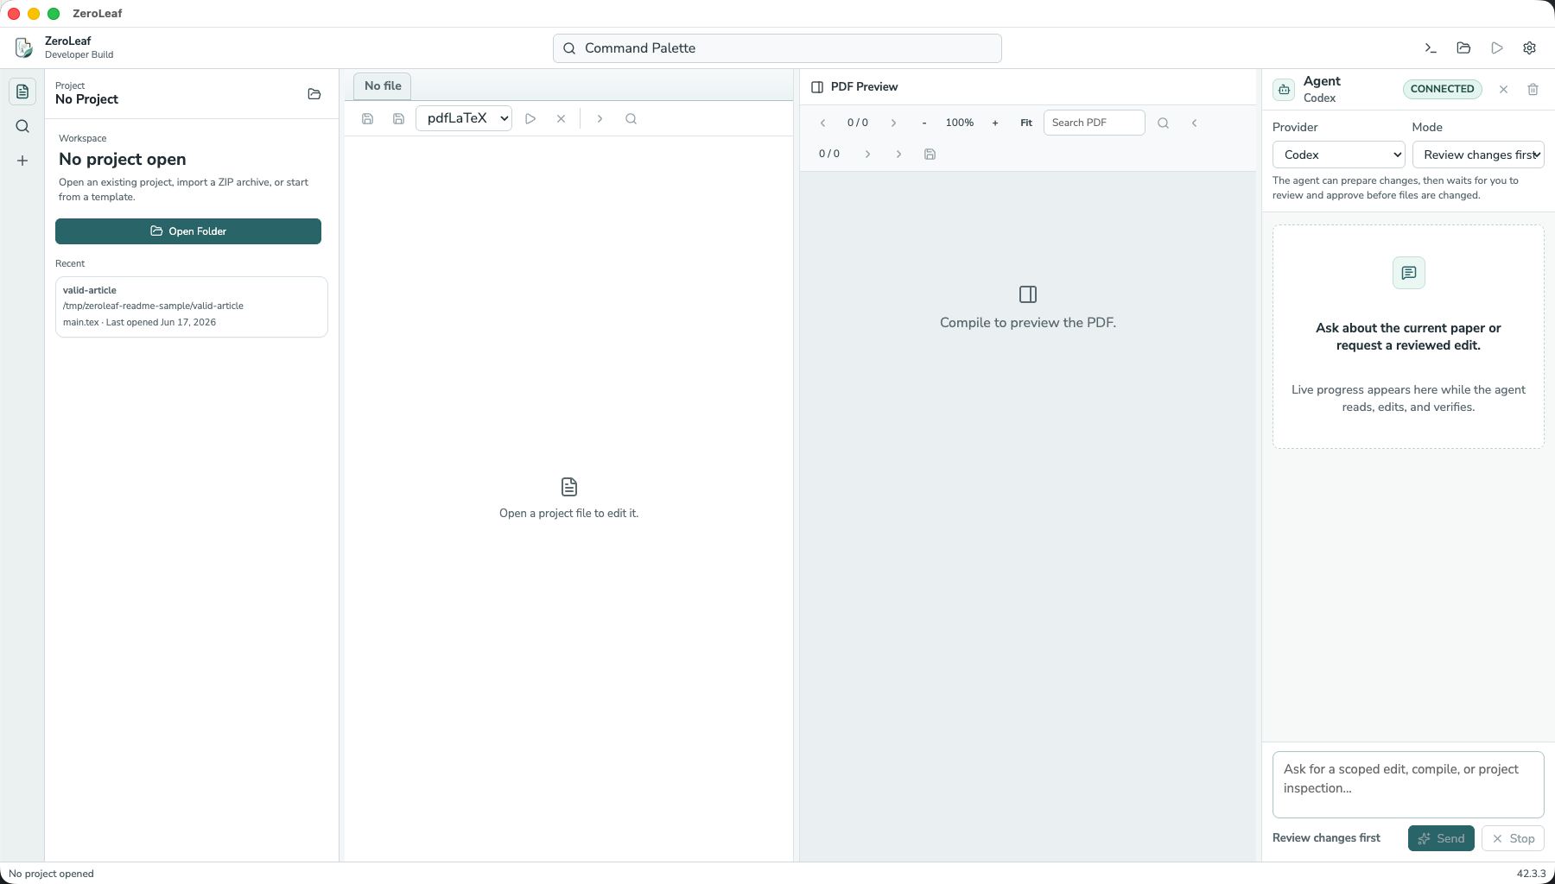
Zeroleaf opens local LaTeX projects and keeps recent work close at hand.

What Zeroleaf Is
Zeroleaf is an alpha desktop LaTeX editor built around local projects. It opens a folder on your computer, shows the project tree, edits source files, compiles with latexmk, previews the PDF, and surfaces diagnostics, logs, references, outline, history, and output in one workbench.
The agent panel is the unusual part. Instead of treating AI as a floating chatbot, Zeroleaf is designed around a patch-first workflow. An agent can inspect the current project, understand a compile error, propose changes, and run a local compile. But the important unit is not a vague answer; it is a reviewable change.
That distinction matters. Academic writing is full of fragile details: citation keys, labels, package choices, figure paths, journal classes, and formatting conventions. If an assistant edits those files, the user needs to see exactly what changed and whether the document still compiles.
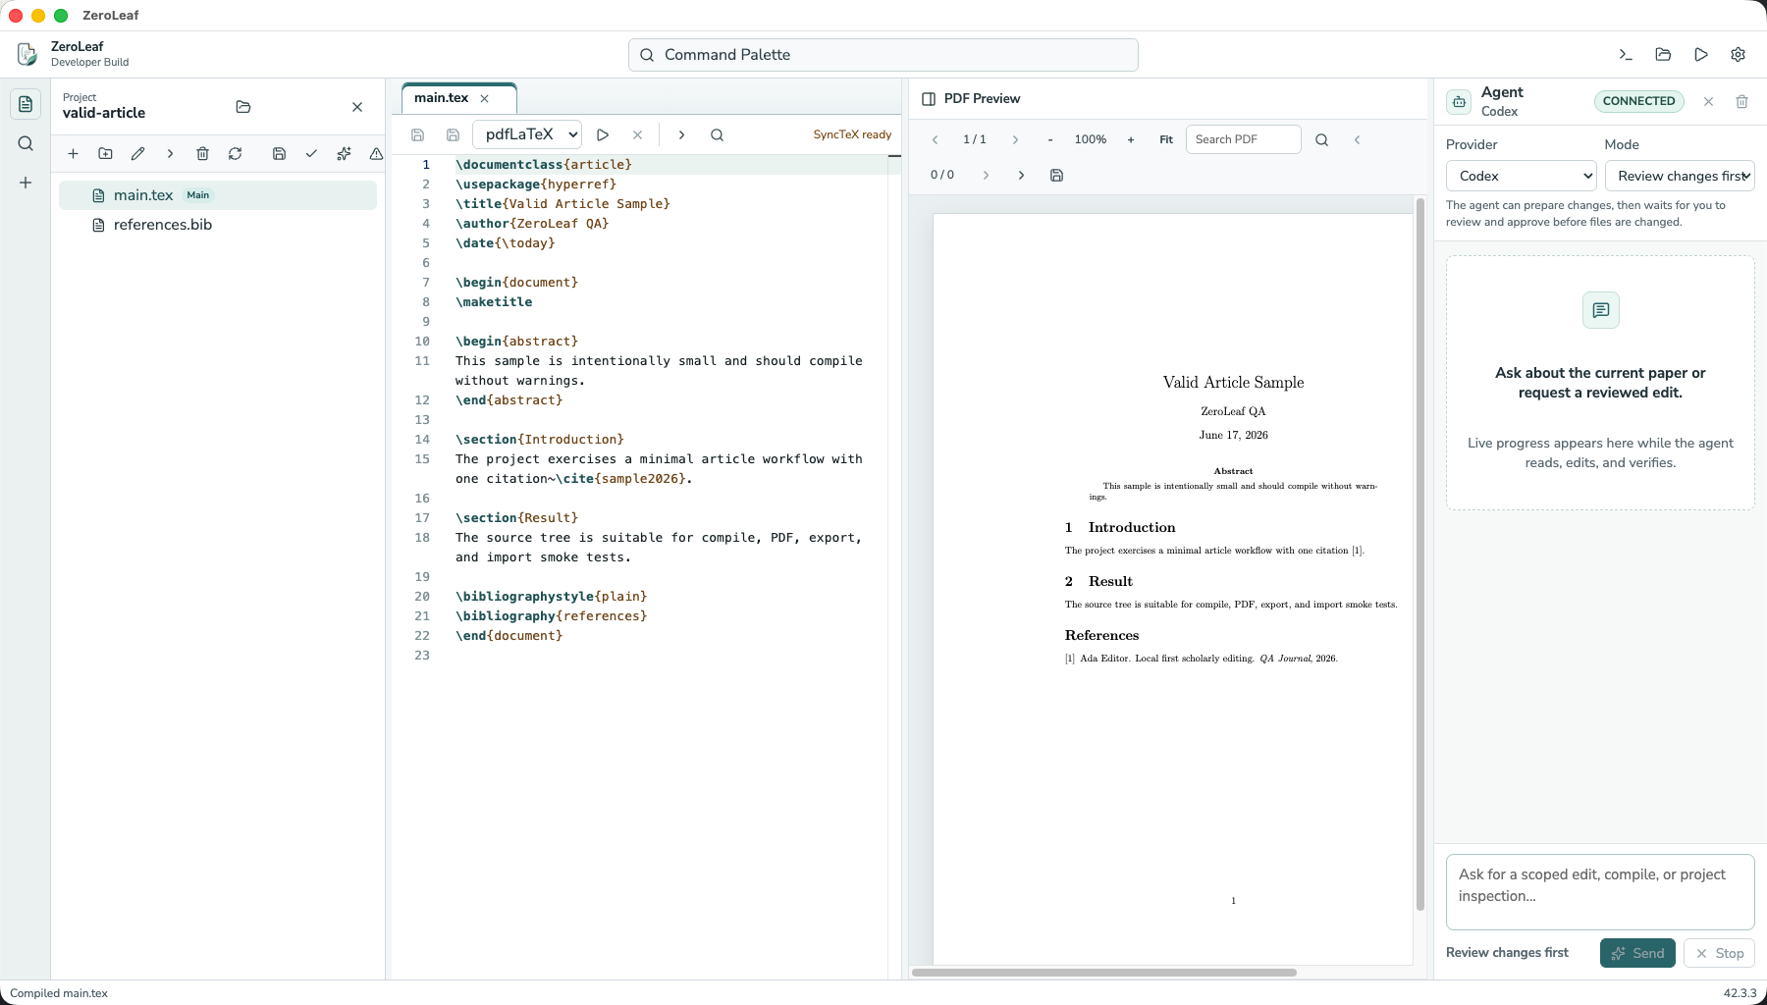
The main Zeroleaf workbench combines source editing, PDF preview, compile status, and an agent panel.

The Overleaf Comparison
The point of Zeroleaf is not that Overleaf is bad. Overleaf is popular because it solves a real problem extremely well: multiple people can open the same document in a browser, edit together, comment, review changes, use templates, and avoid local setup. Overleaf also offers premium features such as project history, Git and GitHub integration, and AI Assist capabilities including document chat and error assistance.
Zeroleaf is aimed at a different center of gravity. It is for writers who want their project to remain a local folder first, who already care about their local toolchain, and who want AI help to operate through visible, reviewable project changes rather than opaque text suggestions.
Workflow need | Overleaf | Zeroleaf
Collaboration | Best fit when real-time browser collaboration is the main job. | Better fit for individual or small-team local workflows today.
Project ownership | Project lives primarily in a hosted web workspace, with export and sync options. | Project starts as a local folder on your machine.
AI workflow | AI Assist adds document chat, writing help, and error support inside Overleaf. | Codex or Claude can inspect files and propose reviewable local patches.
Verification | Compile and preview are integrated in the browser. | Compile, diagnostics, PDF preview, history, and agent verification sit in the desktop workbench.

Why Local-First Matters
Local-first does not mean anti-cloud. It means the durable source of truth is a folder you can inspect, back up, put under Git, zip, compile, and move without asking a hosted editor for permission. That model is especially attractive for drafts with sensitive data, institutional constraints, custom build tooling, or long-lived projects that outlast a single web workspace.
It also changes how AI should behave. A local agent can use the same project files and compile tools you use. It can fail in observable ways. It can leave a diff. It can be asked to fix the first LaTeX error, recompile, and report whether the PDF is fresh. That is a more accountable loop than pasting source into a chat box and hoping the answer lands correctly.

What Zeroleaf Is Not Yet
Zeroleaf is still alpha software. It is not trying to replace Overleaf’s strongest cloud collaboration features today. It does not promise unrestricted autonomous agents, cloud sync, or a full visual editor. The current focus is narrower: open a local LaTeX project, edit it, compile it, inspect the PDF and diagnostics, ask an agent for a scoped fix, review the patch, apply it, and verify the result.
That narrowness is intentional. LaTeX projects are high-trust work. A helpful agent should earn trust by making small, visible, reversible changes and by proving that the document still builds.

The Bigger Idea
The next generation of writing tools should not only generate text. They should understand the project around the text: the source tree, bibliography, figures, logs, compile artifacts, and review history. They should make changes in the same environment where the document is built.
That is the direction Zeroleaf is exploring. Overleaf made collaborative LaTeX accessible in the browser. Zeroleaf asks what happens when LaTeX authoring becomes local-first, agent-aware, and review-first from the beginning.
If your team needs frictionless real-time collaboration, Overleaf remains the obvious benchmark. If your work begins in a local project folder and you want AI assistance that behaves more like a careful project operator than a text generator, Zeroleaf is worth watching.

Publishing Notes
Before publishing, replace the disclosure with your preferred wording, confirm every product claim against the current release, and decide whether to link directly to the Zeroleaf GitHub repository or the latest release page.

Sources Checked
- Overleaf feature overview
- Overleaf AI features
- Overleaf AI assistant
- Overleaf GitHub synchronization
- Overleaf Track Changes
- Zeroleaf release

