**Create the following APP ‘to Do List’**

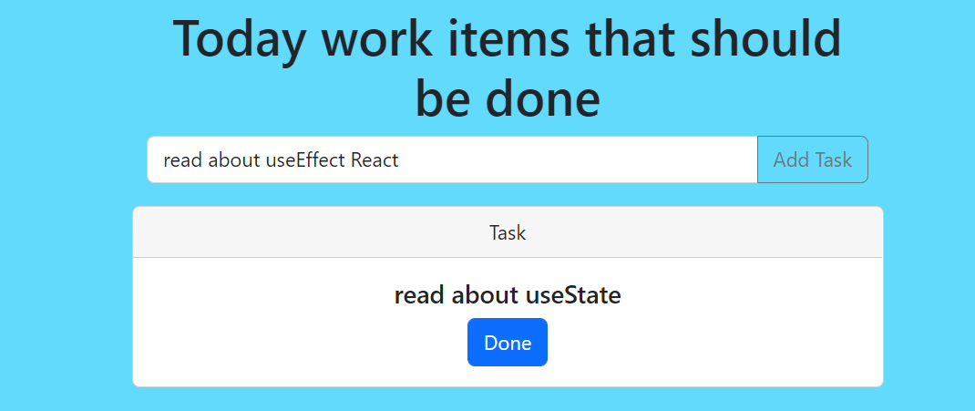

**Hints and tips:**

1. **Use bootstrap please validate that u already add bootstrap to yours project ‘npm I bootstrap’**
2. **Use the flowing component in order to have the same UI/UX**
   1. [**https://getbootstrap.com/docs/5.0/components/card/**](https://getbootstrap.com/docs/5.0/components/card/)
   2. [**https://getbootstrap.com/docs/5.0/forms/input-group/**](https://getbootstrap.com/docs/5.0/forms/input-group/)

* **Create the flowing components – u need at least to create 3 components:**
  + **AddWorkItem**
  + **ToDoList**
  + **WorkItem**
* **Finally u can take a look on my project structure:**

**My App.js file:**

