

A survey on classification models

2026 Data mining Corurse

Mohammad amin Shirmohammadi (610301148)
Amir reza Naeimi (610300107)

.Abstract

.Introduction

.Methods

3.1. Data Cleaning and Initial Feature Pruning
In The first phase of the preprocessing pipeline we focus on streamlining the dataset by removing uninformative variables. A manual evaluation of the raw dataset resulted in the immediate exclusion of several columns prior to model training:

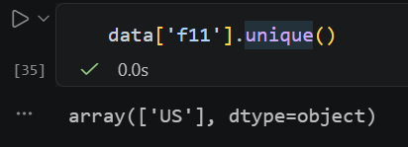
- Feature f11 was dropped entirely. Analysis revealed that this column contained a single, constant value ('US') across all records (figure.1) Consequently, it provided no mathematical variance or predictive power for the algorithms.
Figure 1

- Features f7 and f8 were excluded from the feature space. Extracting meaningful numerical representations from these free-text fields would necessitate advanced Natural Language Processing (NLP) techniques or the integration of Large Language Models (LLMs) which are not in the scope of this semester’s course.(e.g. figure.2)
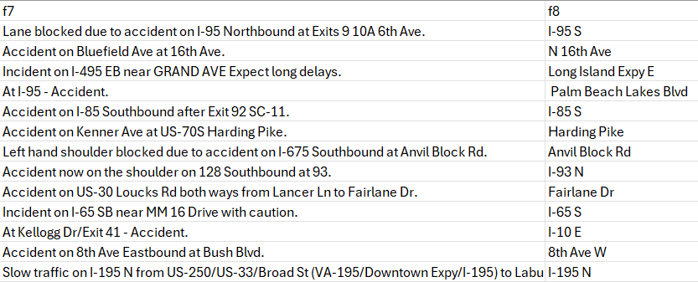
(Figure 2) some values of f7 and f8 columns
3.2. Feature Engineering and Temporal Analysis
To enhance the predictive capabilities of the model, temporal feature engineering was performed. A new continuous feature, duration_min, was derived to quantify the elapsed time between the f13 and the f2 which are two timestamp variables. The calculation was computed as the difference between these two timestamps, converted into minutes.

An exploratory visual analysis was conducted to evaluate the potential predictive utility of this engineered feature with respect to the target variable (y). As demonstrated by the boxplot distributions (figure.3)
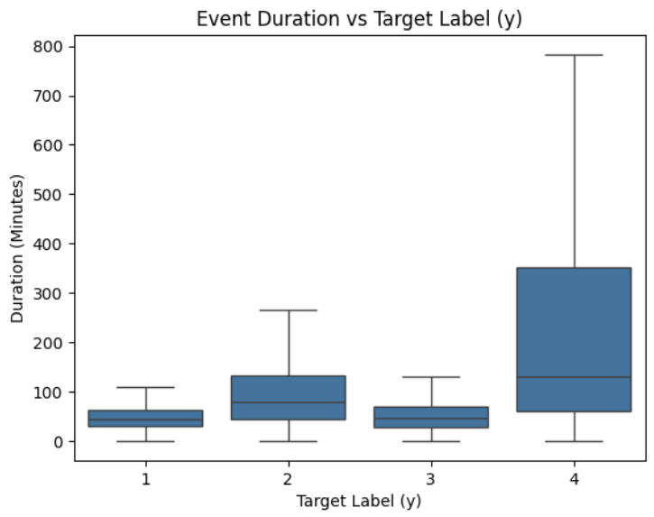
Figure 3

the temporal delay exhibits meaningful variations across the severity classes:
- Labels 1, 2 & 3: These classes typically demonstrate shorter median durations and relatively constrained variance, with labels 1 and 3 exhibiting highly similar distributions.

- Label 4: This class exhibits a significantly wider interquartile range and a notably higher median duration, reaching up to nearly 800 minutes.

Because this derived variable demonstrates distinct distributional shifts conditional on the target label, it was retained as a meaningful feature.

3.3. Temporal Feature Extraction
As we can see the f13 column can have useful metadata which we can test whether they have any information for forecasting our target variable(y) or not.
Consequently, the datetime variable was decomposed into three distinct, mathematically interpretable features:
- Hour of the Day (hour): Extracted as an integer to allow the algorithms to capture daily diurnal patterns, such as morning and evening.
- Day of the Week (day_of_week): Extracted as a categorical integer to differentiate between weekday commuting behaviors.
- Seasonality (season): as we can think, this made-up feature was necessary because the car accidents can vary in different seasons because of their environmental situations(e.g. rainy weather in autumn, snowy weather in winter and sunny weather in summer). The mapping was defined numerically as follows: Spring (Months 3-5) encoded as 1, Summer (Months 6-8) encoded as 2, Autumn (Months 9-11) encoded as 3, and Winter (Months 12, 1, 2) encoded as 4 (this claim is proven in 3.4. …)

Now the pipeline enriches the dataset with actionable, cyclical indicators. While this temporarily expands the total number of columns, it provides a highly descriptive feature set(this claim on hour and day_of_week can be proven feature selection section 3.14 but kept to be rational with intuitionistic observations).

the raw timestamp columns f2 and the f13 were removed. Because their critical temporal information had already been comprehensively extracted and transformed into the duration_min, hour, day_of_week, and season features.

3.4. Bivariate Analysis of Seasonal Trends
a bivariate analysis was conducted to evaluate the relationship between the newly derived season feature and the target variable (y). A row-normalized contingency table(figure.4) was computed to analyze the proportional distribution of accident severities within each of the four defined seasonal quadrants in 3.4
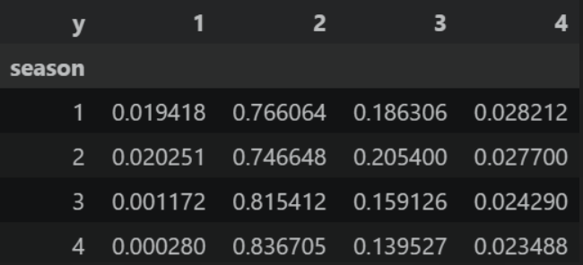
Figure 4
observations show that:

- The data exhibits a heavy skew, with severity level 2 constituting the overwhelming majority of incidents regardless of the time of year (ranging from 74.6% in Season 2 to 83.6% in Season 4).
- distinct proportional shifts occur across the seasons. Most notably, the Label 1 drop precipitously in the latter half of the temporal cycle. They account for roughly 1.9% to 2.0% of incidents in Seasons 1 and 2, but diminish to 0.1% and 0.02% in Seasons 3 and 4, respectively.
- As the relative frequency of Label 1 and Label 3 incidents decreases in Seasons 3 and 4, the concentration of Label 2 incidents intensifies, peaking during the winter months (Season 4).

These observable variances confirm that the engineered season variable captures subtle, non-random shifts in the distribution of accident severities. Demonstrating this variance establishes the feature's statistical relevance.

3.5. Diurnal Feature Redundancy Assessment
To further investigate potential multicollinearity within the dataset, a comparative visual analysis was performed on the newly extracted hour variable mapped against four existing categorical features (f31, f32, f33, and f34), all of which encode "Day" versus "Night" states.
We display the frequency of accidents across the 24-hour cycle, segmented by the categorical values of each respective feature(figure.5)
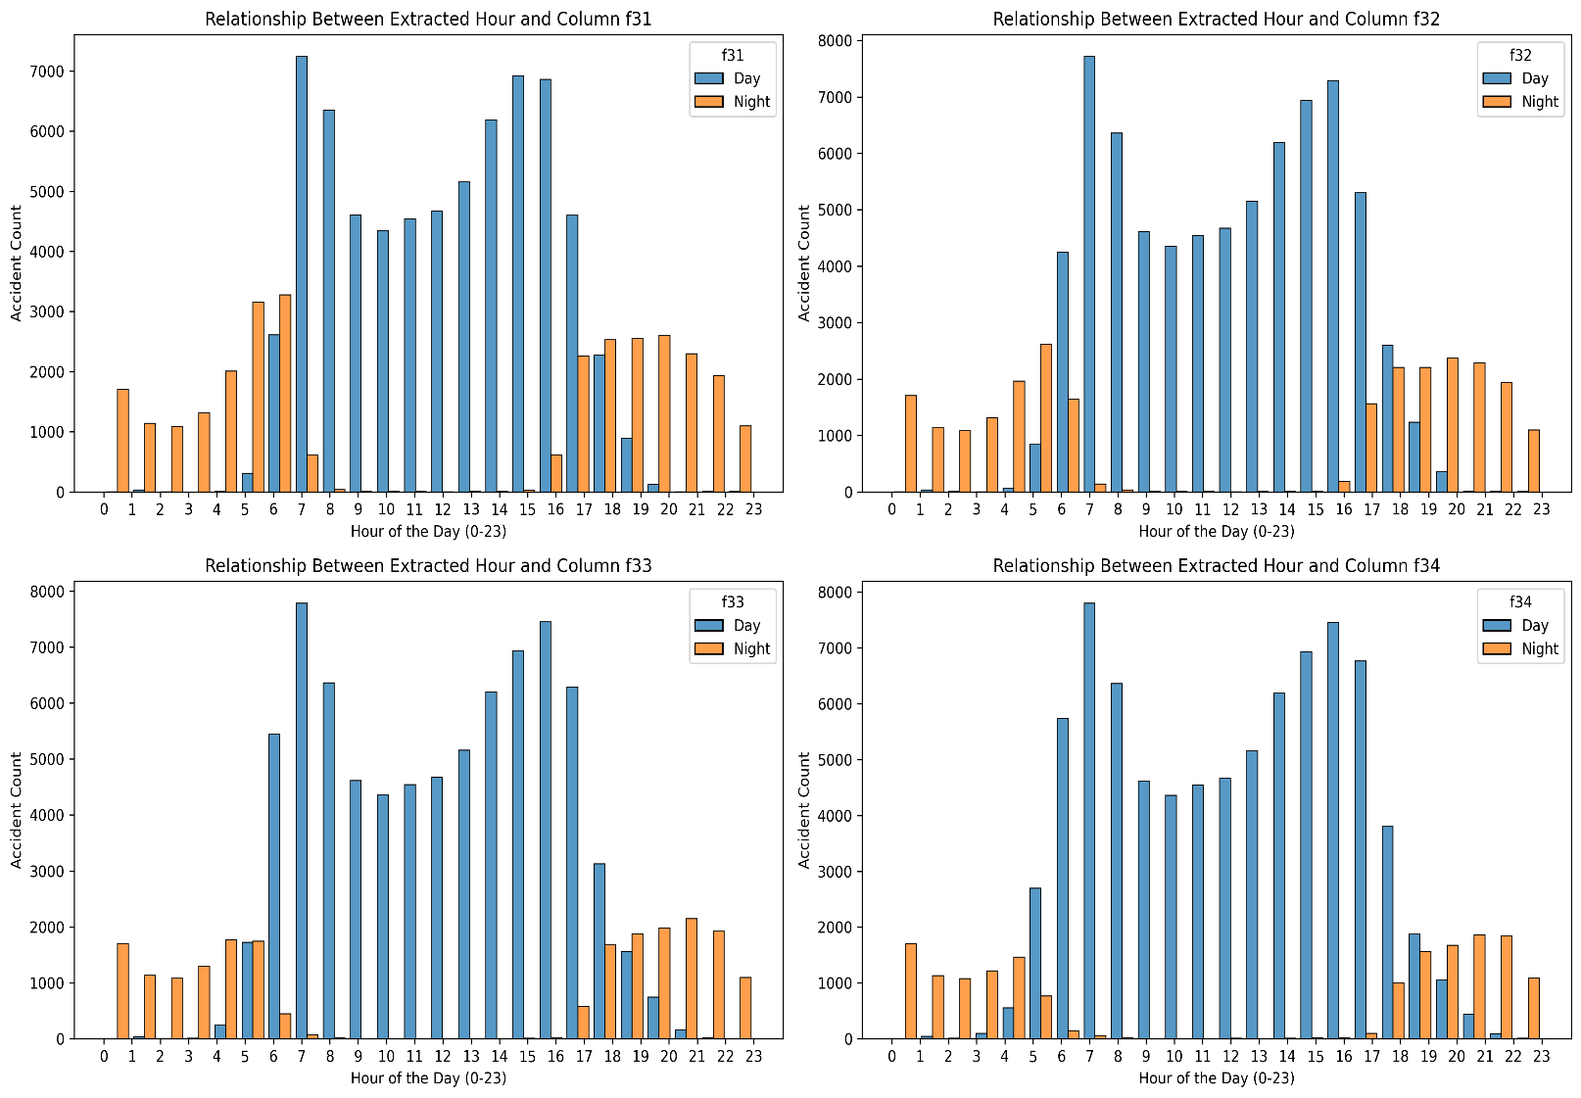
Figure 5
The four subplots display high uniformity. The transition points between 'Day' and 'Night' classifications align almost perfectly across f31, f32, f33, and f34 (with daylight categories dominating the volume between 07:00 and 17:00). This indicates that these four features are capturing the exact same underlying diurnal phenomenon so we can eliminate them.

3.6. deduplication
As a final measure in the foundational data cleaning process, a strict deduplication protocol was applied to the dataset.

3.7. Three-Way Dataset Partitioning
To ensure robust model training and prevent data leakage during the feature selection phase, a rigorous three-way dataset splitting protocol was implemented. The independent variables (X) were separated from the target label (y), and the data was partitioned into three distinct subsets: a training set (70%), a validation set (15%), and a testing set (15%).
A fixed random seed (random_state=123) was utilized to ensure complete reproducibility of the pipeline.

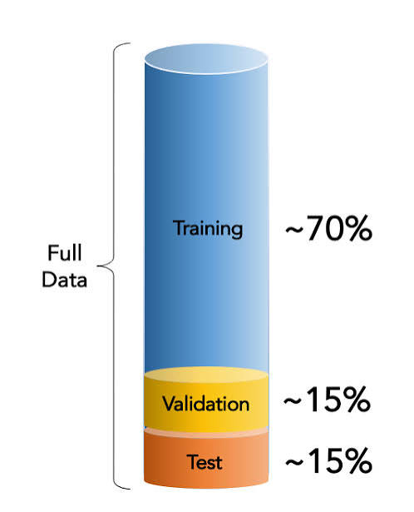

3.8. Statistical Evaluation of Missing Data and Imputation Strategy

WIP

3.9. Generalized Imputation for Low-Sparsity Features

The remaining features requiring imputation were programmatically segregated into numerical and categorical data types to apply the most mathematically appropriate fill strategies:

- Numerical Imputation: numerical features were imputed using a mean-fill strategy. To prevent data leakage, the statistical mean for each column was computed exclusively on the training set X_train. then uniformly applied to transform the training, validation, and testing sets.

- Categorical Imputation: For string or object-based features, missing values were replaced with a constant categorical placeholder "Unknown." To preserve data integrity, a dynamic collision-avoidance mechanism was implemented. The algorithm scans the existing unique values of each categorical column, if the literal string "Unknown" is already a valid category within the data, it iteratively appends an integer suffix (e.g., "Unknown_1") until a unique placeholder is generated.

3.10. Comprehensive Numerical Imputation
To guarantee mathematical stability across the feature space prior to model training, a global mean imputation strategy was applied to all remaining numerical features. While the earlier targeted statistical procedures addressed variables with significant sparsity, this comprehensive pass serves as a rigorous fail-safe to neutralize any residual missingness across the entire continuous and discrete numerical matrix.

3.11. One-Hot Encoding of Categorical Variables
To enable the mathematical processing of nominal text variables by the downstream algorithms, categorical encoding was applied to features f1 and f12. A One-Hot Encoding (OHE) strategy was utilized to expand these variables, transforming each unique categorical state into a distinct, binary indicator column (where 1 represents the presence of the category and 0 represents its absence).

3.12. Boolean Type Conversion
To finalize the homogenization of the dataset's data types, all Boolean indicators were explicitly cast to standard integer formats. While some machine learning frameworks can implicitly handle True and False arrays, explicitly mapping these values to binary integers (1 and 0) guarantees universal compatibility across all downstream mathematical models.

3.13. Feature Scaling and Standardization
To ensure that the variance of features with inherently larger magnitudes does not disproportionately influence the downstream machine learning models, standard scaling (Z-score normalization) was applied to all numerical columns.
3.14. Dimensionality Reduction via Tree-Based Feature Importance

First we get to know how a Tree-based feature selection in a Random Forest classifier works:
Tree-based feature selection in a Random Forest classifier measures how much each feature contributes to reducing uncertainty (or "impurity") across all the decision trees in the forest.

1. Evaluating a Single Node (Gini Impurity)
At the heart of the Random Forest is the decision tree. Every time a tree needs to branch (create a split), it looks at a random subset of features and evaluates which one separates the classes best.

Gini Impurity measures the likelihood of a new, random data point being misclassified if it were given a random class label from the node. The formula for Gini Impurity is:

$$Gini=1-\sum_{i=1}^{c}{p_{i}^{2}}$$

(where $p_{i}$ is the probability of an item belonging to class i)

The algorithm calculates the impurity of the parent node, and then calculates the weighted impurity of the child nodes after a split. The difference between the parent's impurity and the children's impurity is Information Gain(e.g. figure 6)

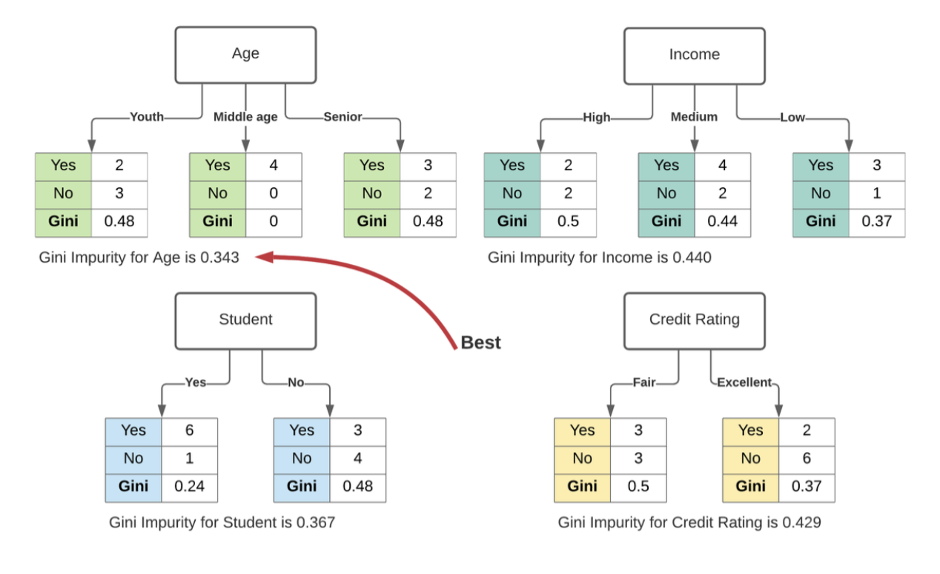
Figure 6

2. Scaling up to a Single Tree
A single decision tree will make dozens or hundreds of splits. As it builds, the algorithm keeps a running tally for each feature.

Every time "Feature A" is used to make a split, the algorithm calculates the Impurity Decrease for that specific split, weights it by the number of samples that passed through that node, and adds it to Feature A's total score for that tree.

3. Aggregating Across the Forest (Mean Decrease in Impurity)
A Random Forest consists of hundreds of individual decision trees. Because each tree is built using a random bootstrap sample of the data and a random subset of features at each split, the model prevents any single feature from dominating the entire process.

To get the final feature importance score, the algorithm calculates the Mean Decrease in Impurity (MDI):

- It takes the total impurity decrease attributed to "Feature A" in every tree, then averages those scores across the entire forest and Finally, it normalizes the scores so that the sum of all feature importances equals 1.0 (or 100%).

4. Making the Selection
Once the model finishes training, you are left with an array of values between 0 and 1 for every feature in your pipeline.

To perform the actual feature selection, you rank the features in descending order. You can then drop the lowest-performing features and keep only the top N features.

The algorithm discarded variables that offered minimal predictive power regarding accident severity(figure 7):

- Infrastructural Indicators: Several Boolean flags (e.g., f20, f22, f24, f26, f27, f28, f29).

- Categorical Expansions: Specific One-Hot Encoded variables that provided low signal, such as the data source flag (f1_Source3) and all distinct time zone indicators derived from the original f12 feature (US/Central, US/Eastern, US/Mountain, US/Pacific, and the Unknown fallback).

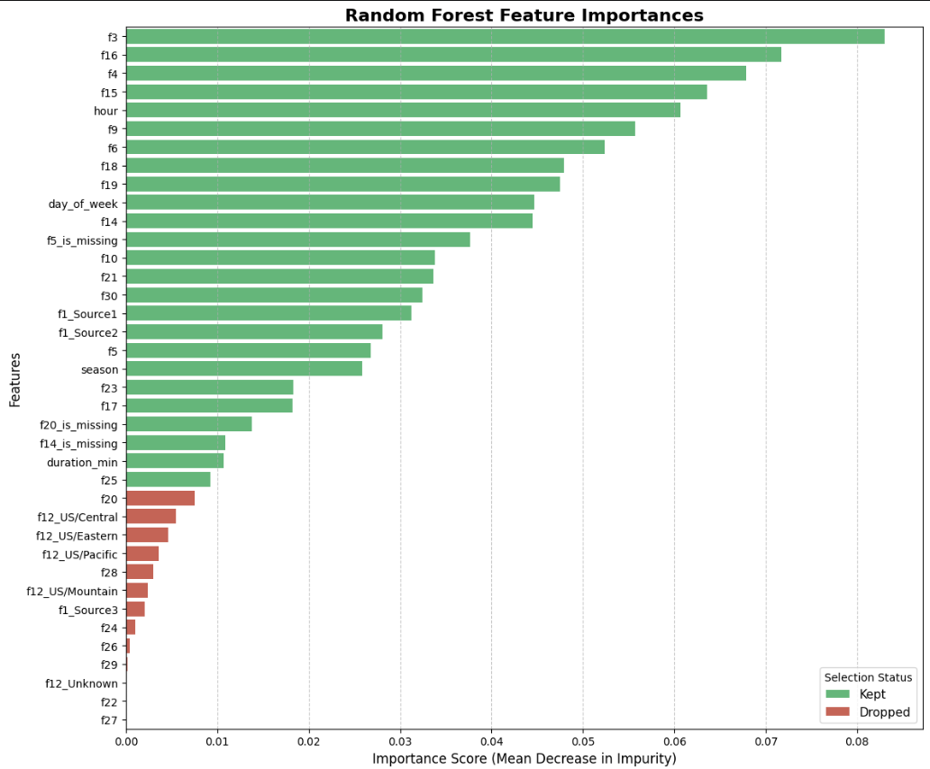
Figure 7

By stripping away these low-impact variables, the pipeline finalizes a lean, high-signal, and strictly numerical feature space that is fully prepared for final model training and evaluation.

.Results and analysis

.Conclusion

.Collaboration

