**DATE:**

**WEB TECHNOLOGY AND MOBILE APPLICATIONS**

**EXPERIMENT-1**

**AIM:**

HTML &amp; CSS

a) Create a web page to embed a map along with hot spot, frames &amp; links.

b) Create a web page using an embedded, external and inline CSS file.

**CODE:**

1. **Map.html**
2. <!DOCTYPE html>
3. <html lang="en">
4. <head>
5. <meta charset="UTF-8">
6. <meta name="viewport" content="width=device-width, initial-scale=1.0">
7. <title>Combined Map, Frames, and Links</title>
8. <style>
9. */* Basic styling for the page */*
10. body {
11. font-family: Arial, sans-serif;
12. margin: 0;
13. padding: 0;
14. background-color: #f4f4f9;
15. color: #333;
16. }
17. h1, h2 {
18. text-align: center;
19. color: #007BFF;
20. }
21. .container {
22. max-width: 1200px;
23. margin: 0 auto;
24. padding: 20px;
25. }
26. .map-container {
27. position: relative;
28. width: 100%;
29. height: 400px;
30. margin-bottom: 20px;
31. }
32. .hotspot {
33. position: absolute;
34. top: 50%;
35. left: 50%;
36. transform: translate(-50%, -50%);
37. background-color: red;
38. color: white;
39. padding: 10px;
40. border-radius: 50%;
41. cursor: pointer;
42. }
43. iframe {
44. width: 100%;
45. height: 100%;
46. border: none;
47. border-radius: 8px;
48. }
49. .grid-container {
50. display: grid;
51. grid-template-columns: 1fr 1fr;
52. gap: 20px;
53. margin-top: 20px;
54. }
55. .frame-section, .links-section {
56. background-color: #fff;
57. padding: 20px;
58. border-radius: 8px;
59. box-shadow: 0 4px 6px rgba(0, 0, 0, 0.1);
60. }
61. .links-section ul {
62. list-style-type: none;
63. padding: 0;
64. }
65. .links-section ul li {
66. margin: 10px 0;
67. }
68. .links-section ul li a {
69. text-decoration: none;
70. color: #007BFF;
71. font-weight: bold;
72. display: block;
73. padding: 10px;
74. border-radius: 4px;
75. transition: background-color 0.3s ease;
76. }
77. .links-section ul li a:hover {
78. background-color: #007BFF;
79. color: #fff;
80. }
81. @media (max-width: 768px) {
82. .grid-container {
83. grid-template-columns: 1fr; */* Stack into one column on small screens */*
84. }
85. }
86. </style>
87. </head>
88. <body>
89. <div class="container">
90. <h1>Embedded Map with Hotspot</h1>
91. *<!-- Embedded Map with Hotspot -->*
92. <div class="map-container">
93. <iframe
94. src="https://www.google.com/maps/embed?pb=!1m18!1m12!1m3!1d3153.8354345093747!2d144.9537353153166!3d-37.816279742021665!2m3!1f0!2f0!3f0!3m2!1i1024!2i768!4f13.1!3m3!1m2!1s0x6ad642af0f11fd81%3A0xf577d2d2f2f1c1b4!2sFlinders%20Street%20Station!5e0!3m2!1sen!2sau!4v1625070000000!5m2!1sen!2sau"
95. allowfullscreen=""
96. loading="lazy">
97. </iframe>
98. *<!-- Hotspot -->*
99. <div class="hotspot" onclick="alert('You clicked the hotspot!')">Hotspot</div>
100. </div>
101. <h2>Frames and Links</h2>
102. *<!-- Grid Layout for Frames and Links -->*
103. <div class="grid-container">
104. *<!-- Frame Section -->*
105. <div class="frame-section">
106. <h2>Embedded Frame</h2>
107. <iframe src="https://www.example.com" title="Example Website"></iframe>
108. </div>
109. *<!-- Links Section -->*
110. <div class="links-section">
111. <h2>Useful Links</h2>
112. <ul>
113. <li><a href="https://www.google.com" target="_blank">Google</a></li>
114. <li><a href="https://www.wikipedia.org" target="_blank">Wikipedia</a></li>
115. <li><a href="https://www.github.com" target="_blank">GitHub</a></li>
116. <li><a href="https://www.stackoverflow.com" target="_blank">Stack Overflow</a></li>
117. <li><a href="https://www.youtube.com" target="_blank">YouTube</a></li>
118. </ul>
119. </div>
120. </div>
121. </div>
122. </body>
123. </html>

**b.**

index.html

<!DOCTYPE html>

<html lang="en">

<head>

    <meta charset="UTF-8">

    <meta name="viewport" content="width=device-width, initial-scale=1.0">

    <title>Modern Web Page with CSS</title>

*<!-- External CSS -->*

    <link rel="stylesheet" href="styles.css">

*<!-- Embedded CSS -->*

    <style>

*/* Embedded CSS */*

        h1 {

            color: #ffffff;

            text-align: center;

            margin-top: 0;

            font-size: 2.5rem;

            font-weight: bold;

            text-shadow: 2px 2px 4px rgba(0, 0, 0, 0.3);

        }

        h2 {

            color: #007BFF;

            font-size: 2rem;

            margin-bottom: 15px;

            border-bottom: 2px solid #007BFF;

            display: inline-block;

            padding-bottom: 5px;

        }

        p {

            font-size: 1.1rem;

            line-height: 1.8;

            color: #444;

        }

    </style>

</head>

<body>

    <header>

        <h1>Welcome to My Modern Web Page</h1>

    </header>

    <main>

        <section>

            <h2 style="color: #FF5733;">About This Page</h2> *<!-- Inline CSS -->*

            <p>

                This web page demonstrates the use of <strong>embedded</strong>, <strong>external</strong>, and <strong>inline</strong> CSS. Each type of CSS is used to style different parts of the page, creating a modern and visually appealing design.

            </p>

        </section>

        <section>

            <h2>External CSS Example</h2>

            <p class="external-style">

                This paragraph is styled using an external CSS file. The external CSS file defines the background gradient, padding, and border-radius for this section, making it stand out.

            </p>

        </section>

        <section>

            <h2>Embedded CSS Example</h2>

            <p>

                This paragraph is styled using embedded CSS. The embedded CSS defines the font size, line height, and text color for all paragraphs, ensuring readability and consistency.

            </p>

        </section>

        <section>

            <h2>Inline CSS Example</h2>

            <p style="background: linear-gradient(135deg, #FFC300, #FF5733); padding: 15px; border-radius: 8px; color: white;">

                This paragraph is styled using inline CSS. Inline CSS is applied directly to this element using the <code>style</code> attribute, creating a unique gradient background.

            </p>

        </section>

    </main>

    <footer>

        <p>&copy; 2023 My Modern Web Page. All rights reserved.</p>

    </footer>

</body>

</html>

Styles.css

*/* External CSS */*

body {

    font-family: 'Arial', sans-serif;

    background: linear-gradient(135deg, #f4f4f9, #e2e2e2);

    margin: 0;

    padding: 0;

    color: #333;

}

header {

    background: linear-gradient(135deg, #007BFF, #00BFFF);

    padding: 40px 20px;

    color: white;

    text-align: center;

    box-shadow: 0 4px 6px rgba(0, 0, 0, 0.1);

}

main {

    padding: 20px;

    max-width: 800px;

    margin: 0 auto;

}

section {

    margin-bottom: 30px;

    padding: 20px;

    background: white;

    border-radius: 10px;

    box-shadow: 0 4px 6px rgba(0, 0, 0, 0.1);

    transition: transform 0.3s ease, box-shadow 0.3s ease;

}

section:hover {

    transform: translateY(-5px);

    box-shadow: 0 8px 12px rgba(0, 0, 0, 0.2);

}

.external-style {

    background: linear-gradient(135deg, #E8F4F8, #D1E8F2);

    padding: 20px;

    border-radius: 8px;

    border-left: 5px solid #007BFF;

}

footer {

    text-align: center;

    padding: 20px;

    background: linear-gradient(135deg, #333, #555);

    color: white;

    margin-top: 40px;

    box-shadow: 0 -4px 6px rgba(0, 0, 0, 0.1);

}

**OUTPUT:**

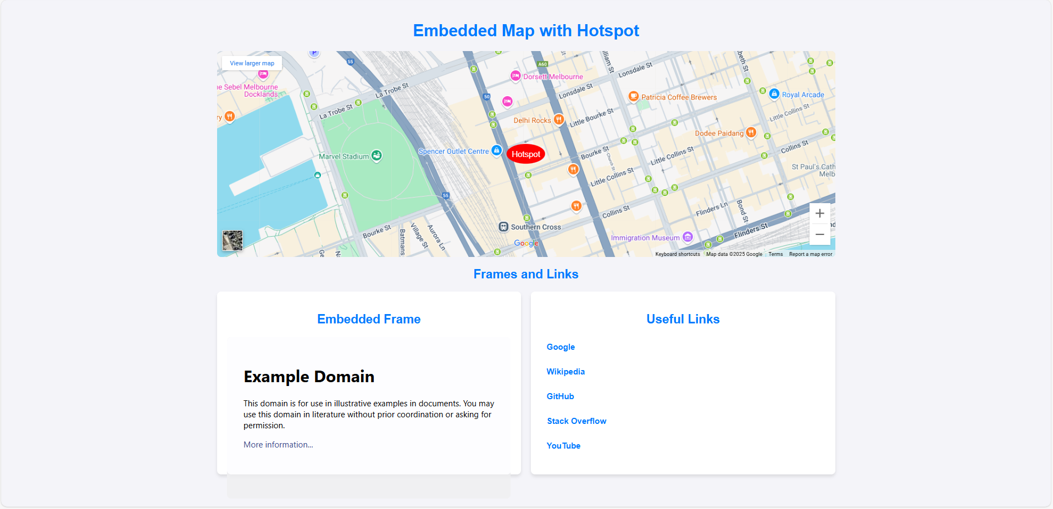

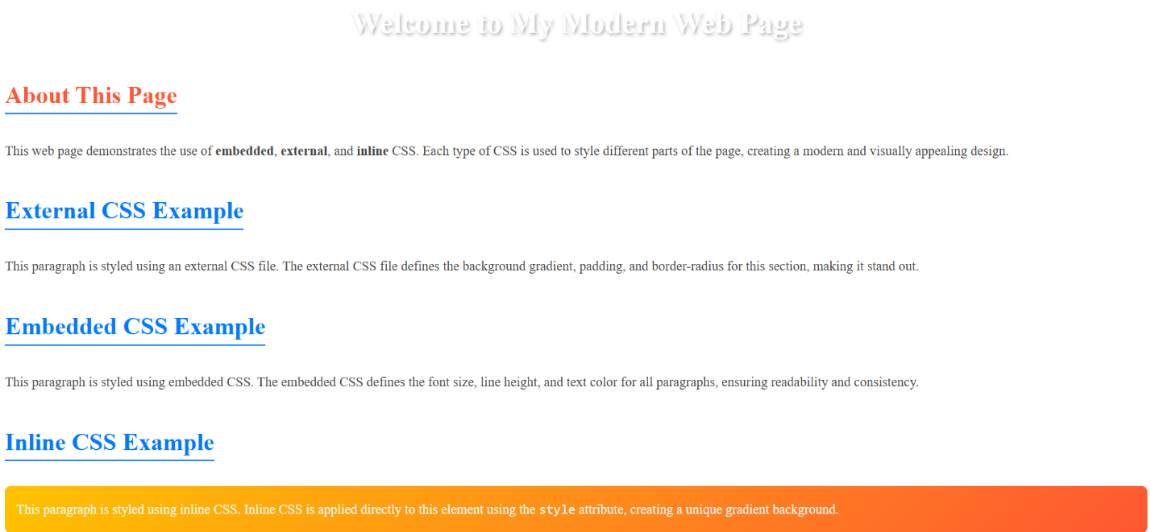

**Result**: Thus, a basic webpage with embedded maps, and a webpage illustrating different css was completed successfully.