**WEB TECHNOLOGY AND MOBILE APPLICATIONS**

**EXPERIMENT-3**

**AIM:**

To create an HTML webpage that displays "Hello World" in the center of the page inside a styled box using CSS for alignment and styling.

**CODE:**

**Index.html**

**<!DOCTYPE html>**

**<html lang="en">**

**<head>**

**<meta charset="UTF-8">**

**<meta name="viewport" content="width=device-width, initial-scale=1">**

**<title>Hello World</title>**

**<style>**

**body {**

**margin: 0;**

**height: 100vh;**

**display: flex;**

**justify-content: center;**

**align-items: center;**

**background: linear-gradient(135deg, #89f7fe, #66a6ff);**

**font-family: 'Segoe UI', Tahoma, Geneva, Verdana, sans-serif;**

**animation: backgroundShift 10s infinite alternate;**

**}**

**@keyframes backgroundShift {**

**0% {**

**background: linear-gradient(135deg, #89f7fe, #66a6ff);**

**}**

**100% {**

**background: linear-gradient(135deg, #ff9a9e, #fad0c4);**

**}**

**}**

**.box {**

**padding: 50px 70px;**

**background: white;**

**border: none;**

**border-radius: 20px;**

**box-shadow: 0 0 30px rgba(0, 0, 0, 0.2), 0 0 60px #66a6ff;**

**font-size: 32px;**

**color: #333;**

**transition: transform 0.3s ease;**

**}**

**.box:hover {**

**transform: scale(1.05);**

**box-shadow: 0 0 40px rgba(0, 0, 0, 0.3), 0 0 80px #66a6ff;**

**}**

**</style>**

**</head>**

**<body>**

**<div class="box">Hello World ✨</div>**

**</body>**

**</html>**

**OUTPUT:**

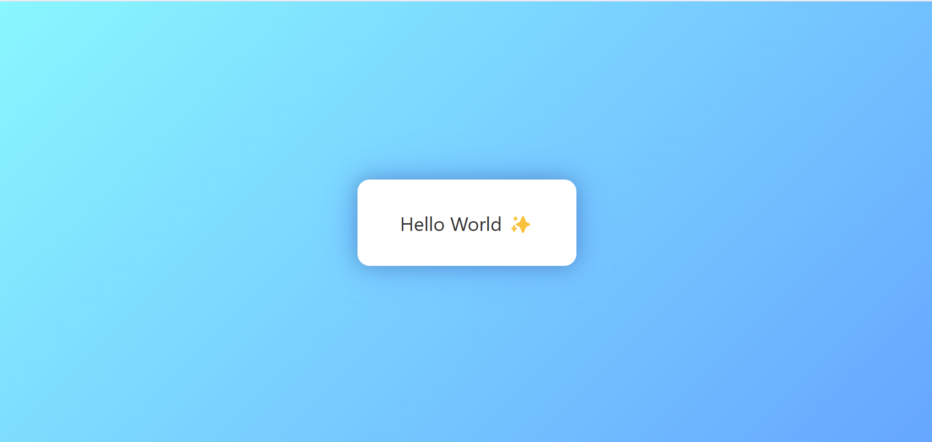

**Result**: Thus the servlet program was successfully executed.