**WEB TECHNOLOGY AND MOBILE APPLICATIONS**

**EXPERIMENT-4**

**AIM:**

To create a web form that accepts a user's name and age, processes the data using JavaScript, and displays the submitted details with a stylish UI and animations.

**CODE:**

**<!DOCTYPE html>**

**<html lang="en">**

**<head>**

**<meta charset="UTF-8">**

**<meta name="viewport" content="width=device-width, initial-scale=1">**

**<title>User Form</title>**

**<style>**

**body {**

**margin: 0;**

**font-family: 'Segoe UI', Tahoma, Geneva, Verdana, sans-serif;**

**background: linear-gradient(135deg, #e0c3fc, #8ec5fc);**

**display: flex;**

**justify-content: center;**

**align-items: center;**

**height: 100vh;**

**animation: gradientShift 10s infinite alternate;**

**}**

**@keyframes gradientShift {**

**0% {**

**background: linear-gradient(135deg, #e0c3fc, #8ec5fc);**

**}**

**100% {**

**background: linear-gradient(135deg, #fbc2eb, #a6c1ee);**

**}**

**}**

**.container {**

**background-color: white;**

**padding: 40px;**

**border-radius: 15px;**

**box-shadow: 0 10px 25px rgba(0, 0, 0, 0.2);**

**text-align: center;**

**transition: transform 0.3s;**

**}**

**.container:hover {**

**transform: scale(1.02);**

**}**

**input {**

**padding: 10px;**

**margin: 10px 0;**

**width: 90%;**

**border: 1px solid #ccc;**

**border-radius: 8px;**

**font-size: 16px;**

**transition: 0.3s;**

**}**

**input:focus {**

**outline: none;**

**border-color: #7f5af0;**

**box-shadow: 0 0 8px #7f5af0;**

**}**

**button {**

**padding: 12px 25px;**

**margin-top: 15px;**

**background-color: #7f5af0;**

**color: white;**

**border: none;**

**border-radius: 8px;**

**cursor: pointer;**

**font-size: 16px;**

**transition: background 0.3s;**

**}**

**button:hover {**

**background-color: #6241c7;**

**}**

**.output {**

**margin-top: 20px;**

**font-size: 20px;**

**color: #333;**

**opacity: 0;**

**transform: translateY(20px);**

**transition: all 0.5s ease;**

**}**

**.output.show {**

**opacity: 1;**

**transform: translateY(0);**

**}**

**</style>**

**</head>**

**<body>**

**<div class="container">**

**<h2>Welcome! 🎉</h2>**

**<input type="text" id="name" placeholder="Enter your name" />**

**<input type="number" id="age" placeholder="Enter your age" />**

**<br>**

**<button onclick="submitForm()">Submit</button>**

**<div class="output" id="output"></div>**

**</div>**

**<script>**

**function submitForm() {**

**const name = document.getElementById('name').value.trim();**

**const age = document.getElementById('age').value.trim();**

**const outputDiv = document.getElementById('output');**

**if (name === '' || age === '') {**

**outputDiv.innerHTML = '🚫 Please fill in both fields!';**

**} else {**

**outputDiv.innerHTML = `👤 Hello, <strong>${name}</strong>!<br>🎂 You are <strong>${age}</strong> years old.`;**

**}**

**outputDiv.classList.add('show');**

**}**

**</script>**

**</body>**

**</html>**

**OUTPUT:**

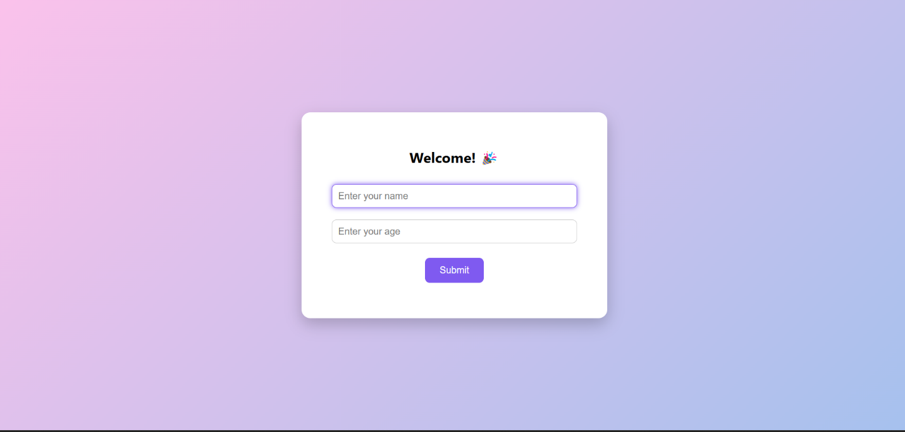

**Result**: : The creation of web form using servlet program was executed successfully.