**WEB TECHNOLOGY AND MOBILE APPLICATIONS**

**EXPERIMENT-5**

**AIM:**

To demonstrate the difference between HTTP GET and POST methods using a Java Servlet by creating a form that sends data using both methods.

**ALGORITHM:**

Step 1: Create an HTML form with GET and POST methods.

Step 2: Develop a Servlet (GetPostServlet.java) to handle requests.

Step 3: Implement doGet() to handle GET requests.

Step 4: Implement doPost() to handle POST requests.

Step 5: Configure web.xml to map the Servlet to /GetPostServlet.

Step 6: Run the server and observe how GET and POST work differently.

**CODE:**

**Index.html**

<!DOCTYPE html>

<html>

<head>

  <title>GET vs POST Demo</title>

  <style>

    body {

      font-family: 'Segoe UI', sans-serif;

      background: linear-gradient(135deg, #d4fc79, #96e6a1);

      display: flex;

      flex-direction: column;

      align-items: center;

      justify-content: center;

      height: 100vh;

      margin: 0;

    }

    h2 {

      color: #333;

    }

    form {

      background: white;

      padding: 30px 40px;

      border-radius: 12px;

      box-shadow: 0 0 15px rgba(0,0,0,0.2);

      margin: 20px;

      width: 300px;

      text-align: center;

      transition: transform 0.3s ease;

    }

    form:hover {

      transform: scale(1.03);

    }

    input {

      padding: 10px;

      margin: 10px 0;

      width: 90%;

      border: 1px solid #ccc;

      border-radius: 8px;

      font-size: 14px;

    }

    button {

      padding: 10px 20px;

      margin-top: 10px;

      border: none;

      border-radius: 8px;

      background-color: #4a90e2;

      color: white;

      font-size: 15px;

      cursor: pointer;

      transition: background 0.3s;

    }

    button:hover {

      background-color: #357ab8;

    }

  </style>

</head>

<body>

  <h2>GET vs POST Servlet Demo 🚀</h2>

  <form action="FormHandlerServlet" method="GET">

    <input type="text" name="name" placeholder="Your Name" required><br>

    <input type="number" name="age" placeholder="Your Age" required><br>

    <button type="submit">Submit via GET 🌐</button>

  </form>

  <form action="FormHandlerServlet" method="POST">

    <input type="text" name="name" placeholder="Your Name" required><br>

    <input type="number" name="age" placeholder="Your Age" required><br>

    <button type="submit">Submit via POST 📩</button>

  </form>

</body>

</html>

**Form. java**

import java.io.*\**;

import javax.servlet.*\**;

import javax.servlet.http.*\**;

public class FormHandlerServlet extends HttpServlet {

    protected void doGet(HttpServletRequest request, HttpServletResponse response)

            throws ServletException, IOException {

        String name = request.getParameter("name");

        String age = request.getParameter("age");

        response.setContentType("text/html");

        PrintWriter out = response.getWriter();

        out.println("<html><body style='font-family:sans-serif; text-align:center; background:#f0f9ff;'>");

        out.println("<h2 style='color:#4a90e2;'>📡 Data Received via <u>GET</u> Method</h2>");

        out.println("<p><strong>Name:</strong> " + name + "</p>");

        out.println("<p><strong>Age:</strong> " + age + "</p>");

        out.println("<p style='color:gray;'>Data is visible in the URL! 🌐</p>");

        out.println("</body></html>");

    }

    protected void doPost(HttpServletRequest request, HttpServletResponse response)

            throws ServletException, IOException {

        String name = request.getParameter("name");

        String age = request.getParameter("age");

        response.setContentType("text/html");

        PrintWriter out = response.getWriter();

        out.println("<html><body style='font-family:sans-serif; text-align:center; background:#fff7f0;'>");

        out.println("<h2 style='color:#e67e22;'>📨 Data Received via <u>POST</u> Method</h2>");

        out.println("<p><strong>Name:</strong> " + name + "</p>");

        out.println("<p><strong>Age:</strong> " + age + "</p>");

        out.println("<p style='color:gray;'>Data is hidden in the request body! 🔐</p>");

        out.println("</body></html>");

    }

}

**OUTPUT:**

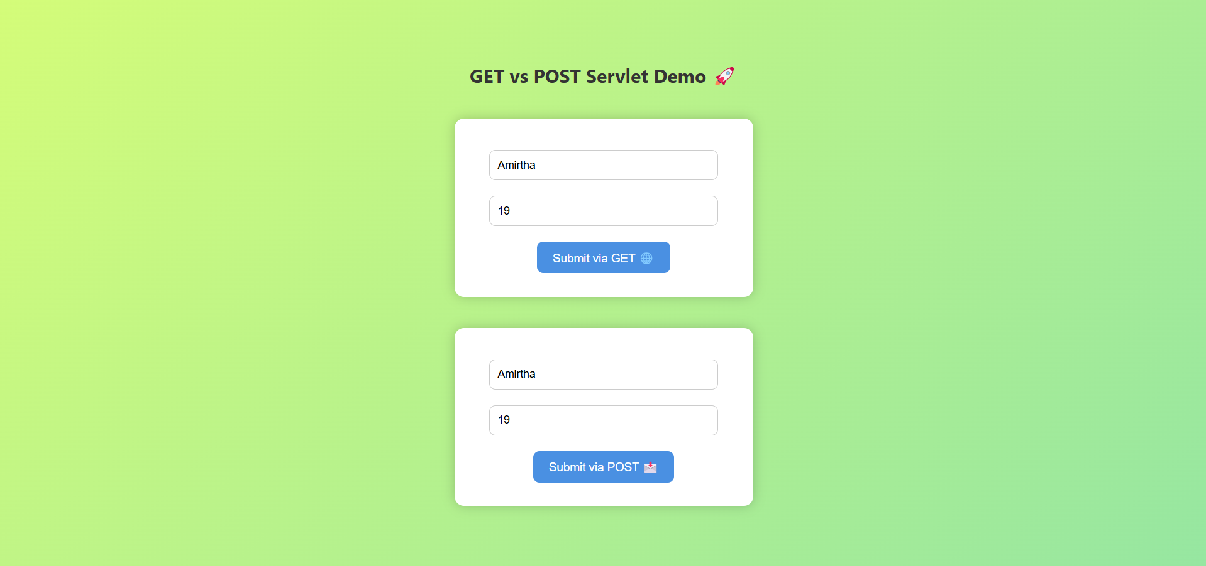

**Result**: : The Get and Post methods were executed successfull