AMIRTHA VARSHINI V

INVENTORY MANAGEMENT AND ANALYTICS
Inventory Management and Analytics Dashboard

1.PROJECT OVERVIEW:
Stock Sphere Intelligence is an interactive inventory management dashboard developed in Microsoft Excel through SQL Queries. It helps businesses monitor stock movement, inventory value, product performance, reorder requirements, and transaction analysis through dynamic KPIs, charts, slicers, and Pivot Tables.
This project demonstrates practical inventory reporting skills commonly required for MIS Executive, Reporting Analyst, and Junior Business Analyst roles.

2. KPI CARDS:
KPI | DESCRIPTION
Total Stock In | Total Quantity of products received into inventory
Total Stock Out | Total quantity issued or sold from inventory
Current Stock | Available inventory after Stock In-Stock Out calculation.
Total Stock Value | Total Monetary Value of available inventory.
Reorder Items | Products that reached or fell below reorder level.

3. VISUALIZATIONS AND INSIGHTS:
TRENDS | CHARTS | DESCRIPTION
Total Stock | Line Chart (12 months) | Monthly Stock In vs Stock Out trends.
Top 10 Products | Columned Bar Chart | Highest stock value products.
Stock In vs Stock Out | Area Chart by Category | Inventory movement comparison.
Category Stock Value | Pie Chart | Stock value distribution by category.
Transaction Count | Bar Chart | Number of inventory transactions.

4. DASHBOARD:
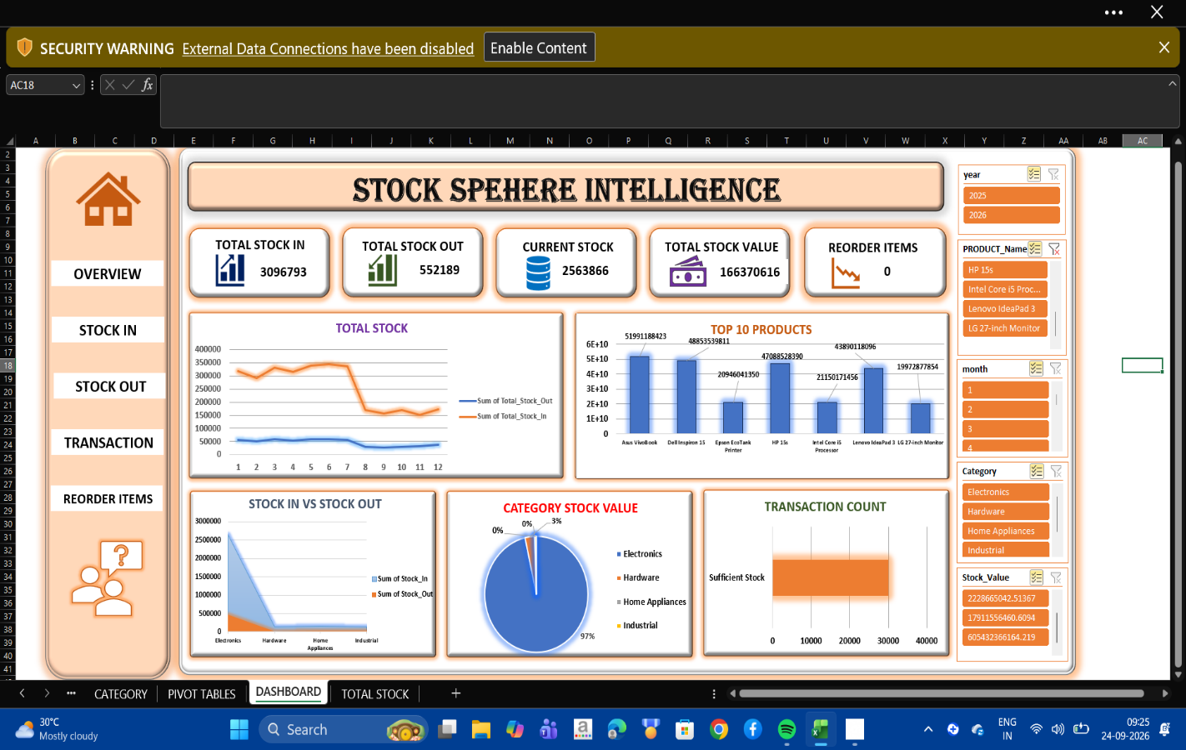

5. CONCLUSION:
Stock Sphere Intelligence is an interactive inventory dashboard built using SQL and Microsoft Excel. It provides real-time insights into stock movement, inventory value, and product performance through dynamic KPIs and charts.
The dashboard helps monitor stock levels, identify reorder items, and analyse category-wise inventory trends.

