**KeepNote RDBMS Assignment boilerplate**

User table fields: user_id, user_name, user_added_date, user_password, user_mobile

*Note table fields: note_id, note_title, note_content, note_status, note_creation_date

Category table fields : category_id, category_name, category_descr, category_creation_date, category_creator

Reminder table fields : reminder_id, reminder_name, reminder_descr, reminder_type, reminder_creation_date, reminder_creator



**NoteCategory table fields : notecategory_id, note_id, category_id

**Notereminder table fields : notereminder_id, note_id, reminder_id

**usernote table fields : usernote_id, user_id, note_id

**Fetch the row from User table based on Id and Password.

**Fetch all the rows from Note table based on the field note_creation_date.

**Fetch all the Categories created after the particular Date.

**Fetch all the Note ID from UserNote table for a given User.

**Write Update query to modify particular Note for the given note Id.

**Fetch all the Notes from the Note table by a particular User.

**Fetch all the Notes from the Note table for a particular Category.

**Fetch all the reminder details for a given note id.

**Fetch the reminder details for a given reminder id.

**Write a query to create a new Note from particular User (Use Note and UserNote tables - insert statement).

**Write a query to create a new Note from particular User to particular Category(Use Note and NoteCategory tables - insert statement)

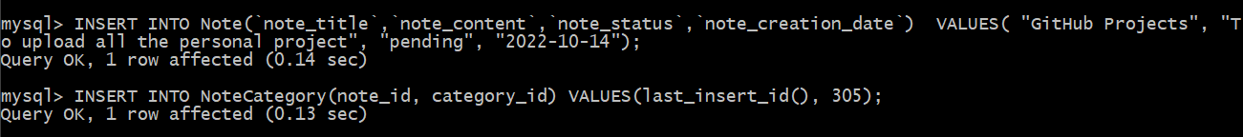

**Write a query to set a reminder for a particular note (Use Reminder and NoteReminder tables - insert statement)

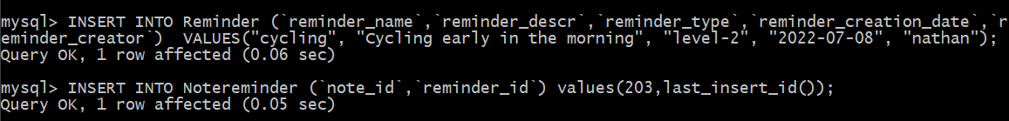

**Write a query to delete particular Note added by a User(Note and UserNote tables - delete statement)

**Write a query to delete particular Note from particular Category(Note and NoteCategory tables - delete statement)

**Create a trigger to delete all matching records from UserNote, NoteReminder and NoteCategory table when :

1. A particular note is deleted from Note table (all the matching records from UserNote, NoteReminder and NoteCategory should be removed automatically)

2. A particular user is deleted from User table (all the matching notes should be removed automatically)

