**IoT PHASE -3**

**PROJECT: ENVIRONMENTAL MONITORING**

TEAM MEMBERS: T Amirtha , Ashwin , V Gayatri , G Gopika

**SENSOR DEPLOYMENT**

Overview: We have used Arduino UNO R3 as a microcontroller to which we have integrated temperature sensor, humidity sensor, Ultrasonic sensor, IR sensor, Soil moisture sensor and LDR Sensor.

**SET UP IMAGE:**

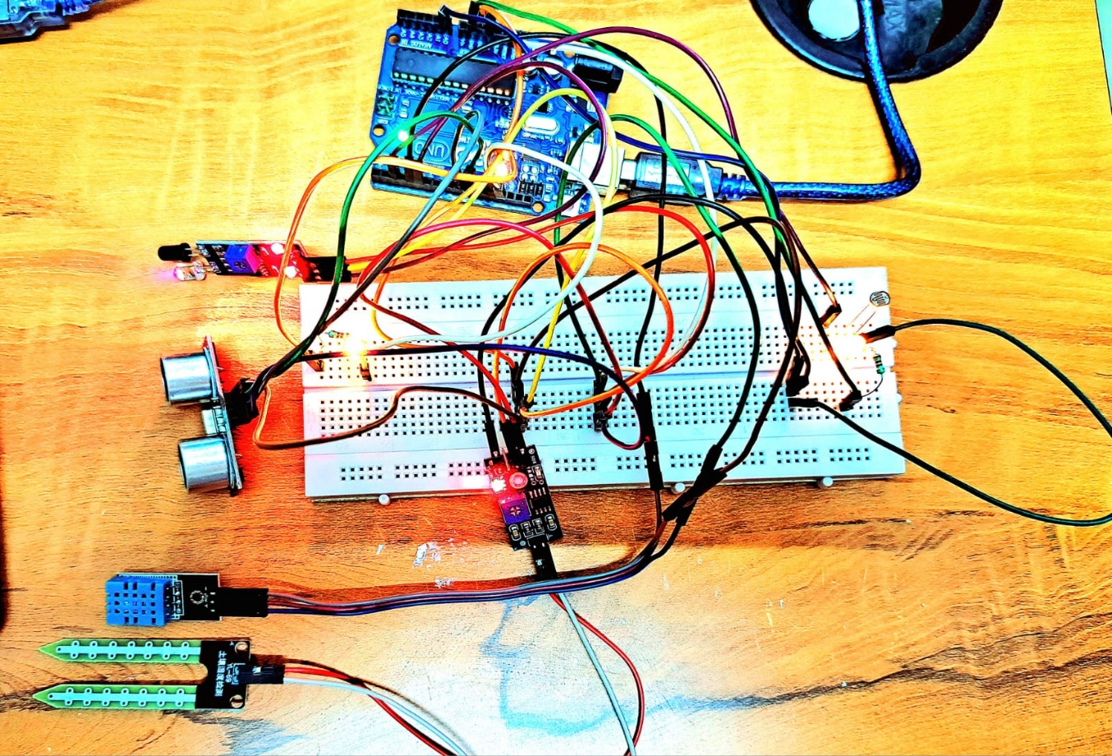



1. Soil Moisture Sensor 2) Humidity Sensor 3)Ultra Sonic Sensor

4) IR Sensor 5)LDR

**SOURCE CODE:**

#include <Adafruit_Sensor.h>

#include <DHT.h>

#define DHTPIN 4

#define DHTTYPE DHT11

DHT kavi (DHTPIN,DHTTYPE);

int trigPin=9;

int echoPin=10;

int duration;

int distance;

int SensorPin = 2;

int OutputPin = 13;

const int ledPin = 5; // digital pin 5

const int ldrPin = A0; // analog pin 0

void setup() {

pinMode(trigPin,OUTPUT);

pinMode(echoPin,INPUT);

Serial.begin(9600);

kavi.begin();

pinMode(OutputPin, OUTPUT);

pinMode(SensorPin, INPUT);

pinMode(ledPin, OUTPUT); // Here LED is determined as an output or an indicator.

pinMode(ldrPin, INPUT); // Here LDR sensor is determined as input.

}

void loop()

{

//Temperature and Humidity sensor

float humidity=kavi.readHumidity();

float temp=kavi.readTemperature();

Serial.print("Humidity(%):");

Serial.println(humidity);

Serial.println();

Serial.print("Temperature(*C):");

Serial.println(temp);

Serial.println("");

delay(1000);

// Ultrasonic sensor

digitalWrite(trigPin,LOW);

delayMicroseconds(2);

digitalWrite(trigPin,HIGH);

delayMicroseconds(10);

digitalWrite(trigPin,LOW);

duration=pulseIn(echoPin,HIGH);

distance=duration*0.034/2;

if(distance>=100)

{

Serial.println("Water level in lake is low");

}

else

{

Serial.println("Water level in lake is high");

}

Serial.print("distance:");

Serial.print(distance);

Serial.println("cm");

Serial.println("");

//IR sensor

int SensorValue = digitalRead(SensorPin);

delay(1000);

if (SensorValue==LOW){ // LOW MEANS Object Detected

digitalWrite(OutputPin, HIGH);

Serial.println("Moving object detected");

}

else

{

digitalWrite(OutputPin, LOW);

Serial.println("Moving object not detected");

}

Serial.print("Value of IR sensor: ");

Serial.println(SensorValue);

Serial.println("");

//Soil Moisture sensor

int level;

level = analogRead(0);

if(level>=800)

{

Serial.println("The soil is dry,need water");

}

else{

Serial.println ("The soil is wet,no need of water");

}

Serial.print ("Value of soil sensor: ");

Serial.println(level);

Serial.println("");

// LDR sensor

int ldrStatus = analogRead(ldrPin);

if (ldrStatus >= 800) {

digitalWrite(ledPin, HIGH); // If LDR senses darkness led pin high that means led will glow.

Serial.println("Darkness over here,turn on the LED ");

}

else {

digitalWrite(ledPin, LOW); // If LDR senses light led pin low that means led will stop glowing.

Serial.println("There is sufficient light , turn off the LED");

}

Serial.print("Value of LDR sensor: ");

Serial.println(ldrStatus);

Serial.println("");

Serial.println("");

Serial.println("");

}

**SERIAL MONITOR OUTPUT: (For the above setup and source code)**

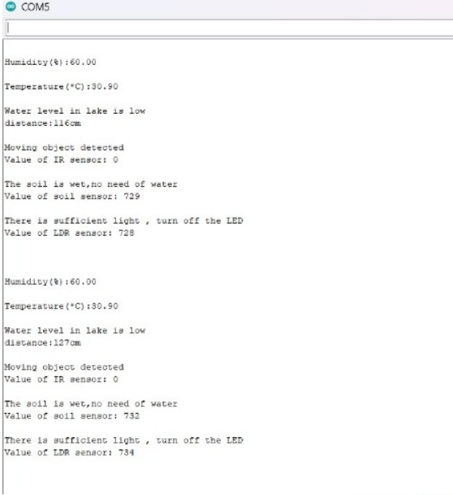

**INDIVIDUAL SENSOR DEPLOYMENT IN TINKER CAD:**

**SOIL MOISTURE SENSOR**

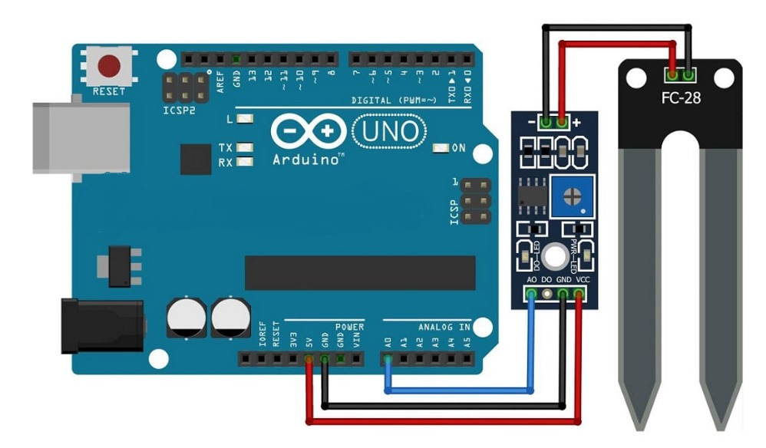

**HUMIDITY SENSOR**

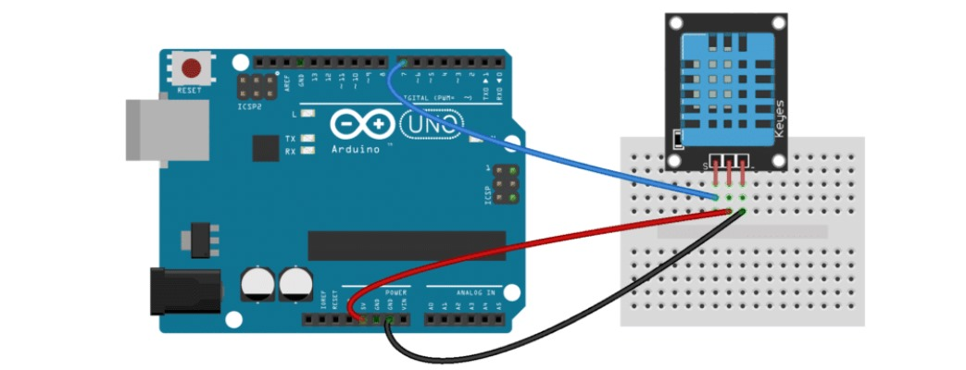

**IR SENSOR**

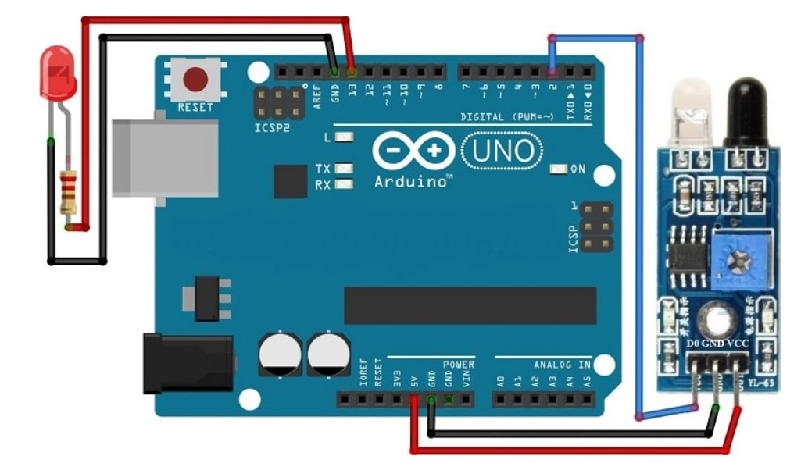

**ULTRASONIC SENSOR**

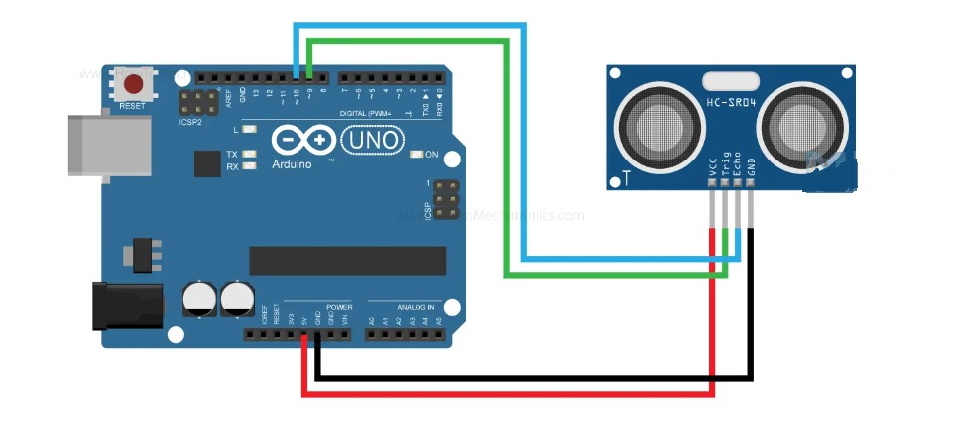

**LDR SENSOR**

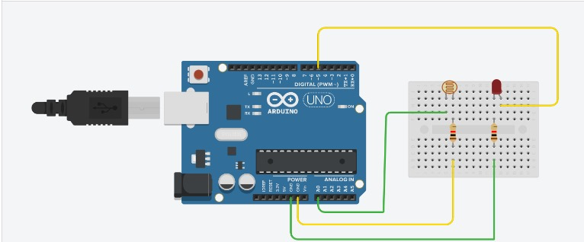

**SOURCE CODE CONVERTED TO PYTHON LANGUAGE:**

import Adafruit_Sensor

import DHT

DHTPIN = 4

DHTTYPE = DHT.DHT11

kavi = DHT(DHTPIN, DHTTYPE)

trigPin = 9

echoPin = 10

duration = 0

distance = 0

SensorPin = 2

OutputPin = 13

ledPin = 5 # digital pin 5

ldrPin = 0 # analog pin 0

def setup():

global kavi

pinMode(trigPin, OUTPUT)

pinMode(echoPin, INPUT)

Serial.begin(9600)

kavi.begin()

pinMode(OutputPin, OUTPUT)

pinMode(SensorPin, INPUT)

pinMode(ledPin, OUTPUT) # Here LED is determined as an output or an indicator.

pinMode(ldrPin, INPUT) # Here LDR sensor is determined as input.

def loop():

global duration, distance

# Temperature and Humidity sensor

humidity = kavi.readHumidity()

temp = kavi.readTemperature()

Serial.print("Humidity(%):")

Serial.println(humidity)

Serial.println()

Serial.print("Temperature(*C):")

Serial.println(temp)

Serial.println("")

delay(1000)

# Ultrasonic sensor

digitalWrite(trigPin, LOW)

delayMicroseconds(2)

digitalWrite(trigPin, HIGH)

delayMicroseconds(10)

digitalWrite(trigPin, LOW)

duration = pulseIn(echoPin, HIGH)

distance = duration * 0.034 / 2

if distance >= 100:

Serial.println("Water level in lake is low")

else:

Serial.println("Water level in lake is high")

Serial.print("distance:")

Serial.print(distance)

Serial.println("cm")

Serial.println("")

# IR sensor

SensorValue = digitalRead(SensorPin)

delay(1000)

if SensorValue == LOW: # LOW MEANS Object Detected

digitalWrite(OutputPin, HIGH)

print("Moving object detected")

else:

digitalWrite(OutputPin, LOW)

print("Moving object not detected")

print("Value of IR sensor: ")

print(SensorValue)

print("")

# Soil Moisture sensor

level = analogRead(0)

if level >= 800:

print("The soil is dry, need water")

else:

print("The soil is wet, no need of water")

print("Value of soil sensor: ")

print(level)

print("")

# LDR sensor

ldrStatus = analogRead(ldrPin)

if ldrStatus >= 800:

digitalWrite(ledPin, HIGH) # If LDR senses darkness led pin high that means led will glow.

print("Darkness over here, turn on the LED")

else:

digitalWrite(ledPin, LOW) # If LDR senses light led pin low that means led will stop glowing.

print("There is sufficient light, turn off the LED")

print("Value of LDR sensor: ")

print(ldrStatus)

print("")

print("")

print("")