AWS CLOUD INFRASTRUCTURE

IoT Device Data Storage
with Backup & Monitoring
Scalable Ingestion • Serverless Processing • NoSQL Storage • Recovery

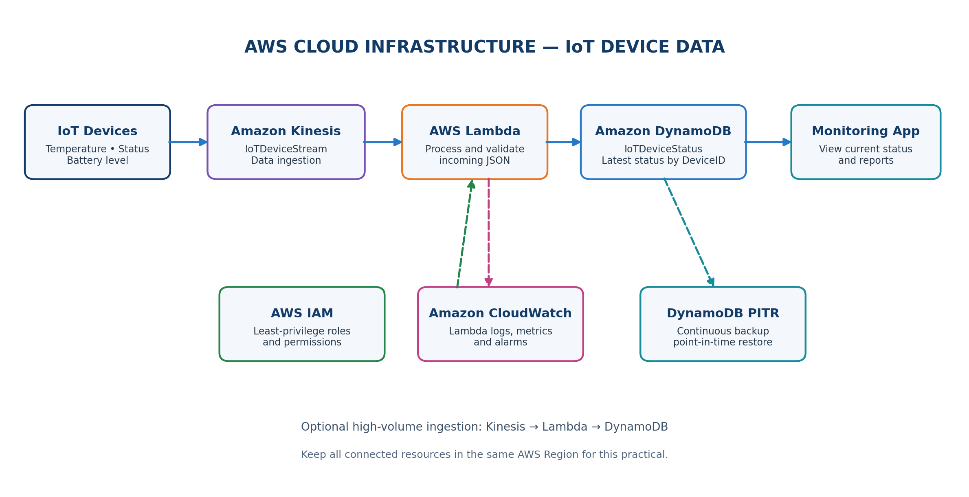
Practical Implementation Documentation
Services: Amazon Kinesis • AWS Lambda • Amazon DynamoDB • IAM • CloudWatch • DynamoDB PITR

1. Objective
Design and implement a scalable IoT device-status storage solution on AWS. Devices continuously report temperature, operating status, and battery level. Kinesis receives streaming records, Lambda processes them without server management, DynamoDB stores the latest status by DeviceID, IAM controls access, CloudWatch collects logs and metrics, and DynamoDB Point-in-Time Recovery (PITR) supports recovery.

2. Proposed Architecture
The diagram is a proposed implementation design, not proof that resources are already deployed. Verify each service in the AWS Console before recording a step as complete.

3. Components and Responsibilities
Component | Purpose in this practical
Amazon Kinesis Data Streams | Accepts continuous device records and buffers high-volume data.
AWS Lambda | Reads stream events, parses JSON, and writes device status to DynamoDB.
Amazon DynamoDB | Stores the latest status for each device using DeviceID as the partition key.
AWS IAM | Grants the Lambda execution role only the permissions required for Kinesis, DynamoDB, and logs.
Amazon CloudWatch | Shows Lambda logs, invocation metrics, errors, and optional alarms.
DynamoDB PITR | Maintains continuous backups and enables restoration to a selected point in the recovery window.
Monitoring application | Reads DynamoDB records to display device status, alerts, and reports.

4. Implementation Notes
- Choose one AWS Region and create the connected resources in that same Region.
- Use dummy device data for the practical; do not send private or sensitive real-world data.
- The sample flow uses Kinesis → Lambda → DynamoDB. Manual DynamoDB insert/retrieve/update operations can be demonstrated separately.
- AWS charges may apply depending on account plan, usage, data retention, and enabled services. Check Billing and Cost Management before deploying.
- Do not claim a step succeeded until its status is verified in the console.

5. Implementation Procedure

Step 1: Select the AWS Region
- Sign in to the AWS Management Console.
- Select a single Region, for example Asia Pacific (Mumbai) — ap-south-1.
- Keep DynamoDB, Kinesis, Lambda, and CloudWatch in the same Region for this practical.
Expected verification: The selected Region is visible in the console header.

Step 2: Create the DynamoDB Table
- Open DynamoDB → Tables → Create table.
- Table name: IoTDeviceStatus.
- Partition key: DeviceID; type: String.
- Select On-demand capacity mode and create the table.
Expected verification: IoTDeviceStatus appears in the table list and its status is Active.

Step 3: Insert and Retrieve Sample Device Records
Open the table → Explore table items → Create item. Add attributes as shown below.
DeviceID | Temperature | OperatingStatus | BatteryLevel | Timestamp
dev001 | 36.5 | Online | 85 | 2026-10-12T10:15:00Z
dev002 | 42.1 | Online | 60 | 2026-10-12T10:16:00Z
dev003 | 28.7 | Offline | 30 | 2026-10-12T10:17:00Z
dev004 | 37.2 | Online | 95 | 2026-10-12T10:18:00Z

- Create each item and save it.
- Use Explore table items to retrieve a record by DeviceID, such as dev001.
- Edit one record and change Temperature or BatteryLevel to demonstrate an update.
Expected verification: Items are visible, can be queried, and can be edited.

Step 4: Enable DynamoDB Point-in-Time Recovery (PITR)
- Open DynamoDB → Tables → IoTDeviceStatus → Backups.
- Find Point-in-time recovery (PITR), choose Edit, and enable it.
- Save the change and confirm the status shows Enabled. Review the available recovery period displayed by AWS.
Expected verification: PITR shows Enabled. A restore, if demonstrated, creates a new table rather than overwriting the original.

6. Streaming and Serverless Processing

Step 5: Create a Kinesis Data Stream
- Open Kinesis → Data streams → Create data stream.
- Stream name: IoTDeviceStream.
- Choose On-demand capacity mode for a simple practical and create the stream.
- Wait until the stream is Active.
Expected verification: IoTDeviceStream appears with Active status.

Step 6: Create an IAM Execution Role
- Open IAM → Roles → Create role → AWS service → Lambda.
- Attach AWSLambdaBasicExecutionRole for CloudWatch Logs.
- Add a custom policy that grants DynamoDB PutItem/UpdateItem access to IoTDeviceStatus and Kinesis read access to IoTDeviceStream.
- Use the exact table and stream ARNs in Resource fields; avoid Resource: * where possible.
- Name the role IoTDataLambdaRole and create it.
Expected verification: The role exists and includes only the permissions required by the function and stream trigger.

Step 7: Create the Lambda Function
- Open Lambda → Functions → Create function → Author from scratch.
- Function name: ProcessIoTData.
- Choose a current Python runtime offered by the console.
- Under permissions, select Use an existing role and choose IoTDataLambdaRole.
Expected verification: ProcessIoTData opens successfully and uses IoTDataLambdaRole.

Step 8: Add the Lambda Code
Replace the starter code with the following, then select Deploy.
import json
import base64
import boto3
from decimal import Decimal

table = boto3.resource("dynamodb").Table("IoTDeviceStatus")

def lambda_handler(event, context):
for record in event.get("Records", []):
raw = base64.b64decode(record["kinesis"]["data"]).decode("utf-8")
device = json.loads(raw, parse_float=Decimal)
table.put_item(Item=device)
print("Processed device:", device.get("DeviceID"))

return {"statusCode": 200, "body": "IoT data processed"}
The function decodes each Kinesis record, parses the JSON payload, and writes the device item to DynamoDB. Each record must include DeviceID and DynamoDB-compatible attribute values.

7. Connect, Test, and Monitor

Step 9: Connect Kinesis to Lambda
- Open ProcessIoTData → Add trigger.
- Select Kinesis and choose IoTDeviceStream.
- Choose starting position LATEST for new records, then add the trigger.
- If prompted, ensure the Lambda execution role has the required Kinesis read permissions.
Expected verification: The Kinesis trigger is listed in the Lambda function overview.

Step 10: Send a Test Record
Open AWS CloudShell in the same Region and run the command below. This uses dummy data.
aws kinesis put-record \
--stream-name IoTDeviceStream \
--partition-key dev005 \
--data '{"DeviceID":"dev005","Temperature":31.5,"OperatingStatus":"Online","BatteryLevel":92,"Timestamp":"2026-10-12T10:30:00Z"}
Expected verification: The command returns a ShardId and SequenceNumber. After Lambda processes the event, dev005 should appear in DynamoDB.

Step 11: Verify DynamoDB and Demonstrate Update
- Open DynamoDB → IoTDeviceStatus → Explore table items and search for dev005.
- Confirm Temperature 31.5, OperatingStatus Online, and BatteryLevel 92.
- For a manual update demonstration, edit dev005 and change Temperature to 34.8 and BatteryLevel to 87; save the item.
Expected verification: The record inserted through the stream appears in DynamoDB and a manual edit is saved.

Step 12: Check CloudWatch Logs
- Open CloudWatch → Logs → Log groups.
- Open /aws/lambda/ProcessIoTData and select the latest log stream.
- Review the processed-device message and check for errors or failed invocations.
- Optionally create a CloudWatch alarm for Lambda errors or throttles.
Expected verification: Recent Lambda invocations and log messages are visible.

Step 13: Verify PITR
- Return to DynamoDB → IoTDeviceStatus → Backups.
- Confirm Point-in-time recovery shows Enabled.
- If a recovery demonstration is required, restore to a selected time into a new table and verify the restored records. Be aware that restored tables can incur additional charges.

8. Data Flow and Validation
Stage | Input / Action | Expected output
1. Ingestion | Device sends JSON status to Kinesis. | Record accepted by IoTDeviceStream.
2. Processing | Lambda receives Kinesis event and parses JSON. | Function invocation succeeds.
3. Storage | Lambda writes item to DynamoDB. | DeviceID item appears in IoTDeviceStatus.
4. Monitoring | Lambda emits logs and metrics. | Logs visible in CloudWatch.
5. Recovery | PITR is enabled for the table. | PITR status shows Enabled.

9. Final Verification Checklist
☐ Selected Region is consistent across the services.
☐ DynamoDB table IoTDeviceStatus exists with DeviceID as a String partition key.
☐ Sample records can be inserted and retrieved.
☐ A record can be updated successfully.
☐ Kinesis stream IoTDeviceStream is Active.
☐ Lambda function ProcessIoTData is deployed and uses the intended IAM role.
☐ Kinesis trigger is attached to Lambda.
☐ A test record is accepted by Kinesis and appears in DynamoDB.
☐ CloudWatch contains Lambda logs and no unresolved processing errors.
☐ DynamoDB PITR is Enabled.
☐ Billing and usage are checked; unused test resources are cleaned up after the practical.

10. Result
The IoT device-status solution is designed to ingest continuous records through Kinesis, process them using AWS Lambda, and store the latest device state in DynamoDB. IAM controls service access, CloudWatch provides execution logs and monitoring, and DynamoDB PITR provides point-in-time recovery. Record the implementation as successful only after the verification checklist has been completed in the AWS Console.

11. Conclusion
This practical demonstrates a serverless, scalable pattern for storing IoT status data without managing a traditional database server. Kinesis supports streaming ingestion, Lambda performs event-driven processing, DynamoDB provides fast key-based access, and CloudWatch, IAM, and PITR support monitoring, security, and recovery.

