
Project Report

Agile Sprint Management Using Jira

Course Name: Introduction to Software Engineering

Course Code: IS1103-1

Assignment Name: Expense Tracker Project

Student Name: Amish Sudhakara

USN / Roll Number: NNM24IS020

Semester & Section: 4th SEM A- Section

Department: Information Science and Engineering

Institution Name: N.M.A.M INSTITUTE OF TECHNOLOGY

Academic Year: 2025-2026

Instructor Name: DR. Jason Elroy Martis

Date of Submission: 12-02-2026

1. Abstract
In this assignment, I utilized Jira in a small software project, Expense Tracker. The primary aim was to experiment with the way Agile functions in practice by creating user stories, dividing them into small tasks, assigning them priorities, and performing a sprint. I have devised 7 user stories to the app that include Add Expense, View Expenses, Delete Expense, Edit Expense, View Reports, Set Budget, and Search Expenses. All these were included in the backlog of the SCRUM Sprint 1. I would then drag the tasks through the three phases of the Jira board of To Do, In Progress, and Done. One of the user stories that I covered in detail was Add Expense and described all the subtasks. Finally, the 7 stories were all executed and the sprint completed. This made me familiar with the functionality of Jira and how it is used by teams to monitor their work throughout a sprint.

2. GitHub Repository Link
GitHub URL: https://github.com/Amish-Sudhakara/ETReportNNM24IS020

3. Introduction
Agile is a method of software project management. Teams adopting Agile work in small cycles referred to as sprints work out what to do first then construct it directly [2]. Every sprint is marked with a series of activities that the team attempts to complete within a given duration. With this, in case something goes wrong or there is an issue, the team can easily correct it and avoid disruption to the entire project.

The Jira tool is designed by an organization known as Atlassian and it assists the teams to organize their work in an Agile manner [1]. You are able to make tasks, delegate them to individuals, assign priorities, and drag them around a board to demonstrate their status. Jira is used by a significant number of software companies on a daily basis, and it is therefore not difficult to learn [7].

In this assignment, I have selected a project named Expense Tracker. The app is a simple one where a user is capable of keeping a record of how he/she used his/her money, what he/she spent on what he/she has left. I selected this as it has numerous various features and all of them are easy to comprehend. This simplified the process of writing user stories and splitting them into tasks.

My work was as follows: I initially prepared the project in Jira. Then I created user stories of each feature of the app. I then divided the stories into smaller tasks and assigned them priorities. Lastly, I performed a sprint by shifting the pieces of work between To Do and In Progress then to Done.

This assignment is related to the aspect of the course that discusses project management and the way Agile is implemented in actual projects [4]. It made me learn about such things as the backlog, sprint planning and how the teams manage to keep organised with the help of tools.

4. Problem Statement
The task for this assignment was to use Jira and show how Agile sprint management works. The project I used was an Expense Tracker app. This was not to create the actual app, but to run it like an actual team, with user stories, tasks, and a sprint board.

I chose the Expense Tracker as it is an exemplary representation of a real application that is utilized by a significant number of people. It has a number of features such as adding expenses, viewing them, deleting them, editing them, setting a budget, searching and viewing reports. All these are independent and simple to comprehend making it easy to organize and operate.

The intention was to see through the end of the process. It would mean placing the project in Jira and all the user stories in the backlog, kick-off the sprint, do the work and place everything in the Done column.

Some things I kept in mind while doing this:
- This is a practice project, so no real code was written.
- I used only one account, so all tasks were under the same user.
- I gave priorities based on which features were more important to the app.
- I was not focused on time, just on going through the process correctly.
- The sprint was finished in one session.

5. Tools and Technologies Used
- Project Management Tool: Jira (Atlassian Cloud)
- Methodology: Agile Scrum
- Sprint Type: SCRUM Sprint 1
- Board Type: Scrum Board with To Do, In Progress, and Done columns
- Access: Web browser via Jira free-tier account

6. Methodology

6.1 Project Setup
I started by opening Jira and then I created a project known as Expense Tracker. The reason why I selected the Scrum type is that it is what the assignment required. A Scrum project in Jira provides you with a backlog where you can add all your tasks, and also a board where you can drag them between columns. I opened the board initially and there was nothing, as no sprint was initiated as yet. It is represented in Screenshot 1 below.
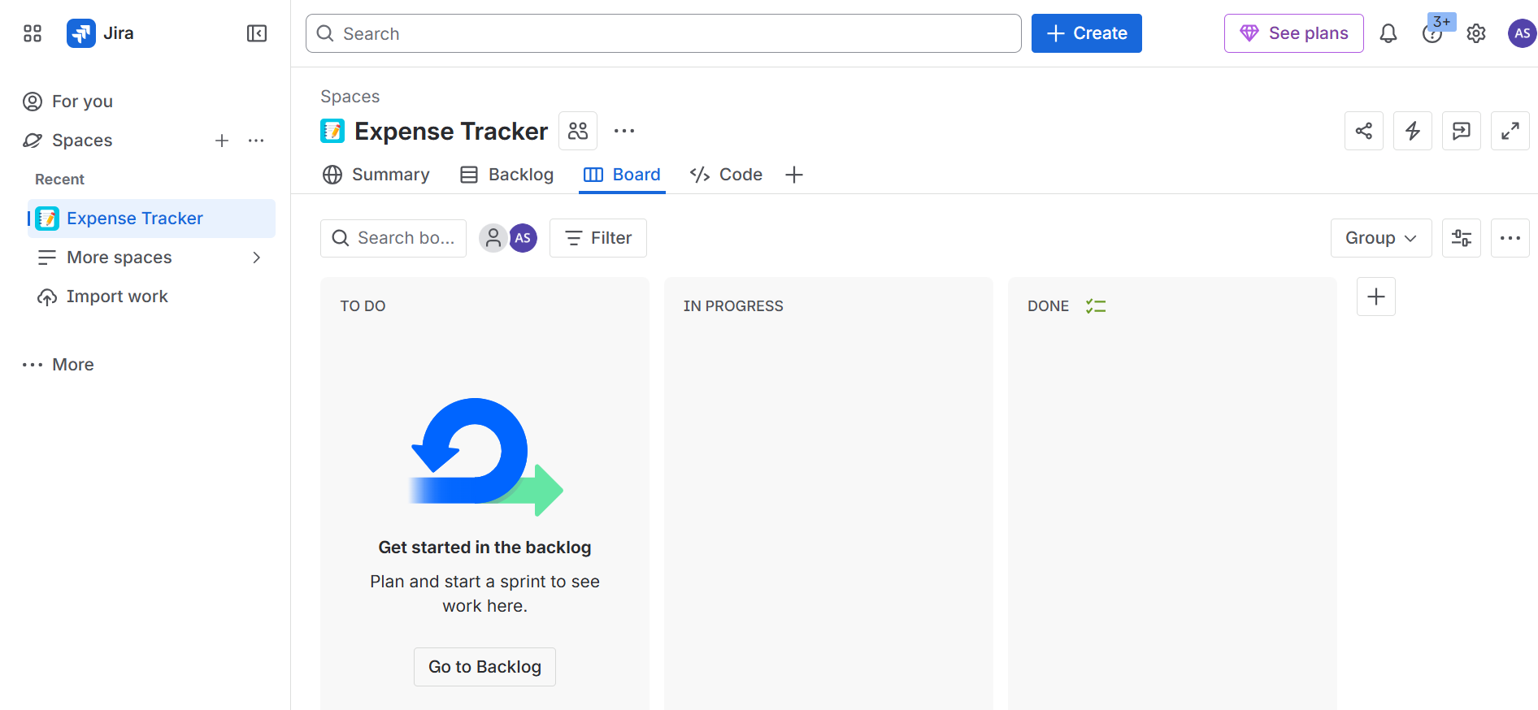
Screenshot 1: Initial Jira board for Expense Tracker project (empty sprint)

6.2 Defining User Stories
I began to add user stories after creating the project. A user story in Agile is simply a sentence that is brief and describes what a user wants to do in the application [3]. This is generally what happens: I want to do something as a user, because I want to receive some benefit. I created 7 user stories, each of which covered one of the key features of the Expense Tracker app.

Here are the 7 user stories I created:
- SCRUM-1: Add Expense – so the user can record what they spent money on.
- SCRUM-2: View Expenses – so the user can see all the expenses they added.
- SCRUM-3: Delete Expense – so the user can remove an expense they added by mistake.
- SCRUM-4: Edit Expense – so the user can fix or update an expense.
- SCRUM-5: View Reports – so the user can see a summary of their spending.
- SCRUM-6: Set Budget – so the user can set a limit on how much they want to spend.
- SCRUM-7: Search Expenses – so the user can find a specific expense easily.

All 7 stories were added to the backlog in the To Do state. Screenshot 2 shows how the backlog looked after I added them all.

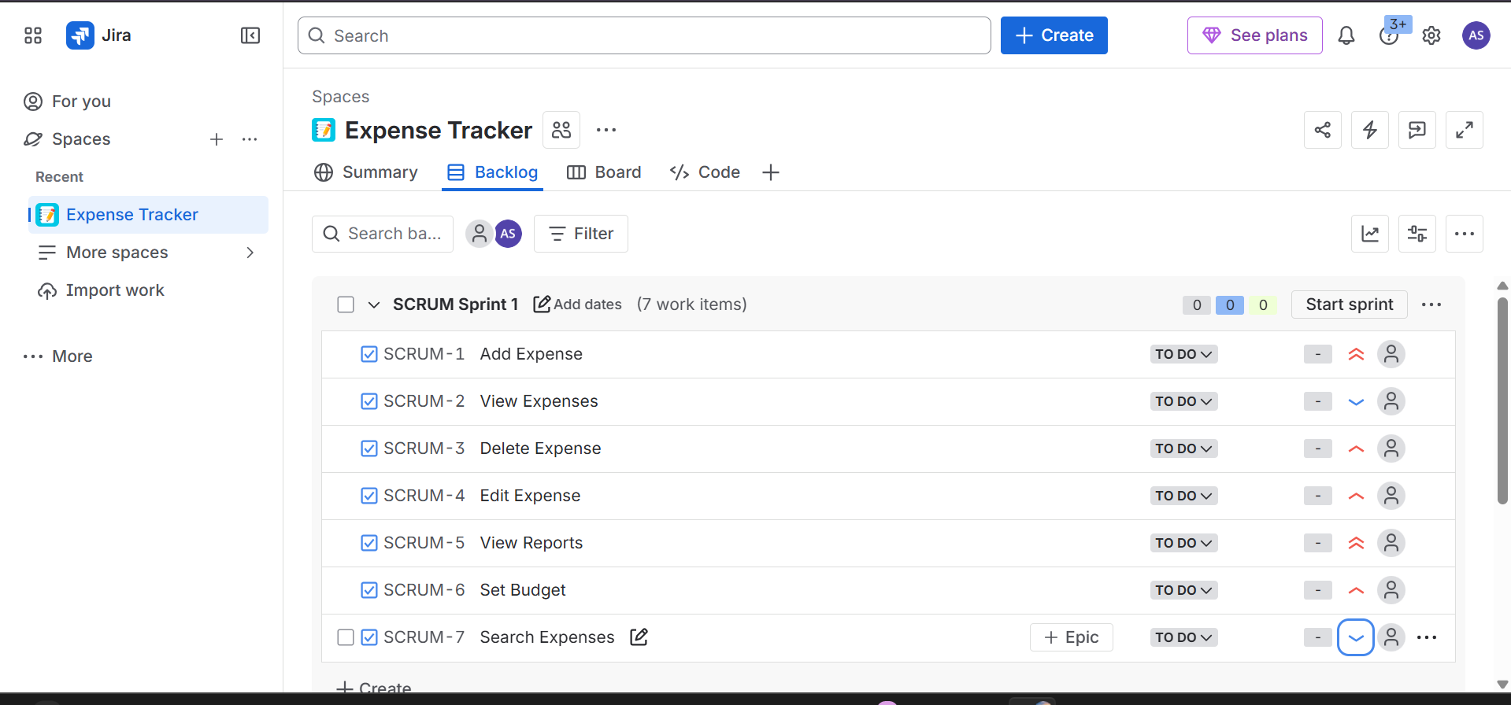
Screenshot 2: Backlog view showing all 7 user stories in SCRUM Sprint 1

6.3 Task Breakdown and Prioritization
Every user story should be subdivided into smaller tasks in order to work on it easier [3]. Priority is also assigned to each task as it is either High, Medium or Low. High is that it must be done at the beginning, Medium is that it is not urgent and important and Low is that it can be done at the end in case there is time [4]. The complete task list of the 7 user stories is presented below.

1. Add Expense (SCRUM-1)
- Create input form → High
- Validate user input → High
- Add submit button → High
- Save expense data → Medium
- Show confirmation message → Low

2. View Expenses (SCRUM-2)
- Display list of expenses → High
- Fetch data from storage → High
- Show total spending → Medium
- Sort expenses by date → Medium
- Filter by category → Low

3. Delete Expense (SCRUM-3)
- Add delete button → High
- Confirm delete action → Medium
- Remove expense from list → High
- Update database → Medium
- Show success message → Low

4. Edit Expense (SCRUM-4)
- Add edit button → High
- Load existing data → High
- Update expense details → High
- Save updated data → Medium
- Show update confirmation → Low

5. View Reports (SCRUM-5)
- Generate expense report → High
- Calculate totals → High
- Display charts/summary → Medium
- Filter by date range → Medium
- Export report → Low

6. Set Budget (SCRUM-6)
- Create budget input → High
- Save budget value → High
- Compare expenses with budget → Medium
- Display remaining budget → Medium
- Show warning alerts → Low

7. Search Expenses (SCRUM-7)
- Add search bar → High
- Implement search logic → High
- Display search results → Medium
- Handle empty results → Medium
- Clear search option → Low

The levels of priority assist in determining what to be done first [4]. The screenshot 3 depicts the appearance of the tasks in Jira regarding SCRUM-1, where I also assigned the Highest priority to the Add Expense story.
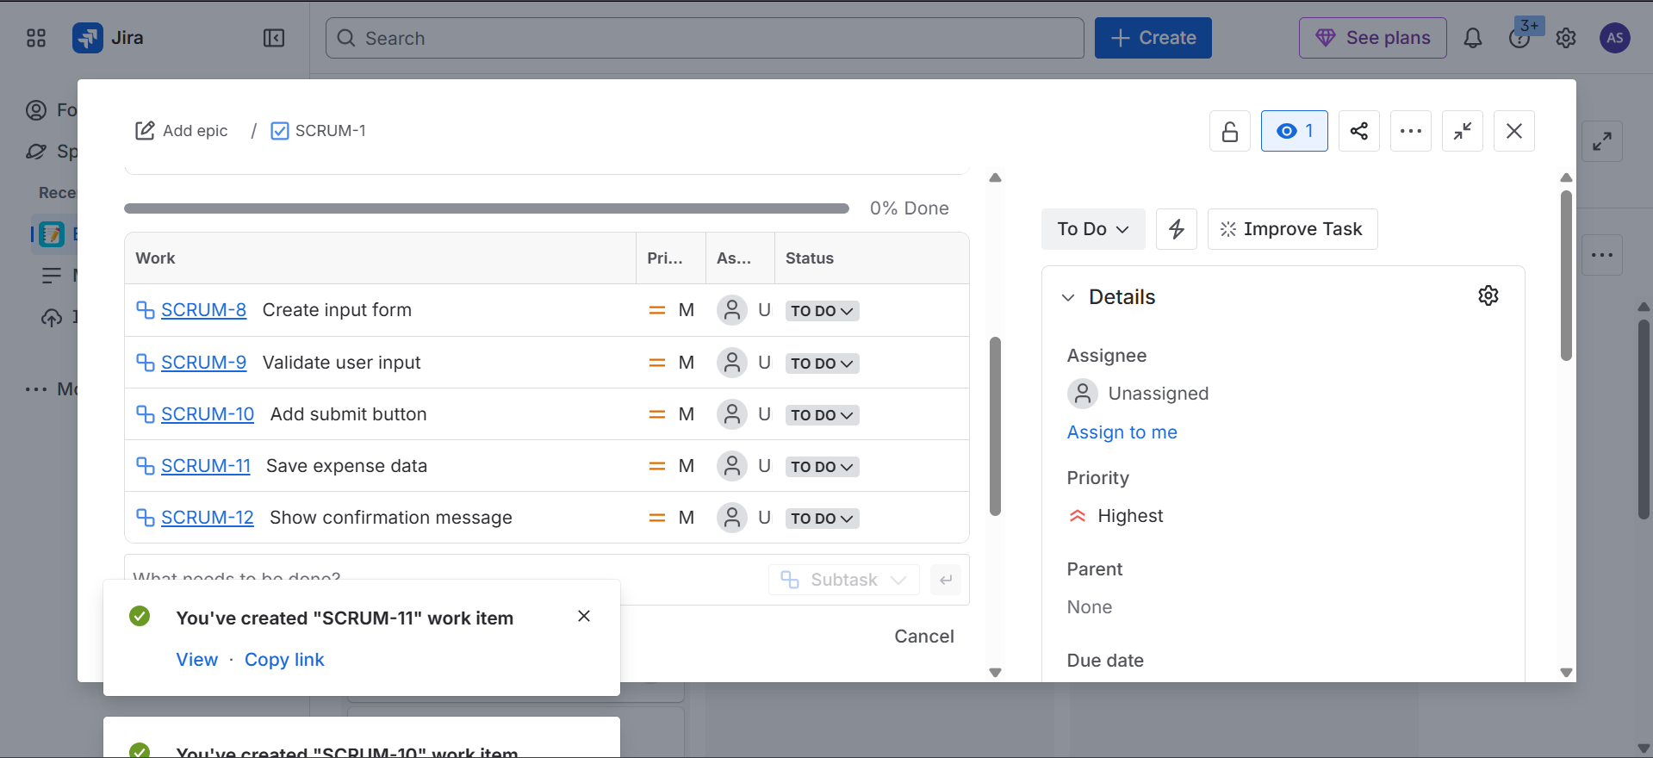
Screenshot 3: Subtasks defined under SCRUM-1 (Add Expense) with priority set to Highest

7. Sprint Simulation

7.1 Sprint Start – Initial State
In the backlog view, I used the Start Sprint button to begin the sprint. Then, the user stories were displayed on the Jira board. There are three columns in the board: To Do, In Progress, and Done. The column of Done was blank at this stage since nothing was completed yet.

I relocated three stories to In Progress. These were View Reports, View Expenses, and Add Expense. I have chosen them as they are the most vital ones. The app cannot actually do anything without Add Expense. View Expenses and View Reports were also rated as high priority since the users require viewing their data. The remaining four Delete Expense, Edit Expense, Set Budget and Search Expenses remained in To Do. The board at this stage is indicated in Screenshot 4.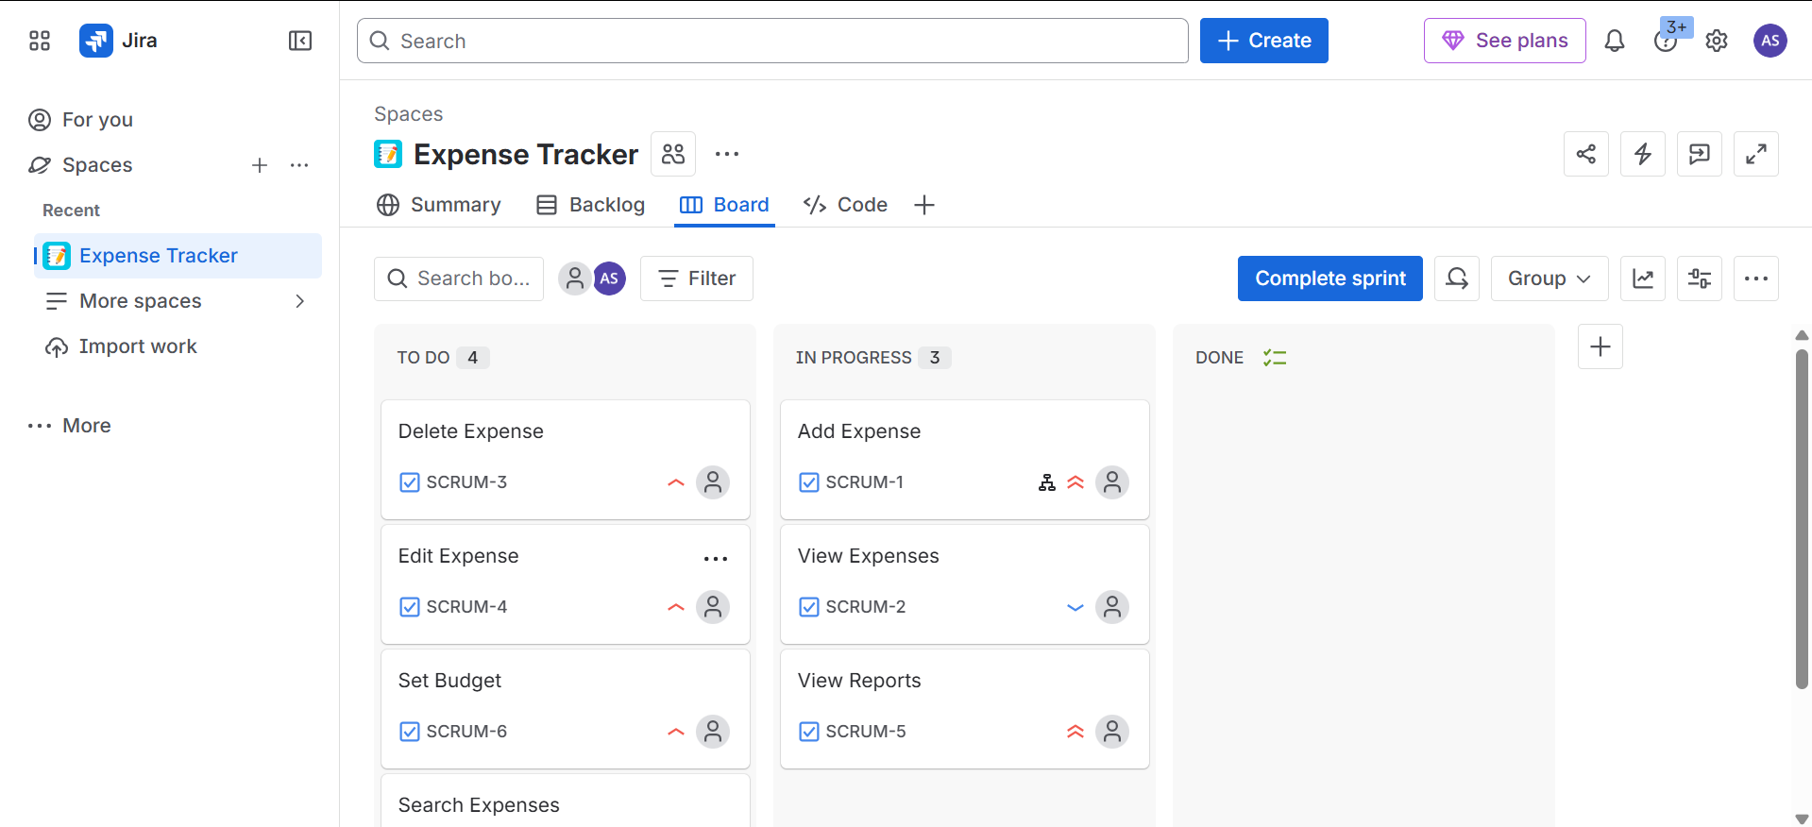
Screenshot 4: Sprint board – 4 items in To Do, 3 items In Progress, Done column empty

7.2 Sprint Progress – Mid Sprint
The first three stories that were In Progress got completed and I moved them to Done as I continued. So View Reports, Add Expense and View Expenses all changed to Done. That resulted in 3 items in the Done column.

Meanwhile, I selected two additional stories and transferred them to In Progress. These were Search Expenses and Edit Expense. The other two Delete Expense and Set Budget were still in To Do. Screenshot 5 demonstrates the appearance of the board at this point, where 2 were in the To Do list, 2 were in the In Progress list, and 3 were in the Done list.
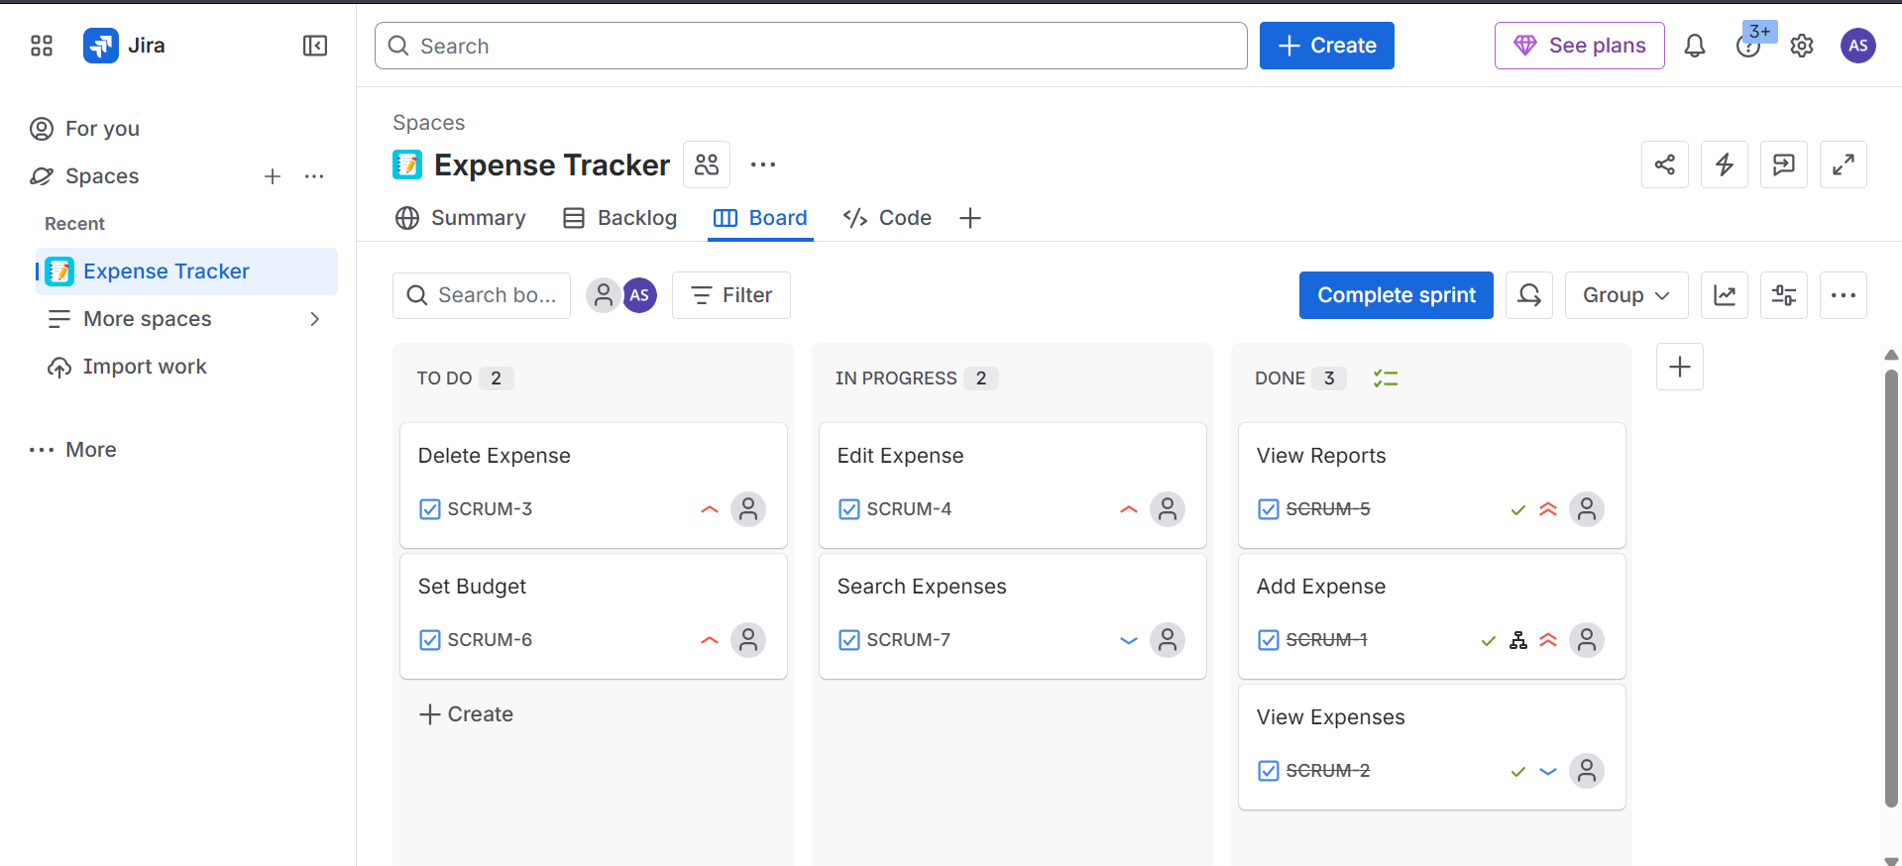
Screenshot 5: Mid-sprint board – 2 To Do, 2 In Progress, 3 Done

7.3 Sprint Completion
During the final section of the sprint, I completed the remaining stories. Edit Expense, Search Expenses, Delete Expense, and Set Budget were all relocated to Done individually. Thereafter, both To Do and In Progress columns were blank and the Done column contained all 7 stories.

When something is termed as Done in Jira, the text on the card is struck through and this makes it easy to notice what has been done. The Complete Sprint button was also displaying at the top right implying that the sprint was ready to be closed. The last position of the board is presented in Screenshot 6.
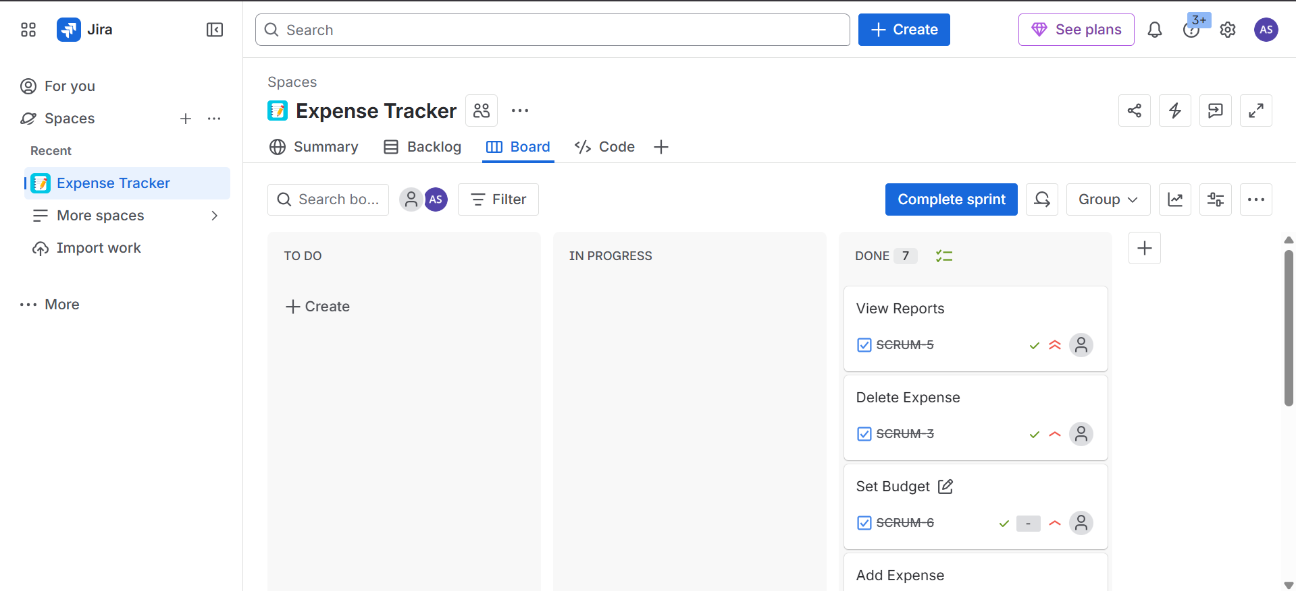
Screenshot 6: Final sprint board – all 7 user stories in Done

8. Detailed Documentation: Add Expense (SCRUM-1)
Among the 7 user stories, I decided to write in greater detail the Add Expense since it is the most significant feature of the app. When the user is not allowed to add an expense, the rest of the app is not quite sensible. This is why I considered it as the greatest priority.

User Story: As a user, I would like to add a new expense to be able to maintain a record as to what I am spending money on.
Acceptance Criteria:
- There should be a form where the user can type in the expense details.
- The form should have fields like amount, category, date, and maybe a short note.
- If the user leaves a required field empty, the app should show an error.
- If the user types something wrong, like a letter in the amount field, it should also give an error.
- When the form is submitted correctly, the expense should be saved and show up in the list.
- After saving, the app should show a message to tell the user it worked.

The passage of this story through the sprint:
I added this story to To Do when I had put it there first. As soon as the sprint started, I moved it to In Progress first because of its high priority. I then tackled each of the 5 subtasks individually. I began with the development of the input form followed by the validation followed by the submit button followed by the data saved followed by the confirmation given. After completing all the 5 subtasks I moved the entire story to Done. This occurred during the middle of the sprint.

I completed this story prior to such items as Set Budget or Search Expenses since unless you can add an expense then the rest of the features have nothing to operate on. As an illustration, you cannot see expenses when no expenses are added. It was only logical to start with this one.

9. Discussion
Doing this assignment helped me understand how Agile and Jira actually work in practice [1]. Before this, I only knew about them from theory. Using the board and moving tasks around made it much clearer. You can see exactly what is happening in the project just by looking at the board, which is much better than using something like a spreadsheet or a list in a notebook.

One thing I noticed is that priorities really matter. I started with Add Expense and View Expenses because those are the features a user would need first [2]. It would not make sense to build something like Search Expenses if the user cannot even add an expense yet. So the order in which things get done matters a lot.

The division of stories into small tasks also contributed to a lot [3]. Looking at Add Expense as a single large task, I found it a little bit vague. However, once I divided it into such parts as create the form, validate the input, add the button, save the data, and show a message, it became much more clear what actually should be constructed. Any little thing is something particular that can be done and completed.

Another thing I found useful about Jira is that it keeps everything in one place [7]. You do not need to message someone to ask what is done or what is left. You just open the board and see it. For teams where people might be in different places, this is really helpful.

The hardest part for me was deciding the priority for some stories. For example, I was not sure whether Delete Expense or Edit Expense should come first. In a real team, this kind of decision is usually made together by the team and the person managing the product, using things like priority ratings or voting [5]. Since I was working alone, I just had to make a judgment call.

10. Conclusion

On the whole, this assignment was positive. I had an opportunity to use Jira in a proper way and experience the entire process of the sprint cycle. I created 7 user stories of the Expense Tracker app, divided them into tasks, assigned them priorities, and moved them through the sprint board until all was completed.

This taught me a couple of significant things. First, the proper way of writing user stories simplifies the comprehension of what is required to be constructed [3]. Second, breaking a story into small tasks will make you really do it step by step rather than get confused. Third, priorities can assist you in making decisions on where to begin and this is truly crucial when there are numerous things to be accomplished [4].

The entire process was visualized and simplified by the use of Jira [1]. The board presents all this in a clear way and you can view the progress without necessarily reading any documentation. I am able to see why it is favored by numerous companies in their projects [7].

Finally, all 7 user stories were fulfilled and the sprint was completed. I believe this task provided me with a fair idea of how a real-life Agile can be implemented and how software such as Jira can assist a team in staying on track [8]. I will certainly use it in the future when I will deal with real projects.

11. References
[1] Atlassian, "Jira Software Documentation," Atlassian, 2024. [Online]. Available: https://support.atlassian.com/jira-software-cloud/
[2] K. Beck et al., "Manifesto for Agile Software Development," Agile Alliance, 2001. [Online]. Available: https://agilemanifesto.org/
[3] M. Cohn, "User Stories Applied: For Agile Software Development," Addison-Wesley Professional, 2004.
[4] K. Schwaber and J. Sutherland, "The Scrum Guide," Scrum.org, Nov. 2020. [Online]. Available: https://www.scrumguides.org/
[5] R. Pichler, "Agile Product Management with Scrum: Creating Products that Customers Love," Addison-Wesley, 2010.
[6] M. Fowler, "Patterns of Enterprise Application Architecture," Addison-Wesley, 2002.
[7] Atlassian, "What is Scrum?," Atlassian Agile Coach, 2023. [Online]. Available: https://www.atlassian.com/agile/scrum
[8] S. Ambler, "Agile Modeling: Effective Practices for eXtreme Programming and the Unified Process," John Wiley & Sons, 2002.
DECLARATION OF ACADEMIC INTEGRITY
I hereby declare that this assignment is my original work and has not been copied or plagiarized from any source. All references and resources used have been properly cited. I understand that any form of academic dishonesty will result in severe consequences including but not limited to forfeiting my marks for this assignment.
Student Name: Amish Sudhakara
USN: NNM24IS020
Date: 12-02-2026
Signature:
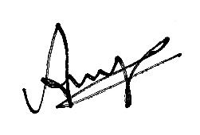
---END OF REPORT---

