
Project Report
Comparing Different Ways to Build an Online Bookstore System
Course Name: Introduction to Software Engineering
Course Code: IS1103-1
Assignment Name: Online Bookstore System
Student Name: Amish Sudhakara
USN / Roll Number: NNM24IS020
Semester & Section: 4th SEM A- Section
Department: Information Science and Engineering
Institution Name: N.M.A.M INSTITUTE OF TECHNOLOGY
Academic Year: 2025-2026
Instructor Name: DR. Jason Elroy Martis
Date of Submission: 12-02-2026

ABSTRACT
This paper looks at three different ways to build software—the Waterfall approach, Incremental building, and the Spiral method—by thinking about how we would create an Online Bookstore System. I have examined how each method deals with what the system needs to do and how well it should work, how it handles problems and changes, and how much time and money it needs. I also made a document listing everything the system should do and how good it should be. Additionally, I created a plan to check if what we wrote down is actually correct and possible, while pointing out common issues we might face. My study shows that the Spiral way of working is best for this online shopping website because it carefully deals with risks at every step and can adjust when the market changes, which really matters when selling things online.

GITHUB REPOSITORY LINK
GitHub URL: https://github.com/Amish-Sudhakara/Online_Bookstore_Report

1. INTRODUCTION
Software engineering means using organized ways to create, operate, and take care of software programs. The Software Development Lifecycle gives us a step-by-step plan for making software from beginning to end. Choosing the right way to develop software really matters because it decides if projects work well, stay within budget, and give users what they want.[1][2]
In this study, I am looking at three well-known ways of developing software—Waterfall, Incremental, and Spiral—by imagining how we would use them to build an Online Bookstore System. Online shopping websites have special difficulties like customers wanting different things all the time, hackers trying to steal information, needing to handle more and more users, and fighting with other companies. These problems make it a great example for comparing different building methods.[3]
When people don't handle requirements properly, it causes around 71% of software projects to fail. This is why understanding what the system needs to do is extremely important. This report covers the first part of our software engineering class, talking about different ways to build software and the basics of figuring out requirements.[4]
What I want to achieve here is:
(1) figure out which building method works best for a complicated online shopping system
(2) make a full list of everything the system needs including features and quality standards
(3) create a strong checking plan that lowers project risks.
2. PROBLEM STATEMENT
The main job I need to do involves looking at how we would develop an Online Bookstore System by:
1. Looking at three ways of building it: Waterfall, Incremental, and Spiral
2. Checking how well each one handles what the system needs to do and how well it should perform
3. Studying how they deal with problems and accept changes
4. Thinking about how long they take and how much money they cost
5. Making a full document of what the system needs
6. Creating a checking plan while pointing out problems we might run into
What I hope to get from this:
- A comparison showing good points and bad points of each method
- Clear suggestions about which way works best
- A well-organized document listing requirements
- A realistic checking plan
What I'm assuming:
- The system sells directly to customers (B2C type)
- The building team has 15-20 people working
- The project will take 12-18 months to finish
- The budget is normal for medium-sized online stores
- We'll use modern web technology and cloud computing

3. CASE STUDY: ONLINE BOOKSTORE SYSTEM
3.1 What the System Is About
The Online Bookstore System is a complete platform where people can look for books, buy them, and get them delivered anywhere in the world. Similar to successful websites like Amazon Books, this system needs to do complicated jobs including keeping track of stock, handling payments, telling customers which books they might like, and maintaining good relationships with customers [5].
3.2 Main Things It Does
The system has these features:
- Letting users create accounts and log in using email or Facebook/Google
- Strong search options by who wrote the book, what type it is, ISBN number, and how much it costs
- Suggesting books to people based on what they looked at and bought before
- Shopping basket and list of books they want later
- Safe payment handling with different ways to pay
- System to track where their order is
- Letting customers write reviews and give star ratings
- Tools for managers to control stock
- Reports showing how the business is doing
- Design that works well on phones and computers

3.3 Who Uses It
- People who buy and read books
- System administrators who manage everything
- Warehouse workers who handle stock
- Marketing people who promote the store
- Customer service workers who help buyers
- Companies that process payments
- Delivery companies that ship books
- Book publishers and sellers who supply books

3.4 What It Needs Technically
The system must have:
- Working 99.9% of the time
- Ability to handle more than 10,000 people using it at once
- Pages that load in less than 2 seconds
- Following PCI-DSS rules to keep payments safe
- Following GDPR rules to protect people's information
- Connections to outside services like payment and shipping companies

4. LOOKING AT DIFFERENT BUILDING METHODS
4.1 Waterfall Method
The Waterfall way follows a straight line where each step finishes completely before starting the next one. Steps include gathering requirements, designing, building, testing, launching, and maintaining.[6]

Waterfall Model Diagram

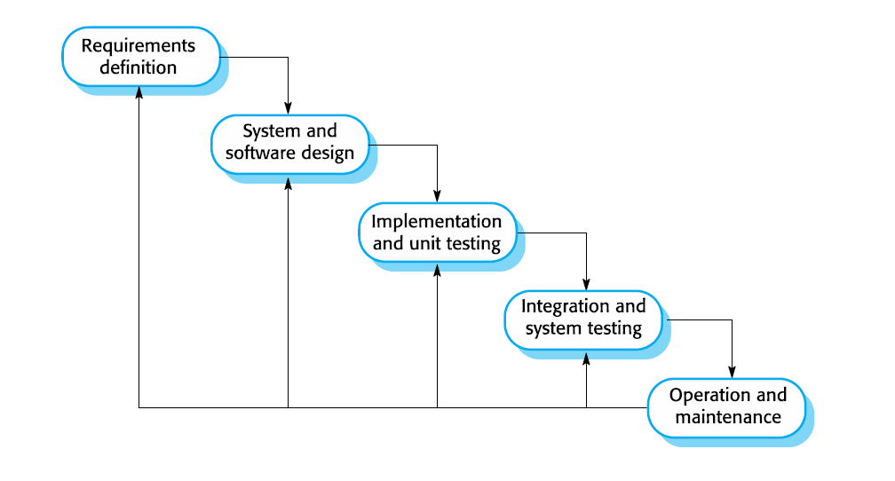
Good points for our bookstore: Clear documentation helps track decisions, defined milestones monitor progress and spending, works well for stable requirements, thorough compliance documentation possible, and easier management with less experienced teams.
Bad points for our bookstore: Can't adapt to market changes easily, customer feedback only after complete build, high risk if initial requirements wrong, long wait before working software, hard to estimate complex features, and late testing makes fixes expensive.
Why it doesn't fit: The Waterfall way doesn't work well because online shopping changes constantly. Customer preferences and technology evolve rapidly. Unable to adjust based on feedback creates big business danger [7].

4.2 Incremental Building Method
Incremental building divides the system into smaller working pieces, where each piece delivers actual usable features. Each piece goes through all building steps.[8]

Incremental Model Diagram
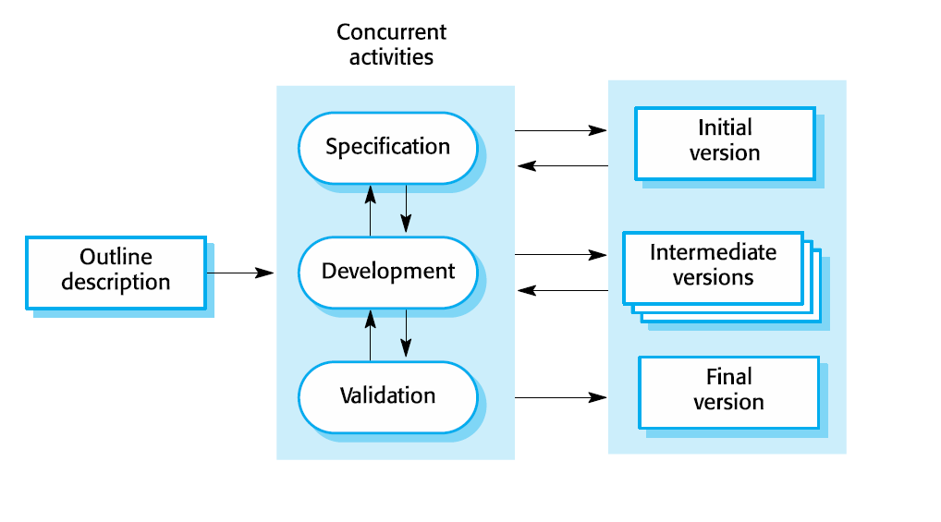
Good points for our bookstore: Users get basic features early, reduced initial investment risk through staged funding, user feedback guides later development, smaller pieces easier to manage and test, can change priorities between stages, and can earn revenue from early releases.
Suggested stages: Stage 1 (Months 1-4): accounts, browsing, search, cart, checkout. Stage 2 (Months 5-8): advanced filters, reviews, wish list, order history. Stage 3 (Months 9-12): recommendations, personalization, loyalty program. Stage 4 (Months 13-16): mobile app, analytics, third-party sellers.
Bad points for our bookstore: Needs careful planning to avoid integration problems, system design might suffer without initial thorough planning, hard to separate connected features, might waste effort if requirements change significantly, and maintaining consistency across stages needs extra work.
Why it fits: Incremental building works reasonably well for our bookstore. It allows testing main features with real customers while continuing development, lowering financial risk and enabling adjustments based on feedback .[9]

4.3 Spiral Method
The Spiral way combines repeated building with careful risk watching. Each spiral cycle has four parts: Planning, Risk Analysis, Engineering, and Evaluation. The focus is finding and fixing problems at every turn.[10]

Spiral Model Diagram
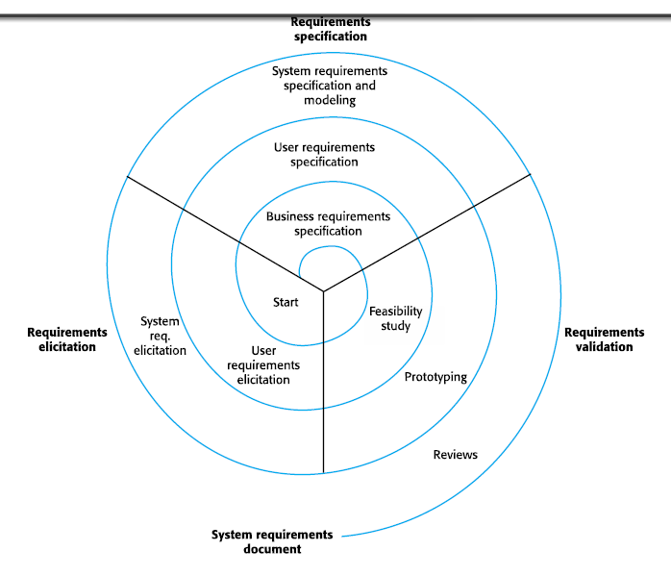

Good points for our bookstore: Directly focuses on security, scaling, and integration challenges, finds technical problems early, continuous stakeholder participation ensures business alignment, early prototypes validate critical features before full investment, handles changing requirements through ongoing risk analysis, and perfect for large, complex, high-risk projects.
Risk analysis for our bookstore includes: Security (payment theft, credential breaches), Performance (slowdown during heavy traffic), Integration (third-party service failures), Market (competitor features making system outdated), Technical (scaling limitations), and Legal (non-compliance with GDPR, PCI-DSS). Each spiral checks these risks and applies solutions before proceeding.
Bad points for our bookstore: Requires significant risk assessment expertise, more expensive due to repeated analysis and prototyping, complex management needing skilled leadership, takes longer than simpler methods, and might be excessive for low-risk components.
Why it fits best: The Spiral method is really good for our bookstore because of natural dangers in online shopping (hackers, handling growth, market competition). The risk-focused approach ensures critical problems get solved early, preventing expensive failures [11].
Things to compare:
- How flexible it is: Not flexible (Waterfall), Somewhat flexible (Incremental), Very flexible (Spiral)
- Dealing with problems: Not good (Waterfall), Okay (Incremental), Really good (Spiral)
- Getting customer opinions: Hardly any (Waterfall), Some (Incremental), Lots (Spiral)
- How fast we can launch: Takes long (Waterfall), Medium time (Incremental), Medium-long time (Spiral)
- How much it costs: Cheapest (Waterfall), Medium cost (Incremental), Most expensive (Spiral)
- Team size needed: Any size works (Waterfall), Medium-Large team (Incremental), Large team (Spiral)
- How well documented: Really well (Waterfall), Pretty well (Incremental), Really well (Spiral)

4.4 Comparing different models
Table 1: Comparison of SDLC Models for Online Bookstore System

Criteria | Waterfall | Incremental | Spiral
Flexibility to Changes | Low - Changes are difficult and expensive after each phase | Medium - Changes possible between increments | High - Built-in flexibility through iterative cycles
Risk Management | Poor - Risks identified late, limited mitigation options | Moderate - Risks reduced through staged delivery | Excellent - Explicit risk analysis each cycle
Customer Involvement | Minimal - Only at beginning and end of project | Moderate - Feedback after each increment | High - Continuous evaluation and feedback
Time to Market | Long - 12-18 months for complete system delivery | Medium - First increment in 3-4 months | Medium-Long - Prototypes early, full system 15-18 months
Development Cost | Lowest - Simple linear approach, minimal overhead | Medium - Some rework between increments | Highest - Multiple prototypes and risk analyses
Suitable Team Size | Any size - Simple structure works with any team | Medium to Large - Requires coordination across increments | Large - Requires experienced risk assessment team
Complexity Handling | Poor - Struggles with complex requirements | Good - Breaks complexity into manageable pieces | Excellent - Risk-driven approach handles complexity
Best Suited For | Stable requirements, well-understood systems | Evolving requirements, staged funding | High-risk projects, uncertain requirements

5. FIGURING OUT WHAT THE SYSTEM NEEDS
5.1 How We Gathered Information
I collected what the system needs through these ways [12]:
- Talking with people who might buy books and people who would manage the store
- Asking 500+ online book buyers questions
- Looking at what competitor websites do (Amazon, Barnes & Noble)
- Meeting with business people to discuss ideas
- Writing out scenarios for important situations
- Studying what successful online stores do
5.2 What the system must do
The system needs these main features for users: signing up and logging in with email or social media, secure password management with reset options, and maintaining personal profiles with payment details. For browsing books, it displays complete book information, organizes by categories, provides search and filtering, and shows real-time availability. The shopping features include basket management, price calculation with taxes and shipping, multiple payment options, order processing with tracking, and 24-hour cancellation. Additional features are personalized book recommendations, customer reviews and ratings, wishlist with price alerts, and administrative tools for inventory and sales reporting.
5.3 How well the system must work
Performance needs: Pages must load under 2 seconds, handle 10,000 simultaneous users, process 100 transactions per minute during busy times, return search results within 1 second, and generate recommendations in under 500ms.
Security requirements: Use AES-256 encryption for payments, follow PCI-DSS and HTTPS standards, secure password storage, protect against hacking attempts (SQL injection, XSS, CSRF), implement role-based access, and maintain transaction logs.
Availability standards: Maintain 99.9% uptime, perform daily backups, support quick disaster recovery (under 1-hour data loss, under 4-hour recovery time), and handle third-party service failures smoothly.
Scalability needs: Support horizontal scaling, handle over 1 million book records efficiently, and accommodate 100% traffic growth without redesign.
Usability standards: Require no training for basic use, meet accessibility guidelines (WCAG 2.1 Level AA), work on all devices, support multiple languages, and provide clear error messages.
Maintenance requirements: Follow coding standards, use modular architecture, document APIs with OpenAPI/Swagger, and maintain 80% test coverage.
Compliance obligations: Follow GDPR for EU users, CCPA for California users, provide data export and deletion options, and keep compliance audit trails.

6. HOW WE'LL CHECK IF REQUIREMENTS ARE RIGHT
6.1 Ways to Check
I will validate requirements using multiple approaches : Requirements reviews with stakeholders to find unclear, missing, or conflicting items; prototyping key features like the shopping interface and recommendation system for concrete feedback; creating test cases for every functional requirement to verify they're testable; building validation models using Use Case, State, Sequence, and Data Flow diagrams to ensure consistency; defining clear acceptance criteria for each requirement using specific examples; and conducting structured stakeholder validation sessions across four weeks with customers, technical teams, security experts, and management.[13]

7. PROBLEMS WE MIGHT FACE WHEN CHECKING
7.1 Requirements Keep Changing - Online shopping requirements change fast because of what's popular in the market and what competitor stores do. Solutions: Check requirements again regularly, rank them by importance (MoSCoW way), have a process for approving changes, save different versions of requirements, and design the system so it can change easily.
7.2 People Disagree - Different groups want different things. Solutions: Have meetings where people can negotiate, use systems to rank what's most important, write down what we're giving up to get other things, make a chart showing how requirements connect to business goals, and have a clear process for when people can't agree.
7.3 Not Sure If It's Possible - Hard to know if advanced features like AI book suggestions will actually work without trying them first. Solutions: Spend limited time researching, get technical experts involved early, build proof versions to test ideas, and separate "nice to have" goals from "must have" requirements.
7.4 Missing Information - People have trouble describing everything the system needs, especially quality stuff. Solutions: Use techniques like scenarios, personas, and user stories, look at industry standards, study what competitor stores do, and hire experienced people who know the business.
7.5 Too Much to Check - With more than 50 requirements about what it does and 20+ about how well it should work, checking everything properly takes lots of time and people. Solutions: Use computer programs to check for conflicts automatically, spend most effort on high-risk requirements, organize requirements in a tree structure, check requirements bit by bit, and use experienced requirements experts.

8. DISCUSSION AND MY RECOMMENDATION
After careful analysis, I believe the Spiral Method works best for the Online Bookstore System. Online shopping faces serious dangers like security breaches, performance failures, and market competition. The Spiral method's risk management directly addresses these concerns [14]. Customer preferences change rapidly in online retail—today's advantages become tomorrow's basics. The Spiral approach handles this through repeated evaluation. Integration with payment services, shipping systems, and recommendation algorithms brings substantial uncertainty. Spiral's prototyping validates feasibility before full commitment. Unlike internal tools where some defects might be acceptable, online shopping platforms must deliver high reliability and security.
My implementation plan uses four spiral cycles: Cycle 1 (Months 1-3) validates core design and payment integration through prototyping and security audits. Cycle 2 (Months 4-7) implements complete shopping flow with load testing. Cycle 3 (Months 8-12) develops recommendation engine with A/B testing. Cycle 4 (Months 13-18) creates mobile app with final reviews.

9. CONCLUSION
After studying different ways to build software for an Online Bookstore System, I've learned that picking the right method really affects project success. Waterfall is simple and documents well, but too rigid for constantly changing online shopping. Incremental provides better flexibility and earlier value delivery, working okay for simpler projects.
The Spiral method is my recommended choice for our Online Bookstore because it carefully manages risks, keeps improving, and handles changing requirements. The natural dangers in online shopping—hackers, market changes, technical complications—match perfectly with Spiral's strengths.
Requirements analysis revealed over 30 functional and 25 quality requirements, showing this system's complexity. My suggested validation plan uses multiple techniques (reviewing, prototyping, modeling, testing) to address common problems like changing requirements, disagreements, and technical uncertainty.
Important learnings: Picking a building method should consider project risks, not just team experience. Requirements work is ongoing; validation is continuous, not one-time. Quality requirements (safety, speed, growth handling) are critical for online shopping success. Everyone's involvement throughout building reduces expensive fixing later.
My final recommendation: Use Spiral method with risk-driven cycles for best danger reduction and market responsiveness.

10. REFERENCES
[1] I. Sommerville, "Software Engineering," 10th ed., Pearson Education, 2015.
[2] R. S. Pressman and B. R. Maxim, "Software Engineering: A Practitioner's Approach," 8th ed., McGraw-Hill Education, 2014.
[3] K. Peffers et al., "A Design Science Research Methodology for Information Systems Research," Journal of Management Information Systems, vol. 24, no. 3, pp. 45-77, 2007.
[4] The Standish Group, "CHAOS Report 2020: Beyond Infinity," The Standish Group International, 2020.
[5] P. Kotler and K. L. Keller, "Marketing Management," 15th ed., Pearson Education, 2016.
[6] W. W. Royce, "Managing the Development of Large Software Systems," Proceedings of IEEE WESCON, vol. 26, no. 8, pp. 1-9, 1970.
[7] B. W. Boehm, "A Spiral Model of Software Development and Enhancement," IEEE Computer, vol. 21, no. 5, pp. 61-72, May 1988.
[8] C. Larman and V. R. Basili, "Iterative and Incremental Development: A Brief History," IEEE Computer, vol. 36, no. 6, pp. 47-56, June 2003.
[9] K. Beck et al., "Manifesto for Agile Software Development," Agile Alliance, 2001.
[10] B. W. Boehm, "Software Risk Management: Principles and Practices," IEEE Software, vol. 8, no. 1, pp. 32-41, Jan. 1991.
[11] P. Kruchten, "The Rational Unified Process: An Introduction," 3rd ed., Addison-Wesley Professional, 2003.
[12] K. Pohl, "Requirements Engineering: Fundamentals, Principles, and Techniques," Springer Publishing Company, 2010.
[13] IEEE Computer Society, "IEEE Recommended Practice for Software Requirements Specifications," IEEE Std 830-1998, 1998.
[14] A. van Lamsweerde, "Requirements Engineering: From System Goals to UML Models to Software Specifications," John Wiley & Sons, 2009.

DECLARATION OF ACADEMIC INTEGRITY
I hereby declare that this assignment is my original work and has not been copied or plagiarized from any source. All references and resources used have been properly cited. I understand that any form of academic dishonesty will result in severe consequences including but not limited to forfeiting my marks for this assignment.
Student Name: Amish Sudhakara
USN: NNM24IS020
Date: 12-02-2026
Signature:
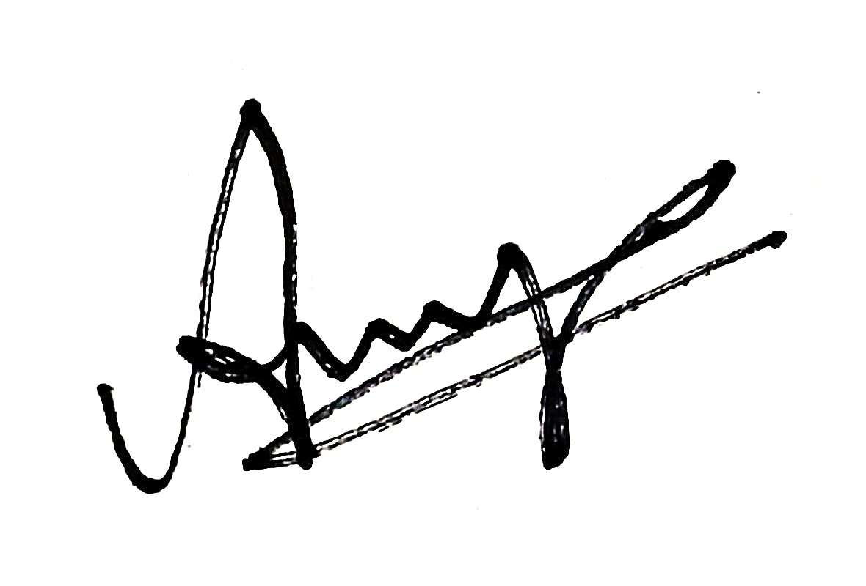
---END OF REPORT---

