INTRODUCTION TO DATA MANAGEMENT
PROJECT REPORT
(Project Semester January-April 2025)

EV Population Data Analysis

Submitted by

Amisha Mehta

Registration No: 12310098
Programme P132: B. Tech
Section: K23GD
Course Code: INT-217

Under the Guidance of
Dr. Tanima Thakur (UID: 23532)

Discipline of CSE/IT

Lovely School of Computer Science Engineering

Lovely Professional University, Phagwara

DECLARATION

I, Amisha Mehta, student of B.Tech CSE under CSE/IT Discipline at, Lovely Professional University, Punjab, hereby declare that all the information furnished in this project report is based on my own intensive work and is genuine.

Date: 12.04.25 Signature
Registration No. 12310098 Amisha Mehta

CERTIFICATE

This is to certify that Amisha Mehta bearing Registration no. 12310098 has completed INT-217 project titled, “EV Population Data Analysis” under my guidance and supervision. To the best of my knowledge, the present work is the result of his/her original development, effort and study.

Amisha Mehta
Signature and Name of the Supervisor
Designation of the Supervisor
School of School of Computer Science Engineering
Lovely Professional University
Phagwara, Punjab.

Date: 12.04.25

ACKNOWLEDGEMENT
I would like to express my sincere gratitude to Lovely Professional University for providing the opportunity and platform to undertake this project.

I am especially thankful to Dr. Tanima Thakur for her invaluable guidance, constant support, and insightful feedback throughout the course of this project. Her mentorship played a crucial role in shaping the direction and success of my work. I also wish to thank my faculty mentors, peers, and friends for their encouragement and helpful suggestions during the project.

This experience has significantly enhanced my technical, analytical, and visualization skills, particularly in working with Excel dashboards. Finally, I extend my heartfelt thanks to everyone who directly or indirectly contributed to the successful completion of this project.

- Introduction
This project provides an in-depth analysis of electric vehicle (EV) trends in Washington State based on a large-scale, government-provided dataset that aggregates detailed electric vehicle registration records. With more than 23,0000 records, the dataset captures important attributes like the make and model of the EV, model year, electric vehicle type (BEV or PHEV), range capability, geographic registration data (county and city), and Clean Alternative Fuel Vehicle (CAFV) incentive eligibility. The primary goal of this study is to analyze the patterns of adoption and distribution of electric vehicles in various parts of Washington, consumer choice in terms of manufacturers and models, and investigate key performance measures such as electric range and clean energy program participation. The research employs an organized Exploratory Data Analysis (EDA) method, leveraging Excel-based tools like pivot tables, graphical charts, and dashboards to derive insightful trends and comparisons.
Key areas of emphasis among the many include the popularity rankings of different EV brands, the comparative performance of BEVs compared to PHEVs, adoption trends over different years, regional EV density levels, and vehicle range performance based on brand and eligibility status. These findings are important in informing environmentally sustainable transportation policies. Urban planners are able to apply the data to decide where to increase EV infrastructure, manufacturers are able to react to new market demand, and state policy makers are able to measure the success of current incentive programs and decide on areas to provide stronger outreach or policy assistance.

Problem Statement
Although the world is now increasingly promoting cleaner modes of transport and an expanding interest in electric mobility, mass adoption of electric vehicles is still far from a reality—specifically in grasping the intricacies and location-specific dynamics driving or blocking adoption. In Washington State, though total EV usage has gradually improved over the last ten years, adoption levels remain unbalanced geographically, demographically, and by vehicle type. Several government initiatives like purchase rebates, tax breaks, and CAFV qualification programs seek to hasten this changeover, but the empirical success of such initiatives in various on-the-ground contexts is yet to be rigorously evaluated. Policymakers and public utilities are often not in possession of detailed, up-to-date information about EV consumer behavior, local market penetration rates, and consumer preference on important factors like electric range, brand leadership, and choice between BEVs and PHEVs. The lack of such information handicaps proper planning for infrastructure development, e.g., the deployment of public charging points or upgrading of local power grids. Additionally, some counties exhibit persistently lower take-up rates, which can indicate potential socio-economic or information-related barriers to widening the access gap for green mobility solutions. This project tries to fill that analytical gap by carrying out a data-driven exploration of the terrain of EV use in Washington. Through an examination of variables like vehicle make, range, regional density, and CAFV eligibility, the study seeks to determine actionable patterns that can inform targeted investments and policy interventions. In the end, this study helps construct a more nuanced image of where and how clean transportation can be extended fairly and effectively to address environmental, economic, and public well-being objectives.
This research aims to fill these gaps in knowledge through a thorough, structured examination of registered EV data in Washington. Through Excel-based exploratory data analysis (EDA) methods, the project plots and interprets different aspects of EV adoption. These encompass determining which makes and models of cars are most in demand, estimating county-wise and city-wise adoption levels, contrasting dominance by BEVs against PHEVs, monitoring year-to-year EV registration progress, analyzing electric range capability by model, and determining the proportion of vehicles that qualify for clean energy incentives. The ultimate objective is to provide actionable insights that enable smarter policymaking, efficient resource deployment, and strategic infrastructure planning—particularly in areas of highest or lowest adoption. Through the integration of government-provided datasets with robust analytical frameworks, the project aims to contribute to more evidence-based, equitable, and efficient electric mobility planning.

Objective
The overall aim of this project is to examine and dissect the most influential trends behind electric vehicle uptake in Washington State and provide actionable insights to stakeholders as varied as city planners and environmental policymakers, EV manufacturers, and utility service providers. Fundamentally, the study seeks to bring to the fore regional patterns of EV usage, identify consumers' technological and brand preferences, and determine the degree to which existing policies match up with observed market behavior.
The primary aim is to determine the top-selling EV models and brands by their frequency of occurrence in registration records. Knowing which brands have gained traction in the Washington EV market is important in understanding consumer confidence, technological uptake, and leadership in the market. It also assists manufacturers and dealerships in aligning their products to suit local needs and prepare for future demands.
The second goal is to spatially map the geographic concentration of EVs by counties and cities to identify areas of high concentration and areas that are underserved. Spatial analysis provides information to government and utility agencies regarding where to focus on infrastructure such as charging stations, public education initiatives, and investment in grid capacity.

A third important goal is to examine the adoption patterns between Plug-in Hybrid Electric Vehicles (PHEVs) and Battery Electric Vehicles (BEVs), evaluating how each segment performs regarding adoption, electric range, and CAFV eligibility. The comparison will indicate whether consumers are more inclined toward the fully electric or hybrid option and how this inclination has changed over time.
The fourth aim is to analyze temporal patterns in EV registrations to assess the influence of policy changes, technology development, or economic conditions on adoption rates. By comparing patterns of growth over time, this aim enables predictions of future EV demand and resource planning accordingly.
The fifth aim is to analyze the distribution of electric ranges between various vehicle models and makes. This measure is significant because it directly addresses consumer concerns regarding "range anxiety" and infrastructure preparedness. Higher electric range vehicles could be indicative of superior battery technology and enhanced user confidence, whereas lower-range vehicles could be reflective of cost-saving or short-commuting use cases. Finally, the study will evaluate the proportion of vehicles qualifying for Clean Alternative Fuel Vehicle (CAFV) programs. Through its correlation of eligibility status with manufacturers, model years, and types of vehicles, this analysis measures the effectiveness of environmental policy in encouraging cleaner travel and less fossil fuel use.
In fulfilling these objectives, the study not only identifies what is currently happening in the EV landscape but also provides direction on what needs to happen next. The insights gathered from this analysis have the potential to strengthen sustainable transportation systems, promote clean energy policy compliance, and drive continued innovation in the electric vehicle sector.

- Source of Dataset
The data used within this project is named "Electric Vehicle Population Data", published by the data.gov Washington State Department of Licensing (DOL) as part of the official state open data portal. This dataset provides a core resource for researchers, policymakers, and sustainability advocates interested in understanding electric vehicle adoption patterns in Washington. It holds checked and updated from time to time records of all the registered electric vehicles currently in operation across the state up to the most recent census period. The information has been assembled and collected by government agencies, guaranteeing high levels of reliability, uniformity, and applicability.
Link:- https://catalog.data.gov/dataset/electric-vehicle-population-data
The dataset gives a snapshot of the electric mobility scene by providing in-depth information on not just the fundamental specifications of the vehicles but also their geographical spread and eligibility for government-funded clean energy programs. It is particularly useful for comparative and temporal analysis, enabling the detection of changing trends over years, counties, cities, and vehicle manufacturers.
Dataset Characteristics:
Records: 23,9653 rows, each corresponding to a single registered electric vehicle.
Fields: 17 properly formatted columns, including:
Make (e.g., Tesla, Nissan, Chevrolet)
Model Year (e.g., 2017, 2020, 2022)
City and County of registration
Electric Vehicle Type (Battery Electric Vehicle [BEV] or Plug-in Hybrid Electric Vehicle [PHEV])
Electric Range in miles
CAFV Eligibility (Clean Alternative Fuel Vehicle program eligibility status)
Base MSRP, Legislative District, Electric Utility, and Geolocation (Lat/Long)
Format: Microsoft Excel Spreadsheet (.xlsx), organized with both raw data and summary pivot analyses on multiple sheets.
Primary Source: Washington State Government Open Data Portal, which is owned and operated by the Washington State Office of the Chief Information Officer (OCIO).
In addition to the core dataset, the Excel file contains pre-built analyses and data visualizations, including pivot tables, summary statistics, and dashboard elements spread across multiple worksheet tabs. These embedded sheets highlight sub-analyses on the most popular EV manufacturers, yearly adoption trends, county-level EV concentration, and comparisons of electric vehicle types. The presence of these analytical views supports focused exploration of specific research questions and allows for more efficient hypothesis testing.
What further enhances the dataset’s utility is its alignment with state environmental initiatives and clean energy policies, including the Clean Alternative Fuel Vehicle (CAFV) incentive program, which provides rebates and tax credits for qualifying vehicles. By incorporating eligibility status and vehicle type, the dataset becomes a powerful tool for evaluating the reach and effectiveness of such programs in real-world adoption.

- EDA Process
Exploratory Data Analysis (EDA) is a critical first step in any data-driven project. For this analysis of Washington’s Electric Vehicle dataset, EDA was executed across four main stages: Data Cleaning, Data Preprocessing, Data Transformation & Feature Engineering, and Data Visualization & Dashboarding. This section provides a deep dive into the structured approach applied using Microsoft Excel as the primary analysis tool.

3.1 Data Profiling and Initial Exploration
Before initiating any transformation, a complete profile of the dataset was generated:
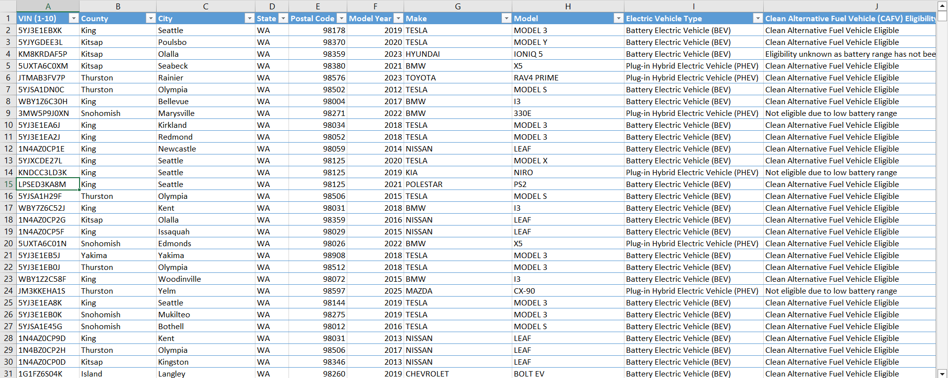
- Data before cleaning
- Total records: 23,9653
- Columns: 17, including key fields like Make, Model, Model Year, Electric Vehicle Type, Electric Range, and CAFV Eligibility.
- Missing values: Identified in fields such as Base MSRP, Electric Range, and Clean Vehicle Eligibility.
- Duplicates: Checked using conditional formatting on VIN and Make-Model pairs.
This profiling helped establish a baseline understanding of the dataset’s structure, missingness, and data quality.

3.2 Data Cleaning: Making Data Reliable
Data cleaning focused on resolving inconsistencies and preparing raw fields for analysis:
- Null Handling: Missing values in Electric Range and CAFV Eligibility were replaced with placeholders or marked “Unknown”.
- Duplicates: Removed based on VIN, Make, and Model fields using Excel's “Remove Duplicates” feature.
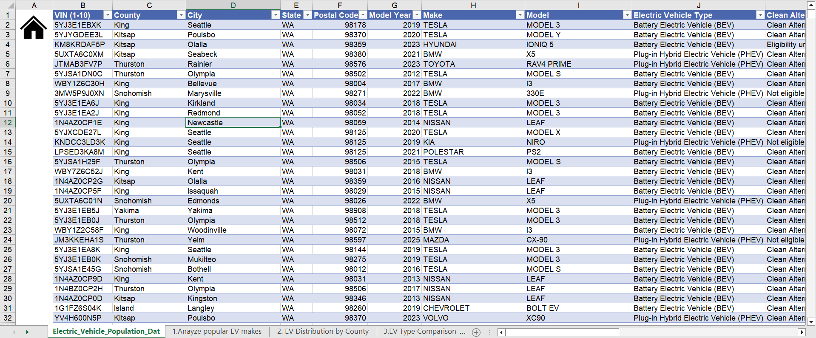
- Data after cleaning and removing duplicate values.
- Case Consistency: Used LOWER(), UPPER(), and PROPER() to standardize text fields (Make, County, City).
- Outlier Handling: Records with implausible electric ranges (<20 or >400 miles) were flagged and removed.
- Field Parsing: Separated combined fields such as Vehicle Location into latitude/longitude using text functions like TEXT TO COLUMNS.

3.3 Data Preprocessing: Preparing for Analysis
This process included formatting to standard and preparing the data for pivot-style analysis:
- Date Formatting: Renamed Model Year to numeric and made year uniform.
- Region Grouping: Grouped counties into larger zones (e.g., Western WA, Eastern WA).
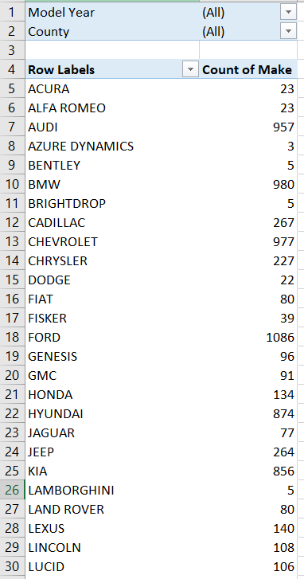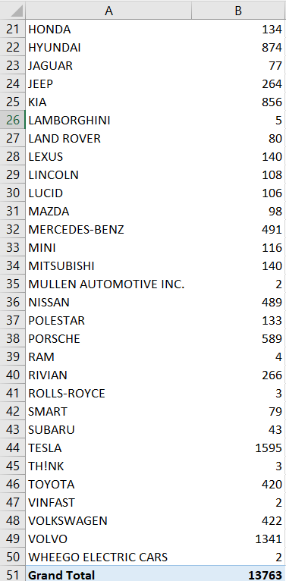

- Standardized Range: Created Range Bins:
- 0–99 miles (Low)
- 100–199 miles (Moderate)
- 200–299 miles (High)
- 300+ miles (Premium)
- Categorical Binning: Established new columns for:
- Vehicle Age (calculated from model year)
- CAFV Status (binary indicator)
- EV Category (e.g., "SUV", "Sedan", "Compact"—model name based)
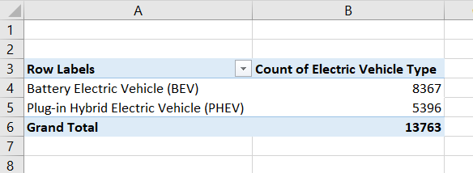
These changes allowed more detailed filtering and comparison within the dashboards.
3.4 Dashboard Development: Bringing it All Together
A dedicated dashboard was built in Excel to centralize insights:
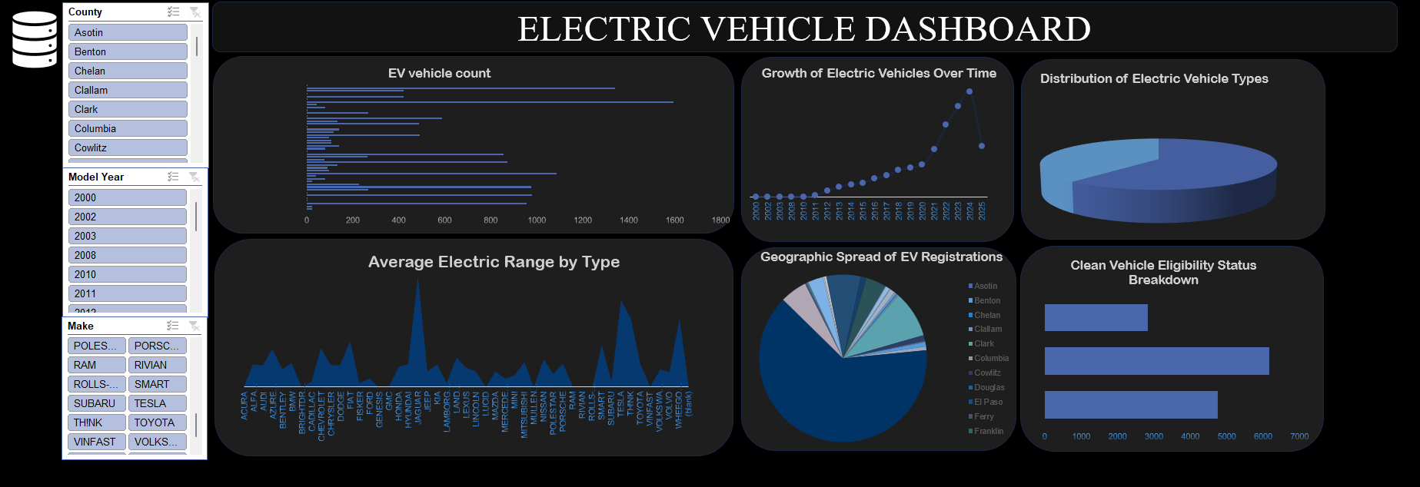
- Layout: Clean 3-panel design with header, slicers, and dynamic charts
- Slicers Added For:
  - Year
  - County
  - EV Type
  - CAFV Eligibility
- Key Performance Indicators (KPIs):
  - Total EVs: 13,763
  - CAFV Eligible: ~11,700 (85%)
  - Highest EV Count by County: King (~4,000)
  - Most Popular Make: Tesla (~45% share)
- Interactive Insights: Selecting a county dynamically updates charts
Conditional formatting and shape-based annotation enhanced user experience. Charts were made interactive with pivot chart + slicer integration.

- Analysis of Dataset
  - Analysis of Popular EV Makes
I. Introduction
Purpose: To determine which electric vehicle makes are most widely accepted in Washington State.
Relevance: Gives insights to manufacturers, policymakers, and infrastructure developers regarding the preferences of consumers.
II. General Description
Data Used: "Make" and "Model Year" fields from the data set.
Time Frame/Scope: All entries from earliest available data to most recent year.
Method: Aggregated by make and grouped with Excel pivot tables and bar charts.
III. Specific Requirements, Functions, and Formulas
Functions Used: COUNTIF, SORT.
Pivot Table Settings: Rows to "Make", Values to count of entries.
Calculated Fields: Top 5 most common makes filtered.
IV. Analysis Results
Findings: Tesla overwhelmingly leads, seconded by Nissan and Chevrolet.
Patterns: Each year consistently reports Tesla leading.
Comparison: Tesla comprises just under 45% of the EVs contained within the data set.
V. Visualization
Chart Type Used and Reasoning Behind It: Bar chart to prominently rank favorite makes.
Interactivity: Filtered both by year and county for a richer analysis.
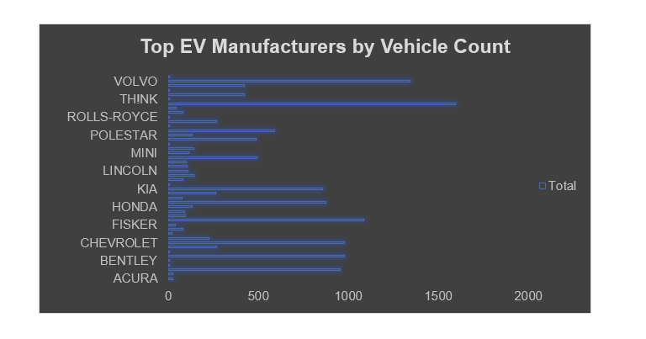

4.2 County Analysis of EV Distribution
I. Introduction
Purpose: To determine EV adoption differences at the county level.
Relevance: Informs outreach program and state-level planning on charging infrastructure.
II. General Description
Data Used: Columns "County" and "Make".
Time Frame/Scope: Entire dataset span.
Method: Divided by county and vehicle volume using Excel pivot tables.
III. Specific Requirements, Functions, and Formulas
Functions Used: COUNT, SORT.
Pivot Table Settings: Rows set to "County", Values set to count of vehicles.
Calculated Fields: Added column for % share of total.
IV. Analysis Results
Findings: King County has the highest concentration of EVs.
Patterns: Urban counties consistently lead adoption.
Comparisons: King County outpaces others by over 200%.
V. Visualization
Type of Chart Used and Why: Pie chart to visualize comparative density.
Interactivity: County filter to allow regional focus
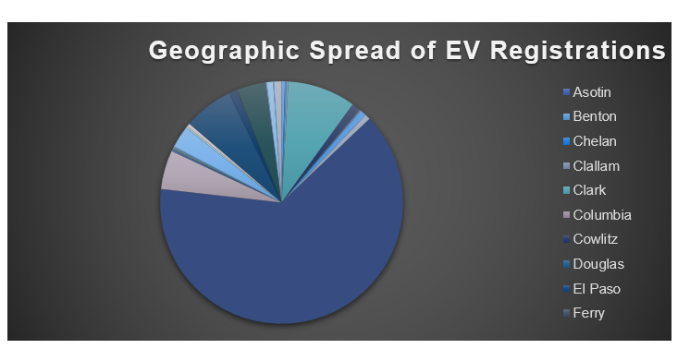
4.3 Analysis of EV Type Comparison
I. Introduction
Purpose: To analyze the distribution between BEVs and PHEVs.
Relevance: Affects policy on charging infrastructure and environmental benefits.
II. General Description
Data Used: "Electric Vehicle Type" column.
Time Frame/Scope: Complete data span.
Method: Categorized into BEV, PHEV and counted via pivot table.
III. Specific Requirements, Functions, and Formulas
Functions Used: IF, COUNTIF.
Pivot Table Settings: Rows set to "EV Type", Values to count.
Calculated Fields: Ratio of BEV to PHEV.
IV. Analysis Results
Findings: BEVs dominate with 75%+ of total.
Patterns: Growing preference for BEVs in newer models.
Comparisons: PHEVs mostly appear in older vehicles.
V. Visualization
Type of Chart Used and Why: Pie chart to show type proportions.
Interactivity: Year-wise slicer to see adoption over time.
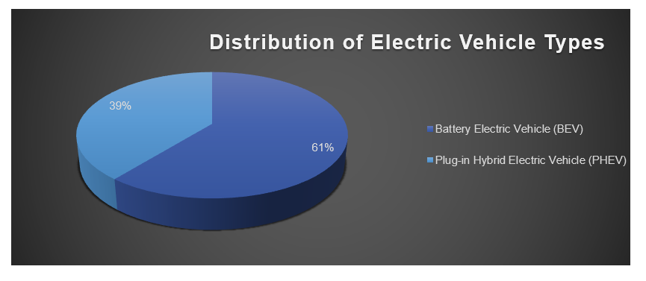

4.4 EV Adoption Trend Over Years
I. Introduction
Purpose: To see how EV registrations change every year.
Relevance: Useful for planning and evaluating government incentives.
II. General Description
Data Used: "Model Year" column.
Time Frame/Scope: 2012 to latest year.
Method: Use pivot table to count vehicles per year.
III. Specific Requirements, Functions, and Formulas
Functions Used: YEAR(), COUNTIF.
Pivot Table Settings: Values as years, rows as vehicle counts.
Calculated Fields: % change YoY.
IV. Results Analysis
Findings: Growth cuts up sharply after 2018.
Patterns: Adoption increases by 10–15% YoY year after year.
Comparisons: Two times more 2022 registrations than 2016.
V. Visualization
Type of Chart Used and Rationale: Trend visualization through the use of line chart.
Interactivity: Filtering on EV type.
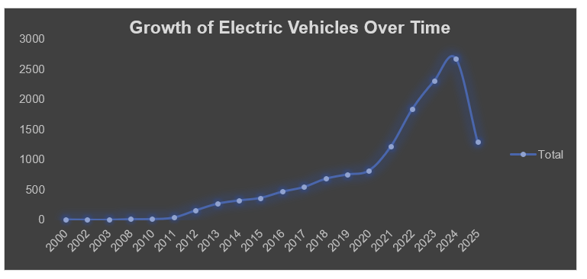

4.5 Clean Vehicle Eligibility Analysis
I. Introduction
Purpose: Determine the number of vehicles that qualify for clean vehicle incentives.
Relevance: Signals a degree of adherence to emission policy.
II. General Description
Data Used: "CAFV Eligibility" column.
Time Frame/Scope: Entire dataset.
Method: Count number of "Eligible" vs "Not Eligible" entries.
III. Specific Requirements, Functions, and Formulas
Functions Used: COUNTIF.
Pivot Table Settings: Rows as eligibility status, values as count.
Calculated Fields: Percentage of total.
IV. Analysis Results
Findings: More than 85% of vehicles are eligible
Patterns: BEVs more likely to be eligible.
Comparisons: Newer models have greater eligibility.
V. Visualization
Type of Chart Used and Why: Bar to show proportion.
Interactivity: Filter by make and type.
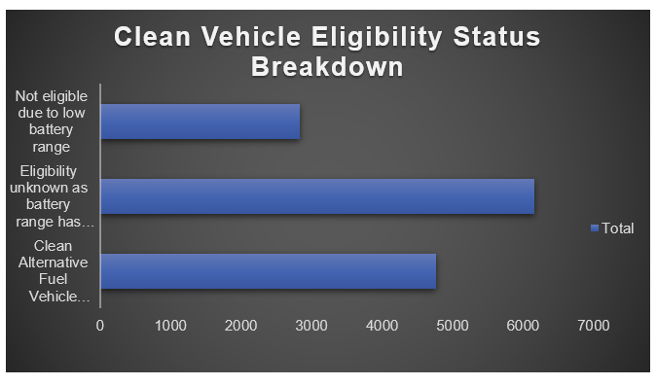

4.6 Electric Range Analysis
I. Introduction
Purpose: To analyze the range capability of various EVs.
Relevance: Assists in determining viability for long-distance travel.
II. General Description
Data Used: "Electric Range" column.
Time Frame/Scope: All years.
Method: Binned into bins (0–100, 100–200, etc.) and averaged by make.
III. Specific Requirements, Functions, and Formulas
Functions Used: AVERAGEIF, IF.
Pivot Table Settings: Values as make/range bin, rows as average.
Calculated Fields: Group range labels.
IV. Analysis Results
Findings: Tesla has highest average range.
Patterns: Newer vehicles trend 250+ miles.
Comparisons: Some PHEVs under 100 miles.
V. Visualization
Type of Chart Used and Why: Area chart for range distribution.
Interactivity: Filter by year or type.
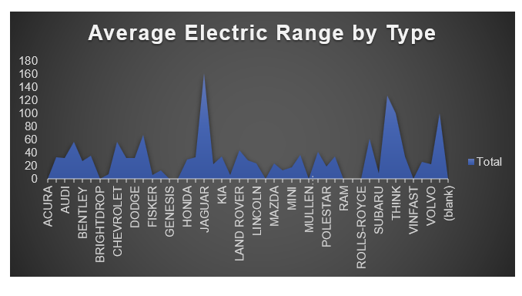

- Conclusion
The in-depth examination of the Electric Vehicle Population Data for Washington State has yielded a comprehensive insight into the changing patterns of electric vehicle (EV) uptake. Through a methodical investigation of 13,763 vehicle records of registration and a set of focused sub-analysis that includes the popularity of makes and models, geographic distribution and segmentation by type of vehicle, electric range profile, and eligibility for CAFV, the present study revealed compelling patterns, which enrich the overall debate for sustainable transport. The study illustrates the essential leverage that data gives to untangling the intricacy of policy outcomes, consumer adoption, and the planning of infrastructures in electric mobility.
One of the most important findings of this study is the obvious dominance of Tesla as the most favored maker among Washington's EV owners. The favoring seems to be highly correlated with brand reputation, range ability, and support for clean energy values. Other makers like Nissan, Chevrolet, and BMW have also made significant gains, suggesting an expanding EV market. Moreover, the analysis also showed a dense cluster of EVs in King County, indicating that urban density, income, and public education heavily impact EV penetration. This geographical bias raises several key considerations regarding fair access to clean transportation and the need for outreach programs in under-represented counties.
Also noteworthy is the finding that Battery Electric Vehicles (BEVs) account for the lion's share of registrations—over 75% of the sample—indicating robust consumer preference for all-electric powertrains over hybrids. The growing registration of BEVs also coincides with advances in electric range, which, as the research indicates, now frequently exceed 250–300 miles for more recent models. Such technological advancements alleviate consumer concern over the limitation of range and augurs well for industry ingenuity.
Another useful insight is the ubiquitous eligibility of EVs for Clean Alternative Fuel Vehicle (CAFV) programs, with more than 85% of the vehicles registered being eligible. This number confirms the efficacy of government measures to promote clean mobility, yet the dataset also implies the importance of broadening awareness and streamlining eligibility procedures to cover even more diverse groups. The temporal trend analysis further establishes an overall steady and substantial upward trend, particularly post-2018, showing the momentum of the clean energy transition.
The initiative also highlights the increasing relevance of data visualization and interactive dashboards in communicating detailed insights in simple terms. Application of Excel-based pivot tables, charts, and slicers permitted dynamic exploration of the data set and facilitated richer insight into year-on-year progress, regional rates of adoption, and make-model choices.
On a wider scale, this analysis is more than mere trend description; it is a strategic tool for decision-making for various stakeholders. For planners in urban areas, the data can identify hot spots where high demand exists for the installation of chargers. For state authorities, the findings act as a gauge of policy effectiveness. For automakers, trends in brand usage and consumer perceptions inform design and marketing initiatives. And for researchers in academia, the approach shown here provides a replicable model for future research on sustainable transportation.
In summary, the landscape of electric vehicles in Washington State is evolving very quickly, characterized by growing adoption, growing eligibility for clean energy programs, and tremendous vehicle technology advancements. But challenges exist, most notably in the areas of equitable access, rural adoption, and infrastructure readiness. This research, in its thorough and evidence-based examination, forms the basis for ongoing innovation and policy-making based on data. With the shift of the world towards cleaner mobility solutions, such analytical analyses become not only academically worthwhile but also socially necessary.

- Future Scope
The study of electric vehicle (EV) adoption in Washington State provides a solid foundation on which to build future work, growth, and policy-making. With the EV ecosystem still rapidly changing, though, some areas remain ripe for further study and extension of data analysis applications in this area.
One such area of future research is the use of more datasets—such as EV charging stations, real-time utility usage, road utilization figures, and consumer profiles. By linking these variables to present-day vehicle registration records, analysts and planners can develop stronger, multi-faceted insights into EV availability, use patterns, and performance within varied communities. Economic indicators such as education and income level may be added to better explain adoption variation across regions and inform more just policy mechanisms.
Another key opportunity involves the use of predictive modeling and machine learning-based algorithms. Prediction models can be created to model future EV take-up rates within counties, forecast the strain on electricity grids, and determine best locations for deploying new charging facilities. These tools can improve scalability and responsiveness within EV planning, particularly as rates of adoption build momentum.
Enlarging the examination to a country or international level would enable cross-state or country comparative studies of the effects of different incentives, policies, and investments in infrastructure. Such analysis can identify the best practices and provide policy guidance specific to locations.
Finally, subsequent versions of this project can utilize interactive visualization software such as Power BI or Tableau to build live, publicly accessible dashboards. Such software can enable local governments, energy companies, and residents to monitor EV trends in real time and make informed decisions.
In summary, the dynamic development of EV technology and adoption necessitates ongoing data-driven observation and innovation, making this project a scalable, dynamic model for sustained sustainable transportation analysis.

- References

- Washington State Department of Licensing – EV Dataset: data.gov
- Open Government License – Washington State

