**Name:Amisha Gupta  
email:**[**amisha.gupta351@gmail.com**](mailto:amisha.gupta351@gmail.com) **Assignment name:**

**Python Basic assignment -1**

Drive link::

[Assignment1](https://docs.google.com/document/d/1Pym_fPofXea02k6v_t2dWOy4lgHASfefZB-uOiq6Wyw/edit?usp=sharing)

**Python Basic assignment -1**

**1 Explain the key features of Python that make it a popular choice for programming**

The key features of python that make it a popular choice for programming are as follows:

* High level language
* Easy to understand
* Huge libraries
* High readability
* Used by top company
* Simple syntax

**2 Describe the role of predefined keywords in Python and provide examples of how they are used in a program**

The role of predefined keywords in python as we know that keyword is a set of special word which has meaning and it is also known as reserved word .

For example   
If /else - it is a keyword which is used for conditional statement

Syntax: if(a>b):

print(“hi”)

else:

print(“hello”)

For loops - it is also a keyword which is used for iteration

Syntax:

for i in range (10):

print(i)

Def: it is used to define a function

def fun1():

return (“welcome”)

**3 Compare and contrast mutable and immutable objects in Python with examples**

Mutable object in python means the value can be changed

Mutable example:

* List
* Dictionaries
* Sets

Immutable object in python mean the value which can’t be changed

Example::

* Tuples

**4 Discuss the different types of operators in Python and provide examples of how they are used**

The different type of operator are as follows:

* Arithmetic operator  
   Examples: +, -, *, /, %, **, //

a+b,a-b

* Comparison operator  
   Examples: ==, !=, >, <, >=, <=

a==0,a==b

* Assignment operator

Examples: =, +=, -=, *=, /=, %=, //=, **=

a=0,a+=1

* Logical operator

Examples: and, or, not

x<y or x>y

* Membership operator

Examples: in, not in

“a” in “apple”

* Identity operator

Example : is, is not

x=10

y=10

x is not y   
 Output

false

* Bitwise operator

Example :: &, |, ^, ~, <<, >>

**5 Explain the concept of type casting in Python with examples**

### **Implicit Type Casting (Automatic)**

* Done **automatically by Python**
* Occurs when Python converts a smaller data type to a larger one to avoid data loss.

a = 5 # int

b = 2.5 # float

c = a + b # Python automatically converts 'a' to float (5.0)

print(c) # Output: 7.5 (float)

**Explicit Type Casting**

Done **manually by the programmer** using functions like int(), float(), str(), etc.

x = "10"

Output:

‘10’

y = int(x) # Explicitly convert str to int

print (y)

Output :

10

**6.How do conditional statements work in Python? Illustrate with examples**

Conditional statements is used to check the multiple condition   
Example::  
 Write a program to check if the not is even or odd   
x=3

if x%2==0:

print("The number is even::" ,x)

else:

print("The number is odd::",x)

Output ::

The number is odd:: 3

In conditional statement we have if else ladder also   
Example :: write a program if the number is positive or negative or zero

x=-1

if x==0:

print("The number is zero::" ,x)

elif x>0:

print("The number is postive::",x)

else:

print("The number is negative::",x)

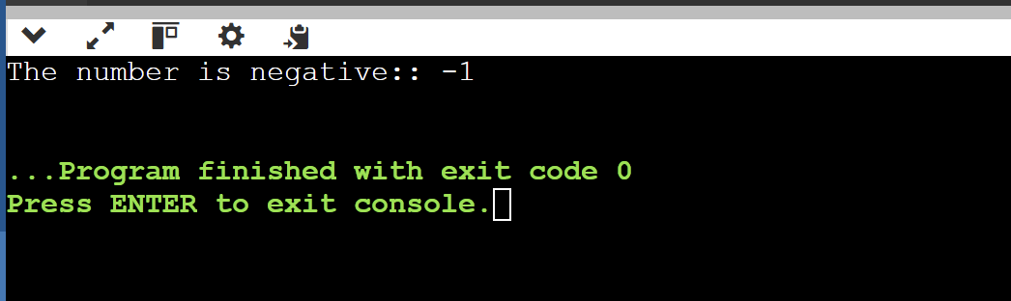

**7 Describe the different types of loops in Python and their use cases with examples.**

The different types of loops in python is ::  
First one is for loop  
We use loop to iterate the data   
For eg ::

a=[1,2,3,4]

for i in a :

print(i)

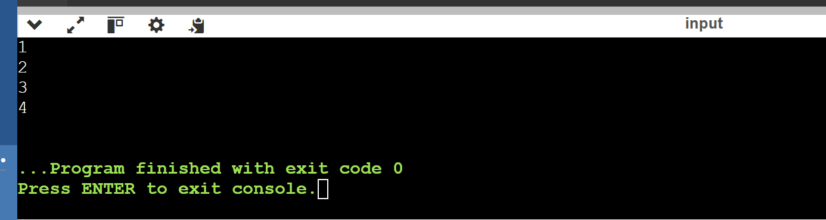

We have another loop that is while loop ,in this type of loop first condition is checked   
Syntax   
 while condition:

Code block  
  
Example   
  
 x=5

while x>0:

print(x)

x=x-1

