The Course Project
The course project includes 3 parts. The first part is to develop a Python MRJob application to retrieve Year and Temperature from original NCDC records (i.e., the dataset we are using for this class) and then write the Year and Temperature data into a text file. The second part is to load the text file into Pig and get the highest and lowest temperatures for each year. The third part is to load the text file into Hive and get the average temperature for each year.

You need to turn in 1) Python MRJob coding file, 2) the commands for executing the Python MRJob application in Hadoop, 3) the text file including Year and Temperature data created by you, 4) the screenshot of the text file being created, 5) the screenshot of the final Pig output showing the year and the highest and lowest temperatures, and 6) the screenshot of the final Hive output showing the year and average temperature.
The original dataset for this project is available on Canvas.

Part 1:

In Local Disk:
scp "/Users/amishafarhanashaik/Desktop/MSBA/BAN 632 - Big Data/Project/temperature_extraction.py" student39@134.154.190.204:/home/student39/

scp "/Users/amishafarhanashaik/Desktop/MSBA/BAN 632 - Big Data/Project/Newprojectdata.zip" student39@134.154.190.204:/home/student39/

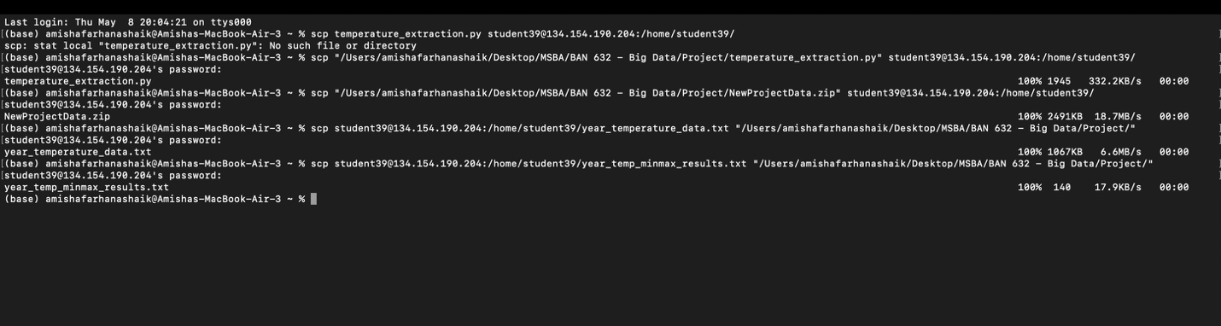

Hadoop Server:
ssh student39@134.154.190.204

Extract the zip file:
unzip NewProjectData.zip
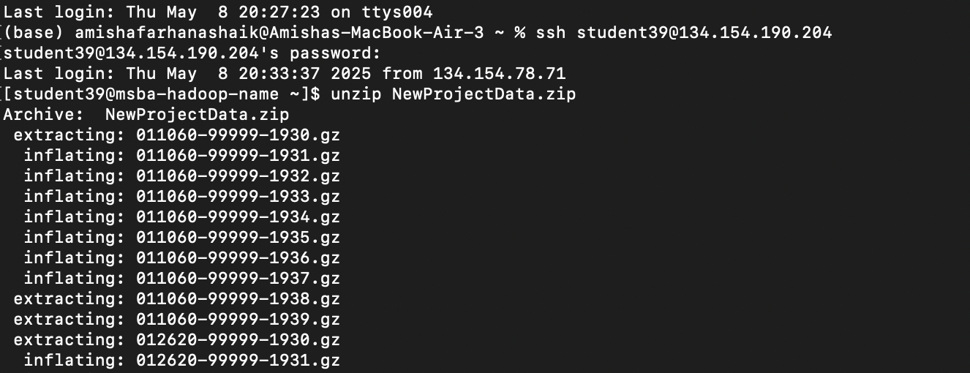

Create the directory and move files into it:
mkdir ncdc_data
gunzip -c *.gz > ncdc_data/all_records.txt
To Verify the file was created:
ls -lh ncdc_data/

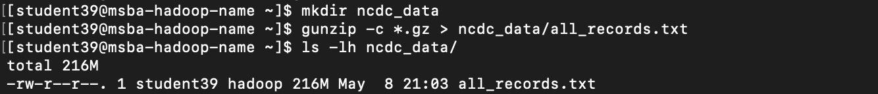

Create a new Python script from scratch:
vi new_temperature_extraction.py

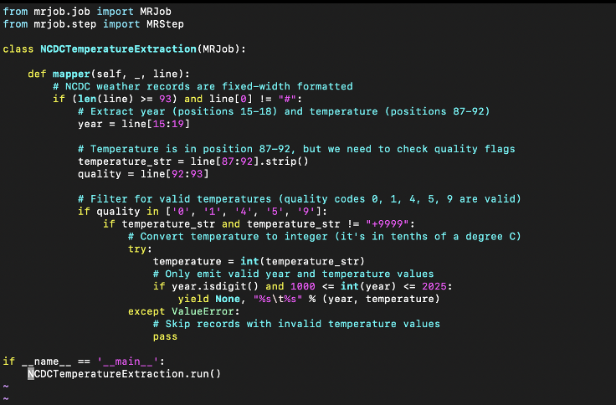

Running the MRJob script on Hadoop:
python new_temperature_extraction.py ncdc_data/all_records.txt -o temperature_output
Cleaning up the data format:
cat temperature_output/part-* | sed 's/^null\s*"//g' | sed 's/"$//g' | sed 's/\\t/\t/g' > year_temperature_data.txt

Copy the file from the Hadoop server to local machine:
scp student39@134.154.190.204:/home/student39/year_temperature_data.txt "/Users/amishafarhanashaik/Desktop/MSBA/BAN 632 - Big Data/Project/"

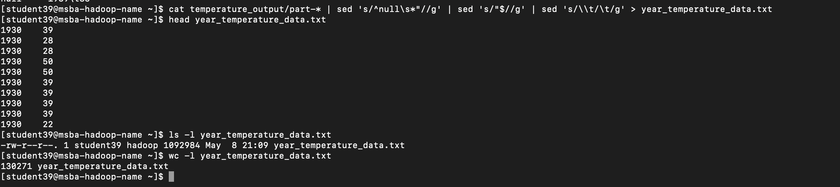

Part2:

Confirm the data file:

Create a Pig script:

year_temp = LOAD '/user/student39/project/year_temperature_data.txt' AS (year:chararray, temperature:int);

grouped_data = GROUP year_temp BY year;

year_temp_minmax = FOREACH grouped_data GENERATE
group AS year,
MIN(year_temp.temperature) AS min_temp,
MAX(year_temp.temperature) AS max_temp;

STORE year_temp_minmax INTO '/user/student39/project/year_temp_minmax';

DUMP year_temp_minmax;

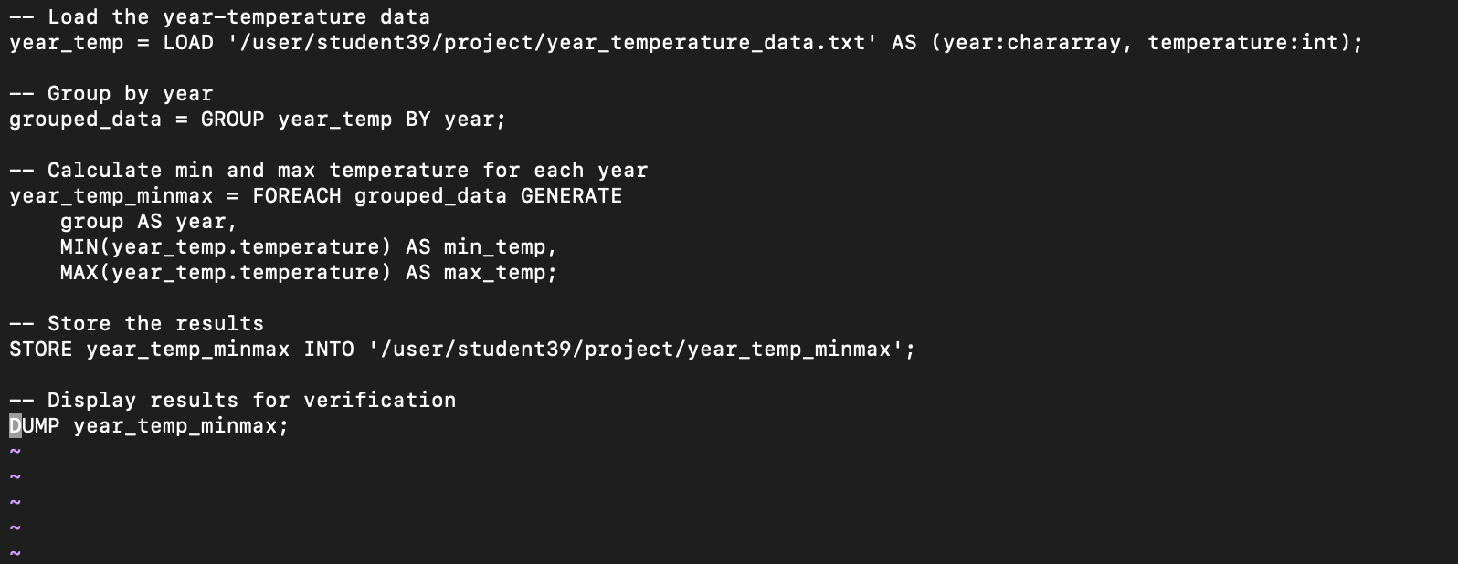

Running Pig Job:
pig temperature_analysis.pig

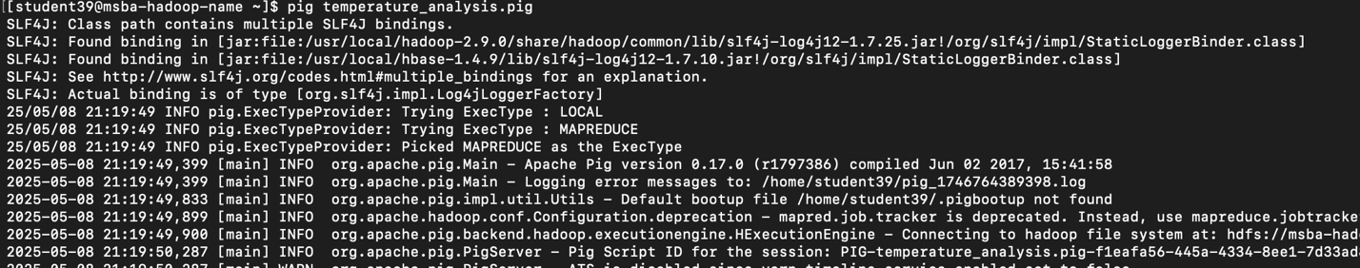

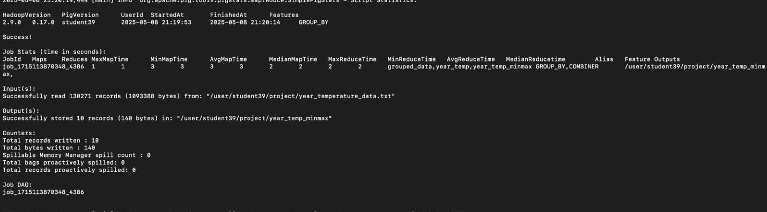

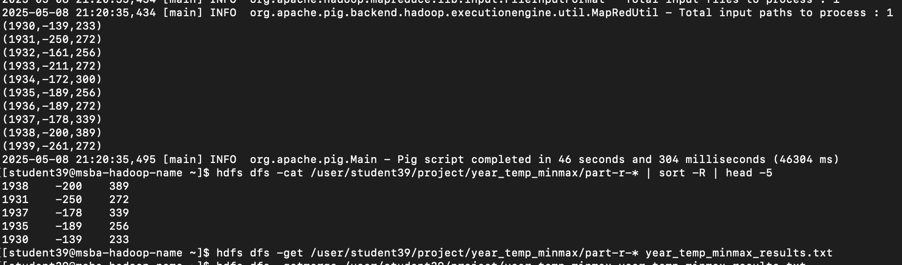

Part 3:

Hadoop Server:
ssh student39@134.154.190.204

Start hive
hive

Create a Hive table for the data
DROP TABLE IF EXISTS year_temp;

CREATE TABLE year_temp (
year STRING,
temperature INT
)
ROW FORMAT DELIMITED
FIELDS TERMINATED BY ' ';
STORED AS TEXTFILE;

LOAD DATA INPATH '/user/student39/input/project_results_temp.txt' INTO TABLE year_temp;

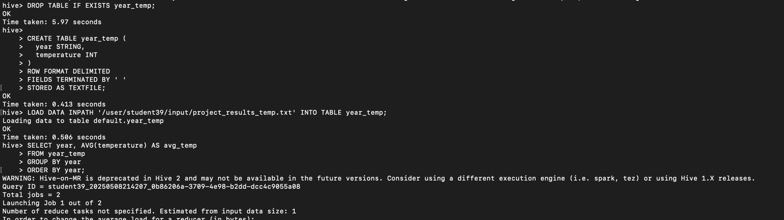

Running the query:
SELECT year, AVG(temperature) AS avg_temp
FROM year_temp
GROUP BY year
ORDER BY year;

