**BOOKBUY.COM**

**REQUIREMENT AND TECHINICAL DESIGN DOCUMENT**

**By**

**Amisha Harshad Gondaliya**

**TABLE OF CONTENTS**

|  |  |
| --- | --- |
| Section title | Page # |
| 1. Project Overview …………………………………………………………………………………………………………………. | 3 |
| 1. Purpose ……………………………………………………………………………………………………………………………….. | 3 |
| 1. Scope …………………………………………………………………………………………………………………………………… | 3 |
| 1. Point of Contact …………………………………………………………………………………………………………………… | 3 |
| 1. Functional Requirements …………………………………………………………………………………………………….. | 3 |
| 1. Database Requirements ………………………………………………………………………………………………………. | 7 |
| 1. Performance Requirements …………………………………………………………………………………………………. | 9 |
| 1. Security ……………………………………………………………………………………………………………………………….. | 9 |
| 1. Maintenance ……………………………………………………………………………………………………………………….. | 9 |
|  |  |
|  |  |
|  |  |
|  |  |

1. **Project overview:**

The application BOOKBUY.COM is created solely for benefitting enthusiastic book readers. It will help book readers get more time to read different books and dive into the world of science, fiction, technology, etc. It is an e-store which will helps book readers buy books online. The application is easy to be used by all type of users – Novice, Amateur, Professional and enthusiastic book readers.

1. **Purpose:**

The purpose of this document is providing technical and design requirements of the BOOKBUY.COM application. It is meant for application designers, developers, quality analysis team and the UAT team.

1. **Scope:**
2. The application is intended to be used by the end users & admin only and not for any library purpose.
3. The application will send out the email when an Order has been placed. It will not send out emails for in cart orders.
4. The application will not perform any multiple login authentication for the same user from multiple places.
5. Application can be used guaranteed on the device as outlines in the hardware requirements section.
6. Application will be using SALT + HASH encryption to store the user passwords – it is assumed that SALT+HASH encryption is thoroughly tested and verified.
7. Application will be able to resist SQL Injection attackers.

1. **Point of Contact:**

|  |  |  |  |
| --- | --- | --- | --- |
| **Position** | **Name** | **Contact** | **Email** |
| Application Designer | Amisha Gondaliya | 9802678146 | [amisha@bookbuy.com](mailto:amisha@bookbuy.com) |
| Application Developer | Amisha Gondaliya | 9802678146 | [amisha@bookbuy.com](mailto:amisha@bookbuy.com) |

1. **Functional Requirements:**
   1. **Interface:**

The application Bookbuy.com has an interface with the following components:

It uses MVC architecture in the frontend for JSP and Servlets, while it uses MYSQL at the backend.

Bookstore database – it connects to MYSQL database using JDBC.

The application will have a separate session for each user login and session will be expire once the user closes the UI.

* 1. **User Interface:**

The following screens are created:

1. Home Screen



1. Catalog Screen

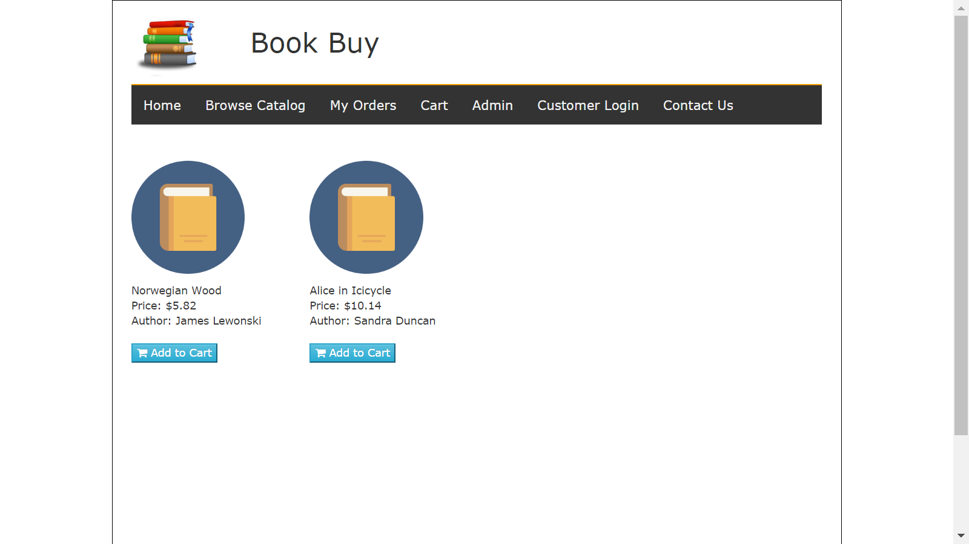

1. Login Page

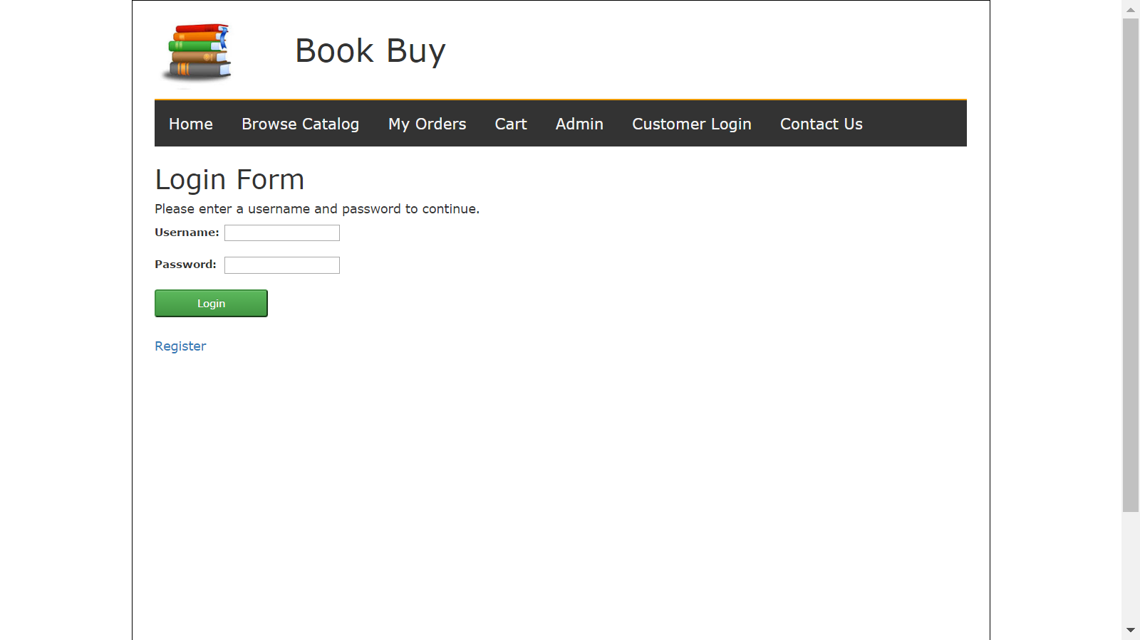

1. My Orders Page

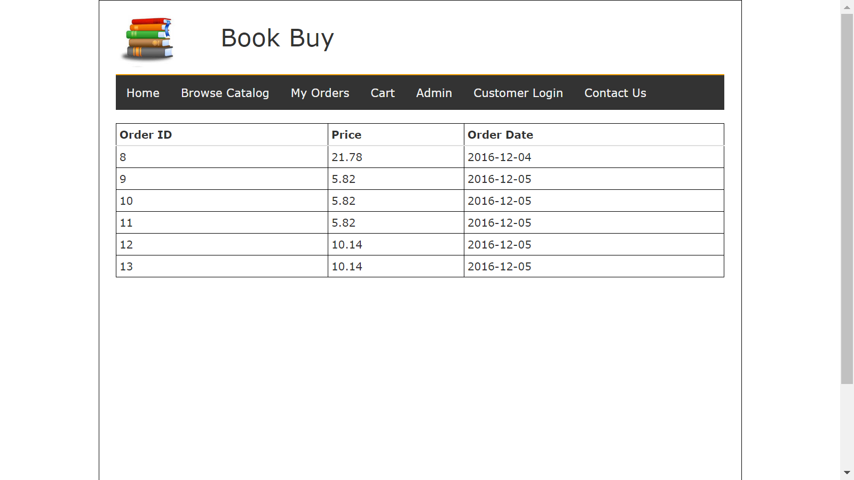

1. Cart Screen

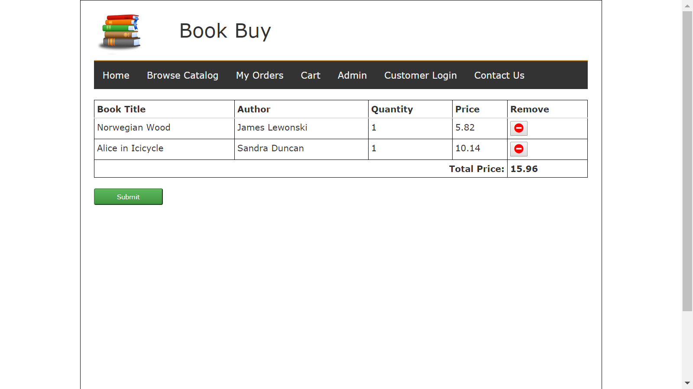

1. Contact US

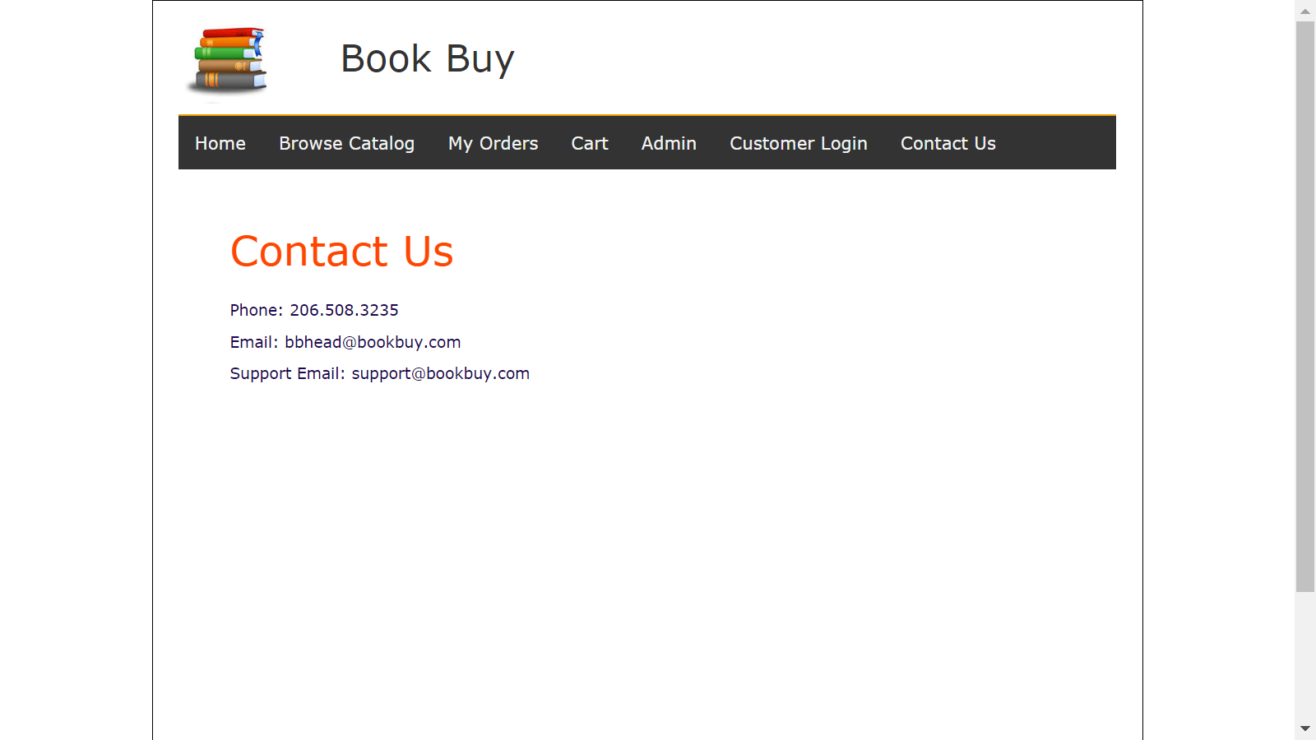

1. Admin page

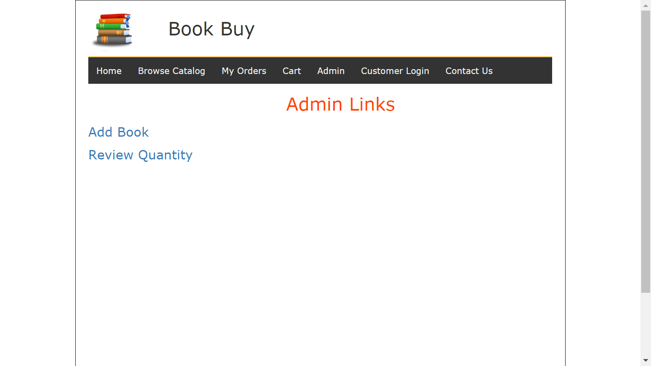

1. **Database requirements:**

Below tables are created as a part of this project.

* + 1. **Tables:**

**USERS**

Primary Key:- userID.

Unique Key:- email

|  |  |
| --- | --- |
| Field | Type |
| userID | varchar(50) |
| pwd | varchar(150) |
| salt | varchar(150) |
| email | varchar(50) |
| firstName | varchar(50) |
| lastName | varchar(50) |
| usercategory | varchar(1) |
| USER_ADDR_LN1 | varchar(100) |
| USER_ADDR_LN2 | varchar(100) |
| ZIP | varchar(10) |
| PHONENUMBER | varchar(15) |
| City | varchar(50) |
| State | varchar(50) |
| Country | varchar(50) |
| cctype | varchar(50) |
| ccnumber | varchar(50) |
| ccexpiration | varchar(50) |

**BOOKS**

Primary key bookID.

Foreign key authorID.

|  |  |
| --- | --- |
| Field | Type |
| bookID | int(11) |
| authorID | int(11) |
| title | varchar(100) |
| ISBN | varchar(100) |
| genre | varchar(50) |
| type | varchar(50) |
| publicationYear | int(11) |
| price | decimal(10,2) |
| bookCondition | varchar(8) |

**Authors**

This table will have AuthorID as primary key.

|  |  |
| --- | --- |
| Field | Type |
| AuthorID | int(11) |
| AuthorName | varchar(100) |
| AuthorInfo | varchar(100) |

**ORDERS**

Primary key: OrderID

|  |  |
| --- | --- |
| Field | Type |
| ORDERID | int(11) |
| USERID | varchar(50) |
| ORDERDATE | date |
| ORDERTOTAL | decimal(5,2) |

**OrderDetails**

This table will store bookID and Quantity of book ordered against the orderID.

Foreign key: OrderID

|  |  |
| --- | --- |
| Field | Type |
| OrderID | int(11) |
| USERID | varchar(50) |
| Quantity | int(11) |
| BookID | int(11) |

**CART**

It is a table, and its contents will be deleted as soon the user places the order or empties the cart.

CartID:- Primary Key

|  |  |
| --- | --- |
| Field | Type |
| CARTID | int(11) |
| USERID | varchar(50) |
| BOOKID | int(11) |
| Quantity | int(11) |

ER Diagram Attached.



1. **Performance Requirements:**

The BookBuy.com application is expected to have around 5 tps. Hence the optimum performance measures should be taken accordingly.

Appropriate indexes must be created to have optimum performance while selecting, inserting, updating & deleting data from the database.

1. **Security:**
2. SALT + HASH (or an equivalent) encryption algorithm must be used to store and retrieve sensitive user details – like password, credit card, etc
3. Application must enforce session security policies to protect the users and application from any brute force attack (~ minimal probability)
4. Application must enforce SQL Injection prevention policies to protect the application and users from any SQL injection attacks.
5. Application users must advise (User manuals, mailers) users from time to time to prevent themselves from any social engineering attacks.
6. **Maintenance:**
   1. **Patch deployment:**

A security / performance / up gradation patch might be applied from time to time for improving the performance of the application.

All patches must be thoroughly tested and validated by the testing team, in order to rule out any production issues.

* 1. **Failure management:**

The deployment and operations team must create a manual or Maintenance and Prevention document which will guide all the operations personnel to perform the application upgrades and deployment.

The operations team must have a StartUp & Shutdown document for the application startup and shutdown for appropriate scenarios.