EduPredicted

Supervisor : | Sir  Muhammad Umer
Batch : | 2306e
Group : | EduPredicted
Serial No. | Enrollment No. | Student Name.
1. | 1447796 | Ameet Kumar Dhera
2. | 1424740 | FAHAD KHAN
3. | 1475502 | MUHAMMAD ZONAIN
4. | 1464320 | KAINAT NAZ

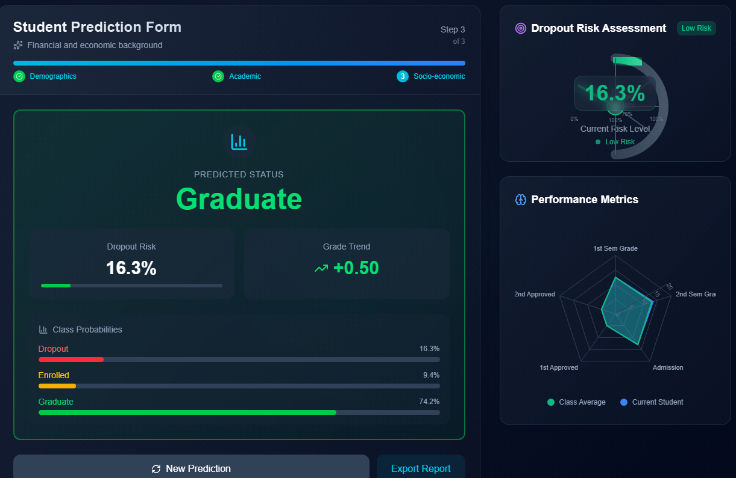

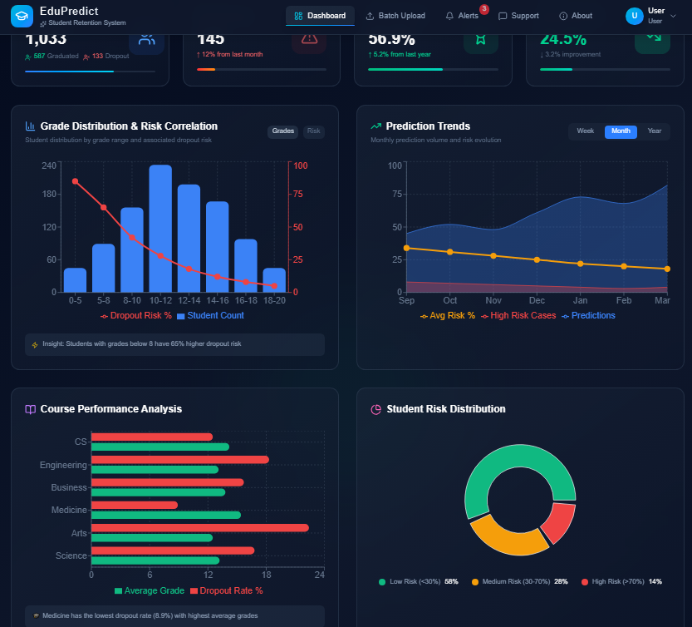

Acknowledgement

First and foremost, I would like to express my sincere gratitude to my teacher, Sir Muhammad Umer, for his invaluable guidance, continuous support, and encouragement throughout the completion of this project within the given timeframe. His expert advice and motivation played a vital role in the successful completion of this work.
I would also like to extend my heartfelt thanks to the eProject team at Aptech Head Office for providing us with the opportunity to work on this innovative and challenging project, the EduPredicted System. Their support, guidance, and resources greatly contributed to enhancing my practical knowledge and technical skills.
Lastly, I am deeply grateful to the entire eProject team for entrusting me with this assignment, which has significantly enriched my learning experience by:
- Strengthening my skills through practical implementation in a real-world project scenario.
- Providing consistent mentorship that kept me focused and motivated throughout the project.
- Enhancing my confidence to face interviews and discussions by enabling me to effectively demonstrate the concepts and technologies learned during the course.

Synopsis
The EduPredicted System is designed to analyze educational data and enhance student performance through data-driven insights and predictive analytics. This comprehensive system provides an integrated platform for managing student records, academic performance, attendance data, and related educational datasets.
By leveraging modern technologies such as big data processing and machine learning, EduPredicted aims to improve decision-making in educational institutions, identify learning patterns, reduce dropout risks, and support personalized learning strategies. The system helps educators and administrators gain meaningful insights through an intuitive and user-friendly interface, enabling more efficient academic planning and student support.

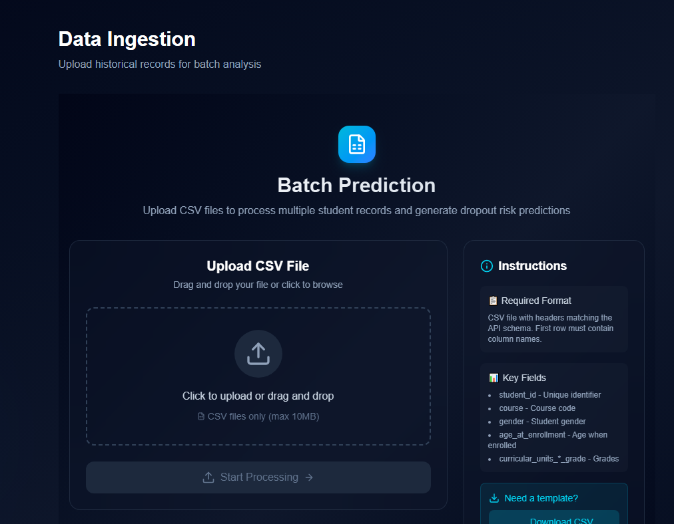

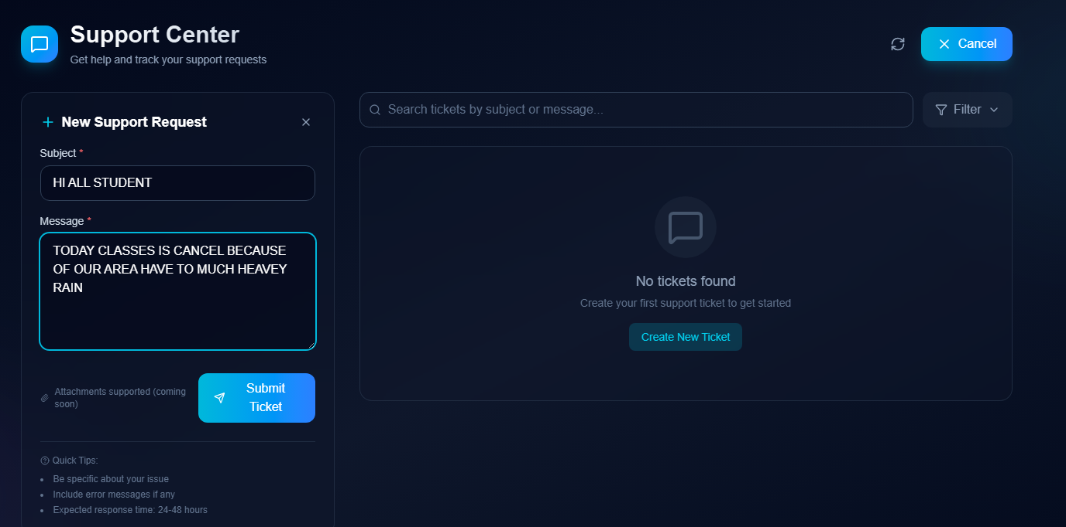

Problems Definition
Educational institutions face significant challenges in managing and analyzing large volumes of student and academic data efficiently, including student performance tracking, attendance monitoring, resource allocation, and dropout risk assessment. Traditional manual or fragmented systems often lead to inaccuracies, delays in decision-making, and reduced effectiveness in improving learning outcomes.
The EduPredicted System addresses these issues by providing a centralized, automated platform that enables real-time data processing, accurate predictive analysis, and seamless coordination of academic information. It ensures better communication among stakeholders, improves decision-making efficiency, and enhances overall educational performance and student success.

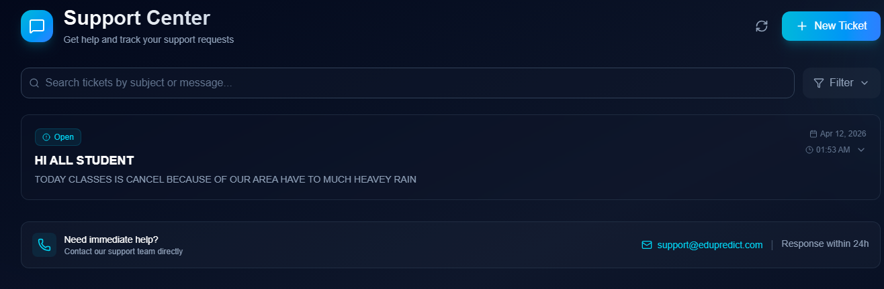

Customer Requirement Specification (CRS)

Features of EduPredicted System
To enhance educational management and student performance analysis, the EduPredicted System includes the following features:
- User Registration and Authentication:
  - Administrators, teachers, students, and analysts can create accounts and securely log in.
  - Password reset and recovery options are available.
- User Role Management:
  - Different access levels for roles such as admin, teacher, student, and data analyst.
  - Ability to modify, manage, and deactivate user accounts as needed.
- Student Profile Management:
  - Creation and management of student profiles with personal details, academic records, and attendance history.
  - Secure storage and retrieval of student data.
- Academic Data Management:
  - Maintain records of student performance, courses, attendance, and assessment results.
  - Real-time updates to ensure accurate academic tracking.
- Enrollment and Course Management:
  - Manage student enrollment in courses and programs efficiently.
  - Track course assignments and academic progress.
- Performance Tracking and Prediction:
  - Monitor student academic performance over time.
  - Use predictive analytics to identify at-risk students and improve outcomes.
- Data Processing and Analytics:
  - Process large educational datasets using batch and real-time processing.
  - Generate insights on student trends, performance patterns, and learning outcomes.
- Reporting and Visualization:
  - Generate customizable reports on student performance, attendance, and dropout risks.
  - Visual dashboards to support decision-making.
- Feedback and Support System:
  - Students and teachers can provide feedback and report issues.
  - Support system for academic assistance and system-related queries.
- System Notifications:
  - Alerts for attendance issues, performance risks, and academic updates.
  - Automated notifications for important academic events and deadlines.
  - .



Scope Of The Work
- The project involves developing a comprehensive EduPredicted System aimed at improving educational decision-making through data analytics and predictive modeling. Key functionalities include:
- A user-friendly interface for administrators, teachers, and analysts to manage academic operations efficiently, including student records, attendance, performance tracking, and reporting.
- A centralized database to store structured and unstructured educational data such as academic records, attendance logs, and demographic information.
- Role-based access control to ensure secure and appropriate access for different users including administrators, teachers, students, and analysts.
- An automated data ingestion system that collects and processes academic data from multiple sources.
- Integrated predictive analytics features to forecast student performance, identify at-risk students, and analyze dropout probabilities.
- Data processing modules for handling large-scale educational datasets efficiently using batch and real-time processing techniques.
- Reporting and visualization tools to present insights in the form of dashboards, charts, and performance summaries.
- A feedback mechanism enabling students and teachers to share input for continuous improvement of the system.
- An administrative dashboard for managing system settings, users, and monitoring analytics results.
- Efficient search and filtering capabilities for quick access to student records, performance data, and reports.
- This system aims to improve the quality of education by centralizing academic data and enabling data-driven decision-making to enhance student success and institutional efficiency.
- .

This system aims to optimize hotel management by consolidating essential operational functions into a single, efficient platform that enhances both staff productivity and guest satisfaction.
Submit
Icon
Icon
Project Ref.No:  Ep/Advertisement  Portal Management  System /01 |  | Project Title | Date Of preparation Of Activity Plan
No. | Task | E  D  U  P  R  R  D  I  C  T  E  D  S  Y  S  T  E  M | Actual  Start Date | Actual Days | Member  Name | Status
01. | User Authentication, User Data Retrieval Screen & Admin Panel Predicted Screen |  | 0  5  -  M  A  R  -  2  0  2  6 | 3  0  -  D  A  Y  S  - | Ameet  Kumar  Dhera | In Progress
02. | Testing, Documentation Checking & Dataset Checking |  |  |  | Kainat Naz
03. | Login/Register UI Development |  |  |  | Muhammad Zonain
04. | Documentation Work |  |  |  | Fahad Khan

