Date: 26/09/2026
Aim of the Experiment:
Reading the analog values and interfacing of potentiometers and light-detecting sensors using Arduino Uno.
Objective:
- Interfacing a potentiometer to control the LED brightness in proportion to the potentiometer reading.
- Interfacing a Light Dependent Resistor (LDR) to turn on an LED under low light conditions and display the LDR readings on the serial monitor.
- Practical application of LDR in street light control. (If the light is on, the green LED is turned on. If the light is off, the red LED is on.
- Implementation of a synchronized audible sound with the variation of light.

Components/Equipment Required:

Sl No. | Name of the Component/Equipement | Specification | Quantity
1 | Arduino UNO R3 | 16MHz | 1
2 | Arduino UNO cable | USB Type A to B | 1
3 | Resistors (carbon type) | ¼ watt (220Ω) | 2
3 | Resistors (carbon type) | ¼ watt (4.7kΩ) | 2
4 | LED | Red | 1
4 | LED | Green | 1
5 | LDR/photoresistor |  | 1
6 | Potentiometer | 10k | 1
7 | Buzzer | passive | 1
8 | Breadboard | 840 Tie points | 1
9 | Jumper Wire | ----------------------- | As per requirement

Objective 1

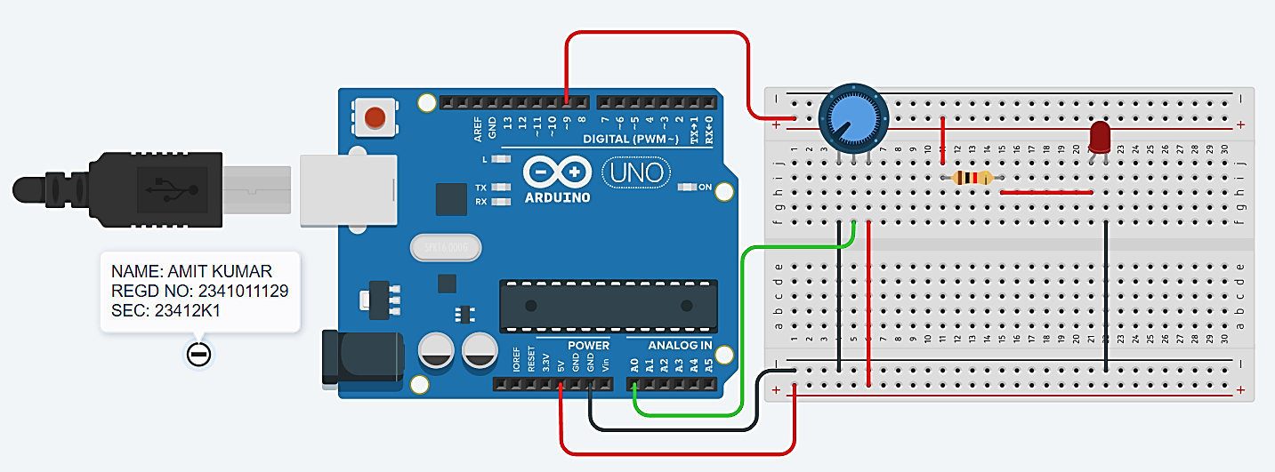
Circuit Diagram(TinkerCAD):

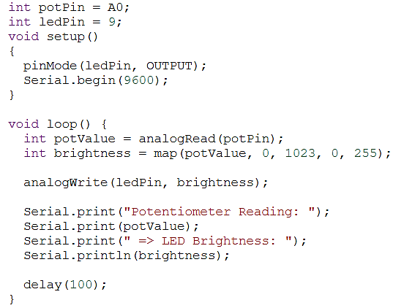
Code/Program:

Observation : The LED brightness varied with the potentiometer reading. The LDR successfully detected light intensity and controlled the LEDs accordingly, while the LDR values were displayed on the Serial Monitor.

Objective 2

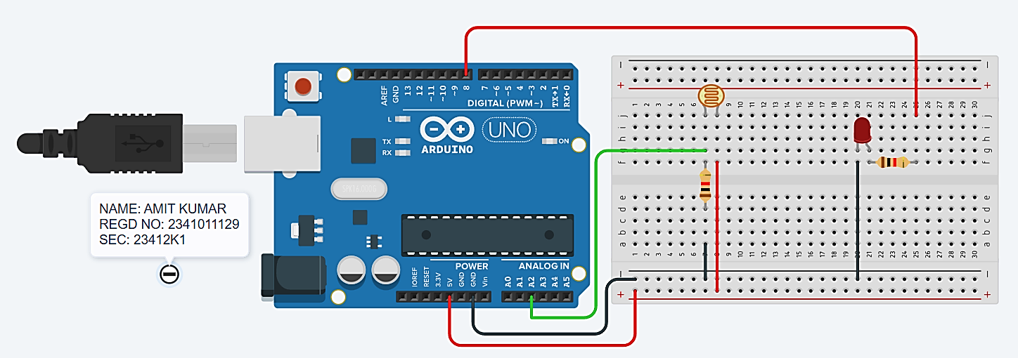
Circuit/Schematic Diagram:

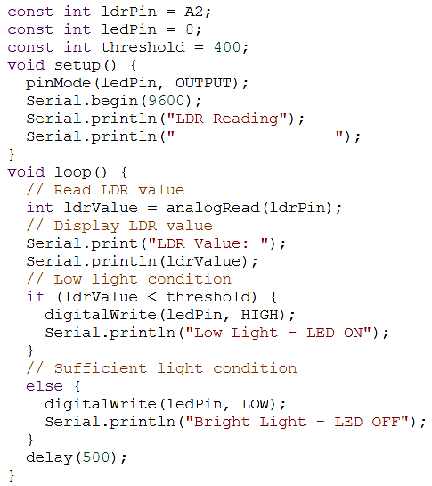
Code:

Observation: The LDR successfully detected changes in light intensity and displayed the corresponding analog values on the Serial Monitor. The LED turned ON under low-light conditions and OFF under sufficient light, demonstrating automatic light-based control using Arduino Uno.

Objective 3

Circuit/Schematic Diagram:
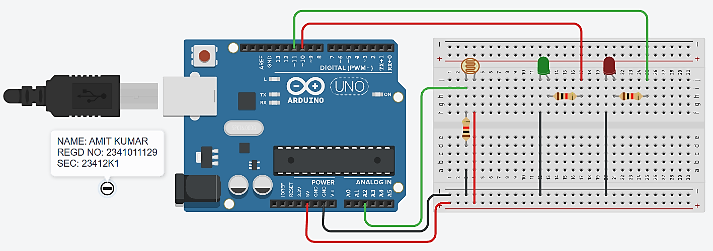
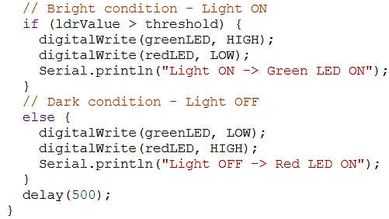
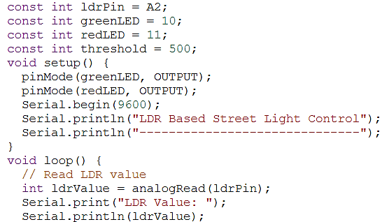
Code:

Observation: The LDR-based street light control was successfully implemented using Arduino Uno. The LDR senses the light intensity and automatically switches the green LED ON in bright conditions and the red LED ON in dark conditions. The LDR readings are also displayed on the Serial Monitor.

Objective 4

Circuit/Schematic Diagram: 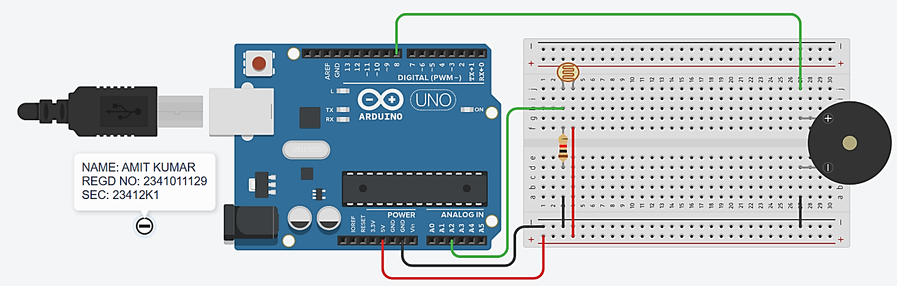
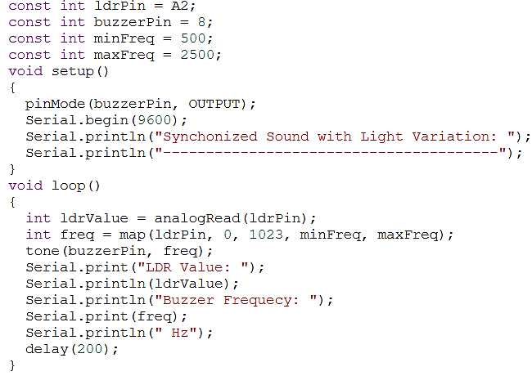
Code:

Observation: The LDR was successfully interfaced with the Arduino Uno, and the buzzer frequency varied according to the detected light intensity. The LDR readings and corresponding buzzer frequency were displayed on the Serial Monitor.
Post Experiment Questionnaire:
- Is LDR depends on wavelength of light? Justify your answer.
Sol^{n}- Yes, an LDR (Light Dependent Resistor) depends on the wavelength of incident light. LDRs are made of semiconductor materials (such as Cadmium Sulfide, CdS). Light absorption occurs when the energy of incident photons (E = hc/λ) is equal to or greater than the bandgap energy of the semiconductor. Therefore, the sensitivity and photo-conductive response of an LDR peak at specific wavelengths corresponding to the material's spectral response curve.
- Rectify the following sentence: The output of LDR is connected to pin 3 of Arduino UNO.
Sol^{n}- "The voltage divider output of the LDR circuit is connected to an analog input pin (such as pin A2) of the Arduino UNO." (Explanation: The LDR produces an analog voltage variation, so it must be connected to an Analog Input pin like A0-A5, rather than a digital pin, to perform analog-to-digital conversion using analogRead()).
- What is theoretical concept behind efficient synchrinization of light value variation with buzzer sound? Develop a mathematical equation to explain this synchronization effect.
Sol^{n}- The theoretical concept relies on linear interpolation and mapping of the analog sensor input range (0 to 1023 from a 10-bit ADC) to the desired audible frequency range (e.g., 500 Hz to 2500 Hz) of a passive buzzer using the map() function.
Mathematical Equation:
The linear mapping equation for frequency f(ADC) as a function of the analog light reading ADC_val is:
f(ADC_val) = f_min + [ (ADC_val - ADC_min) * (f_max - f_min) / (ADC_max - ADC_min) ]
Substituting the experimental parameters (ADC_min = 0, ADC_max = 1023, f_min = 500 Hz, f_max = 2500 Hz):
f(ADC_val) = 500 + [ ADC_val * (2500 - 500) / 1023 ] ≈ 500 + (1.955 * ADC_val) Hz
- Can the Arduino Uno read battery voltage more than 5V? Justify your answer.
Sol^{n}- Directly, no; but indirectly, yes using a voltage divider circuit. The microcontroller (ATmega328P) input pins can only accept voltages between 0V and 5V (VCC). Connecting a voltage greater than 5V directly to an analog input pin can damage the board. However, Arduino can read higher voltages (such as 12V or 24V batteries) by stepping down the voltage using a resistor voltage divider network to scale the measured voltage within the 0–5V safe range.

Name of the Student: Amit Kumar
Registration No: 2341011129
Branch and Section: CSE, 23412K1

