Date: 03/10/2026
Aim of the Experiment:
Measurement of temperature, soil moisture with suitable sensors and tilt sensor interfaced with an Arduino UNO and display the readings on the serial monitor.
Objective:
- Familiarization of Temperature sensor (TMP36) and interfacing it with Arduino uno. Display the Temperature on the Serial Monitor.
- Introduction to TILT switch. Interfacing tilt sensor with Arduino.
- To build a visual indicator, in which in the upright position, the Green LED is illuminated. If the system is tilted, then the red LED is illuminated.
- To interface a soil moisture sensor with Arduino UNO, measure the moisture level of soil, and display the corresponding moisture status on the Serial Monitor.

Components/Equipment Required:

Sl No. | Name of the Component/Equipement | Specification | Quantity
1 | Arduino UNO R3 | 16MHz | 1
2 | Arduino UNO cable | USB Type A to B | 1
3 | Resistors (carbon type) | ¼ watt (220Ω) | 2
3 | Resistors (carbon type) | ¼ watt (4.7kΩ) | 2
4 | LED | Red | 1
4 | LED | Green | 1
5 | Tilt switch |  | 1
6 | Temperature sensor | TMP36 | 1
7 | Soil Moisture Sensor |  | 1
7 | Buzzer | passive | 1
8 | Breadboard | 840 Tie points | 1
9 | Jumper Wire | ----------------------- | As per requirement

Theory:
- TMP36 temperature sensor measures temperature and gives an analog voltage proportional to temperature.
- Soil moisture sensor detects the moisture level in soil.
- Tilt sensor detects the change in orientation or tilting of an object.

Objective 1

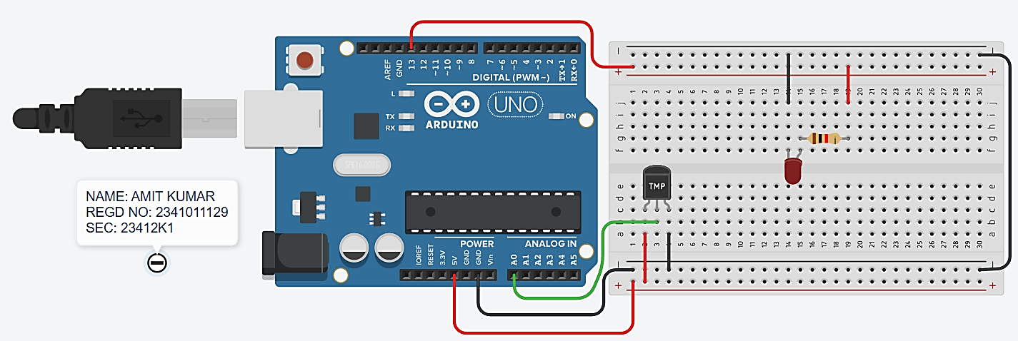
Circuit Diagram(TinkerCAD):

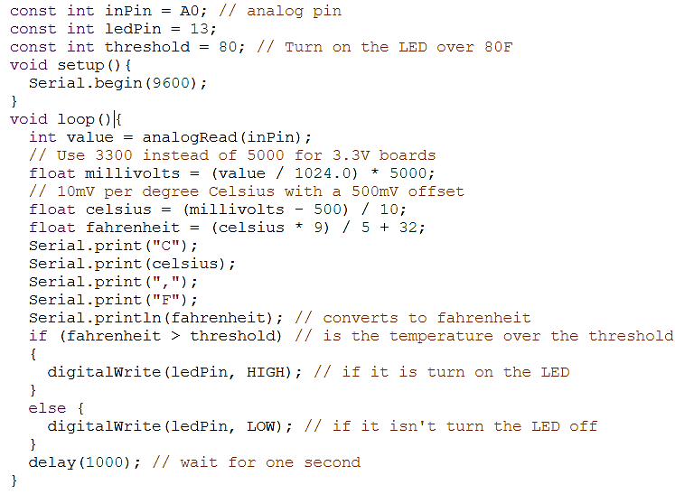
Code/Program:

Observation: The TMP36 temperature sensor was successfully interfaced with the Arduino UNO, and the temperature readings were displayed on the Serial Monitor. The LED responded according to the set temperature threshold, confirming proper operation of the circuit.

Objective 2

Circuit/Schematic Diagram: 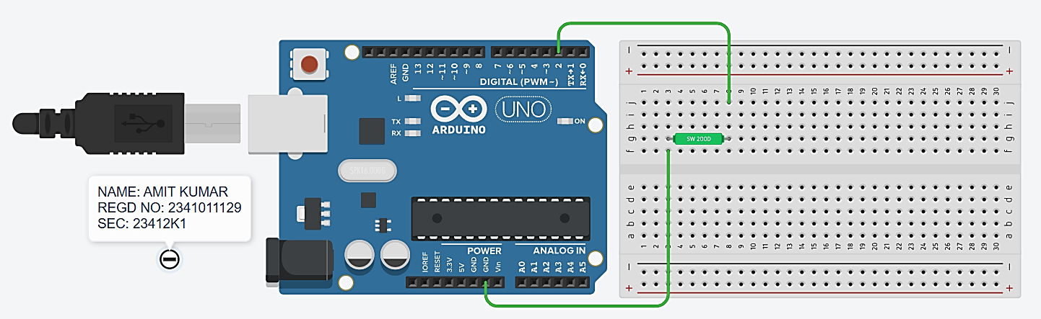
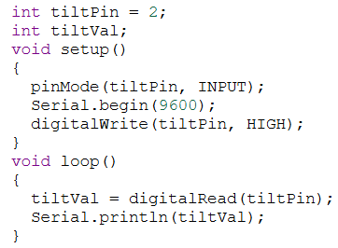
Code:

Observation: The tilt sensor was successfully interfaced with the Arduino UNO, and its digital readings were displayed on the Serial Monitor. The sensor output changed according to the tilt position.

Objective 3

Circuit/Schematic Diagram: 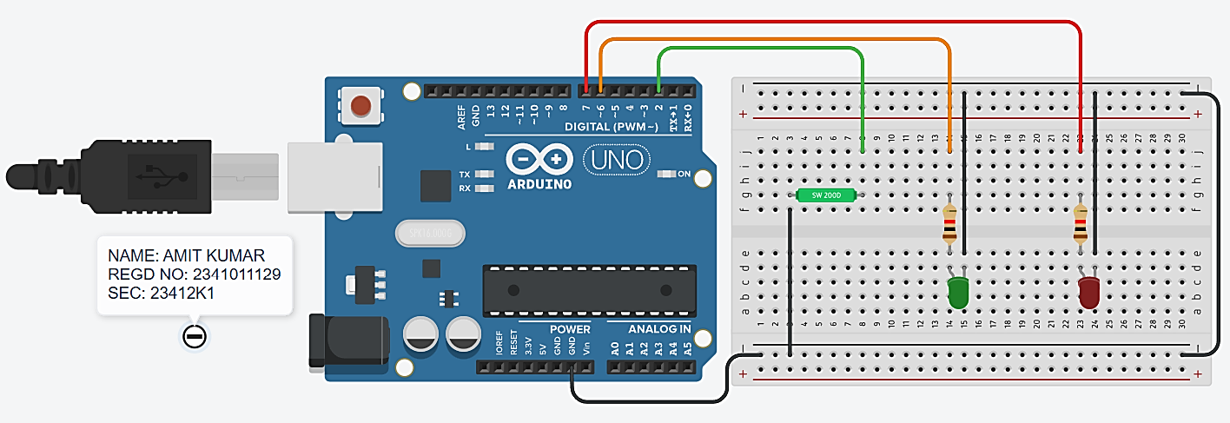
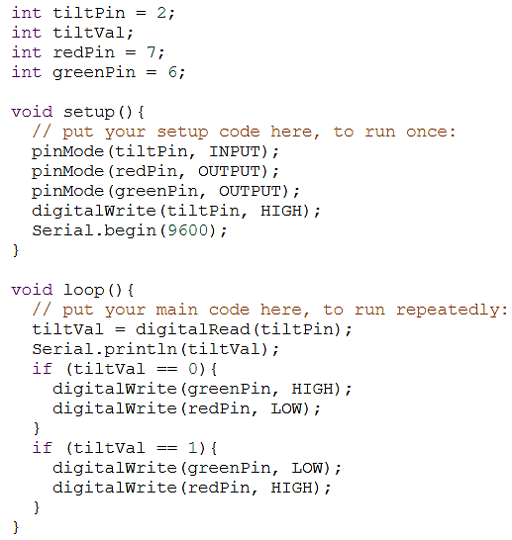
Code:

Observation: The tilt sensor was successfully interfaced with the Arduino UNO. The green LED glows when the system is in the upright position, while the red LED glows when the system is tilted. The sensor readings were also displayed on the Serial Monitor.

Objective 4
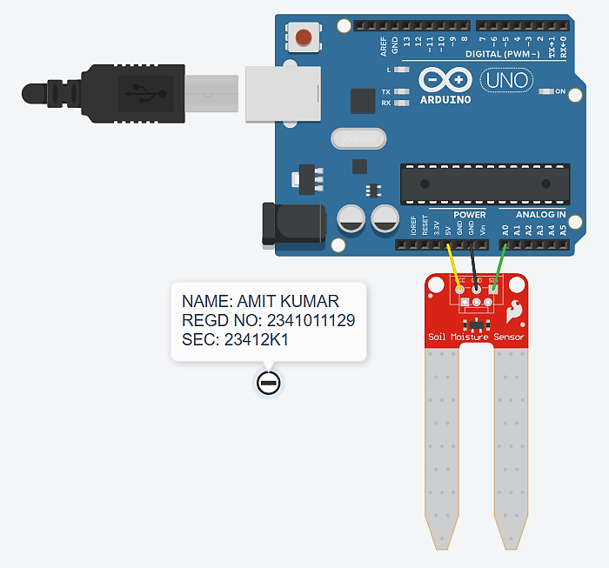
Circuit/Schematic Diagram:

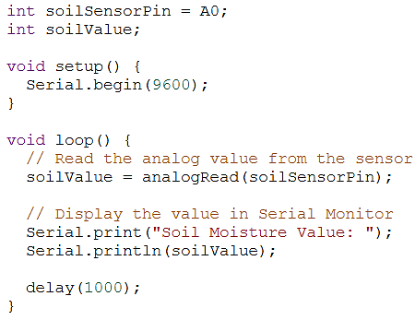
Code:

Observation: The soil moisture sensor was successfully interfaced with the Arduino UNO, and the moisture readings were displayed on the Serial Monitor. The observed reading was approximately ranging between 0 to 876.

Post Experiment Questionnaire:

- Why are sensors important in an embedded system?
Sol^{n} Sensors collect real-world data such as temperature, moisture, and tilt for the embedded system to process.

- How can Arduino control a water pump using a soil moisture sensor?
Sol^{n} Arduino reads soil moisture and turns the water pump ON when the soil is dry and OFF when it is sufficiently wet.

- What happens to the sensor output when the soil becomes wet?
Sol^{n} The sensor output value changes, indicating an increase in soil moisture
- Where the soil moisture sensor should be placed?
Sol^{n} It should be inserted into the soil near the plant roots to measure the actual moisture level.

- Name two commonly used temperature sensors with Arduino.
Sol^{n} TMP36 and LM35

- What are the three pins of TMP36?
Sol^{n} +Vs (VCC), Vout (Output), and GND

- Where can temperature sensors be used?
Sol^{n} They are used in weather monitoring, industrial systems, home automation, and electronic devices.
- Write the working principle of tilt switch.
Sol^{n} A tilt switch detects orientation by opening or closing an electrical contact when tilted

- How do you test a tilt sensor?
Sol^{n} Connect it to an Arduino digital pin and observe its digital output while changing its tilt position. The document specifically demonstrates this through Serial Monitor readings

Name of the Student: Amit Kumar
Registration No: 2341011129
Branch and Section: 23412K1

