Date: 10/10/2026
Aim of the Experiment:
To interface and control a servo motor with Arduino for light-level indication.
Objective:
- Familiarization of Servomotor, Comparison with other motors, and Interfacing of servo motor with Arduino
- Controlling Servo Motor with and without potentiometer.
- Implementation of a visual Dial which indicates the environmental light conditions.

Components/Equipment Required:

Sl No. | Name of the Component/Equipment | Specification | Quantity
1 | Arduino UNO R3 | 16MHz | 1
2 | Arduino UNO cable | USB Type A to B | 1
3 | Resistors (carbon type) | ¼ watt (220Ω) | 2
3 | Resistors (carbon type) | ¼ watt (4.7kΩ) | 1
4 | LDR/photoresistor |  | 1
5 | Potentiometer | 10k | 1
6 | Buzzer | passive | 1
7 | Breadboard | 840 Tie points | 1
8 | Jumper Wire | ----------------------- | As per requirement
9 | Servo Motor | SG90 | 2

Theory:
• Servo Motor: A servo motor provides precise angular position control using a motor, gears, feedback system, and control circuit.
• SG90 Servo: The SG90 typically provides approximately 0°–180° angular movement and is controlled by PWM signals.
• Arduino Control: Arduino controls the servo using the Servo library by specifying the required angle.
• LDR: An LDR is a light-sensitive resistor whose resistance changes according to the intensity of incident light.
• LDR Response: LDR resistance generally decreases with increasing light and increases in darkness.
• Potentiometer: A potentiometer provides a variable analog voltage that can be used to control servo position.
• Visual Dial: The experiment uses the servo as a pointer to visually indicate environmental light conditions.

Objective 1

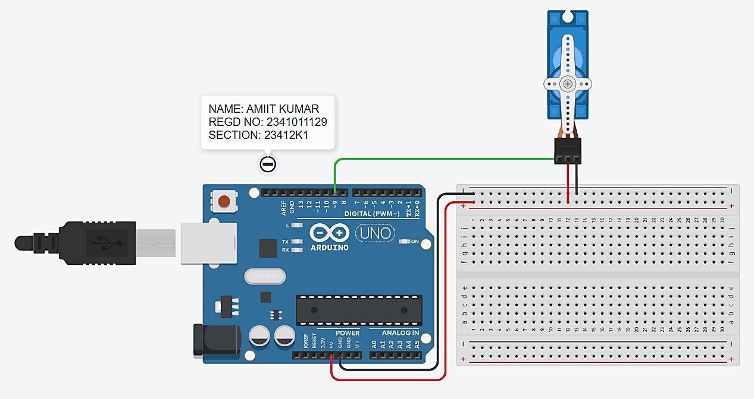
Circuit Diagram (Tinker CAD):

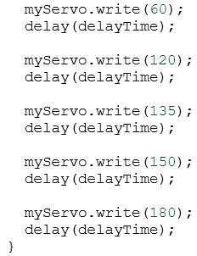
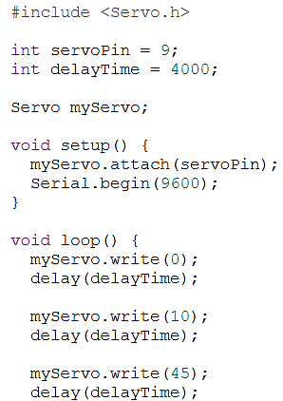
Code/Program:

Observation: The SG90 servo motor responded to the control signal from the Arduino and moved to the commanded angular position. Unlike a normal DC motor, the servo provided controlled angular positioning rather than continuous uncontrolled rotation.

Objective 2

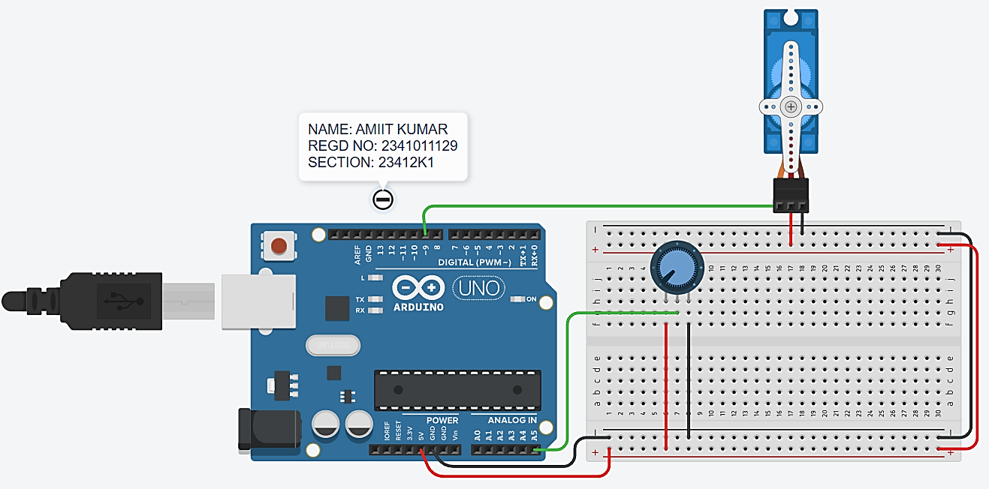
Circuit/Schematic Diagram:
- With Potentiometer

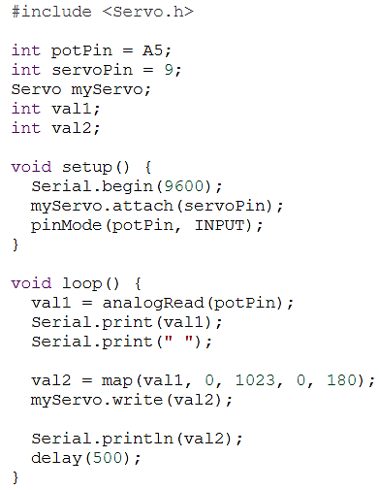
Code:

Observation: When the potentiometer was rotated, its analog output changed. The Arduino converted this analog value into a corresponding servo angle, causing the servo to rotate proportionally.

Objective 2

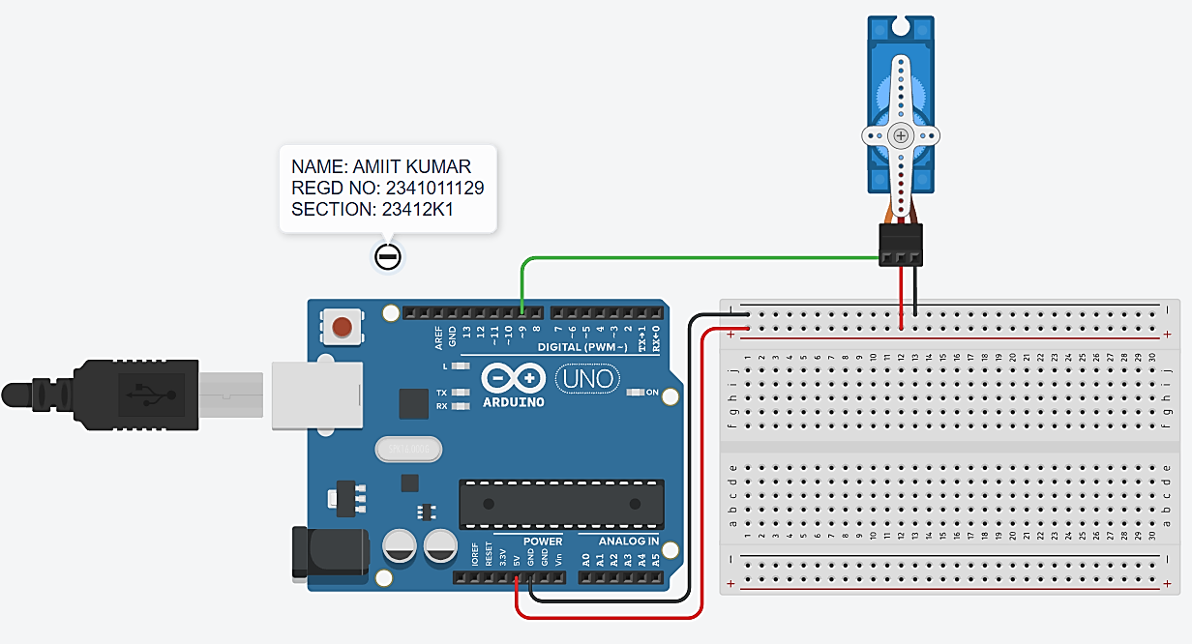
Circuit/Schematic Diagram:
- Without Potentiometer

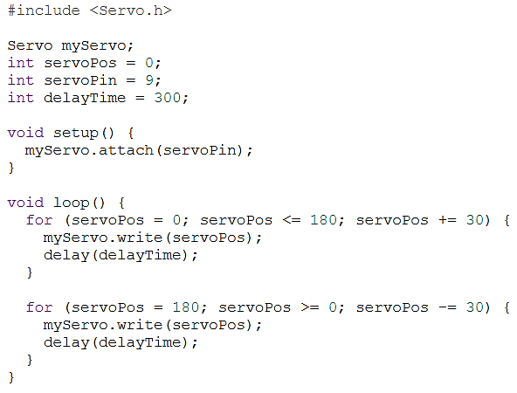
Code:

Observation: Without a potentiometer, the servo angle was directly specified in the Arduino program. The servo moved automatically to the programmed positions.

Objective 3

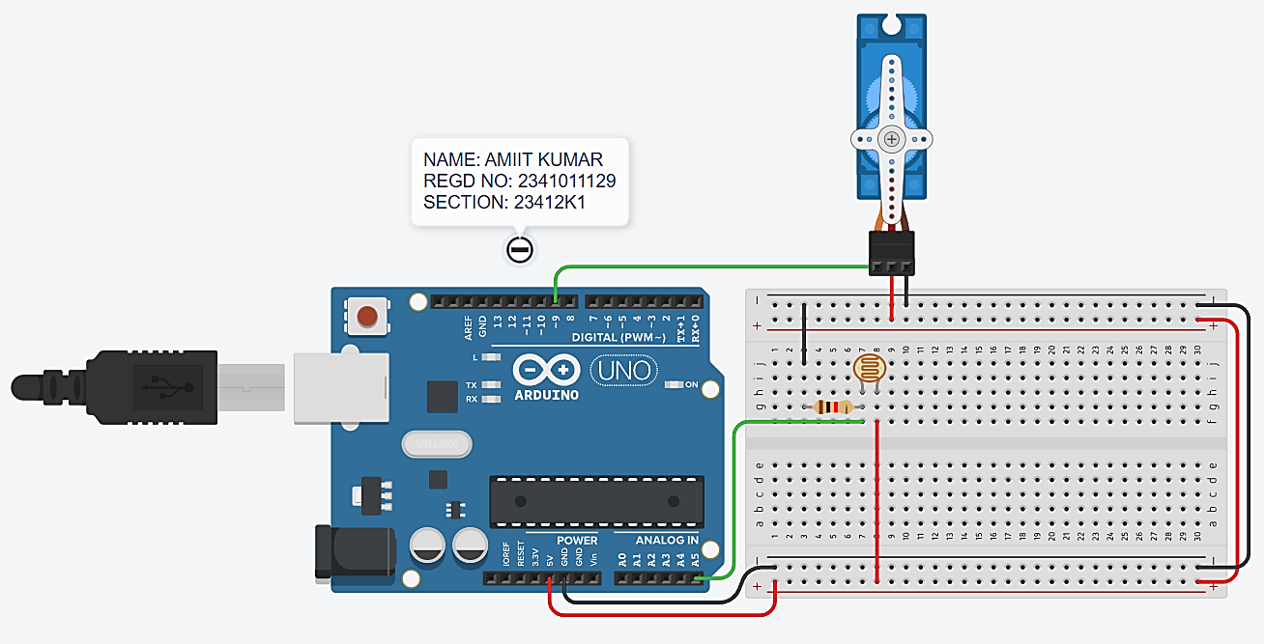
Circuit/Schematic Diagram:

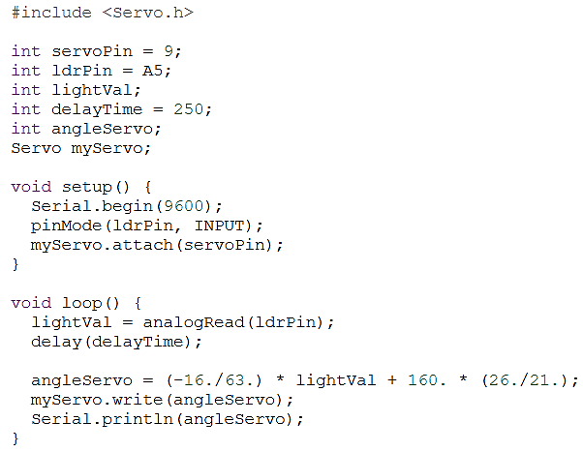
Code:

Observation: The servo pointer changed its angular position according to the light detected by the LDR. Thus, the servo successfully acted as a visual indicator of environmental light conditions.

Post Experiment Questionnaire:

- Which library is used for efficient control of SG90 servo motor in Arduino sketch?
Sol^{n} The Servo library is used to control the SG90 servo motor.
It provides functions such as: #include <Servo.h> and allows the servo to be attached and positioned using functions such as attach() and write().
- Develop a mathematical equation to explain the relationship between LDR light condition and servo angle.
Sol^{n} Let L be the LDR analog reading (0–1023) and θ be the servo angle (0°–180°). The linear mapping is θ = (L × 180)/1023. For L = 512, θ ≈ 90°. If the voltage-divider connection makes the reading decrease as light increases, use θ = 180 − (L×180)/1023.
- Write the syntax of map () function in Arduino sketch. Where is it used? Explain it through one example.
Sol^{n} Syntax: map(value, fromLow, fromHigh, toLow, toHigh). The map() function converts a value from one numerical range to another. For example, int angle = map(analogRead(A0), 0, 1023, 0, 180); converts a sensor reading of about 512 into a servo angle of about 90°.
- Can we replace the servomotor with any other motor in various engineering applications? Justify your answer.
Sol^{n} A servo motor cannot always be directly replaced by another motor. A servo provides feedback-based angular position control, whereas a DC motor usually provides continuous rotation and a stepper motor moves in discrete steps. Replacement is justified only when the alternative motor and its controller meet the application's torque, accuracy, speed, and positioning requirements.

Name of the Student: Amit Kumar
Registration No: 2341011129
Branch, Section: CSE, 23412K1

