Q-1) Create a database for the Hospital Management System based on your ER. Create

appropriate tables & relationships

• create database hospital;

• use hospital;

• create table department (dep_id INT PRIMARY KEY NOT NULL , dep_name VARCHAR(40));

• create table doctor( d_id INT PRIMARY KEY NOT NULL, d_name VARCHAR(40), dep_id

INT, FOREIGN KEY (dep_id) REFERENCES department(dep_id));

• Create table patient(pat_id INT PRIMARY KEY NOT NULL, pat_name VARCHAR(40),

pat_address VARCHAR(100) , pat_contact CHAR(10), date_admitted DATE, date_discharged

DATE, doctor_id int, FOREIGN KEY(doctor_id) REFERENCES doctor(d_id));

Inserting data into tables;

• insert into department(dep_id, dep_name) values(1, “dermatology”);

• insert into department values(2, “neurology”);

• insert into department values(3, “cardiology”);

• insert into doctor values(1, “Amit Bansal”, 1);

• insert into doctor values(2, “Yuvraj Singh”, 1);

• insert into doctor values(3, “Kulbhushan Yadav”, 2);

• insert into doctor values(4, “Gurunath Swami”, 3);

• Insert into patient values(1, “Rahul Roy”, “Jaipur”, 9876543211, 2, ‘2020-07-02','2020-07-09');

• Insert into patient values(2, "Deenanath singh", "Rudrapur", 9876543411, 2,'2020-07-03,'2020-07-08');

• Insert into patient values(3, "Deepali Sharma", "delhi", 9875543411, 1,'2020-07-01','2020-07-09');

• Insert into patient values(4, "Divyanka Tripathi", "Mumbai", 9975543411, 3, '2020-07-08','2020-07-11');

• Insert into patient values(5, "Aaqib Aalam", "Patna", 9975543341, 4, '2020-07-08','2020-07-15');

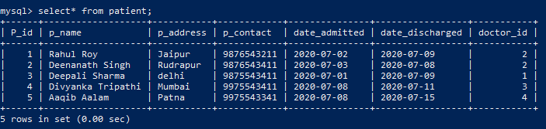

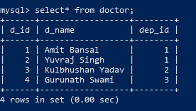

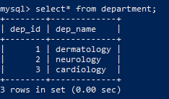

Q-2) Design a query to provide a list of doctors, which department they belong to and patients treated by them (if any).

Ans) select d_name, dept.dep_name, p.p_name from doctor as doc inner join department as dept on dept.dep_id=doc.dep_id inner join patient as p on p.doctor_id = doc.d_id;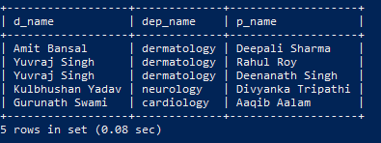

Q-3) Query to provide the count of patients discharged per day in the last week.

Ans) select count(*) as per_day_discharges, date_discharged from patient where DATE(date_discharged) between "2020-07-07" and "2020-07-14" group by date_discharged;

