**Amit Chowdhury**

**M.Tech’24 , IIT Jammu**

**LoRa :**

Learned about what LoRa is and how to get location coordinates simply by coding using Arduino IDE with required libraries. Also implemented a project using Google Map API to visualize the current location on a Map. [Code](https://github.com/Amit-Chowdhury21/LoRa_Communications/tree/main/LoRaGPS)

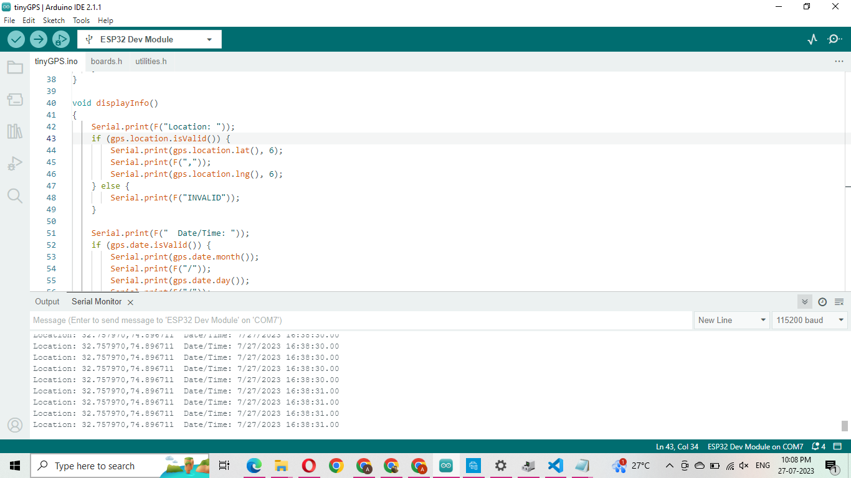

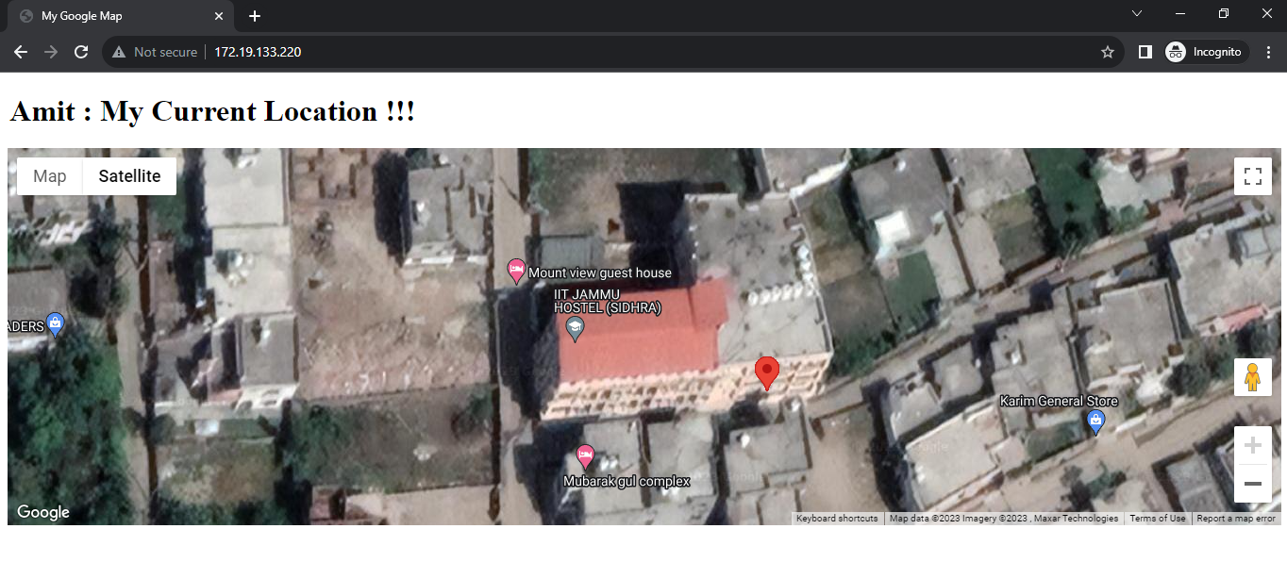

**LoRaMesher Library:**

Learned what LoRa Mesher is !!

Through its [github library](https://github.com/LoRaMesher/LoRaMesher) implemented a project from the example section name: CounterAndDisplay using Visual Studio Code + Platformio. It will send a counter to anyone that can listen in one hop & the counter will be sent directly to one of the nodes inside the routing table. Each time it will change the destination.

To understand the source code gone through readme.md

**Meshtastic Project:**

Learned about Meshtastic Project.

Installed Meshtastic Firmware [2.1.23.04bbdc6 Alpha](https://github.com/meshtastic/firmware/releases/tag/v2.1.23.04bbdc6) in the Lora module using cmd.

Useful References: [1](https://meshtastic.org/docs/getting-started) [2](https://www.youtube.com/watch?v=2v-oRkI7o08) [3](https://play.google.com/store/apps/details?id=com.geeksville.mesh&pli=1) & YTvideos from Andreas Spiess and Ham Radio channel.

The commands used to install the firmware (Windows) are documented [here](https://github.com/Amit-Chowdhury21/LoRa_Communications/blob/main/LoRaProjects/Meshtastic/cmd_Meshtastic_Firmware.txt).

Right after setting the region ‘IN’, connect the Meshtastic Application with LoRa using Bluetooth then set a communication channel.

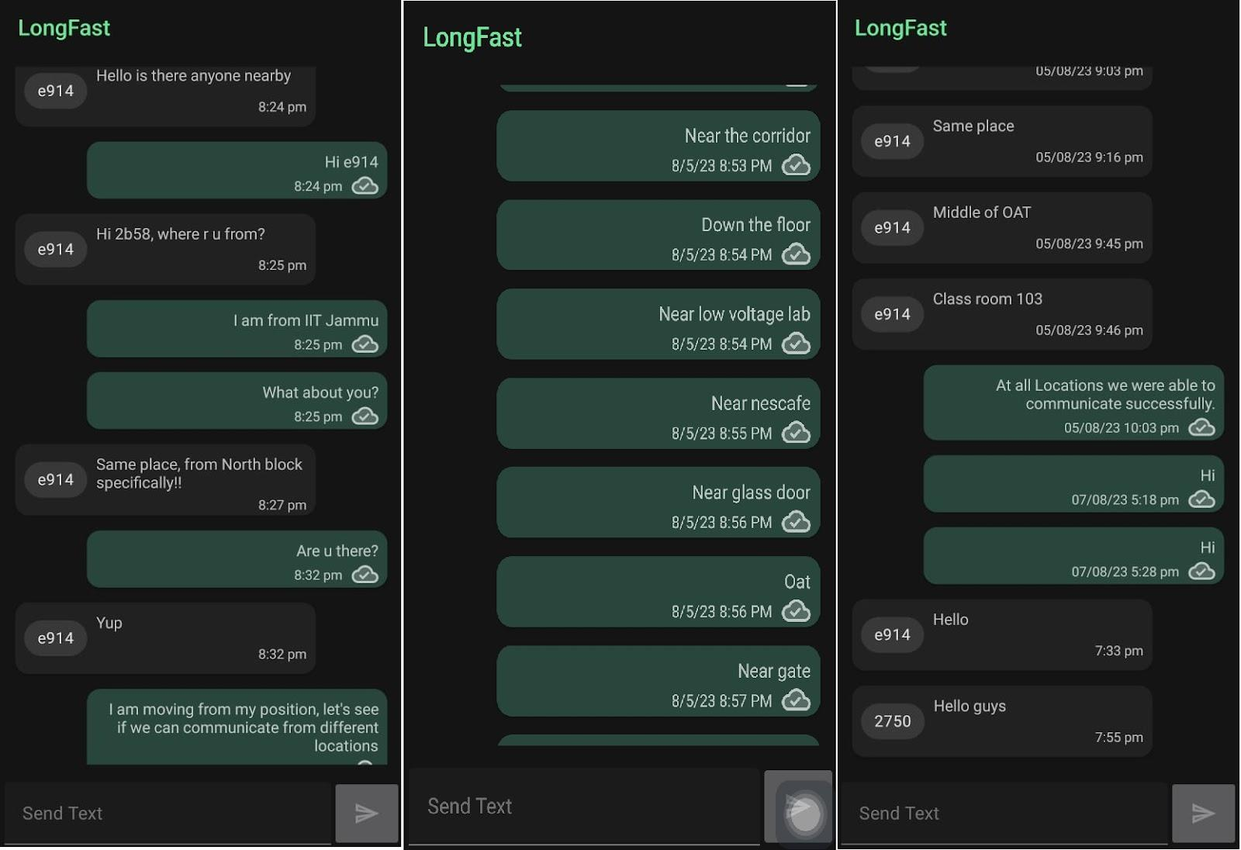

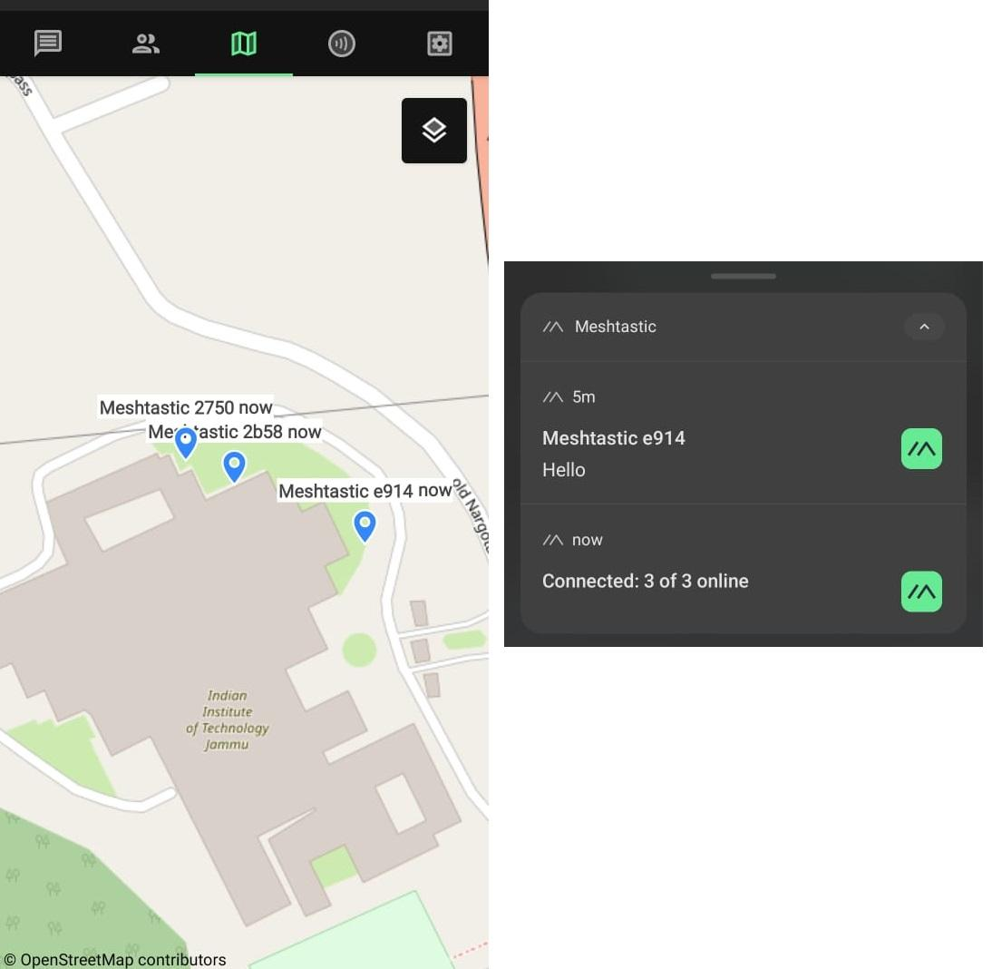

Studied about Helium Network, TTN, NB-IoT.

Range testing with sf=12, the maximum reliable communication range achieved was 2.2km. Positioned one module at an elevation of 124 m above sea level on the IIT Jammu campus, while the other was placed on the car roof at an elevation of 80-110m above sea level. Send messages every 200-300m. The expected range should have been significantly greater, but it appears that the presence of small hills surrounding our campus, along with the second module being in a shadowed region, hindered my ability to establish communication.

Understanding & Modifying the source code of Meshtastic Project to connect a SuperNode with Wifi. Routing all the data packets from different nodes through that SuperNode.